# **Description of the Datasets**

The study was conducted using four datasets related to supermarket transactions: **Item**, **Promotion**, **Sales**, and **Supermarkets**, each provided in a .csv format. The problem description included brief overviews of each dataset but did not provide detailed descriptions of the variables within them. To conduct a thorough analysis, it is crucial to have an in-depth understanding of each variable. Therefore, **general knowledge** and the **OpenAI ChatGPT-4o** model were utilized to gain a more comprehensive description of each variable. The detailed descriptions of these variables are as follows.

**Item Dataset**

|  |  |  |
| --- | --- | --- |
| **Variable** | **Description** | **Data Type** |
| **code** | Unique code for identify item. | int64 |
| **description** | Description of the item. | object |
| **type** | Item type (Type 1, Type 2, Type 3, Type 4) | object |
| **brand** | Brand name of the item | object |
| **size** | Weight of the item in Oz or LB | object |

**Promotion Dataset**

|  |  |  |
| --- | --- | --- |
| **Variable** | **Description** | **Data Type** |
| **code** | Unique code for identify item | int64 |
| **supermarkets** | Unique code for identify supermarket | int64 |
| **week** | Week number of the promotion happen | int64 |
| **feature** | Visibility that products receive in promotional catalog | object |
| **display** | Display locations of products within the store | object |
| **province** | Province of the supermarket (1, 2) | int64 |

The “**Feature”** column represents various types of promotional placements or visibility that products may receive in marketing materials, such as promotional catalogs. In this dataset, there are 8 distinct types of features. Based on the research conducted, a detailed description of each feature type is provided below.

* **Not on Feature:** Product is not in the promotional catalog.
* **Interior Page Feature:** Product is featured inside the promotional catalog.
* **Wrap Interior Feature:** Product is highlighted on the interior wraparound page of the promotional catalog.
* **Wrap Back Feature:** Product is featured on the back of a wraparound page of the promotional catalog.
* **Interior Page Line Item:** Product is listed as a line item within the interior pages of the promotional catalog.
* **Wrap Front Feature:** Product is highlighted on the front of a wraparound page of the promotional catalog.
* **Front Page Feature:** Product is prominently displayed on the front page of the promotional catalog.
* **Back Page Feature:** Product is featured on the back page of a promotional catalog.

The **Display** column provides information about the physical placement or display locations of products within the store. This dataset includes 11 distinct display values, each corresponding to a specific location where a product can be positioned to enhance visibility or serve promotional purposes. A detailed explanation of each display type is provided below.

* **Mid-Aisle End Cap:** Display located at the end of a store aisle, in the middle of the store.
* **Not on Display:** Product is not display in the store.
* **Rear End Cap:** Product is displayed on an end cap at the back of the store.
* **Store Rear:** Product is placed towards the back of the store.
* **Front End Cap:** Display at the front of an aisle near the store's entrance or main walkways.
* **In-Shelf:** Product is located on a regular shelf, alongside other products.
* **Store Front:** Product is placed near the front of the store.
* **Secondary Location Display:** Product is placed in an additional display location beyond its regular shelf spot.
* **In-Aisle:** Product is displayed directly within an aisle.
* **Promo/Seasonal Aisle:** Product is featured in a dedicated aisle for promotional or seasonal items.
* 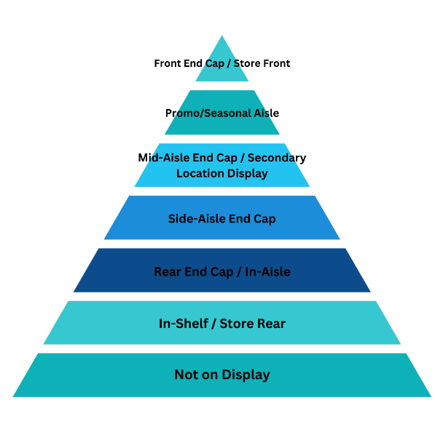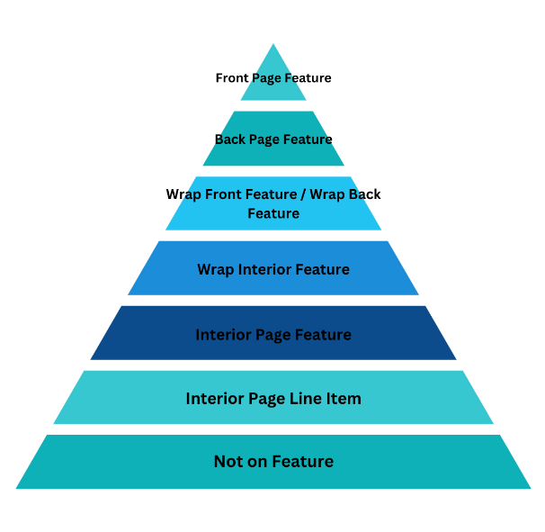**Side-Aisle End Cap:** Refers to an end cap on the side aisles.

**Sales Dataset**

|  |  |  |
| --- | --- | --- |
| **Variable** | **Description** | **Data Type** |
| **code** | Unique code for identify item | int64 |
| **amount** | Total amount that customer pay | float64 |
| **units** | Number of units that customer buy | int64 |
| **time** | Purchase time of the order | int64 |
| **province** | Province of the supermarket (1, 2) | int64 |
| **week** | Week number that purchase happens | int64 |
| **customerId** | Unique code for identify Customer | int64 |
| **supermarket** | Unique code for identify supermarket | int64 |
| **basket** | Unique code for identify items that purchased together by customer | int64 |
| **day** | Day number that purchase happens | int64 |
| **voucher** | Any discount applied or not (0,1) | int64 |

**Supermarket Dataset**

|  |  |  |
| --- | --- | --- |
| **Variable** | **Description** | **Data Type** |
| **supermarket_No** | Unique code for identify supermarket | int64 |
| **postal-code** | Postal code of region where supermarket located | int64 |

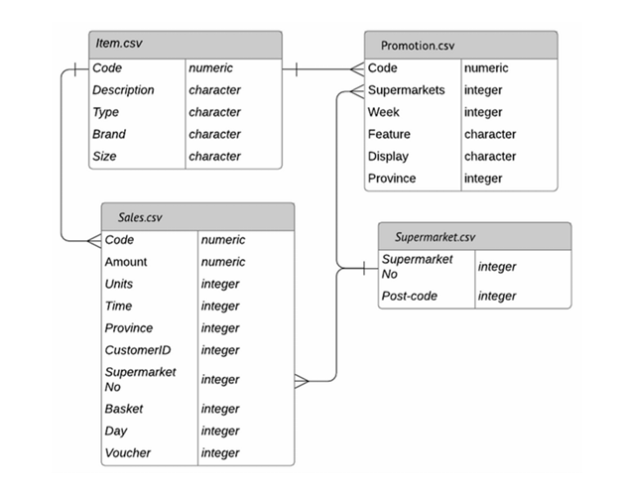Accordingto the problem statement relationships among the datasets represented as follows.

# **Data Cleaning and Pre processing**

There are no missing or duplicate values in the datasets. However, unrealistic values, duplicate classes, and incorrect data types used in certain variables were identified in some instances. These issues are addressed as follows.

### **Cleaning in Item dataset**

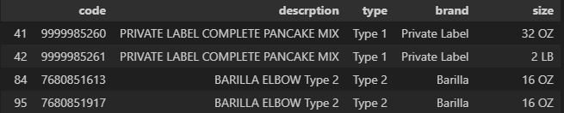It was observed that certain item codes share identical descriptions, as outlined below.

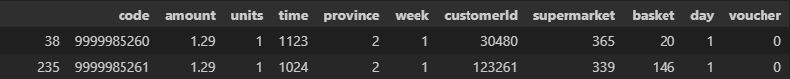While the item codes and sizes may differ, the codes are assigned uniquely to distinguish between them. A closer examination of the sizes reveals that they are often equivalent, albeit represented in different units. For instance, in the first example, 32 ounces (Oz) is equivalent to 2 pounds (LB). This suggests that these entries represent the same item but were recorded under different codes. This conclusion is further supported by analyzing the prices, which appear to be identical on specific days, confirming the initial assumption.

It is important to note **that some items share the same description but differ in size**. Therefore, it is crucial to accurately distinguish these items and avoid making any changes to them.

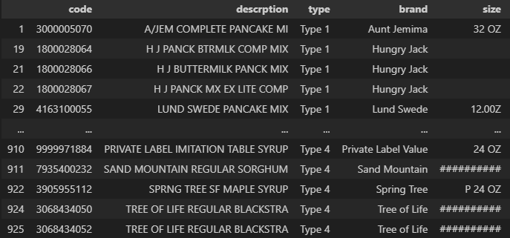Then we move to size variable. We expect value of size variable in a form of **“[number]<space>[unite]”.** But we observe that there are 138 instance go against this. Hence we have to change those instance to correct format. Since those values are in different formats we have to do this manually.