TLSKeyHunter

Our thesis explained

DOCUMENT  Learning guide |  | AUDIENCE  Basic IT knowledge |  | UPDATED  9 September 2026

Original authors | Daniel Baier and Martin Lambertz
Foundation | TLSKeyHunter and its original research
Evidence state | Final v3 report dated 30 August 2026
Purpose | Understand the changes, process, results and limitations

1 Understanding the project
We extended TLSKeyHunter to study a practical problem: after locating a TLS key-making function, how can we recover the right secret from a running program and prove that it belongs to the captured connection? Our work adds a ranked selection method for selected library experiments, version-pinned Firefox experiments, and a stricter acquisition and evidence process. The principal final Firefox TLS 1.2 study recorded 30 complete recoveries from 30 attempts. This is a controlled laboratory result. [3, 4]
TLS protects information travelling between programs. A browser must still use secret values inside its own memory to encrypt and decrypt that information. We observe those values on an authorized laboratory machine while the browser is running. We do not solve the encryption mathematics or discover a website password.

An everyday analogy
Imagine a locked delivery box. Recording the delivery route gives us the encrypted traffic. Watching the authorized sender use the matching key gives us a possible decryption secret. We then fix that candidate in our evidence record and check whether it really opens the recorded box. The analogy explains the idea; actual TLS uses several derived secrets and integrity checks.

How to read this guide
Part | What you will understand
Sections 2 to 4 | TLS basics, the original authors' work, and our specific changes.
Sections 5 to 8 | The laboratory, one complete run, the ranking method, and the Firefox paths.
Sections 9 to 12 | Evidence, controls, results, scope changes, and remaining limitations.
Sections 13 and 14 | A glossary, quick understanding checks, and the source trail.

Here, original work means the research by Daniel Baier and Martin Lambertz and their TLSKeyHunter project. Our work means the thesis extension described in the project records. The supplied long PDF is their presentation; the shorter PDF is their 2025 research paper. [1, 2]
Read the diagrams from left to right unless arrows show a different direction. A candidate is only a possible secret. A recovered session is a connection that has passed the full acceptance checks.

2 The TLS basics we need
A client asks for something, such as a web page. A server answers. Before exchanging protected content, they perform a TLS handshake: they agree on communication settings, establish secret material and authenticate as required by the protocol. HTTPS is HTTP carried inside TLS. [1, section 2]
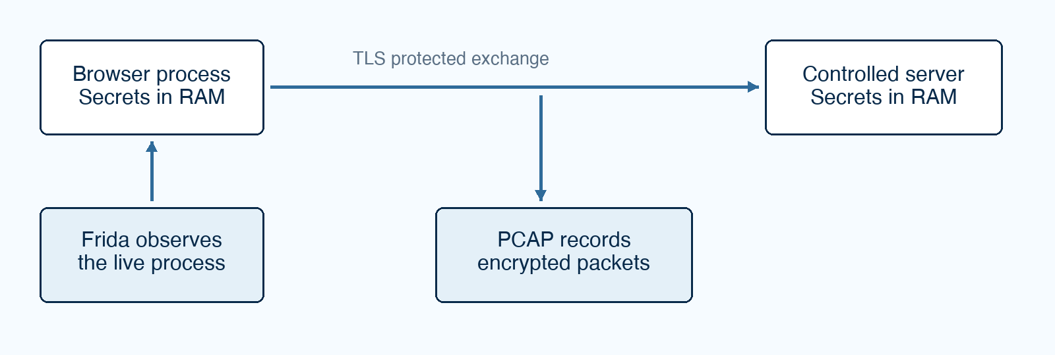
Figure 1. We observe the authorized endpoint and record the encrypted connection. The capture alone does not provide the secret.
RAM is a program's temporary working memory. A process is a running instance of a program. A TLS library is reusable code that handles secure communication: Firefox uses NSS; our smaller comparison clients use OpenSSL or wolfSSL. A hook is an observation point attached to a function while it runs.

TLS 1.2 and TLS 1.3 need different material
Feature | TLS 1.2 in this study | TLS 1.3 in this study
Main recovery material | A 48-byte master secret. | Separate traffic secrets for different stages and directions.
Derivation mechanism | PRF, a function that derives secret bytes. | HKDF, a staged secret-derivation mechanism.
What the decoder needs | Master secret and the relevant handshake/capture context. | Appropriate handshake and application traffic secrets with capture context.
Connection association | ClientHello random helps associate the secret with the session. | The same association is needed even though HKDF does not directly need the ClientHello random.

The ClientHello random is a public 32-byte value in the opening handshake. It is a connection label for key-log association, not a decryption key. TLS 1.3 traffic-secret length depends on the negotiated hash, commonly 32 or 48 bytes. A certificate and its private key are different from the per-connection secrets recovered here. [1, sections 2 and 8.1]
A PCAP is a saved packet capture. Wireshark, or its command-line counterpart TShark, can use the right secrets to interpret the matching captured TLS records.

3 What the original authors developed
The original contribution connects two tasks: finding relevant code in a compiled program, and observing that code during execution. Their TLSKeyHunter tool automates parts of the first task; library-specific Frida hooks perform the second. [1, sections 4 to 6]
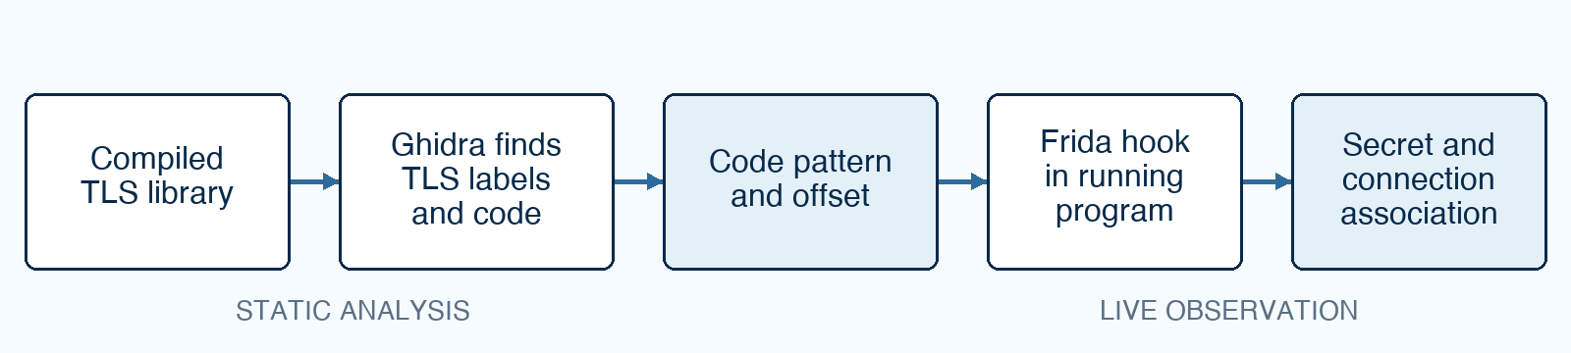
Figure 2. The original static-to-dynamic idea. The fingerprint describes code bytes; it is not a TLS secret.

Finding the key-making code
Compiled software is difficult to read, but TLS derivation uses recognizable labels such as master secret and c ap traffic. TLSKeyHunter uses Ghidra to find these labels and follow how code passes them into functions. It examines candidate functions and wrappers, then records a byte pattern and offset for the relevant code. This is static analysis: studying the program without relying on a live connection.

Watching the code run
Frida locates the matching code inside a running program. A library-specific script observes the call and reads the relevant secret or output structure. The original paper explicitly explains that an analyst must work out which argument or structure contains the material. The authors tried heuristics such as entropy and found them too error-prone in their preliminary work. [1, section 6]

What already existed before our extension
The original work includes TLS 1.2 and TLS 1.3 extraction, a ground-truth client dataset, decryption-based validation, and association with a client random, including pairing with values found in a packet capture. Its evaluation already includes Firefox/NSS. We therefore cannot claim the first Firefox TLS extraction, the first use of entropy, or the invention of client-random association. [1, sections 7 and 8, tables 1 to 3]
The paper reports broad evaluated coverage but also exceptions, including difficulty producing Rustls fingerprints. Its results and our results concern different evaluated targets and conditions; our smaller campaign is not a reproduction of every original result.

4 What we changed and what we retained
We retained the original static-analysis and runtime-hooking foundation. We focused our extension on selection robustness and on making each measured recovery traceable. A means the fixed-position baseline used in our comparison. D means our full rule-based ranker. These are experiment configurations, not TLS versions. [3, 5]
Area | Original foundation | Our bounded extension
Find relevant code | Ghidra follows TLS labels and creates fingerprints. | Record pinned binary identity, static provenance and unique-match checks.
Read live secrets | Library-specific Frida hooks and structure knowledge. | Controlled hooks and runners for selected versions and workloads.
Choose an argument | Analyst encodes the relevant position for a hook; heuristics were explored. | Combine several observable clues in D and compare it with A.
Firefox and NSS | Already evaluated in the original paper. | Implement and evaluate our pinned Firefox 136.0.2/NSS cases.
Associate traffic | Client-random association and capture-based pairing already exist. | Require unambiguous controlled association and stricter verification.
Prove correctness | Ground-truth clients and Wireshark decryption. | Seal acquisition before independent exact comparison and authenticated marker recovery.
Preserve evidence | Original research artifacts and dataset. | Named cases, frozen settings, manifests, controls and non-secret summaries.

Two contributions must stay separate
The A-versus-D study examines argument selection in a native harness and selected OpenSSL/wolfSSL sessions. The Firefox studies examine a version-specific browser acquisition and verification path. The Firefox TLS 1.2 hook reads a returned NSS key object; it does not demonstrate D selecting arbitrary Firefox arguments. The TLS 1.3 hook also uses known NSS argument and structure positions. [6, 7]
A defensible description is: we extended and evaluated TLSKeyHunter under controlled conditions. Saying that we created TLSKeyHunter, automated every library adaptation, or made extraction universally reliable would go beyond the work.

5 How the laboratory fits together
The experiment runs on an authorized Linux x86-64 laboratory host. Firefox or a small TLS client contacts a controlled server. The runner coordinates the client, hooks, capture, private evidence and verification. Localhost means the traffic stays within that host's networking environment. [3, 5, 7]
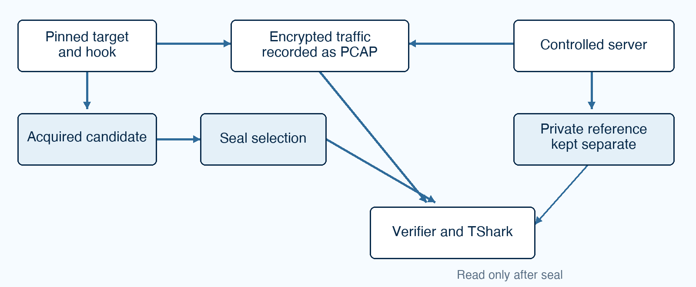
Figure 3. The reference is produced by the server but is only read for verification after the acquired candidate has been sealed.
Component | Its job | What it produces
Ghidra and provenance records | Explain where the selected code pattern came from. | Fingerprint, offset and binary/tool identity.
Runner | Start, coordinate and classify one controlled case. | Case ID, events, timestamps and status.
Frida and the target hook | Observe the relevant operation in the live process. | Candidate material and hook events.
Packet capture | Record handshake and encrypted application traffic. | PCAP for the intended connection.
Controlled server | Serve a known response and export a separate reference. | Server events and private reference secrets.
Verifier and TShark | Check exact equality and decode the intended capture. | Comparison results and recovered markers.
Evidence manifest | Record file checksums for later integrity checking. | A list of files and their SHA-256 hashes.

A visible browser is useful for explaining what happened, but a screenshot cannot establish that the secret was right. The actual proof comes from the candidate record, server reference, traffic recovery and evidence records.

6 One complete run from start to finish
Follow a Firefox TLS 1.2 case. For teaching only, imagine the browser requests /lesson-001 and the server responds with LESSON-001-OK. These are illustrative markers, not copied evidence values. The real runner uses controlled case-specific markers. [3, 7]

Step 1 Prepare a new case
The runner creates a unique evidence ID and refuses to overwrite an existing case. It loads the selected binary, fingerprint and protocol settings. A freeze records the experiment recipe: code version, tools, binaries, settings and related evidence. Changing that recipe requires a separately recorded state.

Step 2 Prepare the observation
Packet capture and the controlled server start before the relevant traffic. Firefox uses a fresh profile so old browsing state is reduced. Target SSLKEYLOGFILE is disabled: we must acquire the candidate through the live hook rather than ask Firefox to write its normal key log. The server may produce a separate private reference, but selection must not read it.

Step 3 Check the target and attach
The runner checks the frozen binary's SHA-256 and Build ID, and requires one matching fingerprint. Zero matches means the expected code was not found; several matches mean the location is ambiguous. The target handshake is held until the hook is ready, so the key-making event is not missed.

Step 4 Allow the request and acquire the result
Firefox contacts the server and TLS creates its secret material. The NSS TLS 1.2 hook waits for the selected derivation operation to finish, then reads the 48-byte result from its returned key object. The hook records a candidate. Capture records the ClientHello random and encrypted request and response.

Step 5 Select and associate before checking the answer
For this single-connection case, the runner requires one distinct master-secret candidate and one captured ClientHello random. It combines them into the key-log representation needed by the decoder. Multiple distinct candidates or multiple randoms are not resolved by trying combinations until one decrypts; they are classified as ambiguity. [7]
At this point we have an acquired candidate associated with the intended capture. We have not yet established that the candidate is correct.

6 One complete run continued

Step 6 Seal the acquisition
Acquisition stops. The candidate file is written with restricted read-only permissions, its SHA-256 is recorded, and an acquisition-seal record is created. This fixes what will be tested. A seal is a recorded software checkpoint with permissions and hashes; it is not hardware that makes privileged modification impossible.
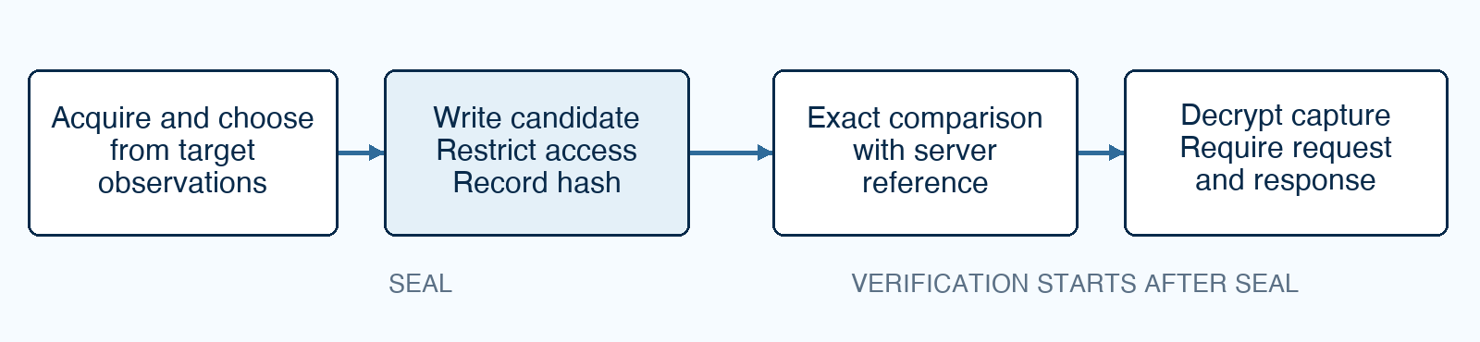
Figure 4. Selection finishes before verification begins. Verification cannot feed the correct answer back into candidate selection.

Step 7 Compare against the independent reference
Only after the seal does the verifier read the server's separately generated reference. It checks that the candidate key-log material matches exactly for the relevant secret label and connection. One incorrect bit is a failure. A candidate with the right length and a convincing appearance can still fail this test.

Step 8 Decrypt the intended captured connection
TShark receives the sealed candidate, not the server reference as a replacement key. It must recover authenticated application content for the intended stream, including both the exact request path and exact response marker. In our teaching example, recovering /lesson-001 without LESSON-001-OK would be incomplete.

Step 9 Finish the evidence and classify the attempt
The runner records the checks, output and file hashes. Complete recovery requires the controlled client/server events, complete handshake, relevant Frida event, valid association, seal, exact reference equality, authenticated request/response recovery and valid evidence. A failure is retained in the attempted-session total. [3, 4, 7]
This order matters. If the verifier were allowed to choose whichever candidate eventually decrypted, the result would demonstrate a search-and-verification procedure. It would not prove that the acquisition method independently selected the correct candidate. The final chronology deliberately separates those claims.

7 How the argument ranker works
A function is a small operation inside a program. Arguments are the inputs it receives. Some inputs are pointers: addresses telling the function where data lives in memory. An output pointer may point to a buffer that the function fills before returning. [6]
Method A reads the position recorded for that hook. It works when that assumption matches the target. If a different layout places the relevant buffer elsewhere, A may read unrelated bytes or find nothing usable. Method D inspects a bounded set of possible positions and ranks observable clues. It is a deterministic scoring method, not a trained AI model.
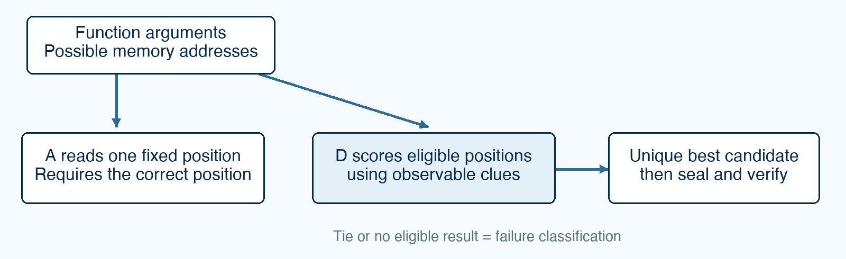
Figure 5. A and D are alternative selection methods. D chooses a unique eligible top score; a tie or no eligible candidate is a recorded failure outcome.
Clue | Plain-language meaning | Why it cannot prove correctness
Readable memory | The pointer allows the expected number of bytes to be read. | An unrelated buffer can also be readable.
Expected length | Read the size expected for this secret and protocol. | Reading that many bytes does not establish the buffer's real purpose.
Entropy and zero count | Prefer varied bytes with relatively few zeros. | Other random-looking data can receive a good score.
Changed during the call | Where before/after observations are supplied, prefer a buffer that changed. | Other outputs can change too.
Repeated-call consistency | Add weight to the same argument position recurring at a call site. | A repeated wrong choice can also be consistent.

D does not use the server reference or trial decryption to calculate its score. Preferred-index scoring is disabled in the final D comparison, and the final path does not silently substitute A if D has no unique candidate. The browser paths remain separately version-specific. [3, 6]

7 What the ranker tests actually establish

The implemented secret score
In arg_ranker.js, a readable read of an expected length starts at 40 points. Entropy of at least 4.0 adds 25; a low zero count adds 10. A changed buffer adds 20 when before-call bytes are supplied. Matching the previously selected argument position at that call site adds 10. Candidates must pass the configured minimum, and the selector requires one highest-scoring candidate. These are implementation rules, not probabilities of being correct. [6]
For example, a readable varied buffer with few zeros can score 75 before change or history bonuses. If two eligible buffers share the highest score, the method reports ambiguity. It does not mean that a score of 75 gives a 75 percent chance of success. The exact-reference check is still necessary.

The native argument-position experiment
A small compiled x86-64 test program deliberately moves a 32-byte test secret through argument indices 0 to 11. Each position is tested ten times for A and ten times for D: 12 positions times 10 calls times 2 methods gives 240 observations. The harness tests whether the right argument can be identified, including positions handled through the architecture's calling convention. It is not 240 browser sessions. [3, 4]
Method | Correct observations | Interpretation
A | 10 of 120 | Correct when the secret occupies its fixed position.
D | 120 of 120 | Correct across all positions under the constructed test conditions.

The live comparison
The next test uses real controlled TLS traffic: two libraries, two TLS versions, two methods and five sessions per combination. That makes 40 attempted sessions, 20 per method. D completed 20 of 20; A completed 10 of 20. A had five no-candidate outcomes and five false candidates. The report states that A succeeded on the frozen wolfSSL layouts and failed on the frozen OpenSSL layouts. [3, 4]
These tests support robustness against the tested position assumptions. They do not prove that every library exposes plain secret buffers, that D understands arbitrary structures, or that the baseline implementation could never be retuned. Different distractors, compilers and layouts need separate evaluation.

8 What happens inside the Firefox paths
Our browser target is Firefox 136.0.2 with pinned NSS library binaries. Pinned means the exact tested files are identified, not merely that their filenames look right. NSS stores some secrets in key objects and structures, so the hook must understand that particular representation. [3, 7]

The TLS 1.2 path
The recorded static fingerprint is in libsoftokn3.so at offset 0x1ca00. The implemented acquisition hook attaches to the exported NSS operation PK11_DeriveWithFlags and filters for the selected extended-master-secret DH derivation mechanism. On return, it uses PK11_ExtractKeyValue and PK11_GetKeyData to access the returned key data. A SECItem structure supplies the pointer and length; the hook accepts a readable 48-byte result. [7]
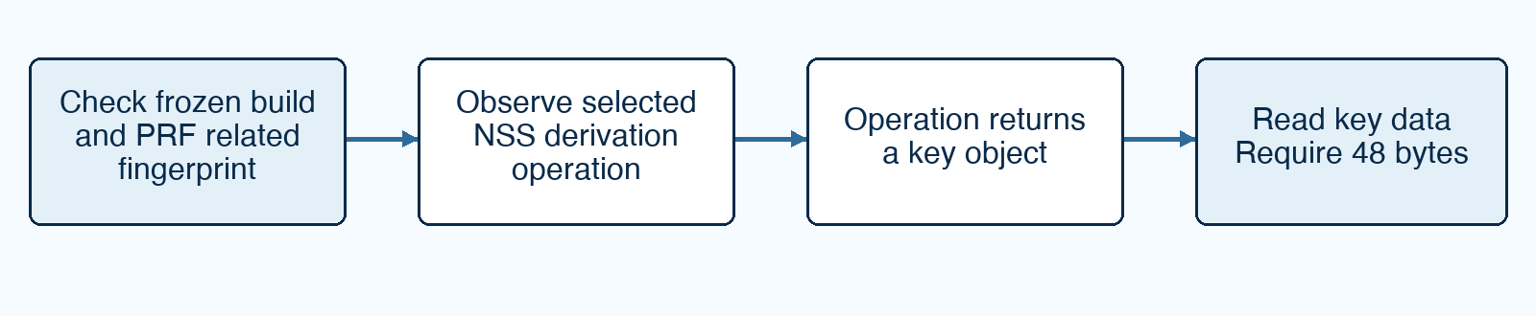
Figure 6. The static fingerprint is a provenance/checking anchor. The actual TLS 1.2 secret read occurs through the returned NSS key-result path.
This distinction matters when explaining the code: finding the PRF-related fingerprint does not mean the script directly reads the master secret from that exact fingerprint address. The post-return NSS API path is the extraction mechanism in this implementation. Its reliance on those exports, object layout and extractability is a limitation.

The TLS 1.3 path
The TLS 1.3 fingerprint is in libssl3.so at offset 0x56e90. The hook observes an NSS derivation wrapper, saves known arguments on entry, and reads the resulting key on return. It uses labels to distinguish client/server and handshake/application secrets, with known NSS structure offsets to obtain connection information. This also relies on version-specific knowledge. [3, 7]
We preserved the earlier 90-session TLS 1.3 campaign as historical functional evidence. A separate five-session strict regression checks the newer sealed-acquisition and exact-reference process. Those two datasets must not be described as if both used the later chronology.

9 How we know a result is trustworthy
No single log message establishes success. We use several checks that answer different questions. Exact equality proves agreement with the controlled reference; authenticated decryption and exact markers link the acquired material to the intended traffic; manifests support checking that the evidence files have not changed. [3, 4]
Check | Question it answers | What it does not establish alone
Binary hash and Build ID | Is this the selected build? | That a hook will read the correct data.
Unique fingerprint | Did the selected pattern identify one location? | That every future build will work.
Candidate and seal | What did acquisition select before verification? | That the selected bytes are correct.
Exact server comparison | Does the acquired material match the independent reference? | That the intended application exchange was fully recovered.
Authenticated decryption and markers | Did these acquired secrets recover this controlled exchange? | Coverage of other versions, workloads or systems.
Manifest | Do the files match the recorded checksums? | That the experiment design was unbiased or the records could never be forged.

The evidence record
A case ID identifies one attempt. The case contains packet capture, hook events, server events, private candidate/reference material, an acquisition seal and verification outputs. A campaign summary combines attempts without discarding failures. A freeze records the exact recipe used across the final work.
Public teaching output contains IDs, lengths, selected indices, scores, hashes and classifications. Raw secrets and reference key logs remain in private evidence. A hash is a checksum for detecting changed bytes; it is not the underlying secret and does not explain how the bytes were acquired.

What the visible demonstration contributes
The separate visual case records a real Firefox session with four stage screenshots and an MP4. It helps show the operator sequence. It is outside the 30-session statistical dataset. The report records successful sealed acquisition, exact match and decryption for that case, but its screenshots are supporting material rather than the proof of correctness. [3]

9 Deliberate failures that check the verifier
A negative control deliberately supplies a bad input or unsupported condition. Passing means the system rejects it as intended. These tests reduce the risk of a verifier reporting success merely because it saw key-shaped text or unrelated traffic. All eight final TLS 1.2 controls passed, and the positive sanity check recovered both markers. [3, 4]
Control | What it checks
No candidate | Traffic cannot be accepted without acquired key material.
Random secret of the same length | Correct size alone is insufficient.
One-bit modified secret | Almost-correct material must fail.
Correct secret with wrong ClientHello random | The key must be associated with the correct connection.
Frida diagnostic text used as key material | A tool message is not a valid secret record.
Correct candidate on the wrong TCP stream | Success on another connection is not success for this case.
Unsupported NSS hash or Build ID | The supported-build boundary must be enforced.
Multiple fingerprint matches | Ambiguous code identification must not be accepted.

How to read failure labels
No candidate means the acquisition did not produce the required selection. Ambiguous means multiple possibilities prevent a unique decision. False candidate means something was selected but it did not match the correct reference. An incomplete session can also fail because capture, handshake, markers or evidence checks are missing. These outcomes remain in the denominator.
The positive sanity test is equally useful: it confirms that the verification setup can accept the correct material. Otherwise, a broken verifier that always rejects everything could appear to pass all negative controls.
Eight passed controls do not exhaust every possible failure. They check named failure modes under this laboratory setup. Additional threat models, versions or workloads would need their own tests.

10 What the final results mean
The final report and machine-readable summaries agree on the following outcomes. Keep their units and evidence standards separate. These are recorded experimental results, not a forecast for arbitrary systems. [3, 4]
Dataset | Outcome | Meaning
Native harness A | 10 / 120 correct | Argument-identification observations.
Native harness D | 120 / 120 correct | Argument-identification observations.
Live library A | 10 / 20 complete | Five no-candidate and five false-candidate outcomes retained.
Live library D | 20 / 20 complete | Sealed selection, exact match and traffic recovery.
Firefox TLS 1.2 final | 30 / 30 complete | Three runs of ten; sealed acquisition and exact comparison for all.
Firefox TLS 1.3 strict regression | 5 / 5 complete | Newer sealed and exact-reference procedure.
Firefox TLS 1.3 historical final | 90 / 90 functional recoveries | Decryption demonstrated; exact reference equality and strict sealing were not measured in this dataset.
Final TLS 1.2 controls | 8 / 8 plus positive sanity | Expected rejection of bad cases and acceptance of a valid one.

Why perfect observed recovery is not universal success
Thirty successes from thirty trials is 100 percent observed recovery. The report gives a 95 percent Wilson interval of approximately 88.65 to 100 percent. This expresses sampling uncertainty under a repeated-trial model; it does not mean there is a 95 percent probability that every Firefox version succeeds.
For the 20-session live D result, the interval is approximately 83.89 to 100 percent. Small, controlled samples cannot remove uncertainty about different environments. Shared tools and fixed workloads also restrict generalization. Larger counts would not by themselves solve version or workload bias.
The report records valid manifests for all 30 final Firefox TLS 1.2 sessions and all 40 live library sessions, along with the preserved historical evidence. A completed measurement campaign is not a declaration of production readiness.

11 How the work and its scope evolved
The work moved from exploration and functional recovery toward a narrower final comparison with stricter evidence. Earlier documents are useful history, but their pending-task lists must not be mistaken for the later final status. [3, 5, 8]
Earlier direction | Final treatment | Consequence for our claim
Compare A, B, C and D | Final comparison keeps A and full D; B/C remain exploratory. | We cannot isolate each clue's contribution from final A/D results alone.
160-session live ablation | Reduced to 40 A/D live sessions. | Feasibility across selected combinations, with small samples.
90 new Firefox TLS 1.2 sessions | Reduced to 30 final sessions in three runs. | Controlled proof of concept, not broad browser coverage.
Repeat accepted TLS 1.3 campaign | Preserve 90 historical sessions; add five strict regression sessions. | Historical and stricter evidence retain different labels.
Timed operator-effort study | Excluded from required scope. | No measured usability or time-saving claim.
GUI evidence as a major deliverable | One separate real visual case supports explanation. | The screen recording does not become a statistical trial.
Candidate/random validation during earlier development | Final procedure fixes the selection before exact verification. | Earlier successful trials do not automatically acquire the newer evidence standard.

Why the labels matter
Development cases help fix implementation. Pilots check readiness. Regression cases check whether accepted behavior still works. Final cases use the fixed experiment settings and planned accounting. Failed, superseded and excluded cases retain those labels. Accepted means that the relevant acceptance conditions were met; it does not imply that the case belongs in every final table.
The final report identifies FROZEN-BASELINE-V4 and experiment commit e65078b5f0be41e61ec9fbdd323133352a9b58eb. That identifies our experiment state. It must not be confused with the original authors' repository revision. [3]

12 The limitations we must explain

Access and timing
The method requires sufficient access to instrument a running target on an authorized host. It is not a technique that recovers keys from a website URL alone. The hook must be ready when the relevant operation runs. A recording made after the event or a process that cannot be instrumented presents a different problem.

Version and representation dependence
The Firefox hooks depend on Firefox 136.0.2 and the pinned NSS binaries. Byte patterns, exported functions, argument positions and structure offsets can change. TLS 1.2 also depends on obtaining data from the returned NSS key object. A hash mismatch, ambiguous fingerprint or unreadable result stops the supported workflow. D does not remove these browser dependencies. [3, 7]

Controlled workload and limited generalization
The studies use Linux x86-64, fixed protocol/cipher policies, a controlled server and one connection per browser case. They do not establish behavior for busy multi-connection browsing, every cipher, resumption, early data, key updates, all architectures or every upstream library. These are boundaries of the evaluation, not assertions that every untested case must fail.

Ranking can still be wrong
Random-looking unrelated buffers, equally scored candidates and misleading repeated positions can defeat heuristic selection. The final study compares the combined D configuration with A. It does not establish a universal best set of weights or prove the individual value of every clue. Exact verification remains essential.

Evidence controls have their own limits
The server reference is independent of target acquisition as a source of secret values, but both are coordinated in one controlled laboratory. Permissions and hashes support the intended chronology; they are not an externally witnessed, tamper-proof chain of custody. Manifest validity checks file integrity, not all possible experimental bias.

What would require new work
Broader claims would require additional pinned builds, independently designed workloads and distractors, multi-connection association tests, other platforms and separately designed usability studies. None of those should be described as completed merely because the current frozen tests passed. [3, 5]

13 Terms and understanding checks
Term | Meaning in this guide
TLS secret | Private per-connection material used to derive traffic-protection keys.
PRF or HKDF | TLS mechanisms that turn input secret material and context into other secret bytes.
Binary | The compiled program or library file.
Fingerprint | A recognizable pattern in compiled code.
Pointer and buffer | An address in memory, and an area of memory holding bytes.
Argument index | A numbered input position at a function call.
ABI | Rules for how compiled code passes arguments and results.
Entropy | A measure of byte variation used here as a heuristic clue.
NSS and SECItem | Firefox's security library family, and one of its data structures.
Key log | A decoder-compatible mapping of secret labels, connection randoms and secrets.
Seal and manifest | A fixed acquisition checkpoint, and a file-checksum inventory.
Ground truth | An independent expected value used to check correctness.
Authenticated decryption | Decryption that passes the TLS record integrity/authentication checks.
Regression | A repeat check of established behavior after changes.

Check your understanding
Why is the ClientHello random insufficient? It associates a connection but is public and is not the secret. Why is a high-scoring buffer insufficient? Other data can look equally convincing. Why seal first? To stop verification from choosing the acquisition answer. Why not call the historical 90/90 an exact-match result? That dataset did not measure the later exact-reference requirement.
A short explanation you can give someone else: We built on a tool that finds TLS key-making code and watches it run. We tested a smarter way to select possible secret buffers in selected libraries, and built a tightly controlled Firefox experiment. We then fixed the acquired material before checking it against an independent reference and the actual captured traffic.

14 Sources and where to look next
Source numbers in this guide refer to the records below. Paper locations use section numbers and PDF page numbers; the supplied paper has a conference cover, so its PDF page 7 is printed article page 6. All diagrams here are new explanatory schematics.

Original research
[1] Daniel Baier and Martin Lambertz. All your TLS keys are belong to Us: A novel approach to live memory forensic key extraction. Forensic Science International: Digital Investigation 54 (2025), 301975. DOI: 10.1016/j.fsidi.2025.301975. Supplied 10-page PDF. TLS basics: section 2; static method: sections 4 and 5; manual hooks and heuristic limitation: section 6, PDF page 7; prior Firefox support and association: section 8 and table 3, PDF page 8.
[2] Baier and Lambertz. Presentation of the same title, supplied 53-page PDF named All-your-TLS-keys-are-belong-to-Us_Daniel-Baier.pdf. Companion visual explanation of the original work. The research paper is the primary source for the attribution and method details used here.

Our final results and methodology
[3] TLSKeyHunter_REPORT_v3.md, generated 30 August 2026. Sections 3 to 7 explain chronology, provenance, selection, browser results and controls. Sections 10 and 11 explain scope changes and limitations.
[4] TLSKeyHunter_v3_results/v3_summary/summary.json; live_ad/summary.json; abi/summary.json; firefox_tls12/campaign-summary.json. These contain the non-secret recorded counts and classifications behind the result tables.
[5] TLSKeyHunter-work/thesis-governance/THESIS_SCOPE.md and CONTRIBUTION_BOUNDARIES.md, 30 August 2026. These describe the bounded research questions, exclusions and attribution rules. Their earlier pending steps are superseded where the final v3 report records completion.

Implementation and history
[6] TLSKeyHunter-work/tlsKeyExtraction/arg_ranker.js and the OpenSSL/wolfSSL hook files in the same directory. Also lab/arg_ranker/native_abi_harness.c and lab/live/run_live_case.py. These explain scoring, controlled argument positions, selection and sealing.
[7] TLSKeyHunter-work/lab/firefox/nss_firefox_136.0.2_tls12.js; nss_firefox_136.0.2.js; phase18a_firefox_nss_runner.py. Read the TLS 1.2 result hook and the runner's acquisition-seal and post-seal verification sections for the precise browser path.
[8] TLSKeyHunter-work/report.md and thesis-governance/UPSTREAM_PROVENANCE.md. Historical development status and upstream attribution. The upstream repository is https://github.com/monkeywave/TLSKeyHunter. The thesis frozen commit is a separate identity from the upstream base revision.

Use footnotes for definitions, assumptions, or terms that need precision without interrupting the main narrative.

