LAB Logbook

Lab 1
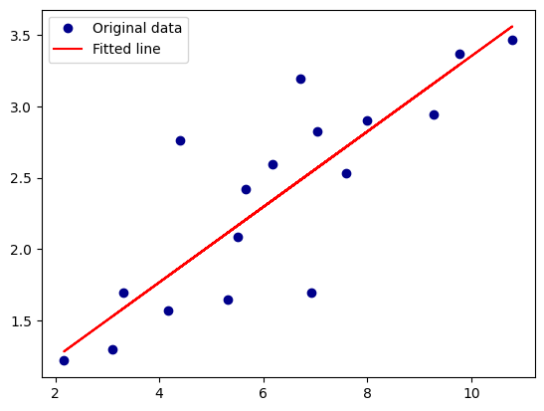

Lab 2
Model 1
Accuracy = 0.905
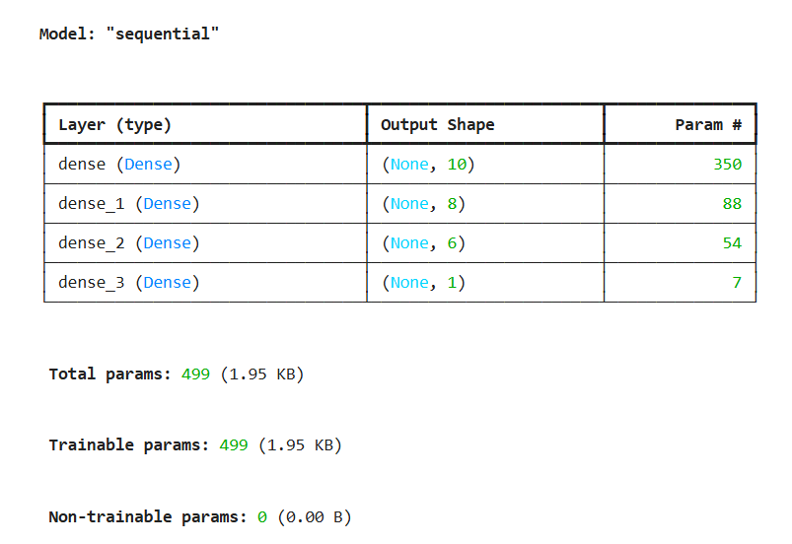
Model 2
Accuracy = 0.922
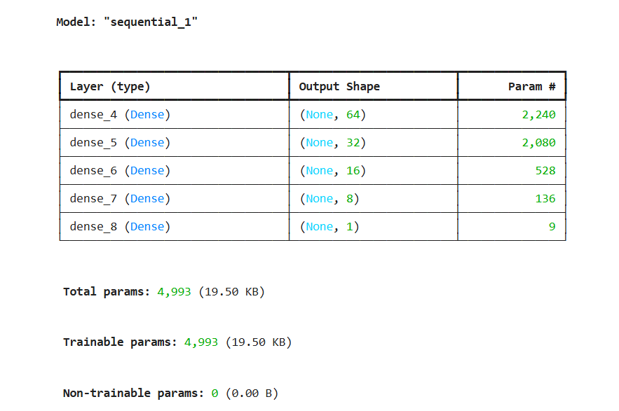

Lab 3

Lab 4

Lab 5

Lab 6

Lab 7

Lab 8

Lab 9

Lab 10

Lab 11

Lab 12

