**1. Revision History**

Revision History identify changes to the Design Document.

|  |  |  |  |
| --- | --- | --- | --- |
| Name | Date | Description | Version |
|  |  |  |  |
|  |  |  |  |
|  |  |  |  |

**2. Use Case Overview**

Use Case Diagram Level 0: Home Bookkeeping Lite System

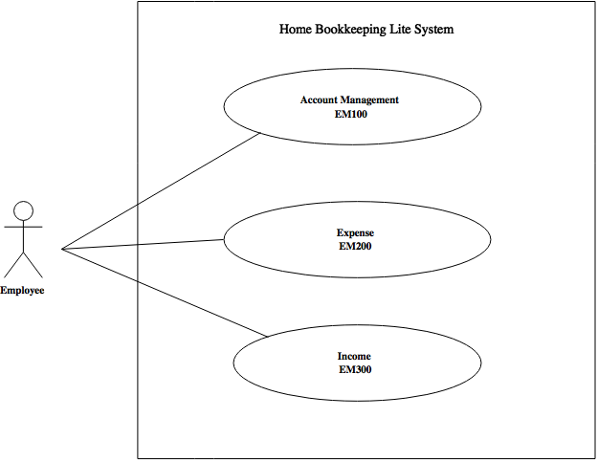

Use Case Diagram Level 1: Account Management Sub-System (EM100)

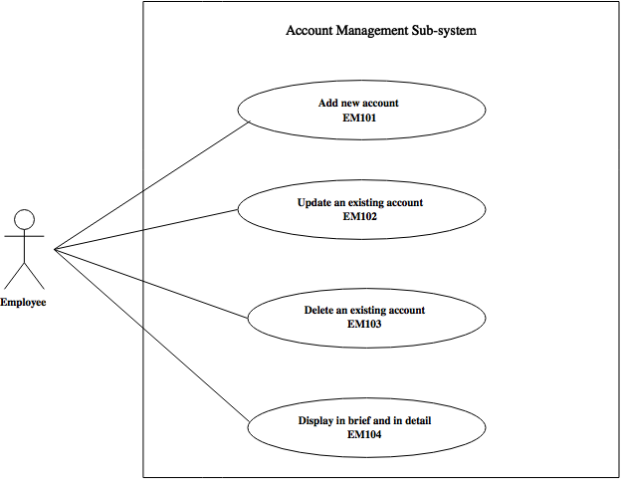

Use Case Diagram Level 2: Add new account (EM101) Sub-System

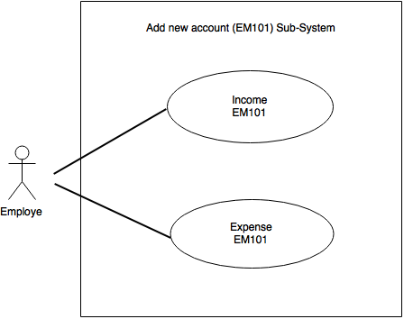

Use Case Diagram Level 2: Update an exiting account (EM102)

Sub- System

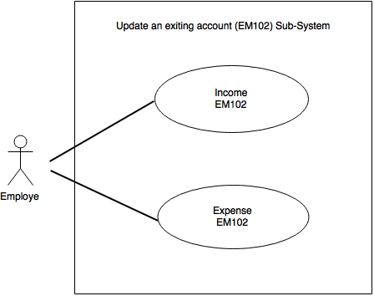

**4. Static structure and Data Analysis**

4.1 Model-View-Controller (MVC) Model

* Add new Account (MVC)

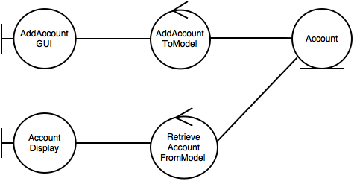

* Update an existing account (MVC)

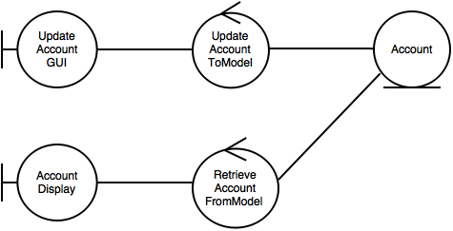

4.2 Entity Class Diagram: Inventory Management

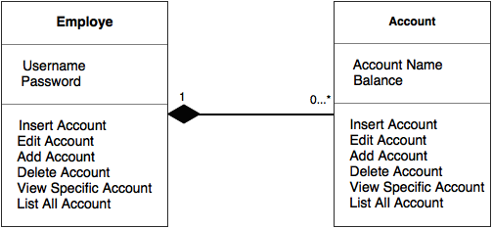

**5. System Behavior Model**

5.1 Sequence diagram demonstrating operation “Add new account”

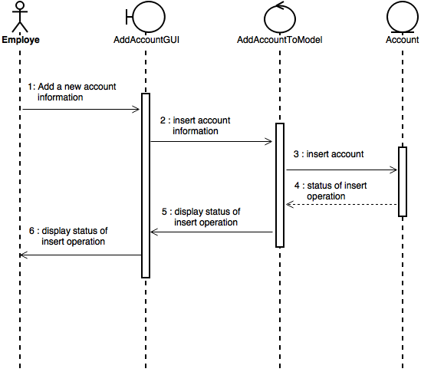

5.2 Sequence diagram demonstrating operation “Update an existing account”

