**1. Revision History**

Revision History identify changes to the Design Document.

|  |  |  |  |
| --- | --- | --- | --- |
| Name | Date | Description | Version |
|  |  |  |  |
|  |  |  |  |
|  |  |  |  |

**2. Use Case Overview**

Use Case Diagram Level 0: Home Bookkeeping Lite System

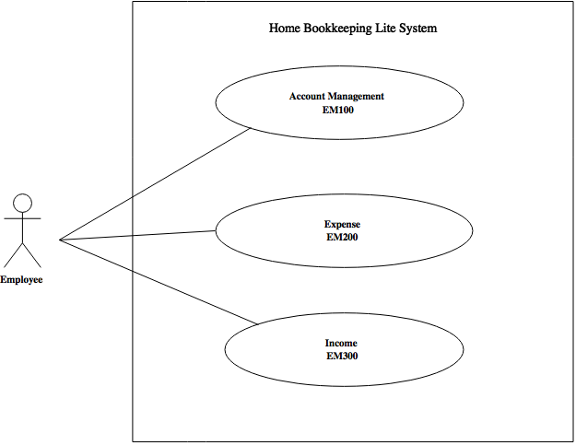

Use Case Diagram Level 1: Account Management Sub-System (EM100)

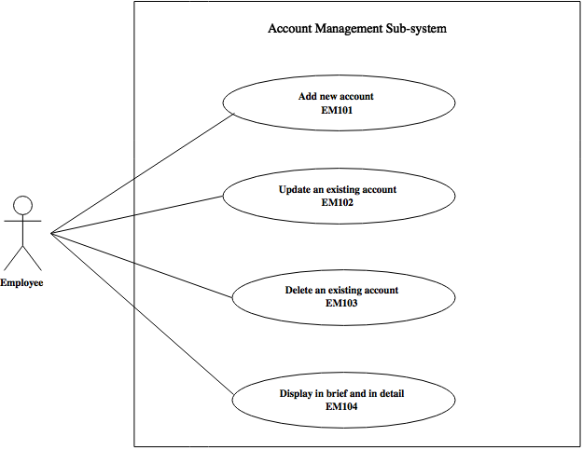

Use Case Diagram Level 1: Expense Sub-System (EM200)

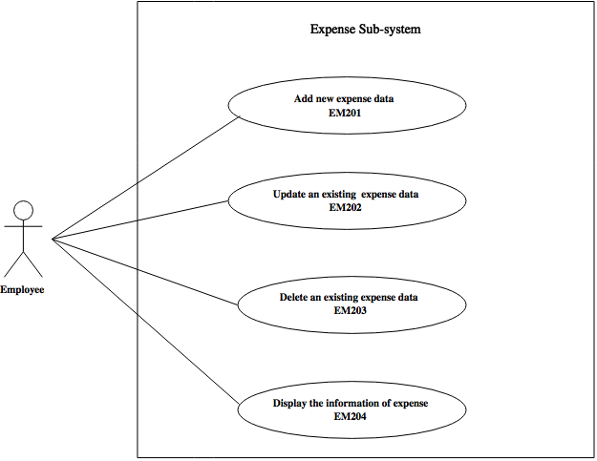

Use Case Diagram Level 1: Income Sub-System (EM300)

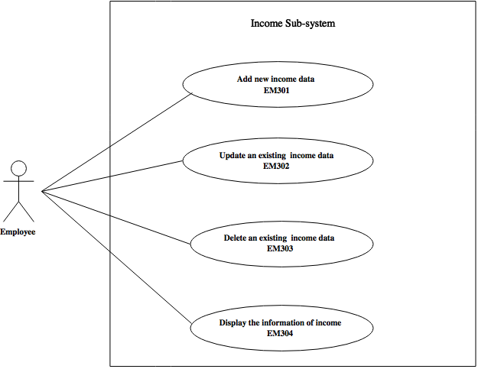

Use Case Diagram Level 2 : Add new expense information and Update an existing expense information

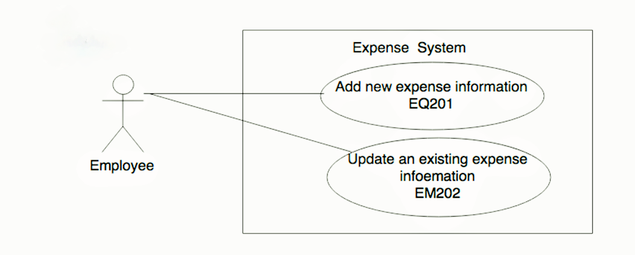

นางสาว จันจิรา หลิมประดิษฐ

**3. System Structure**

Home Bookkeeping Lite

Income Management

Account Management

Expense Management

Add account

Display income information

Delete income data

Update income data

Add income data

Display account

Delete account

Update account

Display expense information

Delete expense data

Update expense data

Add expense data

**4. Static structure and Data Analysis**

4.1 Model-View-Controller (MVC) Model

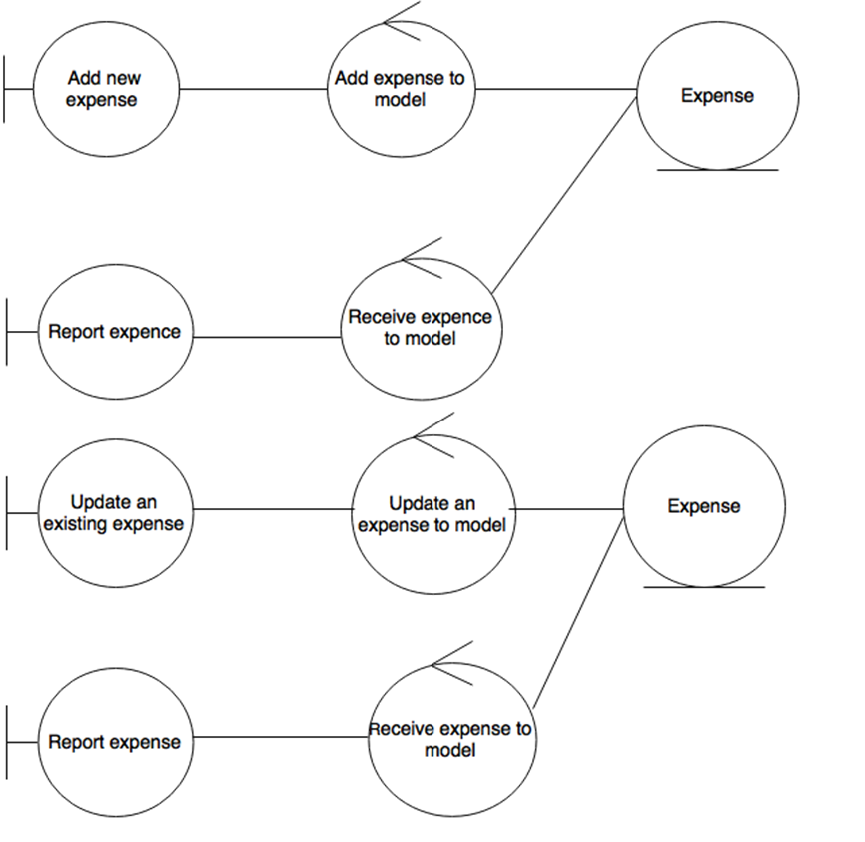

4.2 Entity Class Diagram: Inventory Management

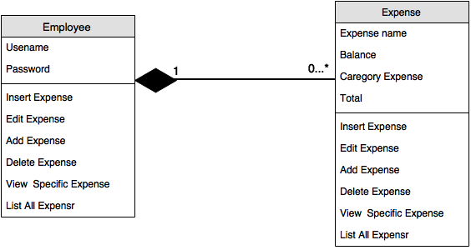

**5. System Behavior Model**

5.1 Sequence diagram demonstrating operation “Add new expense information”

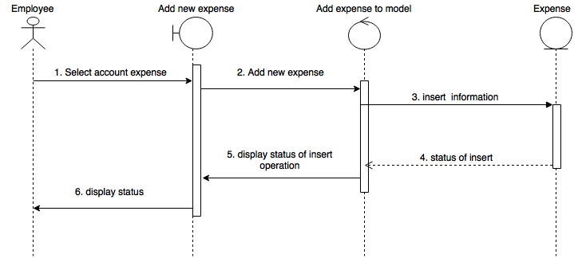

5.2 Sequence diagram demonstrating operation “Update an existing expense information”

