**1. Revision History**

Revision History identify changes to the Design Document.

|  |  |  |  |
| --- | --- | --- | --- |
| Name | Date | Description | Version |
|  |  |  |  |
|  |  |  |  |
|  |  |  |  |

**2. Use Case Overview**

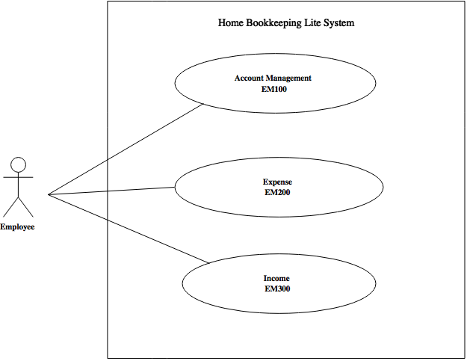Use Case Diagram Level 0: Home Bookkeeping Lite System

Use Case Diagram Level 1: Expense Sub-System (EM200)

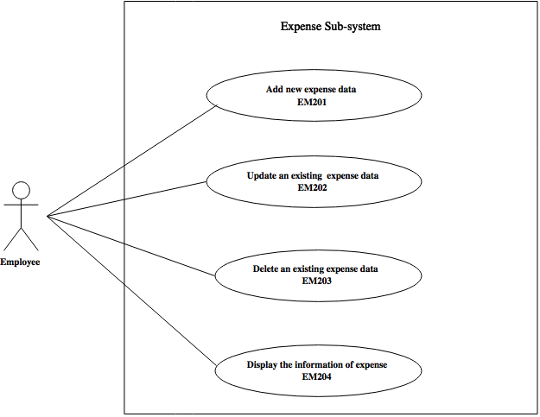

Use Case Diagram Level 2: Delete and Display expense data (EM20)



**3. System Structure**

Home Bookkeeping Lite

Expense Management

Display expense information

Delete expense data

**4. Static structure and Data Analysis**

4.1 Model-View-Controller (MVC) Model

Delete an existing expense data (EM203)****

Display the information of expense (EM204) 

4.2 Entity Class Diagram: Inventory Management

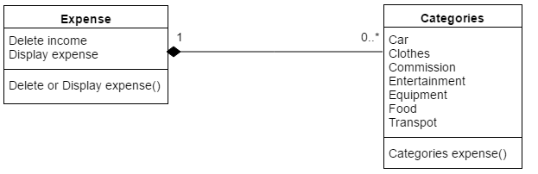

**5. System Behavior Model**

5.1 Sequence diagram demonstrating operation “Put product to Shelf”

Delete an existing expense data (EM203)

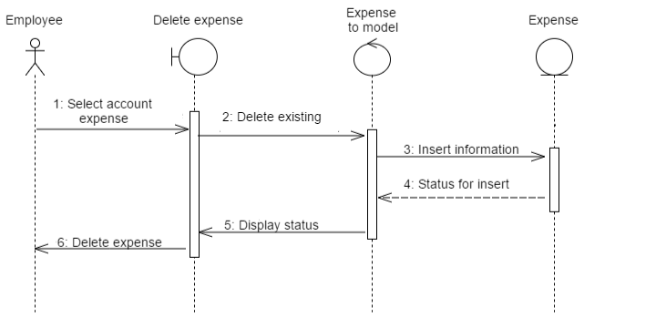

Display the information of expense (EM204)

