**1. Revision History**

Revision History identify changes to the Design Document.

|  |  |  |  |
| --- | --- | --- | --- |
| Name | Date | Description | Version |
|  |  |  |  |
|  |  |  |  |
|  |  |  |  |

**2. Use Case Overview**

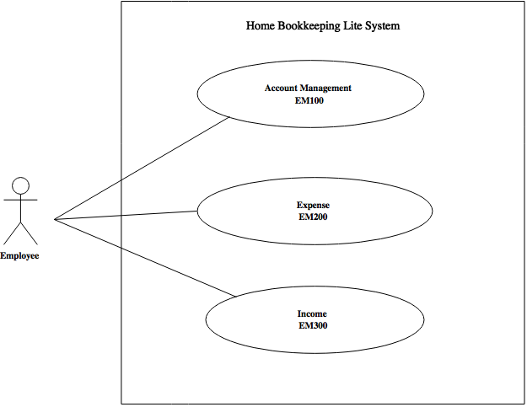Use Case Diagram Level 0: Home Bookkeeping Lite System

Use Case Diagram Level 1: Income Sub-System (EM300)

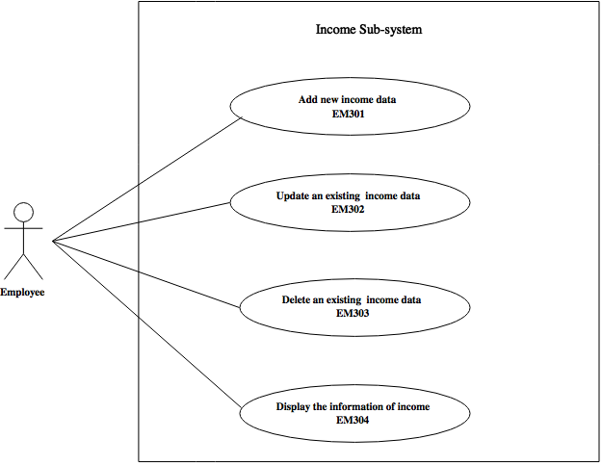

Use Case Diagram Level 2: Add new income data (EM301)



Use Case Diagram Level 2: Update an existing income data (EM302)



**3. System Structure**

Update income data

Income Management

Add income data

Home Bookkeeping Lite

**4. Static structure and Data Analysis**

4.1 Model-View-Controller (MVC) Model

Add new income data (EM311)



Update an existing income data (EM312)



4.2 Entity Class Diagram: Inventory Management



**5. System Behavior Model**

5.1 Sequence diagram demonstrating operation “Put product to Shelf”

Add new income data (EM311)



5.2 Sequence diagram demonstrating operation “Edit Product on shelf”

Update an existing income data (EM312)

