**1. Revision History**

Revision History identify changes to the Design Document.

|  |  |  |  |
| --- | --- | --- | --- |
| Name | Date | Description | Version |
|  |  |  |  |
|  |  |  |  |
|  |  |  |  |

**2. Use Case Overview**

Use Case Diagram Level 0: Income System

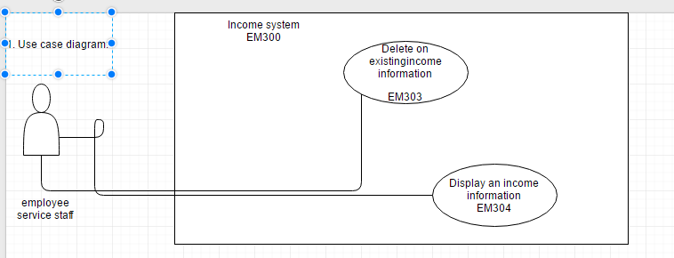

3. **Static structure and Data Analysis**

3.1 Model-View-Controller (MVC) Model

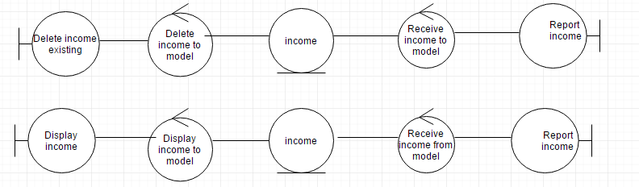

4.2 Entity Class Diagram: Account Management

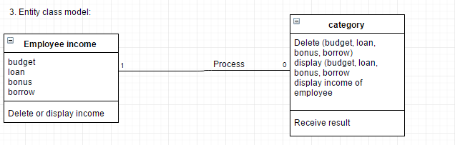

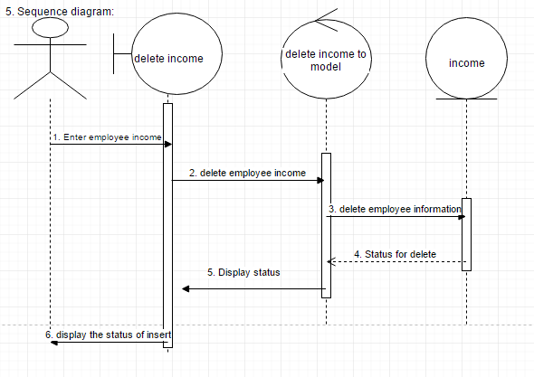**5. System Behavior Model**

5.1 Sequence diagram demonstrating operation “Delete an income account”

5.2 Sequence diagram demonstrating operation “display an income”

