**Analysis Document**

**Home Bookkeeping Lite**

Version 1.0.2

Prepare by

Janjira Limpradit

Poramet Thongkaeokeot

Pattragun Janpan

Adithep Mudausen

Worathep Hirunsai

Ung Pkaypreak

November 7, 2016

**Table of Contents**

1. Revision History………………………………………………………………………………..………………………………..……….……..1
2. Use Case Overview……….………………………………………………………………………………….……………..………...........1

Use Case Diagram Level 0: Home Bookkeeping Lite System.……………………………………………..……...……….1

Use Case Diagram Level 1: Account Management Sub-System (EM100) …………………..…….…….……..2

Use Case Diagram Level 1: Expense Sub-System (EM200) ………………………….…………………………….……..3

Use Case Diagram Level 1: Income Sub-System (EM300) ………………………………………………………….......4

3. System Structure ……………………………………………………………………………………………………………………………..…....5

4. Static structure and Data Analysis …………………………………………………………………………………………............6

4.1 Model-View-Controller (MVC) Model …………………………………………………………………………….……...7

I. EM101: Add new account ……………………………………………………………………………………………….7

II. EM102: Update an existing account …………………………………………………………………………..….7

III. EM103: Delete an existing account ……………………………………………………………………..….…….8

IV. EM104: Display an account in brief and in detail ……………………………………………..….…….8

V. EM201: Add new expense data …………………………………………………………………………..………….9

VI. EM202: Update an existing expense data ……………………………………………………………….......9

VII.EM203: Delete an existing expense data ……………………………………………………………………..10

VIII.EM204: Display the information of expense ……………………………………………………….…….10

IX. EM301: Add new income data ……………………………………………………………………………………..11

X. EM302: Update an existing income data ………………………………………………………………......11

XI. EM303: Delete an existing income data …………………………………………………………….........12

XII.EM304: Display the information of income ………………………………………………………………..12

4.2 Entity Class Diagram: Inventory Management…………………………………………………………………………..13

5. System Behavior Model………………………………………………………………………………………………………………….……..14

I. Sequence diagram demonstrating operation “Add new account” ………………………………………......14

II. Sequence diagram demonstrating operation “Update an existing account” …………………………….14

III.Sequence diagram demonstrating operation “Delete an existing account” ………………………………15

IV.Sequence diagram demonstrating operation “Display an account in brief and in detail”……….15

V. Sequence diagram demonstrating operation “Add new expense data” …………………………………….16

**Table of Contents (continuous)**

VI. Sequence diagram demonstrating operation “Update an existing expense data” ………………..…..16

VII. Sequence diagram demonstrating operation “Delete an existing expense data” ………………….…17

VIII.Sequence diagram demonstrating operation “Display the information ofexpense”………………..17

IX. Sequence diagram demonstrating operation “Add new income data” …………………….……………..18

X. Sequence diagram demonstrating operation “Update an existing income data” …………………..….18

XI. Sequence diagram demonstrating operation “Delete an existing income data” …………………….…19

XII. Sequence diagram demonstrating operation “Display the information of income” ……..……….19

**1. Revision History**

Revision History identify changes to the Design Document.

|  |  |  |  |
| --- | --- | --- | --- |
| **Name** | **Date** | **Description** | **Version** |
| Everyone in group :  Janjira Limpradit | 20/09/2016 | - find the topic of project  - write the project proposal | 1.0.0 |
| Every]one in group :  Janjira Limpradit | 21/10/2016 | - create work breakdown structure | 1.0.1 |
| Everyone in group :  Janjira Limpradit | 02/11/2016 | **-** create Analysis Document | 1.0.2 |

|  |
| --- |
| Janjira Limpradit 5830213012 |

**2. Use Case Overview**

Use Case Diagram Level 0: Home Bookkeeping Lite System

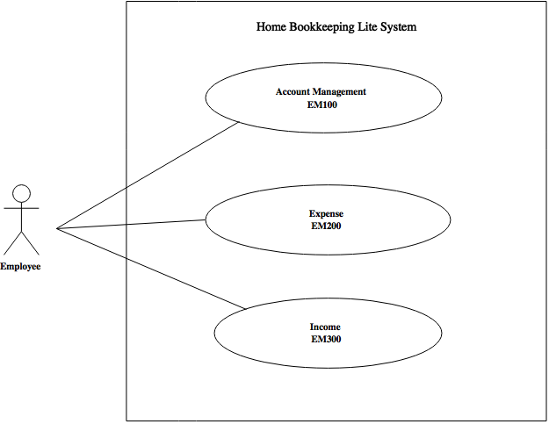

|  |
| --- |
| Janjira Limpradit 5830213012 |

**Use Case Diagram Level 1: Account Management Sub-System (EM100)**

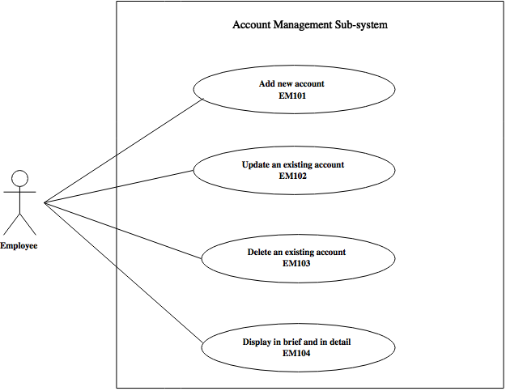

|  |
| --- |
| Poramet Thongkaeokeot 5830213003 |

|  |
| --- |
| Pattragun Janpan 5830213005 |

**Use Case Diagram Level 1: Expense Sub-System (EM200)**

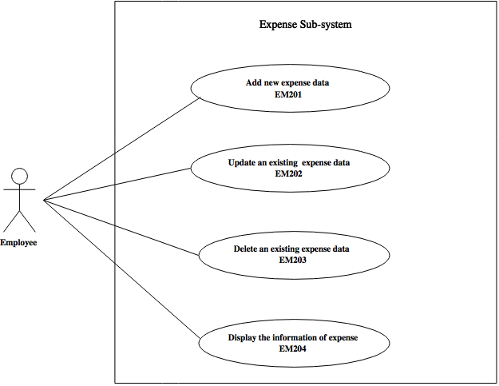

|  |
| --- |
| Janjira Limpradit 5830213012 |

|  |
| --- |
| Adithep Mudausen 5830213034 |

**Use Case Diagram Level 1: Income Sub-System (EM300)**

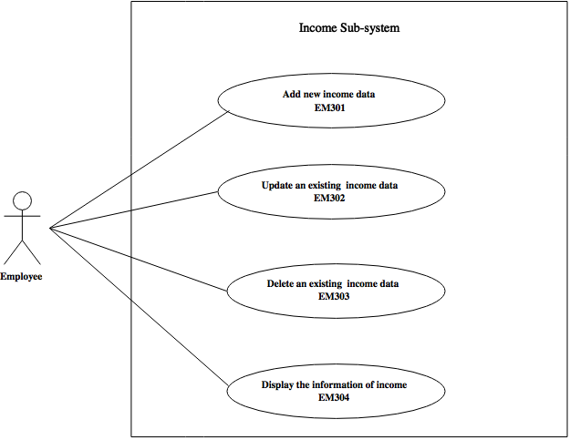

|  |
| --- |
| Woratep Hirunsai 5830213036 |

|  |
| --- |
| Ung Pkaypreak 5830213047 |

**3. System Structure**

This should use structure chart to express the breakdown of the system to the lowest manageable levels. It is used to show the hierarchical arrangement of the subsystems in a system. Each rectangular box represents a subsystems. The names of the subsystems are written inside the box. An arrow joins two subsystems that have an invocation relationship.

Home Bookkeeping Lite

Income Management

Account Management

Expense Management

Add account

Display income information

Delete income data

Update income data

Add income data

Display account

Delete account

Update account

Display expense information

Delete expense data

Update expense data

Add expense data

|  |
| --- |
| Pattragun Janpan 5830213005 |

|  |
| --- |
|  |

**4. Static structure and Data Analysis**

This should show the conceptual description of the systematics of the system. Thus, the class diagram is used to describe this static structure of the system. Furthermore, the class diagram is also used for data modelling. Classes in class diagram are classified into 3 types:

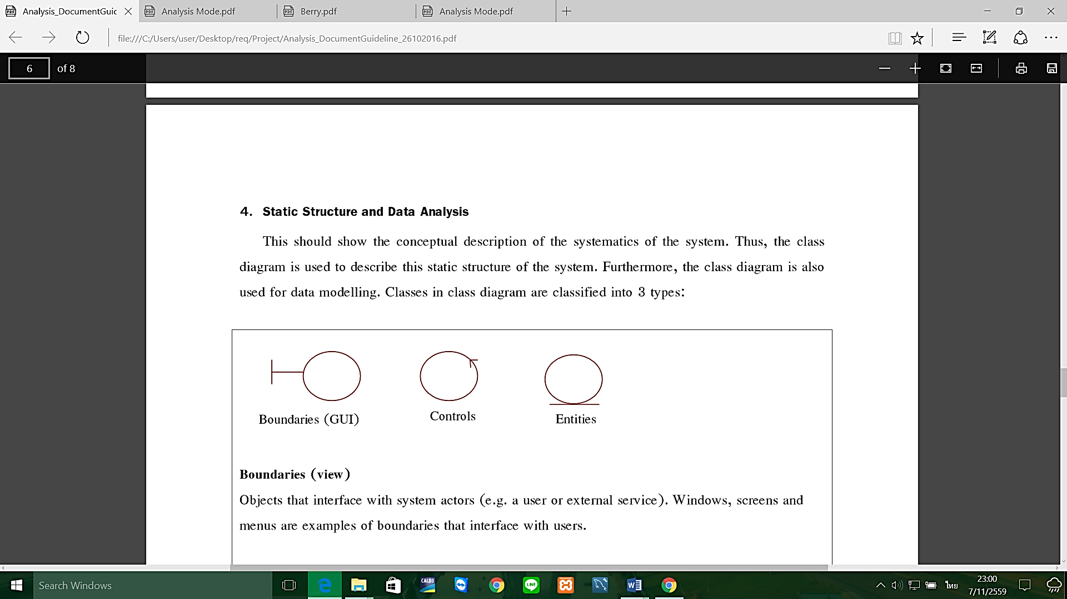

**Boundaries (view)**

Objects that interface with system actors (e.g. a user or external service). Windows, screens and menus are examples of boundaries that interface with users.

**Entities (model)**

Objects representing system data, often from the domain model.

**Controls (controller)**

Objects that mediate between boundaries and entities. These serve as the glue between boundary elements and entity elements, implementing the logic required to manage the various elements and their interactions. It is important to understand that you may decide to implement controllers within your design as something other than objects – many controllers are simple enough to be implemented as a method of an entity or boundary class for example.

**4.1 Model-View-Controller (MVC) Model**

1. EM101: Add new account

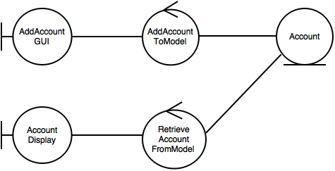

|  |
| --- |
| Poramet Thongkaeokeot 5830213003 |

1. EM102: Update an existing account

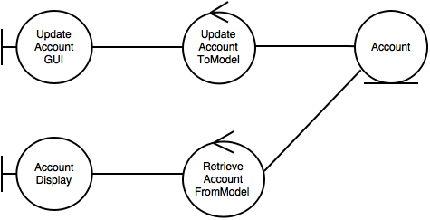

|  |
| --- |
| Poramet Thongkaeokeot 5830213003 |

1. EM103: Delete an existing account

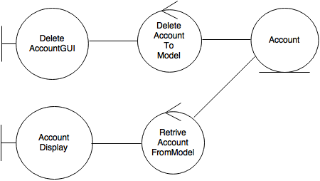

|  |
| --- |
| Pattragun Janpan 5830213005 |

1. EM104: Display an account in brief and in detail

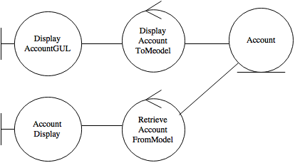

|  |
| --- |
| Pattragun Janpan 5830213005 |

1. EM201: Add new expense data

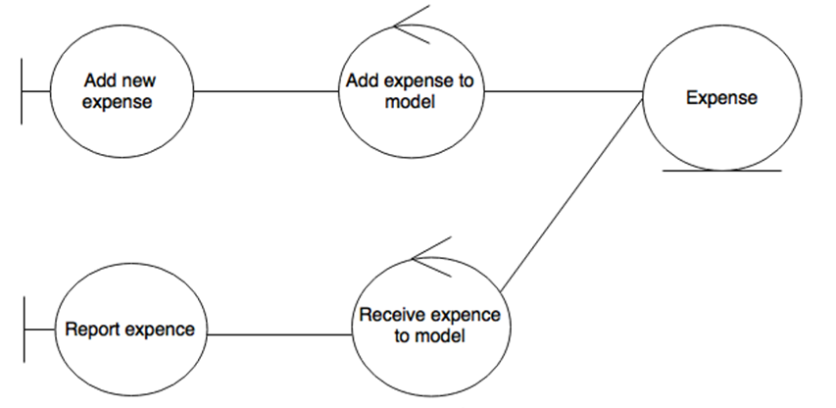

|  |
| --- |
| Janjira Limpradit 5830213012 |

1. EM202: Update an existing expense data

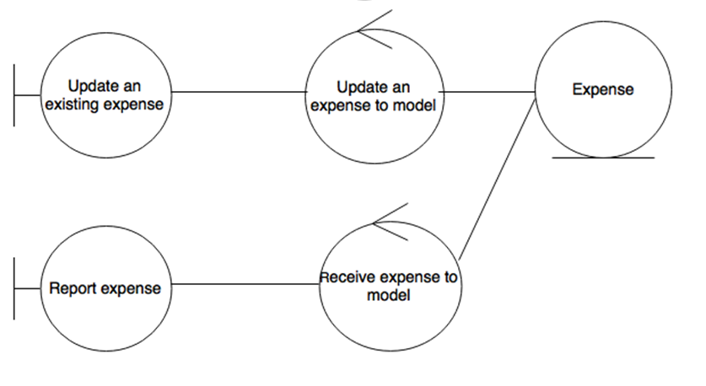

|  |
| --- |
| Janjira Limpradit 5830213012 |

1. EM203: Delete an existing expense data

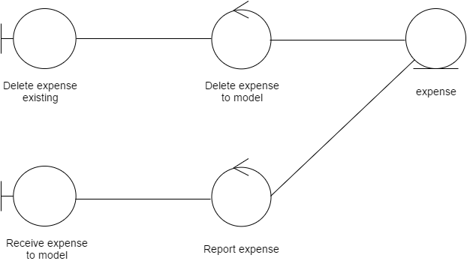

|  |
| --- |
| Adithep Mudausen 5830213034 |

1. EM204: Display the information of expense

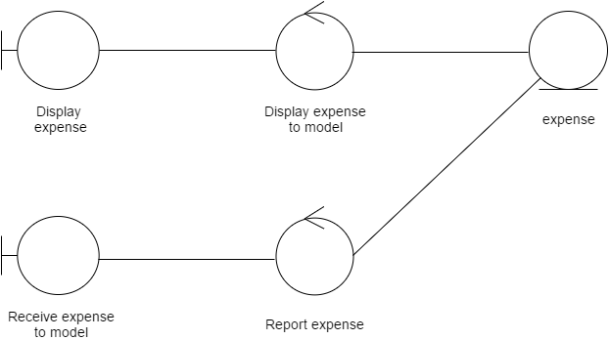

|  |
| --- |
| Adithep Mudausen 5830213034 |

1. EM301: Add new income data

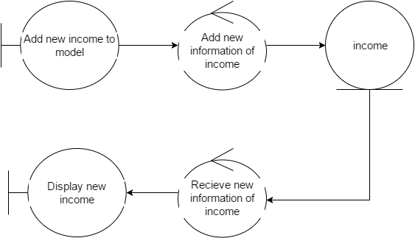

|  |
| --- |
| Woratep Hirunsai 5830213036 |

1. EM302: Update an existing income data

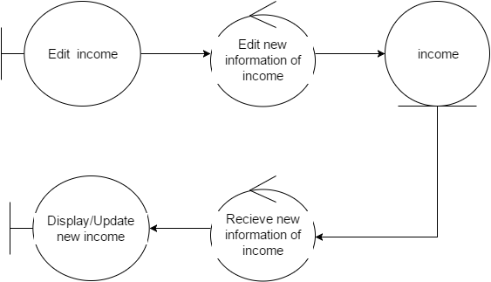

|  |
| --- |
| Woratep Hirunsai 5830213036 |

1. EM303: Delete an existing income data

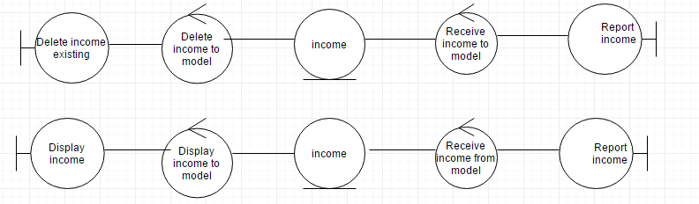

|  |
| --- |
| Ung Pkaypreak 5830213047 |

1. EM304: Display the information of income



|  |
| --- |
| Ung Pkaypreak 5830213047 |

**4.2 Entity Class Diagram: Inventory Management**

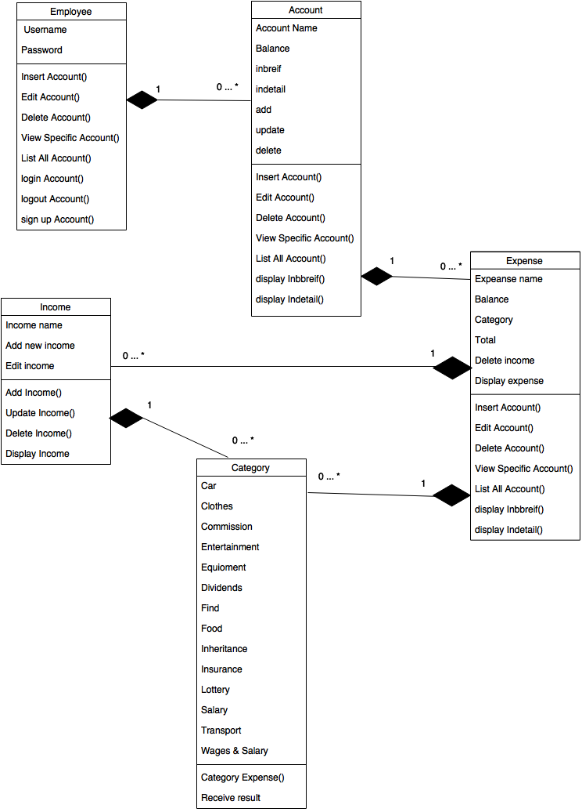

|  |
| --- |
| Janjira Limpradit 5830213012 |

**5. System Behavior Model**

1. **Sequence diagram demonstrating operation “Add new account”**

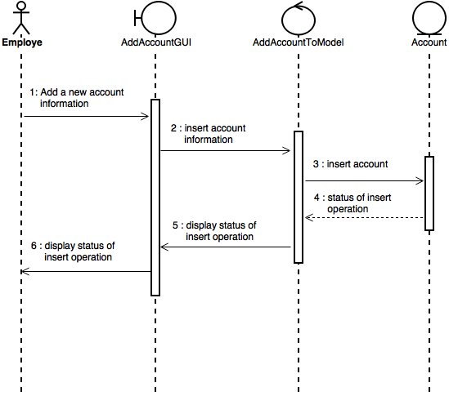

|  |
| --- |
| Poramet Thongkaeokeot 5830213003 |

1. **Sequence diagram demonstrating operation “Update an existing account”**

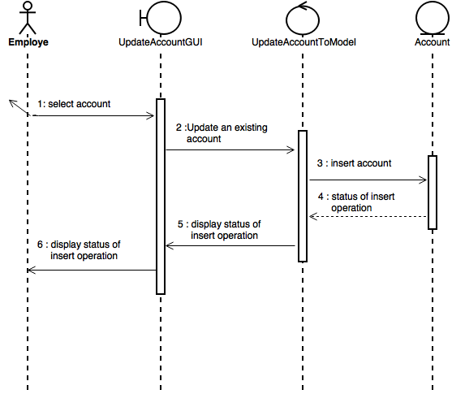

|  |
| --- |
| Poramet Thongkaeokeot 5830213003 |

## **Sequence diagram demonstrating operation “Delete an existing account”**

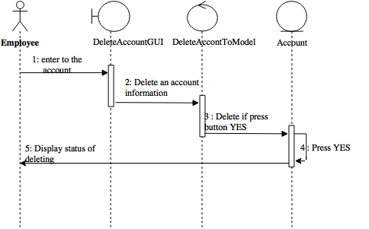

|  |
| --- |
| Pattragun Janpan 5830213005 |

1. **Sequence diagram demonstrating operation “Display an account in brief and in detail”**

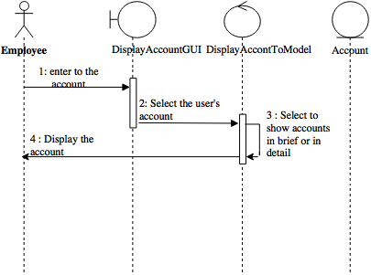

|  |
| --- |
| Pattragun Janpan 5830213005 |

1. **Sequence diagram demonstrating operation “Add new expense data”**

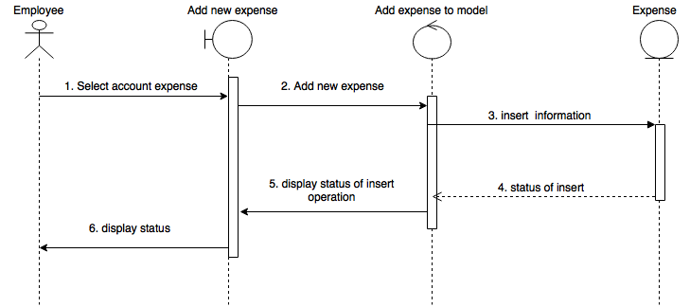

|  |
| --- |
| Janjira Limpradit 5830213012 |

1. **Sequence diagram demonstrating operation “Update an existing expense data”**

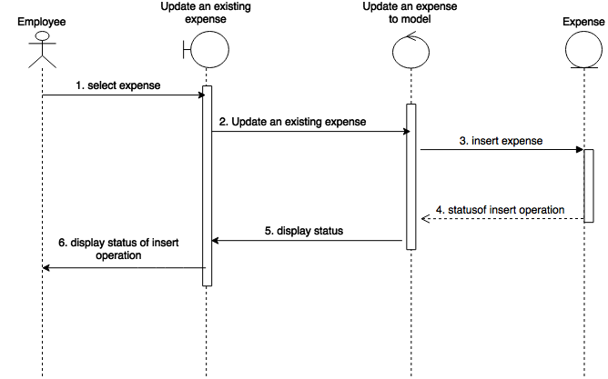

|  |
| --- |
| Janjira Limpradit 5830213012 |

1. **Sequence diagram demonstrating operation “Delete an existing expense data”**

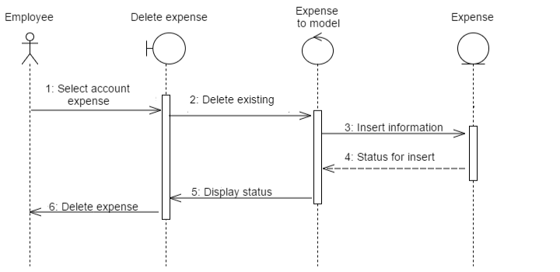

|  |
| --- |
| Adithep Mudausen 5830213034 |

1. **Sequence diagram demonstrating operation “Display the information of expense”**

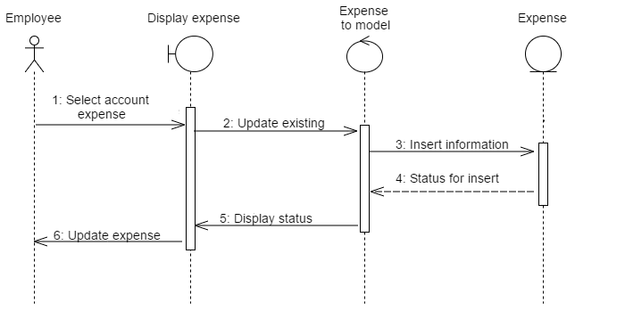

|  |
| --- |
| Adithep Mudausen 5830213034 |

1. **Sequence diagram demonstrating operation “Add new income data”**

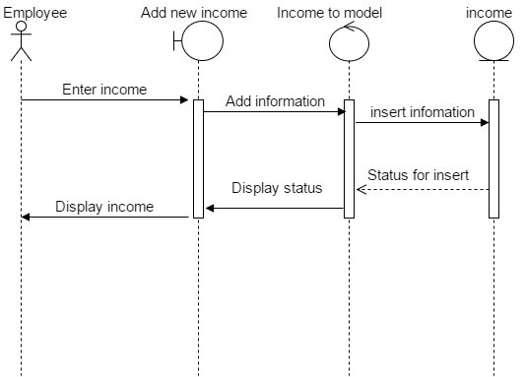

|  |
| --- |
| Woratep Hirunsai 5830213036 |

1. **Sequence diagram demonstrating operation “Update an existing income data”**

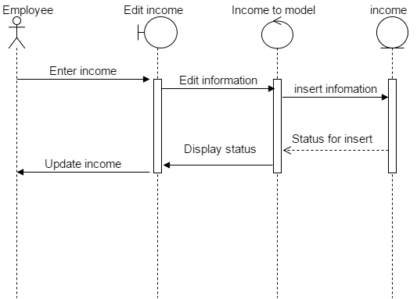

|  |
| --- |
| Woratep Hirunsai 5830213036 |

1. **Sequence diagram demonstrating operation “Delete an existing income data”**

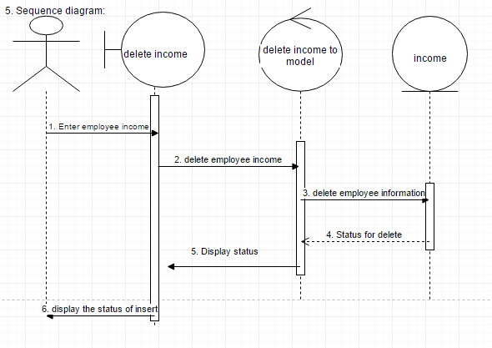

|  |
| --- |
| Ung Pkaypreak 5830213047 |

1. **Sequence diagram demonstrating operation “Display the information of income”**

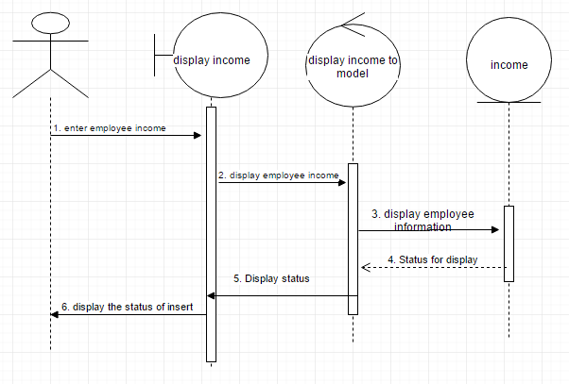

|  |
| --- |
| Ung Pkaypreak 5830213047 |