Christian-Albrechts-Universität zu Kiel
Institut für Psychologie

Master’s thesis

Exploring Cognitive Performance and Resting State EEG in Individuals following SARS-CoV-2 Infection

Submitted by:
Janka Marlene Hauffe
Matrikelnummer: 1125742
Mail: jankamarlene@gmx.de

Supervisors:
Prof. Dr. Christian Kaernbach
Christian Neumann, M.Sc.

31. march 2025

Table of Contents

Introduction 4
Theoretical Background 5
Cognitive Impairment in PCS 5
Cognitive Symptoms in PCS. 5
Assessment of Cognitive Dysfunctioning in PCS. 6
Objective versus Subjective Impairment. 6
Biological factors. 8
EEG as a Tool to assess cognitive impairment and related symptoms 8
Frequency bands. 10
Beta findings. 13
Aim of study 14
Hypotheses 15
Methods 16
Participants 16
Ethics statement 16
Study design 17
Objective cognitive assessment 17
MoCA. 17
TMT Part A and B. 18
N-Back task. 19
PVT. 20
Questionnaires 21
PSQI. 21
HADS. 22
FACIT-F. 22
Data Analysis 23
Cluster Analysis. 23
EEG Recording and Analysis. 24
Power Analysis. 27
Statistical Analysis. 27
Results 27
Hierarchical clustering 28
Two-cluster solution. 28
Four-cluster solution. 31
EEG analysis 34
Data cleaning. 34
Beta Power (central ROI) in the Two-Cluster solution. 34
Delta Power (frontal ROI) in the Two-Cluster Solution. 35
Beta and Delta Power in the Four-cluster solution. 36
Correlation with clinical data 36
Discussion 36
Conclusion 36
Appendix 37

Introduction
Moments of disorientation, trouble concentrating, or forgetting simple tasks are common phenomena that most people recognize. For many individuals recovering from COVID-19, however, this mental cloudiness is more than a fleeting inconvenience. It is a persistent reminder of their illness. These cognitive challenges, along with fatigue and other lingering symptoms, continue to affect their daily lives long after the infection has passed.
Cognition is the most complex function of the brain (Birle et al., 2020) and encompasses a range of mental processes, including the acquisition, storage, manipulation, selection, and retrieval of information (Cambridge Cognition, 2015; Liu et al., 2024), as well as core cognitive functions such as attention, perception, learning, memory, language, problem-solving, thinking, and reasoning (Eysenck & Brysbaert, 2018). These cognitive abilities are vital for decision-making and adapting to daily challenges (Eysenck & Brysbaert, 2018).
But what happens when these vital cognitive abilities begin to decline? Cognitive decline refers to varying degrees of damage to cognitive function resulting from a range of causes (Birle et al., 2020; Liu et al., 2024). The global prevalence of cognitive impairment in adults over 50 years old ranges from 5.1% to 41%, with a median prevalence of 19% (Pais, Ruano, Carvalho & Barros, 2020). The prevalence increases with age (Liu et al., 2024; Pais et al., 2020). Cognitive impairment can range from subjective cognitive decline to mild cognitive impairment and more severe forms, such as dementia.
Cognition can be assessed using various methods, each differing in their level of objectivity and sensitivity (Cambridge Cognition, 2015). Recognizing the importance of cognition underscores the profound effects that cognitive impairment can have on an individual’s independence and quality of life.
This thesis investigates cognitive decline and its associated symptoms in individuals following SARS-CoV-2 infection. An overview of COVID-19 and its association with cognitive impairment in post-COVID-19 syndrome is first provided. The distinction between subjective cognitive decline and objective cognitive impairment is explained, followed by a discussion of the impact of neuropsychiatric symptoms on cognitive difficulties. Next, the role of electroencephalography (EEG) as a neurophysiological tool for assessing cognitive function is introduced. Following this, existing EEG research on subjective and objective cognitive impairment, as well as its application in post-COVID-19 syndrome, is reviewed. Finally, the specific aim of this thesis is introduced, which is to explore how differences in objective cognitive performance in individuals after SARS-CoV-2 infection relate to perceived cognitive functioning, associated neuropsychiatric symptoms, and EEG alterations.

Theoretical Background
As of September 2024, over 760 million confirmed cases of coronavirus disease 2019 (COVID-19) have been documented by the World Health Organization (WHO) globally, leading to approximately 6.9 million deaths (WHO, 2023). The actual numbers are likely to be much higher due to underreporting. COVID-19 is an infectious disease caused by the SARS-CoV-2 virus (WHO, 2021). While most patients fully recover, some experience persistent symptoms such as fatigue, shortness of breath, cognitive dysfunction, and other symptoms that generally have an impact on everyday functioning (WHO, 2021). These remaining effects, referred to as Post-COVID-19 Condition or Syndrome (PCS), usually occur three months after the initial infection with the SARS-CoV-2 virus and last for at least two months with no other explanation. Approximately 10-20% of people infected with SARS-CoV-2 meet the criteria for PCS (WHO, 2021).

Cognitive Impairment in PCS
Cognitive impairment is one of the most frequent symptoms of PCS (Davids et al., 2021; WHO). It affects several cognitive domains, highlighting the diversity of cognitive deficits in PCS patients (Hasting et al., 2023; Widmann et al., 2023).

Cognitive Symptoms in PCS. Among the most frequently reported cognitive symptoms are lack of concentration, attention difficulties, and memory loss (Amin-Chowdhury et al., 2021, Buonsenso et al., 2021; Elkan et al., 2021; Ferrucci et al., 2021; Garrigues et al., 2020; Gonzalez-Hermosillo et al., 2021; Leth et al., 2021; Pilotto et al., 2021; Rauch et al., 2021; Soraas et al., 2021; Sykes et al., 2021; Woo et al., 2020). Patients also frequently report confusion, disorientation, mental slowness, trouble forming or finding words, increased time needed to perform tasks and difficulties in learning new skills (Amin-Chowdhury et al., 2021; Bland et al., 2024; Darley et al., 2021; Ferrucci et al., 2021; Fortini et al., 2021; Kwan et al., 2024; Morin et al., 2021; Woo et al., 2020). These symptoms are often collectively described by patients as “brain fog”, a non-specific term used to express mental cloudiness, slowed thinking, and cognitive fatigue (Amin-Chowdhury et al., 2021; Bland et al., 2024; Fortini et al., 2021; Kwan et al., 2024; Widmann et al., 2023).
Neuropsychological assessments have identified executive functions, attention, verbal learning, processing speed, episodic memory, visuospatial processing, psychomotor coordination as the cognitive domains most frequently impaired (Becker et al., 2021; Damiano et al., 2022; Delgado-Alonso et al., 2022; Ferrucci et al., 2021; García-Sánchez et al., 2022; Hasting et al., 2023; Mazza et al., 2021; Miskowiak et al. 2021).

Assessment of Cognitive Dysfunctioning in PCS. To evaluate these domains, various assessment tools have been employed in the literature, including, for example, the Orientation-Memory-Concentration test (OMC), Montreal Cognitive Assessment (MoCA), Trail Making Test (TMT), Mini-Mental Status Examination (MMSE), Screen for Cognitive Impairment in Psychiatry (SCIP-D), and the Brief Repeatable Battery of Neuropsychological Tests (BRB-NT) (Leth et al., 2021; Mattioli et al., 2021; Morin et al., 2021; Pilotto et al., 2021; Miskowiak et al., 2021; Becker et al., 2021; García-Sánchez et al., 2022; Ferrucci et al., 2021; Frontera et al., 2022; Rass et al., 2021).
While some studies have found that PCS patients perform worse on these assessment tools (Clemente et al., 2023; Cecchetti et al., 2022 Ortelli et al., 2023; Rahimi et al., 2024), others did not find significant differences compared to healthy control (Appelt et al., 2022; Hasting et al., 2023). Importantly, even when group differences are found, patient scores often remain above the clinical cutoff for cognitive impairment (Hasting et al. 2023; Lynch et al., 2022). This shows, that despite the broad spectrum of neuropsychological assessment tools available, a considerable gap persists between subjectively reported cognitive difficulties (CD) and objectively assessed impairments.

Objective versus Subjective Impairment. Around 22% of individuals diagnosed with PCS experience COVID-19-related cognitive impairment, according to a meta-analysis by Ceban et al. (2022). This finding is based on data from 43 studies, 31 of which used subjective assessments and 12 that employed objective measures. Notably, studies using objective assessments of cognitive function reported significantly greater proportions of individuals with impairment (36%) compared to those relying on subjective modes of ascertainment, which identified 18% as cognitively impaired.
However, most studies have reported higher rates of cognitive impairment through subjective cognitive complaints than through objective test results (Schild, Scharfenberg, et al., 2023). Among 52 patients who self-reported cognitive impairment after SARS-CoV-2 infection, the MoCA confirmed impairment in only 25%, while extensive neurological assessment indicated impairments in 60% of these patients (Schild, Goereci, et al., 2023). Similarly, Gomzyakova, Palchikova, Tumova, Kasyanov and Sorokin (2022) found that objective CD, indicated by a MoCA score < 26, was detected in only 40 % of participants who reported subjective CD. This raises questions about the sensitivity of the MoCA in detecting cognitive deficits, as it often yields results within the normal range (Hasting et al., 2023). Moreover, Schild, Scharfberg, Kirchner, et al. (2023) reported that 88% of patients reported persistent self-reported CD, with approximately a 40% discrepancy between the subjective reports and objective test results at both follow-up visits. In line with these findings, it was observed that there was no significant relation between objective and subjective measures of cognitive function, implying that self-reports of “brain fog” may not be reflected by objectively measured cognitive dysfunction (Bland et al., 2024; Brücket al., 2019). It remains unclear what these self-reported symptoms reflect.

Influence of Psychiatric and Health-related Symptoms on Cognitive Decline. “[…] subjective cognitive deﬁcits in everyday situations are predicted by elevated anxiety and fatigue levels more than by objective cognitive performance” (Zamarian et al., 2004). In addition to cognitive impairment, PCS patients often experience a range of other symptoms, with fatigue being the most commonly reported alongside CD (Holdsworth et al., 2022; Premraj et al., 2022; WHO, 2021). Anxiety, depression, and sleep disturbances are also frequently observed (Almeria, Cejudo, Sotoca, Deus & Krupinski, 2020; Badinlou, Lundgren & Jansson-Fröjmark, 2022; Damiano et al., 2022; Deng et al., 2021; Holdsworth et al., 2022; Premraj et al., 2022). However, results on how these symptoms are associated with cognitive impairment are inconsistent (Almeria et al., 2020; Schild, Scharfenberg, et al., 2023). One study found that among ambulatory COVID-19 patients, objective cognitive test results were closely linked to anxiety, depression, fatigue, and pain, a pattern that was not observed in individuals hospitalized due to COVID-19 (Blackmon et al., 2022). In contrast, a study using the MoCA reported no significant correlation between MoCA scores and levels of depression and anxiety (Gomzyakova et al., 2022), which aligns with findings from a separate study that also found no association between objective cognitive impairment and depression, anxiety, sleep disturbance, or fatigue (Henneghan, Lewis, Gill & Kesler, 2022). However, both studies identified significant associations between these symptoms and subjective cognitive complaints (Gomzyakova et al., 2022; Henneghan et al., 2022). Similar associations have been reported in several other studies (Badinlou et al., 2022; Brück et al., 2019; Costas-Carrera et al., 2022; Hill et al., 2016). Conversely, objective cognitive function has been found to be more closely related to perceived stress (Bland et al., 2024).
Taken together, these findings support the assumption of Zamarian et al. (2024) that subjective cognitive deficits in PCS patients may be better explained by elevated anxiety and fatigue, and further complemented by depression and sleep disturbance (Henneghan et al., 2022; Gomzyakova et al., 2022) rather than by objective cognitive performance.

Biological factors. Nonetheless, although individuals with self-reported CD perform within normal ranges on neuropsychological tests, they face an increased risk of developing mild cognitive impairment (MCI) and Alzheimer’s disease (AD) (Li, Yue & Xiao, 2022; Numbers et al., 2023; Rivas-Fernández et al., 2023). Rivas-Fernández et al. (2023) suggest that subjective cognitive decline may manifest in brain structure or physiological changes before becoming evident in neuropsychological testing.
In fact, the persistent symptoms after COVID-19 infection may result from a combination of biological and psychological mechanisms (Premraj et al., 2022). For example, SARS-CoV-2 RNA may persist in brain tissue long-term, potentially contributing to progressive neuronal damage (Najjar et al., 2020; Singh, Chaubey, Chen & Suravajhala, 2020). Structural changes such as hippocampal atrophy, cortical thickening, and altered microstructural integrity have been associated with fatigue severity and cognitive deficits, particularly in attention and memory (Besteher et al., 2024; Díez-Cirarda et al., 2023; Heine et al., 2023). There are still many uncertainties about how and to what extent the virus impacts the brain. To better understand the nature and extent of these changes, neurophysiological methods such as electroencephalography (EEG) may offer valuable insights.

EEG as a Tool to assess cognitive impairment and related symptoms
EEG has been proven to be a valuable tool for assessing both subjective CD (Rossini, Rossi, Babiloni & Polich, 2007) and objective cognitive impairment such as MCI and AD (Babiloni et al., 2011; Dierks, Frölich, Ihl & Maurer, 1994; Jeong, 2004; Perez, Duque, Hidalgo & Salvador, Rossini et al., 2007, Yener, Güntekin & Başar, 2008).
EEG is a neurophysiological technique that records brain electrical activity via scalp electrodes (Babiloni et al., 2011; Babiloni et al., 2016), providing a direct, real-time view of human brain function in physiological and pathological conditions (Berger, 1929; Liu et al., 2024). The human brain consists of approximately 100 billion neurons, forming intricate synaptic networks that support cognitive function (Babiloni et al., 2016). As the brain ages, these synaptic networks weaken due to synaptic pruning, neuronal apoptosis, and the loss of cortico-cortical connections, leading to a decline in cognitive function (D'Amelio and Rossini, 2012). Pathological processes can accelerate this process of brain aging (Babiloni et al., 2016).
The value of EEG in studying cognitive impairment has been recognized for decades. Hans Berger introduced EEG in humans in 1924 and was the first to observe pathological EEG patterns in a verified AD patient (Berger, 1929; Jeong, 2004), laying the foundation for numerous studies on EEG in AD and other neurodegenerative disorders (Jeong, 2004). Several studies have found a strong correlation between the degree of disrupted or atypical brain wave patterns measured through EEG and cognitive impairment (Brenner et al., 1988; Erkinjuntti et al., 1988; Johannesson et al., 1979; Kaszniak et al., 1979; Liddle, 1958; Merskey et al., 1980; Obrist et al., 1962; Rae-Grant et al., 1987; Roberts et al., 1978; Soininen et al., 1982). Babiloni et al. (2021) concluded, that EEG can serve as a supportive diagnostic tool for cognitive impairment, detecting brain dysfunction even before reaching pathological diagnostic criteria.
EEG studies have become increasingly relevant for investigating individuals with COVID-19 and PCS, as they reveal changes in brain neural activity. These changes correlate with fatigue, the most commonly reported symptom alongside cognitive decline, and cognitive deficits in these patients. (Antony & Haneef, 2020; Appelt et al., 2022; Cecchetti et al., 2022; Furlanis et al., 2023; Kopańska et al., 2022; Kubota, Gajera & Kuroda, 2021; Pasini et al., 2020; Pastor, Vega-Zelaya & Abad, 2020; Roberto, Espiritu, Fernandez & Gutierrez, 2020; Wojcik et al., 2023). Furlanis et al. (2023) found that two-thirds of the 20 participants presenting brain fog were characterized by unexpected abnormal EEG patterns. Ortelli et al. (2023) found that lower performance on cognitive tasks, particularly those assessing executive function, was associated with changes in brain activity in PCS patients.
EEG is a direct, non-invasive, safe, cost-effective, and portable method, making it a simple and convenient tool for assessing brain function (Babiloni et al., 2016; Babiloni et al., 2021; Biasiucci, Franceschiello & Murray, 2019; Meghdadi et al., 2021; Neo, Foti, Keehn & Kelleher, 2023; Rossini et al., 2019). Furthermore, EEG offers high temporal resolution (time resolution of ≤ 1 ms) (Biasiucci et al., 2019; Meghdadi et al., 2021; Rossini et al., 2004; Rossini et al., 2019).
Another advantage is its repeatability. EEG markers remain largely unaffected by meta-learning relative to task progression, allowing for repeated assessments throughout disease progression (Babiloni et al., 2016).
Resting-state EEG (rsEEG) has emerged as a valuable method for quantifying neurophysiological brain dysfunction (Babiloni et al., 2011; Babiloni et al., 2016; Perez et al., 2024). RsEEG captures spontaneous brain activity independently of cognitive tasks or stimuli (Babiloni et al., 2016; Babiloni et al., 2021; Mantini, Perrucci, Del Gratta, Romani & Corbetta, 2007; Perez et al., 2024), making it unaffected by factors such as fatigue, movement, anxiety, or meta-learning (Babiloni et al., 2016; Babiloni et al., 2021; Perez et al., 2024).

Frequency bands. Spectral power is one of the most commonly used parameters when analyzing EEG signals. EEG power refers to the squared amplitude of the signal and reflects the amount of energy within a specific frequency band. EEG signals are commonly categorized into five distinct frequency bands: Delta (1-4 Hz), theta (4-8 Hz), alpha (8-13 Hz), beta (13-30 Hz), and gamma (>30 Hz) (Babiloni et al., 2011; Babiloni et al., 2016). These frequency bands provide specific physiological insights into the brain’s functional state during sleep and wake periods (Babiloni et al., 2011; Nunez et al., 1999). Attar (2022) defines the frequency bands as follows: Delta waves are typically absent during wakefulness in healthy adults and are primarily associated with deep sleep. Theta waves are associated with the transition between wakefulness and sleep. Alpha waves are characteristic of relaxed wakefulness. And beta waves are typically present when individuals are awake and mentally or physically active, or under psychological stress. However, there is no universal consensus on their exact frequency ranges, as definitions vary across studies. The current study will consider delta as 0.6-4 Hz (Bachman & Bernat, 2018; Gunasekaran, Azizi, Van Wassenhove & Herbst, 2023; Uchida, Maloney & Feinberg, 1992) and beta as 14-30 Hz (Brovelli, Ding, Ledberg, Chen, Nakamura & Bressler; 2004; Liang, Zhang, Liu, Lou, Liu & Wang, 2020; Pesonen, Hämäläinen & Krause, 2007; Poppelaars, Harrewijn, Westenberg & Van der Molen, 2018; Tzagarakis, West & Pellizzer, 2015).
During normal aging, eyes-closed rsEEG rhythms undergo gradual changes, including a shift in power distribution across frequency bands (Babiloni et al., 2011; Babiloni et al., 2016; Babiloni et al., 2006; Barry & De Blasio, 2017; Liu et al., 2024). However, in pathological aging, such as AD, these alterations become more pronounced and disruptive (Claus et al., 2000; Lejko et al., 2020; Liu et al., 2024).
A key feature of pathological aging is EEG slowing, which has been linked to cognitive impairment, where greater slowing is associated with worse impairment (D’Atri et al., 2021; Farina et al., 2020; Finnigan & Robertson, 2011; Lejko et al., 2020). This slowing is characterized by increased power in low-frequency band (delta, theta) and reduced power in high-frequency band (alpha, beta) (Farina et al., 2020; Lejko et al., 2020; Liu et al., 2024).
In AD, these EEG alterations are well-documented, with a consistent pattern of increased delta and theta power alongside reduced alpha and beta power compared to healthy older adults (Babiloni et al., 2011; Claus et al., 2000; D’Atri et al., 2021; Dringenberg, 2000; Elmståhl, Rosén & Gullberg, 1994; Farina et al., 2020; Fröhlich et al., 2021; Hogan, Swanwick, Kaiser, Rowan & Lawlor, 2003; Jelic, Shigeta, Julin, Almkvist, Winblad & Wahlund, 1996; Jeong, 2004; Lejko et al., 2020; Musaeus et al., 2018; Özbek, Fide & Yener, 2021; Wada, Nanbu, Jiang, Koshino, Yamaguchi & Hashimoto, 1997). However, findings in objective and self-reported CD remain less consistent (Fröhlich et al., 2021).
Investigating all frequency bands exceeds the scope of this work. Therefore, only beta and delta frequency bands will be further addressed. Sibilano et al. (2023) identified the delta band as the most effective in distinguishing subjective cognitive decline from mild cognitive impairment. Further, Farina et al. (2020) reported that the delta band provided the best distinction between objective cognitive impairment and healthy controls. Several studies have also reported abnormalities in delta power in PCS patients (Furlani et al., 2022; Kopańska et al., 2022; Ortelli et al., 2023; Pastor et al., 2020), making it a relevant focus of investigation.
The beta frequency band, on the other hand, is the least studied among the frequency bands (Güntekin, Emek-Savaş, Kurt, Yener, & Başar, 2013). Therefore, examining beta frequencies adds value by contributing to the number of EEG studies.

Delta findings. The literature presents conflicting findings relating delta activity to objective cognitive impairments. Several studies have observed increased delta power in individuals with objective cognitive impairment (Adler, Bramesfeld & Jajcevic, 1999; Babiloni et al., 2006; Babiloni et al., 2010; Farina et al., 2020; Jelic et al., 2020; Koenig et al., 2005; Moretti, Zanetti, Binetti & Frisoni, 2012; Ya, Xun, Wei, Ting, Hong & Yuan, 2015), while others found no significant differences between MCI and healthy individuals (Fröhlich et al., 2021; Jelic et al., 1996), and yet others reported a decrease in delta power during rsEEG (Kwak, 2006; Liddell et al., 2007). Liddell et al. (2007) observed a significant positive correlation between delta power and immediate memory recall in MCI, suggesting that delta power may be linked to memory decline and could serve as a sensitive indicator of prodromal cognitive decline. Similarly, Pastor et al. (2020) demonstrated a significant encephalopathic pattern in PCS patients characterized, among others, by an increase in generalized delta activity. However, in a study with 73 cognitively healthy older adults, relative delta frequency did not correlate with any cognitive measures (Finnigan & Robertson, 2011).
Ortelli et al. (2023) reported significant differences in the delta frequency band between PCS patients with self-reported CD and fatigue and healthy controls, with PCS patients displaying diminished activity compared to healthy controls. Lower delta power was associated with worse cognitive functioning. MoCA revealed significantly lower cognitive performance in PCS patients compared to HC. Interestingly, despite these differences, the global cognitive score in PCS patients remains within the normal range, indicating no clinically significant impairment. However, analyzing the MoCA subscores in each specific domain revealed significant deficits in executive functions, language, and memory in PCS patients compared to HC. These cognitive deficits were associated with brain activity changes in the frontal, parietal, and temporal brain regions at rest. Additionally, PCS patients showed significantly higher fatigue scores than HC, possibly reflecting shared neural mechanisms underlying both fatigue and cognitive dysfunction. Delta band activity in frontal regions has been shown to play a role in maintaining focused attention (Harmony, 2013). During mental tasks, increased delta power is associated with the inhibition of sensory afferents that interfere with internal concentration (Harmony, 2013).
However, findings regarding delta power in PCS patients are not consistent. For instance, Kopańska et al. (2022) found a decrease in delta in the left hemisphere, similar to Ortelli et al. (2023), but also observed an increase in delta activity in the right hemisphere.
In a study by Furlani et al. (2022), EEG abnormalities were observed in 13 out of 20 patients who self-reported cognitive impairment following SARS-CoV-2 infection, with the abnormalities primarily located in the frontal brain regions. Among these, nine patients exhibited a delta-slowing pattern, while four showed epileptic discharges. There was no identifiable pattern to explain why some patients showed EEG abnormalities while others did not. No significant differences were found in age, education, or objective cognitive performance. The MoCA indicated objective impairment (score < 26) in 10 patients, six of whom had EEG abnormalities. The subscores in each specific domain of the MoCA also did not reveal any distinguishing pattern. Finally, no group differences were observed in fatigue levels. Interestingly, of the 20 patients with self-reported cognitive impairment, only two did not meet the threshold for clinically relevant fatigue (FFS ≥ 4.0). This highlights the association between self-reported CD and fatigue in patients following SARS-CoV-2 infection. And raises the question of whether subjectively reported cognitive impairment is primarily driven by fatigue and whether the observed slowing patterns in the data may reflect fatigue rather than actual cognitive impairment. Studies in which fatigue was induced found no changes in delta activity (Jap, Lal, Fischer & Bekiaris, 2009; Li et al., 2020).
Increased delta power has been reported in a longitudinal study, in which hospitalized patients with recent COVID-19 diagnosis and self-reported cognitive complaints underwent neuropsychological assessment and EEG within two months of infection (baseline) and ten months after infection (Cecchetti et al., 2022). At baseline, 53% of patients (n = 49) showed impairments in at least one cognitive domain on neuropsychological assessment, with executive functions being most affected and with overall worse performance compared to HC. Interestingly, 28% of patients reported psychiatric symptoms (10% depressive symptoms, 12% PTBS, and 6% both). Significantly greater delta power in bilateral frontal and central-temporal regions was found in patients compared to HC. At follow-up, a reduction in objective cognitive impairment was observed, with 36% of patients (n = 33) showing impairments in at least one cognitive domain, while delta frequency showed no significant changes over time. Notably, 33% of patients continued to report psychiatric symptoms (6% depressive, 18% PTSD, and 9% both). At follow-up, better performance on the TMT-BA was associated with higher baseline left central-temporal delta power. Age, sex, education, and clinical and global cognition data did not differ between controls and patients.
To summarize, findings on delta power concerning cognitive impairment are inconsistent, with some studies reporting increased delta activity, while others show no significant differences or even decreases. In post-COVID-19 syndrome, changes in delta activity, particularly in the frontal and central-temporal regions, are associated with cognitive deficits, but the relationship between these findings and related symptoms, such as fatigue and depression, remains unclear.

Beta findings. Findings on beta power in objective cognitive impairment are also inconsistent. Several studies found no significant differences between objective cognitive impairment in beta power compared to healthy control (Babiloni et al., 2006; Fröhlich et al., 2021; Jelic et al., 1996; Ya et al., 2015). However, Jelic et al. (1996) noted a tendency toward higher beta values in frontal regions in individuals with objective memory disturbance, though this difference was not statistically significant. Conversely, other studies have reported a decrease in beta power (Babiloni et al., 2015; Jelic et al., 2020; Koenig et al., 2005), particularly in the temporal and occipital regions (Jelic et al., 2000).
While Ortelli et al. (2023) and Cecchetti et al. (2022) found no significant differences in beta frequency bands in PCS patients, Kopańska et al. (2020) reported increased higher beta frequency activity in both hemispheres and elevated lower beta frequency activity in the left hemisphere in PCS patients. In contrast, Gaber et al. (2024) observed decreased beta power in PCS patients. Further complexity in beta power findings was highlighted by Benis et al. (2024), who reported differential effects for low beta (13-19 Hz) and high beta (19-36 Hz) in a case report. The PCS patient with prominent apathy exhibited elevated high beta power but decreased low beta power compared to healthy controls. These conflicting findings suggest heterogeneous beta activity alterations in PCS, possibly influenced by individual differences in symptoms or underlying neurophysiological mechanisms.
In a review of rsEEG in psychiatric disorders, a dominant finding was an increase in absolute beta power in patients with depression (Newson & Thiagarajan, 2019). However, no significant difference was found in relative beta power. Another review suggests that increased beta power may be associated with high levels of anxiety in healthy participants, indicating abnormal hyperarousal and heightened brain alertness (Wang et al., 2025). Beta activity was found to significantly decrease in patients with induced fatigue (Jab et al., 2009). Further, sleep deprivations seem to be related to higher relative and absolute beta (Corsi-Cebrera et al., 1992; Gorgoni et al., 2014), and delta power (Gennaro et al., 2007; Gorgoni et al., 2014).
In summary, the relationship between beta power and cognitive impairment remains unclear in the literature. Increased beta power has been observed in individuals with depression, anxiety, and sleep deprivation, while decreased beta activity has been associated with fatigue. However, these findings should be interpreted with caution, as the literature is limited.

Aim of study
As of yet, it has not been possible to differentiate between EEG patterns associated with cognitive impairment and those related to fatigue or psychiatric symptoms. However, EEG findings in PCS patients are mainly based on self-reported CD rather than objective measures of impairment. Therefore, this study aims to examine beta and delta power during resting state in groups defined solely by objective cognitive measures to provide a clearer understanding of the relationship between EEG patterns and cognitive functioning in patients with a history of SARS-CoV-2 infection.
Furthermore, this approach allows for a deeper subgroup analysis of beta and delta power and associated symptoms in relation to both self-reported CD and objectively observed impairments. Specifically, this examination explores whether differences in beta and delta power can be observed between groups where self-reported CD aligns with objectively measured CD but more importantly, it might provide insights into when and why these measures differ.
The study aims to explore the differences among groups that differ significantly in their objective cognitive performance levels following SARS-CoV-2 infection. This investigation is crucial given the widespread cognitive impairments reported in those individuals and their profound impact on everyday functioning and quality of life. Due to the inconsistent findings in EEG patterns in beta and delta power in patients with PCS, but also in patients with similar symptom patterns, there is a need for further investigation of this aspect. Specifically, the research will address the following research question: How do individuals with different cognitive performance levels differ in their self-perceived cognitive functioning after SARS-CoV-2 infection, their neuropsychiatric symptoms scores, and their resting state neural activity?

By examining the similarities and differences between objective cognitive assessments and self-reported CD, as well as the influence of related symptoms such as fatigue, depression, anxiety, and sleep deprivation, this study aims to provide insights into the complex relationship between cognitive functioning and psychological health in individuals after SARS-CoV-2 infection.

Hypotheses
Following SARS-CoV-2 infection, two distinct groups of individuals will be identified based on objective cognitive assessments, with significant differences in performance levels between them. Based on this, the following hypotheses are proposed:
- Individuals with objectively lower cognitive performance will report more frequent cognitive difficulties compared to those with higher objective performance.
- Individuals who self-report cognitive difficulties but are not classified as low performers in objective cognitive assessments may have:
- Elevated fatigue levels
- Elevated anxiety levels
- Elevated depression levels
- Concerning the delta frequency:
- A decrease in delta power is expected in patients with objectively lower cognitive performance compared to better performers.
- However, abnormal delta power may also be related to fatigue, suggesting that decreased delta power could be observed in patients with self-reported cognitive difficulties who do not exhibit lower objective cognitive performance.
- Concerning the beta frequency:
- An increase in patients with objective lower performance compared to the better performers is expected.
- However, abnormal beta power may also be related to anxiety or depression, suggesting that increased beta power could be observed in patients with subjective cognitive impairment who do not exhibit lower objective cognitive performance.

Methods
The current data were collected as part of a larger research project EEG Post-Covid (EPOC), which investigates neurophysiological parameters identified from neuropsychological paradigms using a high-resolution stationary laboratory EEG to reflect cognitive impairments and fatigue. The primary goal of the EPOC study is to find EEG parameters that can serve as neurophysiological markers for progression- and therapy-evaluation concerning cognitive functions in PCS.

Participants
Participants for the EPOC study were recruited from COVIDOM, a population-based, prospective multi-center study to investigate PCS within the German National Pandemic Cohort Network (NAPKON). COVIDOM participants were recruited through public health authorities and were assessed between November 15, 2020, and September 19, 2021, at University Medical Center Schleswig-Holstein, Campus Kiel, and University Hospital Würzburg in Germany (Bahmer et al., 2022; Horn et al., 2021; Schons et al., 2022). Inclusion criteria for the COVIDOM study were: A polymerase chain reaction (PCR) confirmed SARS-CoV-2 infection at least 6 months before the study visit, a primary residence in one of the three study regions, age ≥ 18 years at the time of recruitment (Berlin) or infection (Würzburg, Kiel). Participants with acute reinfection of SARS-CoV-2 at the time of the scheduled study visit were excluded (Horn et al., 2021).
In the EPOC study, a subset of individuals from Schleswig-Holstein who participated in COVIDOM was selected. Before participation in the EPOC, participants were asked wether they experienced ongoing cognitive difficulties as a long-term symptom of their SARS-CoV-2 infection. Based on their responses, they were assigned to either the “self-reported CD” group or the “no self-reported CD” group. No other factors were relevant for grouping.
As EPOC is still ongoing at the time of writing, the analysis was conducted based on a preliminary subset of 79 participants. Participants did not receive payment/financial compensation for their participation. Transportation and parking costs were reimbursed.

Ethics statement
The study was approved by the Ethics Committee of the medical faculty of the Christian-Albrechts-University of Kiel, Germany (record identification: D 446/23). In accordance with the Declaration of Helsinki, informed written consent was obtained from all participants.

Study design
The study was carried out at the University Medical Center Schleswig-Holstein (UKSH), Campus Kiel. Participants first filled out a questionnaire on demographic data (e.g. age, education) and psychological and neurological conditions (Appendix A), followed by neuropsychological testing to assess cognitive domains such as working memory, attention, preprocessing speed, cognitive flexibility, executive functions, and multisensory integration. The first test administered was the Trial Making Test (TMT). Following this, participants were seated comfortably in front of a 27-inch screen. The EEG cap was placed, and participants were instructed to minimize movement. Electroencephalographic activity was recorded continuously while participants completed a series of additional neuropsychological tests, starting with the redundant target effect (RTE), followed by an auditory oddball paradigm, an n-back task, and lastly the psychomotor vigilance task (PVT). Finally, resting state activity was recorded for five minutes with eyes open and five minutes with eyes closed. During the eyes-open condition, participants were instructed to keep their gaze on a fixation cross displayed on the screen to reduce eye movement. An auditory signal at the end of the eyes-open recording cued participants to close their eyes. There was a short pause between each measurement during which participants received instructions for the upcoming task. The light was turned off during task execution. After completing the resting state measurement, the EEG cap was removed, and participants filled out three questionnaires assessing fatigue (FACIT-F), sleep quality (PSQI), depression (HADS-D), and anxiety (HADS-A). In all, the experiment took up to 3 hours.

Since this thesis focuses on behavioral data obtained from the TMT, n-back, and PVT, as well as rsEEG data, and data from the questionnaires, the RTE, and the oddball task will not be further explained. In addition, the MoCA score was measured in the previous COVIDOM study.

Objective cognitive assessment
MoCA. The Montreal Cognitive Assessment (MoCA; Nasreddine et al., 2005) is a widely used, validated screening tool originally designed to detect mild cognitive impairment (MCI) and dementia. It assesses several cognitive domains, including visuospatial skills, executive function, naming, memory, attention and concentration, language, abstraction, calculation, and orientation (Freitas, Simões, Alves & Santana, 2013; Hobson, 2015; Kang et al., 2018; Nasreddine et al., 2005). The MoCA has a total possible score of 30 points, with a score of ≥ 26 considered normal (Nasreddine et al., 2005). Cognitive performance on the MoCA is influenced by sociodemographic factors such as age and education (Kang et al., 2018; Larouche et al., 2016). To account for educational background the MoCA test manual specifies that one additional point is added for individuals with ≤ 12 years of formal education, allowing for a maximum score of 30 points (Nasreddine et al., 2005). Additionally, to address variations in performance related to age, normative data for the MoCA for individuals ≥ 65 years are available for precise interpretation of scores (Larouche et al., 2016).

TMT Part A and B. Originally, developed as part of the Army Individual Test Battery (AITB) in 1944, the Trail Making Test (TMT) was later integrated into the Halstead-Reitan Battery (Reitan & Wolfson, 1985; Tombaugh, 2004). It is now one of the most popular and widely used neuropsychological assessments, included in most test batteries (Tombaugh, 2004). Its widespread use is supported by strong evidence of its validity (Arbuthnott & Frank, 2000; Sánchez-Cubillo et al., 2009). The TMT assesses cognitive processing speed and executive functioning (Lezak, 1995; Mitrushina et al., 2005; Sánchez-Cubillo et al., 2009; Strauss et al., 2016; Tombaugh, 2004), as well as visual search, and mental flexibility (Sánchez-Cubillo et al., 2009; Tombaugh, 2004).
The TMT consists of two parts: Part A (TMT-A), a number-connection task, and Part B (TMT-B), a number-letter alternation task. Both parts were administered according to the guidelines provided by Strauss et al. (2006).
In TMT-A, participants were instructed to connect consecutively numbered circles from 1 to 25 on an A4 page by drawing lines between them with a pencil, aiming to complete the task as quickly and accurately as possible. In TMT-B, the task becomes more complex (Gaudino, Geisler & Squires, 1995). Participants were instructed to draw lines alternating between numbered circles from 1 to 13 and lettered circles from A to L in sequential order (e.g. 1 to A, to 2, to B, etc.) on an A4 page. The aim, again, was to complete the task as quickly and accurately as possible.
The administration of the TMT began with TMT-A, followed by TMT-B. For each part, participants were first given an example to familiarize themselves with the task. After completing the example, they proceeded to the actual test. If participants made a mistake, the experimenter immediately pointed it out, and the participant was required to correct it before continuing. The experimenter timed each part, with the time of completion for each part representing its direct score. In addition to the direct scores, the difference between TMT-B and TMT-A (TMT-B – TMT-A) was calculated.

N-Back task. The n-back task (Kirchner, 1958) has become a widely used tool in neuroscience for assessing working memory (Jaeggi, Buschkuehl, Perrig & Meier, 2010; Pelegrina et al., 2015). N-back tasks are continuous-recognition measures, that present sequences of stimuli (Kane, Conway, Miura & Colflesh, 2007). In these tasks, participants must determine whether a given stimulus matches one that was presented in “n” trials before. The reliability of the n-back task varies across studies, with more complex levels (e.g., 2-back, 3-back) generally yielding higher reliability coefficients (Jaeggi et al., 2010; Pelegrina et al., 2015).
In this study, participants completed two blocks of the n-back task: A 1-back task followed by a 2-back task, with a pause between blocks during which the instructor provided additional instructions before participants proceeded to the second block. The task was programmed in PsychoPy and presented on a 27-inch computer screen.
In both conditions, participants were shown a series of 60 linguistic stimuli, consisting of 16 different consonants (B, C, D, F, G, H, J, K, M, Q, R, S, T, V, X, Z) presented individually in the center of the screen. Each block contained 20 target trials and 40 non-target trials. A trial began with a 250 ms fixation period (a red dot was shown on the screen, for the participant to fixate), followed by a 150 ms black screen. The stimulus letter then appeared for 500 ms, succeeded by a variable inter-trial interval of 180 to 220 ms (black screen). Total trial duration ranged from 1080 to 1120 ms.
For the 1-back task, participants were instructed to press the spacebar when the current letter matched the previous one. For example, in the sequence “B, C, C, D,” participants were supposed to respond to the second “C” as it matches the previous letter (Figure 1, A). In the 2-back task, they were instructed to press the spacebar when the current letter matched the letter presented two trials prior. For instance, in the sequence “B, B, D, F, D,” participants should press the spacebar when the second “D” occurred, as it matches the letter presented two trials before (Figure 1, B). The response window was limited to the 500 ms stimulus presentation period. Reaction time, hits, misses, and false alarms were recorded. In total, the experiment took around five minutes.
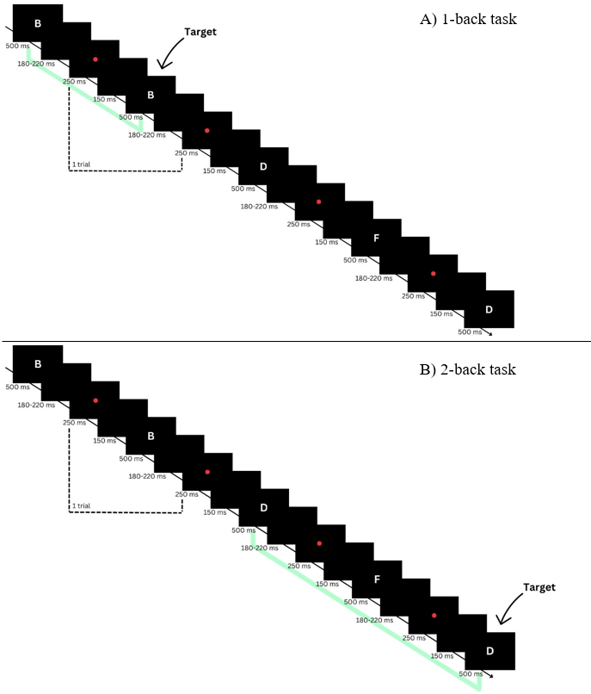
Figure 1. The n-back task

PVT. The Psychomotor Vigilance Task (PVT) is a widely used reaction time task developed in 1985 to assess sustained attention, particularly in contexts involving fatigue and sleep deprivation (Drummond et al., 2005). It has been shown to be sensitive to sleepiness in clinical and experimental settings (Molina, Sanabria, Jung & Correa, 2019).
The key feature of the PVT is its monotonous and unpredictable target presentation which makes participants highly prone to lapses of attention. This unpredictability minimizes learning effects, ensuring that performance remains largely independent of prior abilities and experience (Basner & Dinges, 2011). Reaction time measured by the PVT has been linked to cognitive function in both healthy subjects and patients, supporting its validity as an assessment tool (Jakobsen, Sorensen, Rask, Jensen & Kondrup, 2011).
This study employed a 5-minute version of the PVT, which has been established as a valid alternative to the traditional 10-minute PVT-192 (Lamond et al., 2008).
The dynamic stimulus appeared as a red number, counting up in milliseconds, representing the participant’s reaction time. Participants were instructed to respond immediately, when the stimulus occurred, by pressing the spacebar. Between trials, a white fixation cross was displayed on a black screen for a variable interval ranging from 2 to 10 seconds. Participants were required to maintain their gaze on this fixation cross. Each trial concluded when a response was made. Following each response, the participant’s reaction time was displayed on the screen for 500 ms as feedback before the next trial began (Figure 2).
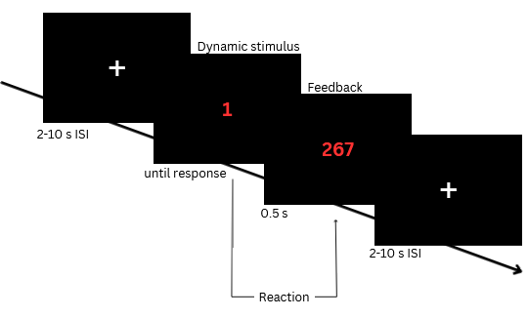
Figure 2. The Psychomotor Vigilance Task (PVT)

After receiving instructions, participants underwent a training block of 8 trials to familiarize themselves with the task. Following the training, participants proceeded to the main experiment, which consisted of 50 stimulus presentations.

Questionnaires
PSQI. The Pittsburgh Sleep Quality Index (PSQI), developed by Buysse, Reynolds, Monk, Berman, and Kupfer in 1989 is a self-rated questionnaire that assesses sleep quality and disturbance over the past month. The PSQI is the most commonly used sleep health assessment tool in both clinical and research settings (Manzar et al., 2016). Its reliability and validity have been consistently demonstrated in multiple studies (Carpenter & Andrykowski, 1998; Manzar et al., 2018; Mollayeva et al., 2016). The questionnaire consists of 24 items in total, 19 of which are self-reported by the patient and 5 of which require input from a room or bed partner. Only the 19 self-reported items are used for the quantitative evaluation of sleep quality, as perceived by the patient (Buysse et al., 1989; Manzar et al., 2018). The response formats across the items vary, including the recording of usual bed and wake times, number of hours slept, minutes taken to fall asleep, as well as forced-choice Likert-type responses (Buysse et al., 1989). The items are categorized into seven components, which are sleep quality, sleep latency, sleep duration, habitual sleep efficiency, sleep disturbance, use of sleeping medications, and daytime dysfunction, for each component given a score. Together, these component scores generate a global sleep quality score ranging from 0 to 21, with scores >5 indicating poor sleep quality (Buysse et al., 1989; Hinz et al., 2017).

HADS. The self-assessment Hospital Anxiety and Depression Scale (HADS) was originally developed by Zigmond & Snaith in 1983 to identify the presence of anxiety and depression states among patients in non-psychiatric hospital clinics. HADS is an extensively used, reliable, and valid instrument to measure anxiety and depression, not only in psychiatric, and clinical patients (Herrmann, 1997) but in general populations (Bjelland, Dahl, Haug & Neckelmann, 2002; Herrero et al., 2003; Spinhoven et al., 1997). The questionnaire assesses anxiety and depression symptoms during the past week, excluding symptoms also related to physical disorders, e.g., headache, dizziness, or insomnia (Bjelland et al., 2002; Hinz & Braehler, 2011; Zigmond & Snaith, 1983). The scale consists of 14 items, divided into a 7-item anxiety (HADS-A), and a 7-item depression subscale (HADS-D). Both subscales are rated on a four-point Likert scale, giving subscale scores ranging from 0 to 21 (Zigmond & Snaith, 1983). There is no universally accepted cut-off score for the HADS (Herrero et al., 2003; Spinhoven et al., 1997). In this study, the cut-off point was set to eight, indicating caseness anxiety and depression for scores ≥8, following the recommendations by Zigmond and Snaith (1983), as well as Bjelland et al. (2002) and Herrero et al. (2003).

FACIT-F. The 13-item Functional Assessment of Chronic Illness Therapy - Fatigue Scale (FACIT-F) was used to assess self-reported fatigue and its impact on daily activities and functions (Cella, Lai, Chang, Peterman & Slavin, 2002; Yellen et al., 1997) during the last 7 days. While it was originally developed for cancer-related fatigue (Cella et al., 2002; Yellen et al., 1997), it has been shown, that the FACIT-F is a reliable and valid measure of fatigue across various health conditions (Cella et al., 2002), making it a widely used tool for both clinical practice and research (Cella et al., 2022; Butt et al., 2013; Montan, Löwe, Cella, Mehnert & Hinz, 2018; Tinsley, Macklin, Korzenik & Sands, 2011). This questionnaire utilizes a five-point Likert scale, with total scores ranging from 0 (severe fatigue) to 52 (no fatigue). Based on general population data, scores ≤30 indicate clinically significant fatigue (Piper & Cella, 2010).

Data Analysis
All codes described in the data analysis part can be found in this GitHub repository: https://github.com/JankaMarlene/masters_thesis.

Cluster Analysis. To classify individuals based on objective cognitive assessment, a cluster analysis was conducted. Cluster analysis is an exploratory statistical method that organizes objects, data points, or observations into homogeneous groups, known as clusters, based on similarities (Ketchen & Shook, 1996). The objective is to maximize intragroup homogeneity while ensuring high intergroup heterogeneity (Bacher, Pöge & Wenzig, 2010; Backhaus, Erichson, Gensler, Weiber & Weiber, 2011). Cluster analysis does not follow a straightforward, single-step procedure but rather involves a multi-stage process, with each step depending on the outcome of the previous one (Bacher & Wenzig, 2010). Consequently, the analysis and interpretation of results may require revisiting certain steps, particularly when the initial outcomes do not allow for a meaningful interpretation (Backhaus et al., 2011). The goal was to identify the best possible solution for the dataset. The cluster analysis was conducted in R (version 2024.4.2.764) within Rstudio (Posit Team, 2024).
Ward’s method was selected for clustering, as it is widely used in practice and known for its effectiveness in identifying distinct clusters (Backhaus et al., 2011) with squared Euclidean distance as a distance matrix. It is considered a reliable algorithm, provided that the variables are on a metric scale, are uncorrelated, and do not contain outliers (Wentura & Pospeschill, 2015).
Before the initial clustering, data were preprocessed to meet the methodological requirements of the algorithm. The MoCA variable was converted to a binary variable, with scores ≤25 indicating cognitive impairment, as the test is designed to screen for impairment without assessing severity (Nasreddine et al., 2005) For the n-back task, missing values were assigned if a participant reported not understanding the task. To ensure complete cases for analysis, rows with missing values in relevant cognitive variables were removed.
Addressing outliers was essential, as they can significantly impact the result by distorting the clustering process, obscuring underlying patterns, and introducing bias (Backhaus et al., 2011; Wentura & Pospeschill, 2015). To mitigate these effects, winsorizing was applied, to replace outliers by capping extreme values beyond 1.5 times the interquartile range (IQR) for the relevant cognitive variables (). In total, four outliers were detected and winsorized for PVT reaction time, two for TMT-A time, and four for TMT-B time.
Where appropriate, age adjustment of neurocognitive data was performed in a way that best reflected the sample distribution (Table B-1) under the assumption that cognitive performance declines with increasing age (Tombaught, 2004; Strauss, Sherman & Spreen, 2006). Subsequently, data were standardized (z-scores) allowing for comparison between measures and ensuring that each variable contributed equally to the distance measure. Exploratively, different combinations of variables were tested to identify those that best distinguish between levels of cognitive performance. The number of clusters was chosen based on visual inspection of the dendrogram.

EEG Recording and Analysis. For each participant, 5 minutes of resting state with eyes open and 5 minutes of resting state with eyes closed were recorded using high-density EEG. Since the eyes-closed condition represents a simple, standardized procedure (Babiloni et al., 2016), it is the most commonly used (Babiloni et al., 2022) and will therefore be analyzed in this study to ensure comparability. EEG signals were recorded using a 128-channel EEG cap (128Ch Standard Brain Cap for actiCHamp Plus, Easycap GmbH, Wörthsee, Germany) with electrodes positioned in an equidistant layout, connected to an actiCHamp Plus Amplifier (Brain Products GmbH, Gilching, Germany).
The sampling rate was 1000 Hz with an amplitude resolution of 0.1 µV. Electrolyte gel was applied to improve conductivity between skin and electrodes, ensuring impedances remained below 20 kΩ. Eye movements and changes in the resting potential of the retina (EOG activity) were monitored using two EOG electrodes placed below each eye, with impedances tried to maintain below 20 kΩ. In addition, a ground electrode was positioned on the forehead, and a reference electrode was positioned on the tip of the nose. Impedances for both the reference and ground electrode were tried to be kept below 5 kΩ.

Preprocessing. Data preprocessing was performed using the FieldTrip toolbox (Fieldtrip-20240504; Oostenveld, Fries, Maris & Schoffelen, 2011) and the EEGLab toolbox (v2024.0; Delorme & Makeig, 2004) in Matlab (v24.1.0.2578822 (R2024a) Mathworks Inc., 2024, MathWorks® https://de.mathworks.com) on Windows.

Filtering and Resampling. A finite impulse response (FIR) windowed-sinc (firws) filter, designed with a hamming windowed sinc function, was used for both high-pass and low-pass filtering of the continuous data. For high-pass filtering, a cut-off frequency of 0.1 Hz was applied to eliminate slow drift and offset effects (Keil et al., 2013). This cut-off was based on the findings of Delorme (2023) and Winkler, Debener, Müller, and Tangermann (2015), where filtering at 0.1 Hz or higher significantly improved data quality compared to no filtering.
Before applying low-pass filtering, the data was downsampled from 1000 Hz to 250 Hz, to reduce computational load while preserving sufficient temporal resolution for subsequent analysis. A cut-off frequency of 45 Hz was then used to eliminate high-frequency noise and mitigate potential 50 Hz line noise (Delorme, 2023). Finally, the data underwent re-referencing using the Common Average Reference (CAR) technique to remove the influence of the reference and improve signal quality (Ludwig et al., 2009). As the name implies, an average of the recordings from all electrode sites was computed and used as the reference (Ludwig et al., 2009; Offner, 1950).

Artifact removal. After the initial filtering and resampling, artifacts were detected and removed. First, large artifacts were removed from the data. Channels with flat lines for more than 5 seconds were removed. This ensured the exclusion of “dead” or disconnected channels, thereby improving data quality (Pernet et al., 2021). Channels were further excluded if their signal could not be predicted from a randomly selected subset of the remaining channels for at least 85% of the recording time, to remove those that were highly dissimilar from the rest of the channels (Gil Ávila et al., 2023; Pernet et al., 2021). The Euclidean distance metric was used to calculate the similarity between channels. Data segments with abnormally high amplitude bursts, exceeding 100 SD compared to neighboring segments, were eliminated, as such extreme bursts are considered unlikely to reflect brain signals (Chang et al., 2018). The default BurstCriterion is set to 20, but it may be adjusted if the default setting results in rejecting too many data segments. Some scientists recommend setting the threshold to 100 (EEGLAB, "Automated Pipeline Tutorial", 2024), which aligns with the optimal cut-off range of 10 to 100 suggested by Chang et al. (2018). Therefore, a mild threshold of 100 was chosen here, as it still effectively removes large-amplitude artifacts while retaining valuable data (Chang et al., 2018). Time windows where more than 40% of the channels were marked as noisy were removed, to ensure the quality of the remaining data. A more lenient threshold of 0.4 was chosen over the default of 0.25 to retain more data (even if it is potentially noisier). Again the data was re-referenced to the average reference (CAR) (Gil Ávila et al., 2023).
Secondly, Independent Component Analysis (ICA) (Bell and Sejnowski, 1995; Hyvärinen, 2013, Jung et al., 2000; Lee et al., 1999; Palmer et al., 2008) was performed on the data, to detect and reject further artifacts, such as eye or muscle movements (Makeig et al., 1995). ICA with the runica algorithm was employed with the extended InfoMax method. To avoid rank deficiency, the number of components was set to one less than the total number of channels (Kim, Luo, Chu, Cannard, Hoffman & Miyakoshi, 2023). This approach decomposes the EEG signal into independent components, potentially separating artifacts from neural activity. Due to the non-deterministic nature of the ICA algorithm, its results vary across repetitions (Gil Ávila et al., 2023).
Automatic component rejection was implemented using ICALabel (Pion-Tonachini, Kreutz-Delgado & Makeig, 2019), as automatic artifact rejection is preferred over manual one to ensure standardization (Miljevic et al., 2022). Artifactual components are automatically classified by the ICLabel classifier (Pion-Tonachini et al., 2019). Thresholds were set at probabilities of 0.8 (80%) for muscle-related components (Pernet et al., 2021) and 0.5 (50%) for eye-related components. Components exceeding these thresholds were flagged and automatically removed. The two EOG channels (31 and 32) were removed from the dataset. The cleaned dataset was then checked for consistency.
Thirdly and finally, an additional artifacts removal step was implemented to address any remaining problematic channels. This process involved a statistical approach to identify outlier channels based on their signal characteristics. The standard deviation and mean were calculated for each channel across all time points. Then, overall mean values for these standard deviations and means were computed across all channels. Thresholds were established at 2.5 standard deviations above and below the overall mean, creating an acceptable range for channel activity. Channels with standard deviations falling outside this range were removed. This step ensures that channels with unusually high or low variability, which might represent persistent artifacts or malfunctioning electrodes, are excluded from subsequent analyses.
Channels removed in the previous step were interpolated with the default spherical splines method (Perrin, Pernier, Bertrand & Echallier, 1989), ensuring a consistent number of channels across participants (Gil Ávila et al., 2023). Data was then segmented into epochs, to achieve high resolution, while maintaining an adequate trial count (Bonello, Garg, Garg & Audu, 2018).

Power Analysis. Preprocessed EEG data were converted from EEGLAB format to FieldTrip format. Spectral parameterization was performed using SpecParam (formerly FOOOF, Fitting Oscillations & One Over F; Donoghue et al., 2020), which is implemented in the Brainstorm Toolbox (Tadel et al., 2011) and available in FieldTrip. This approach separates the periodic and aperiodic components of the power spectrum.
Spectral analysis of relative power across the 128 scalp electrodes was conducted using FieldTrips’s multitaper spectral estimation with Hanning taper, analyzing frequencies between 0.3 and 30 Hz with a frequency resolution of 0.2 Hz. The fooof output was set to a fixed aperiodic mode. Delta power was defined as 0.6-4 Hz and beta power as 14-30 Hz. The summed power across all frequencies within each band was used to compute the relative power per channel.
Once the relative power per channel was computed, further analysis was performed in R (version 2024.4.2.764) within Rstudio (Posit Team, 2024). To identify and remove extreme values, an initial outlier detection was performed. For each participant, channels exceeding ± 3 SD from the mean relative power were excluded. This process was applied separately for delta power and beta power.

Statistical Analysis. The resulting clusters were compared across cognitive measures, demographic variables, questionnaire scores, and their relative beta and delta power in rsEEG to identify emerging patterns. Particular attention was given to how the objective results of the cluster analysis aligned with or differed from self-reported CD, how associated variables help explain these findings, and how rsEEG beta and delta power are related to this.
To address this, comparisons were conducted not only across clusters but also between all relevant subgroups. To ensure the validity of statistical testing, assumptions for t-tests and ANOVA were first examined. The Shapiro-Wilk test was used to assess normality, and Levene’s test was applied to evaluate the homogeneity of variances. When these assumptions were violated, the non-parametric Wilcoxon test was used. For comparisons involving more than two groups, the Kruskal-Wallis test was used to determine whether significant group differences existed in the examined variable. If significance was indicated, pairwise Wilcoxon rank-sum tests with Bonferroni correction were performed as a post-hoc analysis. To test correlations, Spearman’s rank correlation was calculated.

Results

Hierarchical clustering
To investigate groups that differ as strongly as possible in their objective cognitive performance, a hierarchical cluster analysis was conducted using Ward’s method with Euclidean distance.
From the initial sample, nine participants were excluded due to missing values in at least one of the cognitive variables, TMT, n-back, or PVT. This resulted in a final sample of 70 participants for the cluster analysis. The final clustering was based on completion times in TMT-A and TMT-B, as well as reaction time in the PVT. Since the TMT difference score (TMT-diff) is derived from TMT-B and TMT-A, it was not considered a clustering variable to avoid redundancy and thereby unequal weighting of the variables.
The inclusion of the n-back task as a clustering variable resulted in poorer cognitive differentiation between clusters compared to when it was excluded. Participants generally performed poorly on the n-back task, particularly in the 2-back condition (M = 13.5 missed targets, range = 3–20), resulting in low variability and limited discriminative power. Consequently, n-back scores were not used as cluster variables. Visual inspection of the dendrogram revealed that a reasonable number of resulting clusters could be either two (Figure C-1) or four (Figure C-2). Both the two-cluster and four-cluster solutions were examined in terms of their differences.

Two-cluster solution. The identified cluster 1 (C1) comprised 41 participants, of whom 33 reported subjective CD. Cluster 2 (C2) comprised 29 participants, with 10 reporting subjective CD (Table 1). A comparison between the two clusters was conducted using the nonparametric Wilcoxon test, as the assumptions of normal distribution and homogeneity of variance were not met for most variables. All results are listed in Table 1. The participants of C2 completed the TMT and reacted in PVT significantly faster than participants in C1. Missed targets in the n-back task were significantly more frequent in C1 compared to C2. No significant differences were found between clusters in age, level of education, fatigue score, quality of sleep, anxiety, and depression. No abnormal values were observed in HADS or FACIT-F. However, PSQI scores indicated poor sleep quality in both clusters (C1: M = 7.4, SD = 4.3; C2: M = 6.2, SD = 3.7).

Table 1
Two-Cluster Solution: Cluster Information and Comparison
 | Cluster 1 | Cluster 2 | p
Socio-demographic variable
n | 41 | 29 | -
Reported CD | 33 | 10 | -
No reported CD | 8 | 19 | -
Sex [F/M] | 27/14 | 14/15 | -
Age [years] | 50.6 ± 14.8 | 47.9 ± 12.1 | .316
Education [years] | 14.9 ± 2.8 | 15.8 ± 3.4 | .412
Cognitive variable
PVT [s] | .357± .07 | .29 ± .02 | 4.38e-09***
TMT-A [s] | 30.0 ± 8.0 | 19.5 ± 4.0 | 1.25e-08***
TMT-B [s] | 62.8 ± 25.2 | 42.0 ± 10.5 | 4.44e-05***
TMT-diff [s] | 32.8 ± 22.1 | 23.5 ± 9.5 | .113
1-back [miss] | 11.3 ± 5.2 | 5.8 ± 3.9 | 1.50e-05***
2-back [miss] | 15.6 ± 3.0 | 10.5 ± 4.0 | 9.69e-07***
MoCA < 26 | 9 | 2 | -
Questionnaires
FACIT-Fa | 33.2 ± 12.4 | 37.2 ± 11.4 | .182
HADS-Anxietyb | 6.7 ± 3.8 | 5.2 ± 3.7 | .190
HADS-Depressionb | 5.7 ± 4.6 | 4.4 ± 4.3 | .103
PSQIc | 7.9 ± 4.3 | 6.2 ± 3.7 | .147
Note. PVT: Psychomotor Vigilance Task, TMT: Trail Making Test, MoCA: Montreal Cognitive Assessment, FACIT-F: Functional Assessment of Chronic Illness Therapy – Fatigue Scale, HADS: Hospital Anxiety and Depression Scale, PSQI: Pittsburgh Sleep Quality Index
Values denote mean ± standard deviation
P values refer to the Wilcoxon rank-sum test (p < .05)
a scores < 31 indicate clinically significant fatigue
b scores > 7 indicate caseness
c scores > 5 indicate poor sleep quality

To allow for a more in-depth analysis, the subgroups no self-reported CD (C1), self-reported CD (C1), no self-reported CD (C2) and self-reported CD (C2) were compared (Table C-2).
In addition to the observed group differences in cognitive variables, the Kruskal-Wallis test revealed significant group differences across all questionnaire scores (Table C-3). Dunn’s post hoc tests indicated significant differences between the no self-reported CD (CD) and self-reported CD (C2) groups in PSQI, FACIT-F, and HADS-A scores (Figure 3). The self-reported CD (C2) group showed the most severe scores across all questionnaire measures compared to the other three subgroups. It was the only subgroup exhibiting clinically significant fatigue (FACIT-F: M = 27.7, SD = 11.1) and elevated levels of anxiety (HADS-A: M = 8.00, SD = 3.3). In contrast, the no self-reported CD (C2) group showed the least severe scores relative to the other three subgroups.
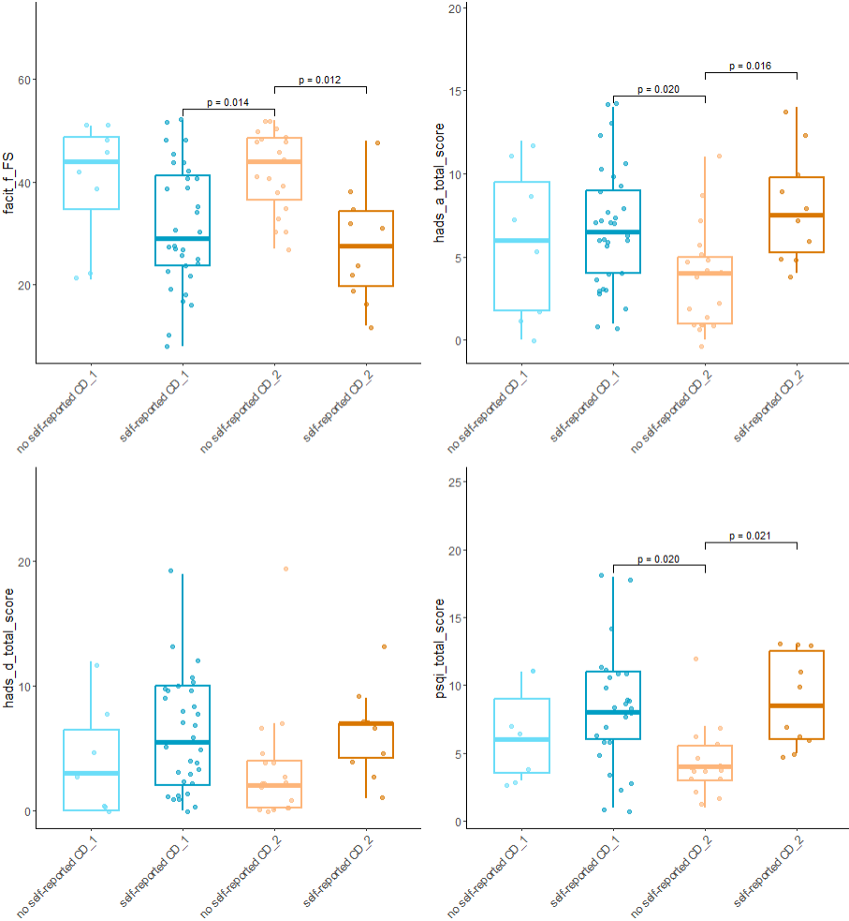
Figure 3. Two-Cluster Solution: Comparison of the four subgroups in questionnaire scores. Significant Bonferroni-adjusted p-values are shown in the plot. Dunn’s test was used for pairwise group comparisons. FACIT-F: Functional Assessment of Chronic Illness Therapy – Fatigue Scale, HADS: Hospital Anxiety and Depression Scale, PSQI: Pittsburgh Sleep Quality Index.

Four-cluster solution. C2 remained unchanged from the two-cluster solution, while C1 was divided into three new clusters (Figure C-2). The updated clustering resulted in C1 comprising 17 participants (13 with self-reported CD), C3 comprising 16 (13 with self-reported CD), and C4 comprising 13 (6 with self-reported CD) participants (see table 2).

Table 2
Four-Cluster Solution: Cluster Information
 | Cluster 1 | Cluster 2 | Cluster 3 | Cluster 4
Socio-demographic variable
n | 17 | 29 | 16 | 8
Reported CD | 13 | 10 | 13 | 7
No reported CD | 4 | 19 | 3 | 1
Sex [F/M] | 13/4 | 14/15 | 9/7 | 5/3
Age [years] | 47.5 ± 16.0 | 47.9 ± 12.1 | 52.4 ± 13.4 | 53.4 ± 15.0
Education [years] | 15.2 ± 2.7 | 15.8 ± 3.4 | 14.5 ± 2.7 | 15.1 ± 3.4
Cognitive variable
PVT [s] | .38 ± .08 | .29 ± .02 | .31 ± .02 | .42 ± .05
TMT-A [s] | 25.9 ± 6.5 | 19.5 ± 4.0 | 30.9 ± 7.8 | 36.7 ± 6.7
TMT-B [s] | 46.5 ± 9.7 | 42.0 ± 10.5 | 67.2 ± 19.4 | 88.4 ± 34.3
TMT-diff [s] | 20.6 ± 6.4 | 23.5 ± 9.5 | 36.3 ± 21.3 | 51.7 ± 30.3
1-back [miss] | 11.1 ± 4.0 | 5.8 ± 3.9 | 9.8 ± 5.6 | 14.9 ± 5.6
2-back [miss] | 14.5 ± 3.0 | 10.5 ± 4.0 | 16.1 ± 2.9 | 17.3 ± 2.6
MoCA < 26 | 1 | 2 | 3 | 5
Questionnaires
FACIT-Fa | 32.2 ± 13.7 | 37.2 ± 11.4 | 36.1 ± 11.7 | 28.9 ± 10.8
HADS-Anxietyb | 6.9 ± 4.1 | 5.2 ± 3.7 | 6.1 ± 3.6 | 7.1 ± 3.6
HADS-Depressionb | 5.5 ± 4.7 | 4.4 ± 4.3 | 6.3 ± 5.1 | 5.0 ± 3.6
PSQIc | 8.4 ± 4.6 | 6.2 ± 3.7 | 7.1 ± 4.5 | 8.2 ± 2.8
Note. PVT: Psychomotor Vigilance Task, TMT: Trail Making Test, MoCA: Montreal Cognitive Assessment, FACIT-F: Functional Assessment of Chronic Illness Therapy – Fatigue Scale, HADS: Hospital Anxiety and Depression Scale, PSQI: Pittsburgh Sleep Quality Index
Values denote mean ± standard deviation
a scores < 31 indicate clinically significant fatigue
b scores > 7 indicate caseness
c scores > 5 indicate poor sleep quality

The data did not meet the assumptions of normality and homogeneity of variance. Therefore, the Kruskal-Wallis test was used to identify overall differences between clusters, and Dunn’s post hoc tests were applied to further examine these differences (Table B-4).
Participants in C2 showed the best overall cognitive performance, performing significantly better than all other clusters across all cognitive tests. In contrast, participants in C4 demonstrated the lowest performance across all cognitive measures, with significantly lower cognitive performance in all tests compared to participants in C2. Participants in C1 performance better on TMT-A and significantly better on TMT-B, but performed significantly lower in PVT compared to participants from C3 (figure 4).

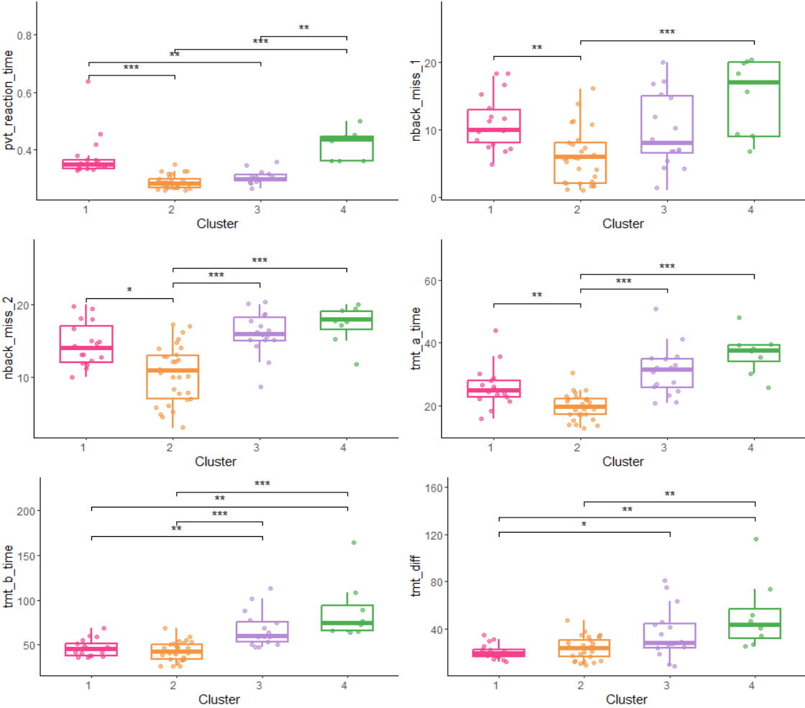
Figure 4. Four-Cluster Solution: Comparison of the four clusters in cognitive variables. Bonferroni-adjusted p-values are shown in the plots. Significance is displayed with stars as follows:this: *p < .05, **p < .01,***p < .001. Dunn’s test was used for pairwise group comparisons. PVT: Psychomotor Vigilance Task, TMT: Trail Making Test.

No significant differences were found between clusters in demographic or questionnaire variables (table 2). However, participants in C4 showed a mean FACIT-F score of 28.9 (SD = 10.75), indicating clinically relevant fatigue. No elevated levels of anxiety or depression were observed at the cluster level. However, mean PSQI scores across all clusters indicated overall poor sleep quality.
Due to the small sample sizes of subgroups within each cluster, no statistical comparisons were conducted between the eight subgroups. Descriptively, the participant with no self-reported CD in C4 had a fatigue score of 21, along with elevated depression (score = 8) and anxiety (score = 11). The MoCA score was normal in that participant.

The clusters of the two-cluster solution, as well as the clusters from the four-cluster solution, were also compared in their rsEEG delta and beta power.

EEG analysis
Data cleaning. Due to an empty dataset and file naming issues, two participants were excluded from the analysis, resulting in a final sample size of 68 participants, with one less in each cluster in the two-cluster solution (C1: n = 40, C2: n = 28) and one less in C2 (n = 28) and C4 (n = 7) in the four-cluster solution.
ICA artifact removal resulted in the retention of 86% of channels in C1 (M = 110.3, SD = 11.4, range = 75–125) and 85% in C2 (M = 109, SD = 11.0, range = 78–124) in the two-cluster solution. In the four-cluster solution, ICA artifact removal retained 86% of channels in C1 (M = 110.8, SD = 11.84), 85% in C2 (M = 109, SD = 11.03) and C3 (M = 108.6, SD = 12.19), and 88% in C4 (M = 113, SD = 6.64); ranges were 75–125, 78–124, 77–122, and 105–123, respectively. Following the additional artifact removal step, which included the exclusion of outlier channels, 84% of channels were retained in C1 (M = 108, SD = 11.2, range = 73–121) and 83% in C2 (M = 106.6, SD = 10.9, range = 77–121) in the two-cluster solution. In the four-cluster solution, 85% of channels remained in C1 (M = 108.4, SD = 11.46, range = 73–121), 83% in C2 (M = 106.6, SD = 10.92, range = 77–121), 83% in C3 (M = 106.3, SD = 12.17, range = 74–120), and 86% in C4 (M = 111.1, SD = 6.20, range = 104–121).
To maintain an adequate trial count while achieving higher temporal resolution, continuous EEG data were segmented into 5-second non-overlapping epochs. This resulted in an average of 37.7 good epochs (SD = 14.7, range = 4–60) in C1 and 37.9 (SD = 16.6, range = 3–59) in C2 in the two-cluster solution. In the four-cluster solution, the average number of good epochs was 37.6 in C1 (SD = 16.2, range = 4–58), 37.9 in C2 (SD = 16.6, range = 3–59), 35.9 in C3 (SD = 14.5, range = 9–60), and 42 in C4 (SD = 12.5, range = 24–60)

Beta Power (central ROI) in the Two-Cluster solution. In the two-cluster solution, mean beta power did not significantly differ between C1 (M = 1.64, SD = 1.43) and C2 (M = 1.86, SD = 1.75), as indicated by a two-sided Wilcoxon rank-sum test, z = -.112, p = .9107, r = .0136.
When considering both cluster affiliation and self-reported CD, beta power was highest in individuals with self-reported CD (C2) (M = 2.44, SD = 2.41), followed by those with no self-reported CD (C1) (M = 2.1, SD = 2.18). Lower beta power was observed in individuals with no self-reported CD (C2) (M = 1.56, SD = 1.39) and those with self-reported CD (C1) (M = 1.53, SD = 1.22). Pairwise Wilcoxon rank-sum tests comparing central beta power across these four groups revealed no statistically significant differences after Bonferroni correction (all p_adj = 1.00, r = .03 - .19).

Delta Power (frontal ROI) in the Two-Cluster Solution. In the two-cluster solution, mean delta power did not significantly differ between C1 (M = 1.11, SD = 1.21) and C2 (M = 1.15, SD = .87), as indicated by a one-sided Wilcoxon rank-sum test, z = -.735, p = .2311, r = .089 (see figure 5).

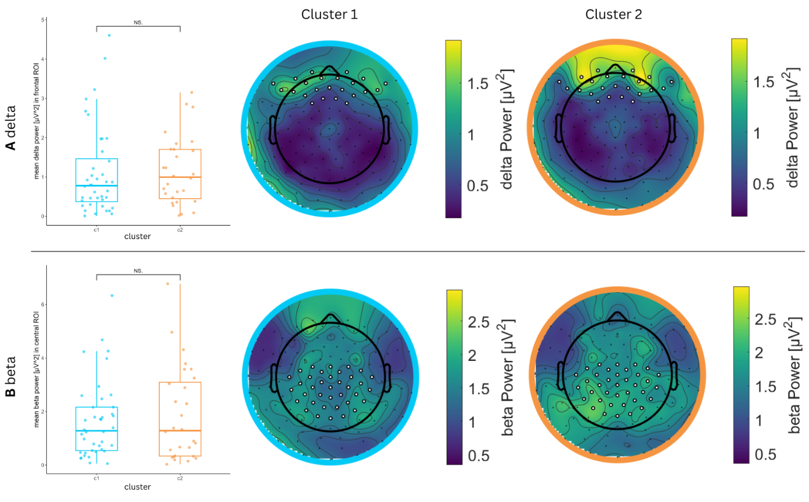
Figure 5. Results of the power analysis in the (A) delta (0.6–4 Hz) and (B) beta (14–30 Hz) frequency bands for Cluster 1 and Cluster 2. The topographic map shows the distribution of (A) delta and (B) beta activity on the scalp for Cluster 1 and Cluster 2. White dots indicate the respective regions of interest (ROIs).

When accounting for both cluster affiliation and self-reported CD, delta power was highest in participants with no self-reported CD group in C1 (M = 1.94, SD = 1.38), followed by those with self-reported CD in C2 (M = 1.48, SD = 1.08), and those with no self-reported CD in C2 (M = .94, SD = .75). Delta power was lowest in those with self-reported CD in C1 (M = .91, SD = .97). Pairwise Wilcoxon rank-sum tests revealed no significant differences in mean delta power between these four groups after Bonferroni correction (all p_adj > .05). However, an uncorrected difference was observed between participants with self-reported CD and no self-reported CD in C1 (p = .031, r =.34, moderate effect), but this did not survive correction (figure).

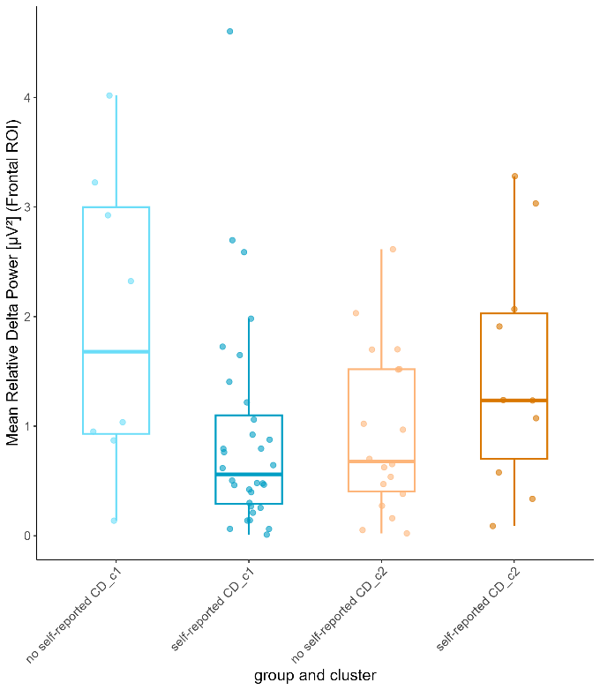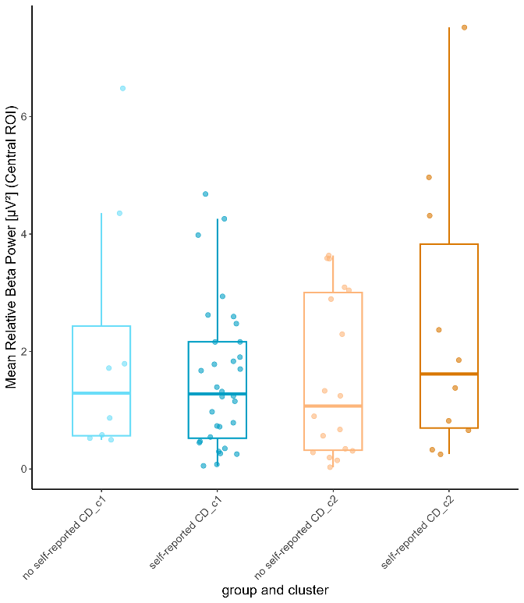

Beta and Delta Power in the Four-cluster solution. Relative delta and beta power in the central region were examined across the four EEG clusters to explore potential differences in spectral characteristics. Descriptively, C1 exhibited the highest average delta power (M = 1.34, SD = 1.34), followed by C2 (M = 1.15, SD = 0.87), C4 (M = 0.998, SD = 1.18), and C3 (M = 0.91, SD = 0.78). In contrast, beta power was lowest in C1 (M = 1.43, SD = 1.41) and highest in C3 (M = 1.97, SD = 1.72), with intermediate values observed in C2 (M = 1.86, SD = 1.75) and C4 (M = 1.62, SD = 1.43).
However, non-parametric Kruskal–Wallis tests indicated that these differences were not statistically significant. For relative beta power, the test yielded χ²(3) = 0.93, p = .819; for relative delta power, χ²(3) = 1.12, p = .772.
For the eight subgroups also no significant difference was found (appendix), small sample size. Further comparisons across the eight subgroups defined by self-reported CD within each cluster also revealed no statistically significant differences (see Appendix).

Correlation with clinical data
Central beta power was significantly correlated with TMT-A performance (p(66) = .27 ,p = .025) in a Spearman Rank correlation (see table 3). A trend towards a positive correlation with TMT-B was also observed (p(66) = .21, p = .09). Frontal delta power did not show significant correlations with any of the examined variables (Table X).
PVT reaction time correlated significantly negatively with the FACIT-F score (p(66) = -.28, p = 0.02). A trend towards a positive correlation between PVT reaction time and PSQI score was also observed (p(66) = .26, p = .05).

Table 3
Correlation of delta and beta power with cognitive tests and clinical health parameters
Variable | δ | β | TMT A | TMT B | PVT | PSQI | FACIT | HADS A | HADS D | MoCA
δ | 1
β | .06 | 1
TMT A | -.06 | .27* | 1
TMT B | .03 | .21 | .72*** | 1
PVT | .06 | .04 | .47*** | .33** | 1
PSQI | .20 | -.11 | .14 | .08 | .26 | 1
FACIT | -.17 | .003 | -.09 | -.08 | -.28* | -.72*** | 1
HADS A | .20 | -.02 | .19 | .10 | .14 | .68*** | -.70*** | 1
HADS D | .15 | .01 | .21 | .19 | .15 | .59*** | -.77*** | .64*** | 1
MoCA | -.02 | -.18 | -38** | -.46*** | -.40*** | -.01 | .02 | -.05 | -.11 | 1
Note. *p < .05, **p < .01, ***p < .001. δ = delta power, β = beta power, TMT: Trail Making Test, PVT: Psychomotor Vigilance Task, PSQI: Pittsburgh Sleep Quality Index, FACIT-F: Functional Assessment of Chronic Illness Therapy – Fatigue Scale, HADS: Hospital Anxiety and Depression Scale, MoCA: Montreal Cognitive Assessment

Discussion
This study aimed to investigate the cognitive and electrophysiological profiles of individuals exhibiting self-reported CD through hierarchical cluster analysis. The primary goal was to explore how these individuals differ in cognitive performance and EEG characteristics, particularly in terms of delta and beta power, and how these relate to measures of fatigue, anxiety, depression, and sleep quality.
The main findings indicate that the two-cluster solution revealed significant differences in cognitive performance, with C2 outperforming C1 across all cognitive variables. Within C2, participants with self-reported CD exhibited the highest levels of fatigue and anxiety. The four-cluster solution further differentiated cognitive performance, with C4 displaying the poorest cognitive performance and the highest fatigue scores. While questionnaire variables did not significantly differ between clusters in either solution, closer examination of self-reported vs. non-self-reported CD groups within clusters revealed differences. EEG analysis did not show significant differences in beta or delta power between clusters. However, beta power correlated with TMT-A performance, and PVT reaction time was associated with fatigue.

Cognitive performance
The hierarchical clustering approach revealed distinct patterns in cognitive performance. In the two-cluster solution, individuals with lower cognitive performance in the PVT, TMT-A, and n-back tasks were grouped into C1. In contrast, individuals in C2 performed significantly better in these cognitive measures than those in C1. In the four-cluster solution, participants in C2 exhibited the highest overall cognitive performance, significantly outperforming all other clusters across all cognitive tests. In contrast, participants in C4 demonstrated the lowest performance across all cognitive measures, with significantly lower scores in all tests compared to those in C2.

TMT. Normative test data for the TMT defines normal cognitive performance in the age group 45–54 years as a TMT-A completion time of 21.85–41.71 seconds and a TMT-B completion time of 49.34–78.18 seconds (Tombaugh, 2004). This indicates that while C1 performed worse than C2, their performance still falls within the normal cognitive range, suggesting no global cognitive impairment based on TMT measures. Moreover, C2 appears to be a high-achieving group, as they completed both TMT tasks faster than the normal completion range (TMT-A: M = 19.5, SD = 4.0; TMT-B: M = 42, SD = 10.5).
In the four-cluster solution, C4 demonstrated a mean completion time of 88.4 seconds (SD = 34.3) on the TMT-B, indicating an abnormally prolonged completion time compared to individuals in the same age group. This exceeds the normal completion range for TMT-B in this population, suggesting impairments in cognitive domains related to processing speed and executive functioning (Lezak, 1995; Mitrushina et al., 2005; Sánchez-Cubillo et al., 2009; Strauss et al., 2016; Tombaugh, 2004), as well as visual search and mental flexibility (Sánchez-Cubillo et al., 2009; Tombaugh, 2004), which are reflected in TMT-B performance.

PVT. Regarding the PVT, no normative data are available that establish normal and abnormal reaction time ranges in relation to age. When analyzing PVT reaction time data, most studies define a reaction time threshold of 500 ms to delineate lapses from normal responses and use this as a comparison metric (Gabel, Kass, Joyce, Spitschan, & Zeitzer, 2019; Lee, Bardwell, Ancoli-Israel, & Dimsdale, 2010). However, in this study, lapses were not calculated, making it impossible to directly compare the results to previous studies or to determine whether the observed PVT scores fall within normal or abnormal ranges.
One study examined average reaction times in a sample of eight healthy individuals and 40 individuals with sleep apnea, with mean ages of 49.5 years (SD = 9.23) and 49.15 years (SD = 9.51), respectively, similar to the age group in this study. The mean reaction times reported were 288.01 ms (SD = 52.33) for the healthy participants and 264.78 ms (SD = 42.85) for the apneic group (Lee et al., 2010). In comparison, the reaction times observed in all clusters (both in the two-cluster and four-cluster solutions) were higher than those reported in Lee et al. (2010). Specifically, reaction times in C1 (M = 357 ms) in the two-cluster solution, as well as in C1 (M = 357 ms) and C4 (M = 420 ms) in the four-cluster solution, were markedly slower. This suggests a general slowing of reaction time, not only within the study sample but also in comparison to external cohorts. However, statistical significance was not tested, and further research is needed to establish clear normative and abnormal ranges for PVT reaction times.
As all clusters (in both the two-cluster and four-cluster solutions) exhibited poor sleep quality based on PSQI scores, a generally slower reaction time in the PVT compared to other cohorts is plausible. This aligns with previous findings indicating that PVT performance is sensitive to sleepiness and affected by sleep deprivation (Drummond et al., 2005; Molina et al., 2019).

TMT and PVT. Interestingly, in the four-cluster solution, individuals from C1 performed significantly worse on the PVT than individuals from C3. But at the same time perform significantly better in the TMT-B than individuals from C3. That could be a hint to that in these patients different cognitive domains are with deficits. Here it would indicate, that C1 would have more difficulties in sustained attention (Drummond et al., 2005), while individuals in C3 have more difficulties in TMT-B related cognitive domains, such as processing speed, executive functioning (Lezak, 1995; Mitrushina et al., 2005; Sánchez-Cubillo et al., 2009; Strauss et al., 2016; Tombaugh, 2004), visual search, or mental flexibility (Sánchez-Cubillo et al., 2009; Tombaugh, 2004). This could ofcourse also be positively formulated, as the TMT-B score does not indicate cognitive impairment, in the way, that C1 might have a strengh in sustained attention, while C3 individuals might have a strengh in the mentioned related cognitive domain to TMT. C1 and C3 did not differ significantly between variables assessed via questionnaires, but C1 had a lower score, yet not clinically relevant of fatigue and a poorer clinical relevant sleep quality than C3.

MoCA. When examining the MoCA test results, 9 participants in the lower-performing cluster and 2 participants in the higher-performing cluster (C2) had a score indicative of clinically significant cognitive impairment. Notably, all 9 participants with an impaired MoCA score also reported cognitive decline (CD).
In this study, only the global MoCA score was used. However, it would have been valuable to analyze the sub-scores of different cognitive domains within the MoCA to determine whether specific cognitive patterns emerge that may be particularly relevant to subjective and objective impairment in PCS patients. While the MoCA score can serve as a useful screening tool for cognitive assessment, it should not be the sole criterion for diagnosing cognitive impairment (Petersen, 2016). Instead, the MoCA can help identify which cognitive domains are specifically affected (Petersen, 2016). Therefore, investigating the subdomain scores of the MoCA could provide more meaningful insights than relying solely on the global score

Subjective cognitive CD versus objective cognitive impairment
The first hypothesis was that individuals with objectively lower cognitive performance would report more frequent cognitive difficulties compared to those with higher objective performance. Of the 43 participants who self-reported cognitive difficulties (CD), 33 were in the lower performing cluster (C1), while 10 were in the better performing cluster (C2), resulting in a sensitivity of 76.7%. Among the participants who did not report CD, 19 were in the better performing cluster (C2) and 8 were in the lower performing cluster (C1), giving a specificity of 70.4%. However, these results should be interpreted with caution, as the classification might be misleading. Participants were specifically asked prior to the examination whether they experienced CD as a result of their SARS-CoV-2 infection. This means that individuals who had been experiencing CD before the infection would be classified as participants with no self-reported CD, though the exact number of such participants is unknown. Nevertheless, it was observed that most participants with self-reported CD were in the lower performing cluster (C1), and most participants without self-reported CD were in the better performing cluster (C2).

Self-reported CD and related symptoms
The second hypothesis tried to explain the observed discrepancy between objective and subjective CD in the studygroup, by hypothesing that individuals who self-report CD but are not classified as low performers in objective cognitive assessments may have elevated fatigue levels, anxiety levels or depression levels.
Indead, individuals with self-reported CD that were not identified as lower performers on cognitive test, reported clinically relevant levels of anxiety and fatigue, the other three groups did not show clinical significant scores on these two variables. No subgroup revealed a clinically significant score for depression but therefore showed all groups except for the no reported CD group in C2 poor quality of sleep. Wherby the subgroup reported CD in C2 had the highest average PSQI score. This supports the assumption that subjective perceived CD is related to elevated anxiety, fatigue and sleep disturbance (Gomzyakova et al., 2022; Henneghan et al., 2022; Zamarian et al., 2024) and thereby the hypotheses, that fatigue and anxiety can serve as explainatory factors, when objective cognitive impairment is not bestätigt. Interestingly in the four cluster solution, the one person in cluster 4, that did not reported CD, had a low fatigue score (21), high anxiety score (11) and an elevated depression score (8). The MoCA was normal.

Delta power
The first hypothesis concerning delta power was that a decrease in delta power would be observed in patients with objectively lower cognitive performance compared to better performers. However, this hypothesis could not be confirmed in either the two-cluster or the four-cluster solution.
Delta appears to be a promising frequency band for investigating PCS patients, as previous studies have identified differences in this band (Cecchetti et al., 2022; Furlani et al., 2022; Kopańska et al., 2022; Ortelli et al., 2023). However, this study did not find significant differences between the clusters. When considering research on MCI and AD, this may not be surprising. In all observed variables, the clusters differed significantly only in cognitive performance measures. Cognitive impairment was not indicated based on the scores in the TMT. The findings on PCS patients in the studies mentioned above may not reflect objective cognitive impairment but rather associated symptoms.
Research on MCI and AD has shown that abnormalities in the form of increased delta power are associated with more advanced cognitive decline and are not typically seen at the onset of conditions like AD or MCI (Dringenberg, 2000; Elmståhl et al., 1994; Farina et al., 2020; Schreiter-Gasser, Gasser, & Ziegler, 1994), therefore it might not be surprising, that no difference in delta power was found between clusters. Theta power, on the other hand, appears to be the first frequency band to show abnormalities, most commonly an increase in power, in individuals with cognitive impairment (Dringenberg, 2000; Elmståhl et al., 1994; Schreiter-Gasser et al., 1994). Therefore, it may be particularly relevant to investigate the role of theta power in individuals suffering from PCS to examine the relationship between PCS and reported cognitive impairment more closely.
Regarding the second hypothesis concerning delta power, it was hypothesized that decreased delta power might be associated with higher levels of fatigue. Interestingly, the greatest difference in delta power was found between the self-reported CD and no self-reported CD group within C1. The no self-reported CD group exhibited the highest delta power, whereas the self-reported CD group showed the lowest. This could further suggest, that delta power might not be related to CD but rather to associated symptoms. However, these two subgroups did not significantly differ in any of the assessed questionnaire variables and did not indicate clinically relevant fatigue, anxiety, or depression. Notably, the fatigue score was lower in the self-reported CD group within that cluster. Both subgroups had a clinically relevant score in the PSQI, indicating poor sleep quality. The self-reported CD group showed a higher PSQI score than the other subgroup, but significant differences were not found. No explanation could be found for the difference found. However, the difference was also not significant.
A study on the Chronic Fatigue Syndrome (CFS), which might have a similar symptom pattern to PCS, found that ultra-slow delta power (0.5-0.8 Hz) during sleep is lower in CFS than in healthy control (Le Bon et al., 2012). Further investigations could be to analyse ultra-slow delta power, to distinguish between fatigue and cognitive impairment.

Beta power
Concerning the hypotheses the first hypothesis about beta power, which was that an increase in beta power in patients with objective lower performance compared to better performers is expected could not be bestätigt werden, as there was no significant difference between the two clusters both in the two-cluster solution and in the four-cluster solution. Eventhough there was also no significant difference found between the four subgroups in the two-cluster solution, interestingly, individuals with self-reported CD in the better performing cluster (C2) reveild the highest mean in beta power, while the self-reported CD group in the lower performing cluster (C1) reveild a decrease in beta. As in hypotheses 4b suggested, an increased beta power could be an indicater for experiencing subjective CD as a result of higher levels of anxiety and depression, but not objective cognitive impairment. In fact, individuals with self-reported CD in the better performing cluster (C2) was the only subgroup that had a mean of 8 in the HADS-A, indicating elevated levels of anxiety. However, ein Mittelwert von 8 ist gerade an der Grenze zur clinical significant anxiety. Depression was not elevated, but dafür had that group the lowest score on the FACIT-F scale indicating fatigue. Also the only subgroup, where clinical relevant fatigue was observed. That could suggest that an increase in beta power in fact is more related to symptoms that are related to cognitive impairmant rather than objective cognitive impairment itself. An increase in beta power in patients with anxiety was also found different studies (Wang et al., 2025). However the finding, that increased beta power might also be related to higher fatigue levels in contradicting to the finding of Jab et al. (2009) were beta power significantly decreased in patients with induced fatigue. That was also found in a study by Li et al. (2020) Where relative beta power was decreased significantly both in rsEEG and task state EEG in patients with mental fatigue. However, the observed difference between the self-reported CD groups with better and lower performance was not significant und daher ist es auch nicht eine Aussage über den Zusammenhang von Fatigue und Anxiety in bezug zur beta power gemacht werden. However it would be interesting to investigate this further. If it actually should be right, that beta power increases in individuals with anxiety symptoms, but decreases in individuals experiencing mental fatigue, how would be expected regardings beta power, if participants experience both, anxiety and fatigue, which might have contradicting influences on beta power, as it was the case in that subgroup. It would be interesting to further analyse different combinations of symptoms in PCS patients. However, in this study no correlation could be found between the FACIT-F score (a measure of fatigue), HADS anxiety score and beta power, indicating, that fatigue and anxiety do not have a direct relationship with beta power.
As mentioned earlier, literature on beta power in PCS and in deseases related to cognitive impairment is scattered and limited. However, the beta connectivity seems to be more associated/interesting when investigating PCS patients. Beta connectivity could be interesting to be looked at, as studies found abnormals in beta connectivity when investigating fatigue (Buyukturkoglu et al., 2017; Wu et al., 2023).

Limitations
Sex differences in rsEEG was not investigated but probably should have been.
The cognitive status of the individuals before the infection with the virus was not measured, cannot tell if those experienced cognitive CD actually are a result of the virus.
What do TMT-A and B and PVT actually reflect?

Conclusion

Appendix A
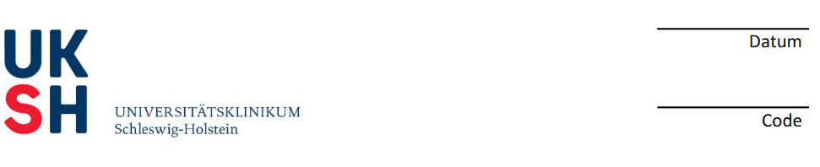
Questionnaire on demographic data and psychological and neurological conditions
Created by Christian Neumann

Persönliche Daten:
Geburtsdatum: ____________________
Geschlecht: Männlich ☐ Weiblich ☐ Divers ☐ Keine Angabe ☐
Sehfähigkeit: Mit Brille Korrigiert ☐ Mit Kontaktlinsen korrigiert ☐ normal ☐
Höchster Abschluss:
Hauptschule ☐ Realschule ☐ Abitur ☐
Lehre ☐ Fachwirt ☐ Universitätsabschluss ☐
Bildungsjahre:
__ Jahre Grundschule
__ Jahre weiterführende Schule (Hauptschule/Realschule/Gymnasium
__ Jahre Ausbildung/Lehre
__ Jahre Studium
__ Gesamt
Leiden Sie an neurologischen Vorerkrankungen?
ja ☐ nein ☐
Wenn ja, welche neurologischen Vorerkrankungen?

Leiden Sie an anderen sonstigen Vorerkrankungen?
Appendix B
Additional tables

Table B- 1
Defined age groups for the variables PVT, TMT-A and TMT-B
 |  | PVT | TMT-A | TMT-B
Age group | n
18 – 34 years | 12 | .317 ± .053 | 18.2 ± 3.9 | 39.9 ± 11.8
35 – 49 years | 19 | .325 ± .058 | 24.5 ± 7.1 | 45.9 ± 10.5
50 – 64 years | 33 | .328 ± .543 | 27.1 ± 7.5 | 59.0 ± 16.2
65 – 80 years | 6 | .334 ± .018 | 34.6 ± 10 | 65.1 ± 21.3
Note. PVT: Psychomotor Vigilance Task, TMT: Trail Making Test
Values denote mean ± standard deviation

Table B- 2
Two-Cluster Solution: Clusterinformation based on the self-reported group
 | Cluster 1 |  | Cluster 2
 | No reported CD | Reported CD | No reported CD | Reported CD
Socio-demographic variable
n | 8 | 33 | 19 | 10
Sex [F/M] | 6/2 | 21/12 | 7/12 | 7/3
Age [years] | 49.1 ± 20.0 | 50.9 ± 13.6 | 46 ± 12.8 | 51.5 ± 10.4
Education [years] | 14.6 ± 3.7 | 15.0 ± 2.6 | 16.1 ± 3.4 | 51.5 ± 10.4
Cognitive variable
PVT [s] | .362 ± .05 | .362 ± .07 | .288 ± .3 | .293 ± .02
TMT-A [s] | 28.2 ± 8.5 | 30.4 ± 7.9 | 19.0 ± 4.5 | 20.4 ± 2.9
TMT-B [s] | 58.7 ± 24.4 | 63.7 ± 25.7 | 43.1 ± 11.1 | 42.7 ± 9.7
TMT-diff [s] | 30.6 ± 21.1 | 33.3 ± 22.6 | 24.0 ± 10.2 | 22.4 ± 8.4
1-back [miss] | 8.8 ± 4.1 | 11.9 ± 5.3 | 4.2 ± 3.0 | 9.0 ± 3.5
2-back [miss] | 15.8 ± 3.1 | 15.6 ± 3.0 | 10.1 ± 4.0 | 11.2 ± 3.9
MoCA < 26 | 0 | 9 | 1 | 1
Questionnaires
FACIT-Fa | 40 ± 12.1 | 31.4 ± 12.1 | 42.2 ± 8.1 | 27.7 ± 11.1
HADS-Anxietyb | 5.9 ± 4.6 | 6.8 ± 3.6 | 3.68 ± 3.0 | 8.0 ± 3.3
HADS-Depressionb | 4.0 ± 4.7 | 6.1 ± 4.6 | 3.3 ± 4.5 | 6.3 ± 3.3
PSQIc | 6.4 ± 3.5 | 8.2 ± 4.4 | 4.5 ± 2.6 | 8.9 ± 3.5
Note. PVT: Psychomotor Vigilance Task, TMT: Trail Making Test, MoCA: Montreal Cognitive Assessment, FACIT-F: Functional Assessment of Chronic Illness Therapy – Fatigue Scale, HADS: Hospital Anxiety and Depression Scale, PSQI: Pittsburgh Sleep Quality Index
Values denote mean ± standard deviation
a scores < 31 indicate clinically significant fatigue
b scores > 7 indicate caseness
c scores > 5 indicate poor sleep quality

Table B- 3
Two-Cluster Solution: Comparison of the four subgroups in several variables
 | Kruskal-Wallis Test |  |  | Dunn’s Test
 | Test Statistic χ² | d.f. | Sig. | Pairwise Comparisons | Adj. Sig.
Age | 2.32 | 3 | .0508 | -
Education | 1.59 | 3 | .662 | -
PVT | 30.0 | 3 | >.000 *** | CD C1 – No CD C1
 |  |  |  | CD C1 – CD C2 | .003 **
 |  |  |  | CD C1 – No CD C2 | >.000 ***
 |  |  |  | No CD C1 – No CD C2 | .030 *
 |  |  |  | No CD C1 – CD C2
 |  |  |  | No CD C2 – CD C2
TMT-A | 33.3 | 3 | >.000 *** | CD C1 – No CD C1
 |  |  |  | CD C1 – CD C2 | .002 **
 |  |  |  | CD C1 – No CD C2 | >.000 ***
 |  |  |  | No CD C1 – No CD C2 | .024 *
 |  |  |  | No CD C1 – CD C2
 |  |  |  | No CD C2 – CD C2
TMT-B | 17.0 | 3 | .001 ** | CD C1 – No CD C1
 |  |  |  | CD C1 – CD C2 | .030 *
 |  |  |  | CD C1 – No CD C2 | .002 **
 |  |  |  | No CD C1 – No CD C2
 |  |  |  | No CD C1 – CD C2
 |  |  |  | No CD C2 – CD C2
FACIT-F | 14.3 | 3 | .003 * | CD C1 – No CD C1
 |  |  |  | CD C1 – CD C2
 |  |  |  | CD C1 – No CD C2 | .014 *
 |  |  |  | No CD C1 – No CD C2
 |  |  |  | No CD C1 – CD C2
 |  |  |  | No CD C2 – CD C2 | .012 *
HADS-A | 12.0 | 3 | .007 ** | CD C1 – No CD C1
 |  |  |  | CD C1 – CD C2
 |  |  |  | CD C1 – No CD C2 | .020 *
 |  |  |  | No CD C1 – No CD C2
 |  |  |  | No CD C1 – CD C2
 |  |  |  | No CD C2 – CD C2 | .016 *
HADS-D | 8.5 | 3 | .038 * | CD C1 – No CD C1
 |  |  |  | CD C1 – CD C2
 |  |  |  | CD C1 – No CD C2
 |  |  |  | No CD C1 – No CD C2
 |  |  |  | No CD C1 – CD C2
 |  |  |  | No CD C2 – CD C2
PSQI | 11.6 | 3 | .009 ** | CD C1 – No CD C1
 |  |  |  | CD C1 – CD C2
 |  |  |  | CD C1 – No CD C2 | .020 *
 |  |  |  | No CD C1 – No CD C2
 |  |  |  | No CD C1 – CD C2
 |  |  |  | No CD C2 – CD C2 | .021*
Note. *p < .05, **p < .01,***p < .001. Only significant adj. p-values are displayed
Significance values for Dunn's test were adjusted by the Bonferroni correction for multiple tests
Dunn’s test was performed only if the Kruskal-Wallis test yielded a significant p-value
PVT: Psychomotor Vigilance Task, TMT: Trail Making Test, FACIT-F: Functional Assessment of Chronic Illness Therapy – Fatigue Scale, HADS: Hospital Anxiety and Depression Scale, PSQI: Pittsburgh Sleep Quality Index

Table B- 4
Four-Cluster Solution: Comparison of the Clusters in several variables
 | Kruskal-Wallis Test |  |  | Dunn’s Test
 | Test Statistic χ² | d.f. | Sig. | Pairwise Comparisons | Adj. Sig.
Age | 2.6 | 3 | .458 | -
Education | 1.6 | 3 | .658 | -
PVT | 47.0 | 3 | >.000 *** | C1 – C2 | >.000 ***
 |  |  |  | C1 – C3 | .006 **
 |  |  |  | C1 – C4
 |  |  |  | C2 – C3
 |  |  |  | C2 – C4 | >.000***
 |  |  |  | C3 – C4 | .001 **
TMT-A | 38.8 | 3 | >.000 *** | C1 – C2 | .009 **
 |  |  |  | C1 – C3
 |  |  |  | C1 – C4
 |  |  |  | C2 – C3 | >.000 ***
 |  |  |  | C2 – C4 | >.000 ***
 |  |  |  | C3 – C4
TMT-B | 34.9 | 3 | >.0001 *** | C1 – C2
 |  |  |  | C1 – C3 | .008 **
 |  |  |  | C1 – C4 | >.000 ***
 |  |  |  | C2 – C3 | >.000 ***
 |  |  |  | C2 – C4 | >.000 ***
 |  |  |  | C3 – C4
FACIT-F | 3.7 | 3 | .291 | -
HADS-A | 3.3 | 3 | .351 | -
HADS-D | 2.0 | 3 | .578 | -
PSQI | 3.1 | 3 | .376 | -
Note. *p < .05, **p < .01,***p < .001. Only significant adj. p-values are displayed
Significance values for Dunn's test were adjusted by the Bonferroni correction for multiple tests
Dunn’s test was performed only if the Kruskal-Wallis test yielded a significant p-value
PVT: Psychomotor Vigilance Task, TMT: Trail Making Test, FACIT-F: Functional Assessment of Chronic Illness Therapy – Fatigue Scale, HADS: Hospital Anxiety and Depression Scale, PSQI: Pittsburgh Sleep Quality Index

Appendix C
Additional figures

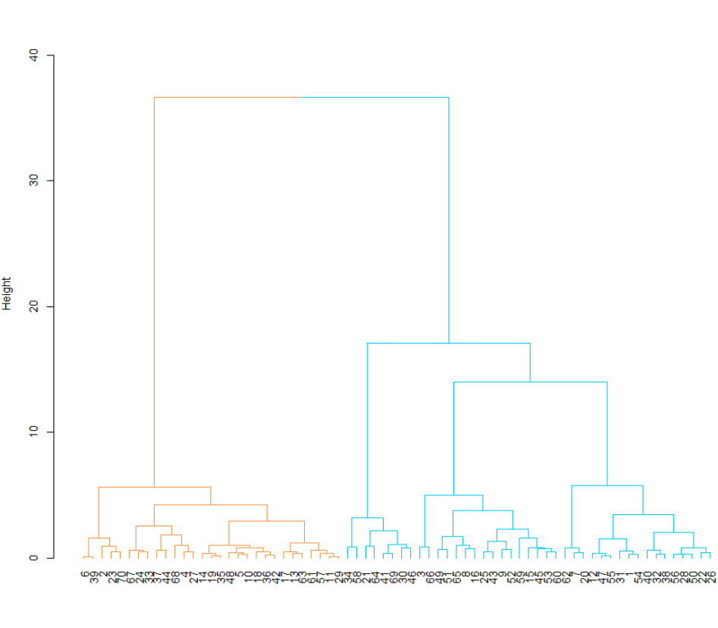
Participants
Cluster 1
Cluster 2
Figure C- 1. The Cluster Dendrogram for the Two-Cluster Solution.
Cluster 1 = blue, Cluster 2 = orange

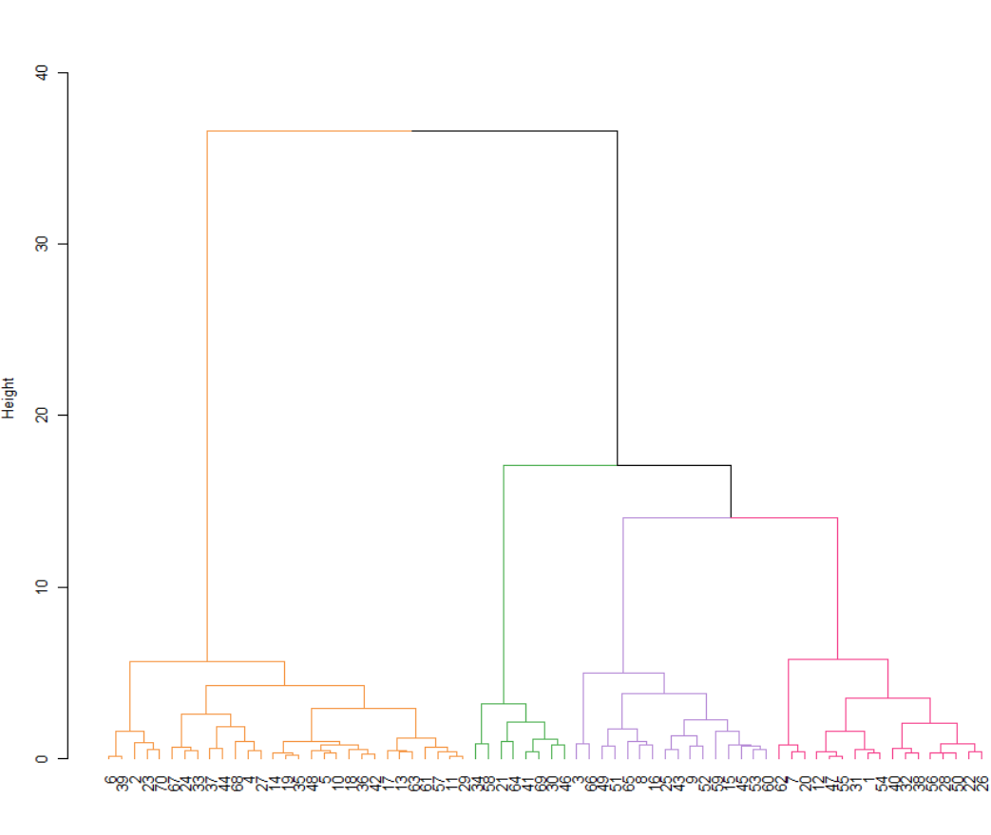
Participants
Cluster 2
Cluster 4
Cluster 3
Cluster 1
Figure C- 2. The Cluster Dendrogram for the Four-Cluster Solution.
Cluster 1 = pink, Cluster 2 = orange, Cluster 3 = purple, Cluster 4 = green

Appendix D
Eigenständigkeitserklärung

Ich bestätige, dass ich die vorliegende Arbeit selbstständig verfasst und keine anderen als die angegebenen Hilfsmittel verwendet habe. Die vorliegende Masterarbeit habe ich nicht bereits in derselben oder einer ähnlichen Fassung an einer anderen Fakultät oder in einem anderen Fachbereich zur Erlangung eines akademischen Grades eingereicht.
Mit der Einstellung dieser Arbeit in die Institutsbibliothek des Institutes für Psychologie bin ich einverstanden.

Kopenhagen, 31.03.2025
Ort, Datum Unterschrift

