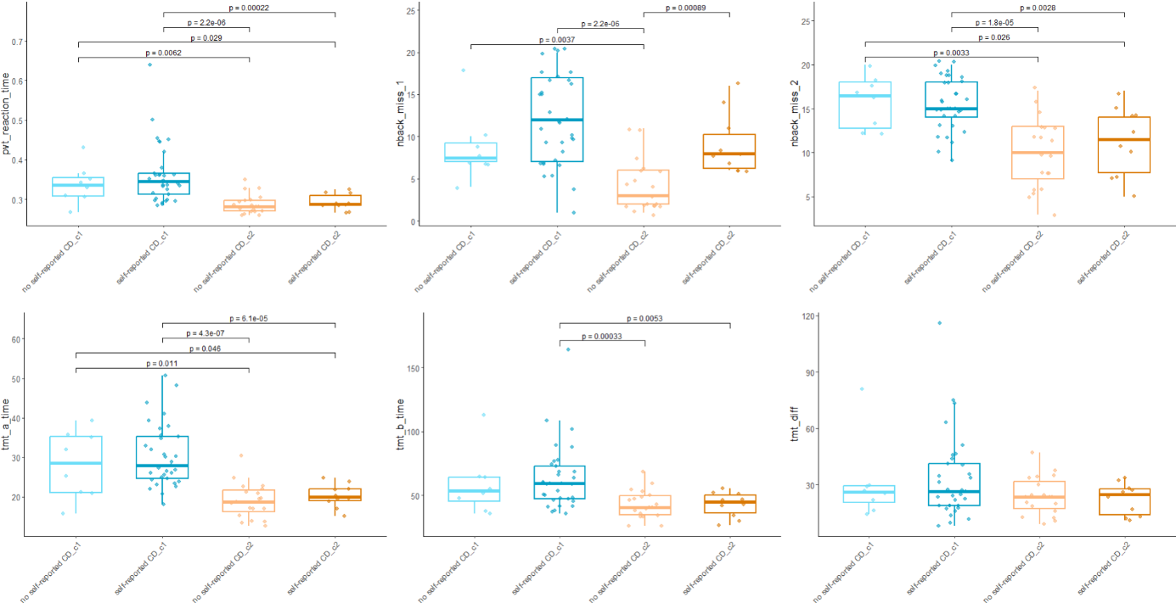

Results
Beta Power (central ROI)
In the two-cluster solution, mean beta power did not significantly differ between Cluster 1 (M = 1.64, SD = 1.43) and Cluster 2 (M = 1.86, SD = 1.75), as indicated by a two-sided Wilcoxon rank-sum test, z = -.112, p = ,9107, r = .0136.
When considering both cluster affiliation and self-reported CD, beta power was highest in individuals with self-reported CD in Cluster 2 (M = 2.44, SD = 2.41), followed by those with no self-reported CD in Cluster 1 (M = 2.1, SD = 2.18). Lower beta power was observed in individuals with self-reported CD in Cluster 1 (M = 1.53, SD = 1.22) and those with no self-reported CD in Cluster 2 (M = 1.56, SD = 1.39). Pairwise Wilcoxon rank-sum tests comparing central beta power across these four groups revealed no statistically significant differences after Bonferroni correction (all p_adj = 1.00, r = .03 - .19).

In the four-cluster solution

Delta Power (frontal ROI)
In the two-cluster solution, mean delta power did not significantly differ between Cluster 1 (M = 1.11, SD = 1.21) and Cluster 2 (M = 1.15, SD = .87), as indicated by a one-sided Wilcoxon rank-sum test, z = -.735, p = .2311, r = .089.
When accounting for both cluster affiliation and self-reported CD, delta power was highest in participants with no self-reported CD group in Cluster 1 (M = 1.94, SD = 1.38), followed by those with self-reported CD in Cluster 2 (M = 1.48, SD = 1.08), those with no self-reported CD in Cluster 2 (M = .94, SD = .75), and lowest in those with self-reported CD in Cluster 1 (M = .91, SD = .97). Pairwise Wilcoxon rank-sum tests revealed no significant differences in mean delta power between these four groups after Bonferroni correction (all p_adj > .05). However, an uncorrected difference was observed between participants with self-reported CD and no self-reported CD in Cluster 1 (p = .031, r =.34, moderate effect), but this did not survive correction.

In the four-cluster solution
Correlation with clinical data
Central beta power was significantly correlated with TMT-A performance (p(66) = .27 ,p = .025) (in a Spearman Rank correlation). A trend towards a positive correlation with TMT-B was also observed ( p(66) = .21, p = .09). Frontal delta power did not show significant correlations with any of the examined variables (Table X).
PVT reaction time correlated sgnificantly negatively with the FACIT-F score (p(66) = -.28, p = 0.02). A trend towards a positive correlation between PVT reaction time and PSQI score was also observed (p(66) = .26, p = .05).

Variable | δ | β | TMT A | TMT B | PVT | PSQI | FACIT | HADS A | HADS D | MoCA
δ | 1
β | .06 | 1
TMT A | -.06 | .27* | 1
TMT B | .03 | .21 | .72*** | 1
PVT | .06 | .04 | .47*** | .33** | 1
PSQI | .20 | -.11 | .14 | .08 | .26 | 1
FACIT | -.17 | .003 | -.09 | -.08 | -.28* | -.72*** | 1
HADS A | .20 | -.02 | .19 | .10 | .14 | .68*** | -.70*** | 1
HADS D | .15 | .01 | .21 | .19 | .15 | .59*** | -.77*** | .64*** | 1
MoCA  Note. *p < .05, **p < .01, ***p < .001. δ = delta power, β = beta power, | -.02 | -.18 | -38** | -.46*** | -.40*** | -.01 | .02 | -.05 | -.11 | 1

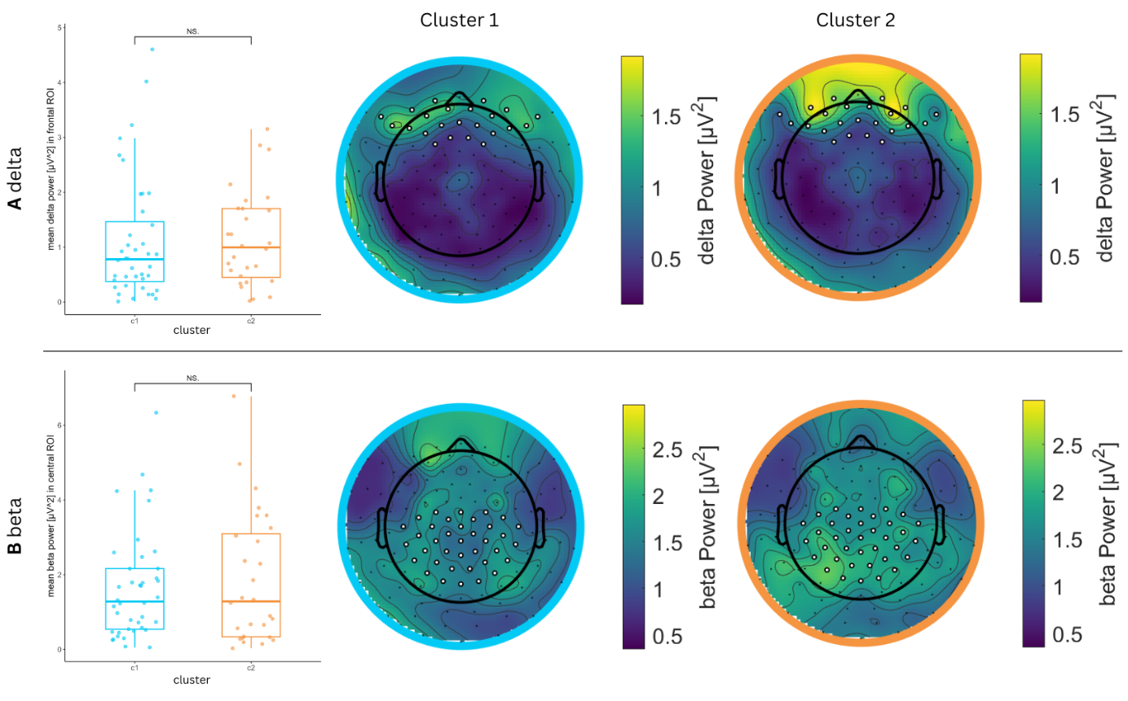
Figure X. Results of power …..

