Enterprise Document RAG Assistant
- Features and scope of work:
Organizations have large volumes of internal documents (policies, manuals, reports, SOPs). Searching manually is slow and inefficient.
This system enables natural language Q&A over private documents using Retrieval-Augmented Generation (RAG).

🧩 CORE FEATURES

1️⃣ Document Ingestion
- Upload PDFs, DOCX, TXT, CSV
- Extract and clean text
- Chunk text intelligently
- Store metadata (source, page number, doc name)

2️⃣ Embedding & Vector Storage
- Generate embeddings for chunks
- Store in vector database (FAISS/Chroma/pinecone)
- Enable similarity search

3️⃣ Retrieval-Augmented Generation (RAG)
- Retrieve top-k relevant chunks
- Inject into LLM prompt
- Generate grounded, contextual answers

4️⃣ Chat Interface (UI)
- Streamlit-based chat UI
- File upload support
- Chat history
- Display citations/sources

5️⃣ Logging & Monitoring
- Log:
  - User queries
  - Retrieved chunks
  - LLM responses
  - Latency
- Save logs to file / CSV

6️⃣ Evaluation & Optimization
- Response relevance scoring
- Retrieval confidence estimation
- Adjustable chunk size, overlap, top-k

7️⃣ Deployment & MLOps
- Dockerized application
- Environment variable management
- Easy local/cloud deployment

🛠️ TECH STACK
Layer | Technology
Language | Python
LLM Orchestration | LangChain
Embeddings | HuggingFace / OpenAI
Vector DB | FAISS or ChromaDB or pinecone
LLM | OpenAI GPT-4 / Mistral / Llama
UI | Streamlit
Logging | Python logging / CSV
Deployment | Docker
Version Control | Git
Optional | MLflow for experiments

- Architecture and data flow diagram:

DATA FLOW DIAGRAM (Step-by-step)
- User uploads documents
- Text extracted and cleaned
- Text chunked
- Embeddings generated
- Stored in vector DB
- User asks a question
- Query embedded
- Similarity search retrieves relevant chunks
- Chunks passed to LLM prompt
- LLM generates answer
- Answer + sources returned to UI
- Logs saved

SYSTEM ARCHITECTURE:

User → Streamlit UI → Query
↓
Retriever (Vector DB)
↓
Relevant Document Chunks
↓
Prompt Template + LLM
↓
Contextual Answer + Sources
↓
UI Display
RAG FLOW:

Your Documents
↓
Chunking + Embeddings
↓
Vector Database (memory)
↓
User Question
↓
Similarity Search (retrieval)
↓
Relevant Chunks
↓
LLM Prompt
↓
Final Answer (grounded, not guessed)
- Setup Steps:

Requirements:
OS: windows 11
Python 3.11.9

- Clone repository:
$ git clone JankiMandviya/Enterprise_document_RAG_assistant
- Check if python 3.11.9 is available:
$Py -0
If it lists 3.11, installation for 3.11 is not required.
- Create virtual environment:
$ py -3.11 -m venv RAG_venv
- To activate the virtual environment
$ source RAG_venv/Scripts/activate
- Check python version in venv
$ python --version
- Install langchain
$ pip install -U langchain

# Installing the OpenAI integration
$ pip install -U langchain-openai

# Installing the Anthropic integration
$ pip install -U langchain-anthropic

Verify installation:
$ python -c "import langchain; print(langchain.__version__)"

- Core building blocks:

Block | Role
Loader | Reads PDFs / files
Chunker | Breaks text into pieces
Embeddings | Convert text chunks → vectors
Vector DB | Stores vectors
Retriever | Finds relevant chunks according to user query
LLM | Generates answer
Prompt | Controls behaviour

Why RAG instead of Fine tuning?

RAG | Fine-tuning
Fast to build | Expensive
Data updates instantly | Requires retraining
No risk of model forgetting | Risky
Best for private docs | Best for behavior change

Why does an LLM need a retrieval step instead of just being asked the question directly?
Because LLMs hallucinate if they were to provide answers purely on its own knowledge and LLM doesn't know our document content for giving correct answers. therefore it is important to get chunks from vector DB first and provide it in LLM prompt for proper context and avoid hallucinations.

- Stage 1: Loader
Document Ingestion & Chunking:
🎯 Goal of this stage
Convert raw documents (PDF, DOCX, TXT) into clean, meaningful text chunks that:
- Preserve context
- Fit into LLM context windows
- Work well with embeddings
Bad ingestion = bad RAG, no matter how good the LLM is.

🧠 Why chunking is REQUIRED
LLMs and embeddings models:
- Have token limits
- Lose meaning in very long text
- Perform poorly on tiny fragments
So we chunk text to balance:
- Context (enough information)
- Precision (not too much noise)

So, chunk size affects the performance of RAG systems.
Imagine a company policy document:
❌ One giant chunk → irrelevant info mixed
❌ One sentence per chunk → no context
✅ Medium chunks with overlap → best retrieval

📏 Chunk Size & Overlap (Key Concept)
Typical values:
- Chunk size: 500–1000 tokens
- Overlap: 10–20%
Overlap ensures:
- Sentences split across chunks still make sense
- Important context isn’t lost

We will use LangChain loaders for this task, because they have unified interface for PDFs, Docx, CSV.
Built in text splitters

Option | When to use
LangChain | Fast prototyping, standard
LlamaIndex | More data-centric pipelines
Custom parsing | Full control, more effort

We choose LangChain.
This stage includes:
- Loads documents
- Extracts raw text
- Splits text into chunks
- Attaches metadata (source, page)

Chunk format:
{
"text": "Some meaningful paragraph...",
"metadata": {
"source": "policy.pdf",
"page": 3
}
}

Meta data is important for citations.
- Why is recursive chunking better than naïve fixed-length splitting for documents like books or PDFs?
- The RecursiveCharacterTextSplitter attempts to keep larger units (e.g., paragraphs) intact.
- If a unit exceeds the chunk size, it moves to the next level (e.g., sentences).
- This process continues down to the word level if necessary.
splitting strategy: creating split that maintain natural language flow, maintain semantic coherence within split, and adapts to varying levels of text granularity.

- Stage 2 = Embeddings + Vector Database
In this stage, we will convert cleaned chunks text in embeddings(multi-dimensional space numerical data).
Right now we have:
- Cleaned documents
- Meaningful chunks with metadata
But LLMs cannot search text directly.
We need:
- A way to convert text into numbers
- So we can find semantically similar chunks
- When a user asks a question
Example:
- “How to find balance in life”
- “Life purpose and balance”
Different words → close vectors
Vector DB lets you ask:
“Give me chunks whose meaning is closest to this question”

What are embeddings?
- A neural model converts text → fixed-length numeric vector
- Similar meanings → similar vectors
- Distance = cosine similarity / dot product / L2

Embedding model choice (for this project)
Use:
Sentence-transformers (MiniLM or BGE) OR OpenAI embeddings (if cloud)

Why NOT OpenAI first?
- Paid
- API dependency

Why SentenceTransformers?
- Local
- Fast
- Industry-accepted

What embedding happens in RAG?
- All document chunks (offline, once)
- User query (runtime)
Then compare vectors.
Choosing the embedding model
e5-base-v2 :
refer benchmarks:
Specs
- 0.1B parameters
- 768-dim embeddings
- Data type = float
- Strong top k retrieval accuracy
Pros
- Designed for RAG
- Better at “question → document” matching
- Handles longer, complex chunks better
- Industry-grade choice
- Open source. No API dependency
Cons
- Slower than small
- More memory usage

Why not all-MiniLM-L6-v2?
Even though it is faster, it struggles in long and complex passages,
excellent latency and QPS but lower Top-K accuracy for exact entity lookup
Why not OpenAI embeddings?
Handles mix and complex data well, but paid and API dependency.

Implementing Embedding model:
E5 models are not generic sentence encoders.
They were trained with explicit intent prefixes.
- For document chunks:
"passage: <chunk text>"
- For user queries (later):
"query: <user question>"

If you forget this:
- Retrieval quality drops
- RAG feels “random”
- You won’t know why it’s failing
This is not optional.

Embedding strategy: batching
Why batching matters
- Faster
- Lower overhead
- More realistic for production
- Avoids repeated model calls
Collect all chunk texts → add passage: prefix → embed in batches
Here, we chunk chunk.page_content not metadata. Metadata is stored alongside, not inside the vector.

Batching implementation:
The input data for sentence transformer should look like:
input_texts = [
'query: how much protein should a female eat',
'query: summit define',
"passage: As a general guideline, the CDC's average requirement of protein for women ages 19 to 70 is 46 grams per day. But, as you can see from this chart, you'll need to increase that if you're expecting or training for a marathon. Check out the chart below to see how much protein you should be eating each day.",
"passage: Definition of summit for English Language Learners. : 1 the highest point of a mountain : the top of a mountain. : 2 the highest level. : 3 a meeting or series of meetings between the leaders of two or more governments."
]

But we will keep all chunks passages in input_texts.
Important note:
Once we get embedding vector of shape (no_of_chunks, 768), we will not modify original chunks. We will keep them as it is and maintain this embedding vector separately for cosine similarity score calculation.
text_chunks -> original chunks with human readable content and metadata.
embeddings -> array of embeddings generated by sentence transformer with shape (no_of_chunks, 768).
After finding embeddings, try this test code:

query = "query: how to find purpose in life?"
q_emb = embedding_model.encode(query, normalize_embeddings=True)
scores = embeddings @ q_emb.T
print(scores)
top_k = scores.squeeze().argsort()[::-1][:5]
print(top_k)

for k in top_k:
print(text_chunks[k])

- Stage 7: FAISS integration
In FAISS indexes, we will use ‘IndexFlatIP’ # IP = Inner Product
Because we already have normalized embeddings, simply finding dot product with embeddings in FAISS, will return cosine similarity. We are using Flat indexing because it is accurate and reasonably fast for data size<=1 Million. Since we have small dataset Flat index will product fast results.
FAISS accepts float32 embeddings. Check the datatype using embeddings.dtype before adding them to database.
After adding all embeddings to database,
When a query comes in:
- Prefix query correctly
(important for E5)
- Embed query
  - same model
  - same normalization
  - same dtype
- Search FAISS index
  - top-k results
  - returns indices + similarity scores
- Retrieve chunks from indices
  - page content
  - metadata (page number, source)

- Stage 4 — Answer Generation (LLM layer)
This stage answers actual user questions, not just fetch matching relevant chunks from database.
This is where hallucination control lives.
- Context construction:
This stage decides what the LLM sees.
LLMs only reason over what we give them.

Chunk filtering strategy:

Step 1: Retrieve top-k (e.g., 5–8)
Why?
- Increases recall
- Avoids missing relevant info

Step 2: Apply similarity threshold
Only keep chunks where:
similarity ≥ threshold
Typical mental ranges (don’t hardcode yet):
- High confidence: > 0.80
- Medium: 0.70–0.80
- Low: < 0.65 → drop
If zero chunks survive:
→ returns “Answer not found” (NO LLM call)
This saves:
- money
- latency
- hallucinations

Storing only 3-4 number of chunks:
If we give lots of chunks to LLM in context, LLM gets confused and hallucinates. Give only 3-4 meaningful important chunks.

Truncating very long chunks and keeping maximum context length for LLMs:
Sometimes, we end up adding huge chunks which contain noise and some redundant information. If we provide these long chunks, LLM answer focuses on these chunks most which contains redundant information. Therefore, limit the length of chunks.

Importance of Ordering
Chunks should be ordered by:
highest similarity → lowest (first filter)
page number low to high (secondary filter, if similarity matches)
Why?
- LLMs pay more attention to earlier context
- To give context in perfect order.
- First chunk heavily anchors/dominates the answer
Never randomize.

Note: after this stage, LLM will get data in following format(removing any unnecessary metadata).

Eg.
For debug mode (LLM doesn’t see it, only developer does)
[source: {chunk['source']} | title: {chunk['title']} | page: {chunk['page']} | similarity_score: {chunk['similarity_score']}]
{content}
For LLM prompt template(debug==false)
[source: {chunk['source']} | title: {chunk['title']} | page: {chunk['page']}]
{content}

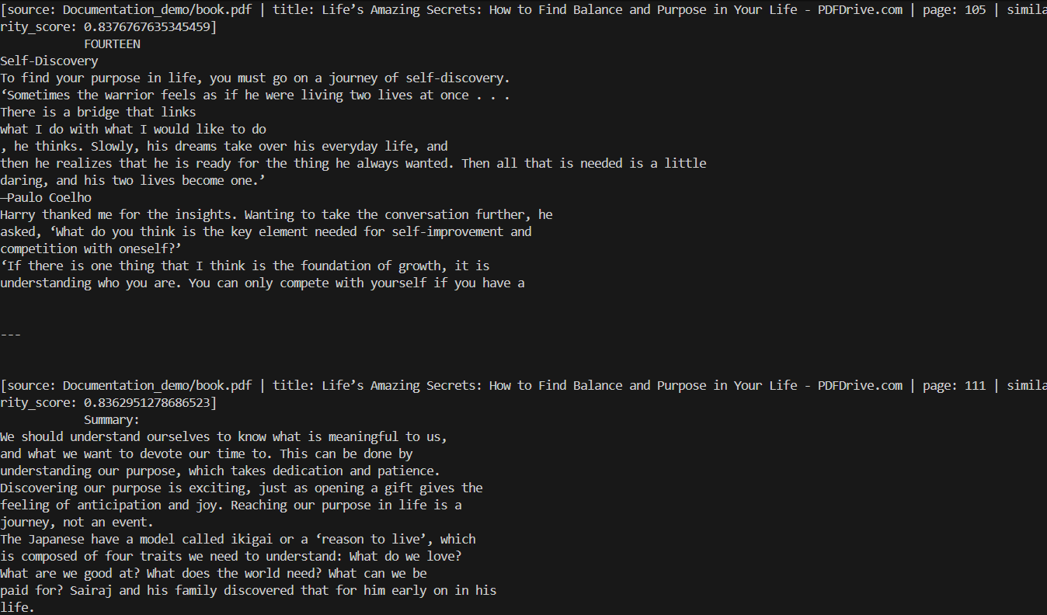

- LLM integration:
We will have two prompt templates which uses the built context in last stage and query entered by the user.
Strict prompt:
Use STRICT mode when ANY of these are true:
1️⃣ High-risk domains
- Medical
- Legal
- Financial
- Policy / compliance
- Academic citation use
2️⃣ Answer must be exact
- “What does the document say about…”
- “According to the policy…”
- “Does the document mention…”
3️⃣ Auditability required
- Logs
- Human review
- Legal defensibility
4️⃣ Binary questions
- Yes / No
- Is / Is not
- Allowed / Not allowed

Relaxed prompt:
1️⃣ Exploratory or understanding queries
- “Explain…”
- “Summarize…”
- “What are the main ideas…”
- “How does X relate to Y…”
2️⃣ Low-risk domain
- Books
- Manuals
- Internal docs
- Learning material
3️⃣ User intent = comprehension, not proof
4️⃣ Multi-chunk synthesis is expected

Practical switching logic (no code, just logic)
You can decide mode based on:
A. Query classifier (simple)
- If query contains:
  - “according to”
  - “does it say”
  - “exactly”
  - “cite”
→ STRICT
- If query contains:
  - “explain”
  - “summarize”
  - “overview”
  - “compare”
→ RELAXED

B. Retrieval signal
- Only 1 chunk, very high similarity → STRICT
- Multiple medium-high similarity chunks → RELAXED

C. Confidence drop detection
If after strict mode:
- Answer = “I don’t know”
- But similarity scores are decent
→ Auto retry in RELAXED mode

User Query
↓
Intent / Risk Check
↓
STRICT RAG Attempt
↓
If refusal + decent similarity → RELAXED RAG
↓
Final Answer

References:
https://docs.langchain.com/oss/python/langchain/rag
https://research.aimultiple.com/open-source-embedding-models/
https://huggingface.co/intfloat/e5-base-v2
https://bge-model.com/tutorial/3_Indexing/3.1.3.html
https://arithmancylabs.medium.com/understanding-faiss-indexing-86ec98048bd9
https://docs.langchain.com/oss/python/integrations/vectorstores/faiss
https://faiss.ai/index.html

