Probabilisitc Programming Exercises 2 – Jan Boerman, Jasper van Rooijen

**Exercise 1**

x := 10;

y := 20;

while (x > 0 || y > 0) {

{ x := x-5 } [1/2] { { x := x*2 } [2/3] { { y := y-2 } [3/5] { y := y+1 } } }

}

**Exercise 2**

$$For target State 6, we consider$$

$$\sum_{?}{=\{s_{1}, s_{2}, s_{3}, s_{4}\}}$$

$$(I-A)= \left(\begin{matrix}\begin{matrix}1 & -1/2 \\ -1/3 & 1\end{matrix} & \begin{matrix}0 & -1/2 \\ -1/3 & 0\end{matrix} \\ \begin{matrix}0 & -3/4 \\ 0 & 0\end{matrix} & \begin{matrix}1 & -1/4 \\ -4/5 & 1\end{matrix}\end{matrix}\right)$$

$$x= \left[\begin{matrix}\begin{matrix}s_{1} \\ s_{2}\end{matrix} \\ \begin{matrix}s_{3} \\ s_{4}\end{matrix}\end{matrix}\right]$$

$$b= \left(\begin{matrix}\begin{matrix}0 \\ 1/3\end{matrix} \\ \begin{matrix}0 \\ 0\end{matrix}\end{matrix}\right)$$

Such that holds:

$$\left(I-A\right)*x=b$$

Gaussian elimination yields:

$$\left(\begin{matrix}\begin{matrix}s_{1} \\ s_{2}\end{matrix} \\ \begin{matrix}s_{3} \\ s_{4}\end{matrix}\end{matrix}\right)=\left(\begin{matrix}\begin{matrix}14/19 \\ 16/19\end{matrix} \\ \begin{matrix}15/19 \\ 12/19\end{matrix}\end{matrix}\right)$$

Thus the probability of reaching state 6 from state 1 is the probability as yielded by the elimination: 14/19, thus 73,7%.

**Exercise 3**

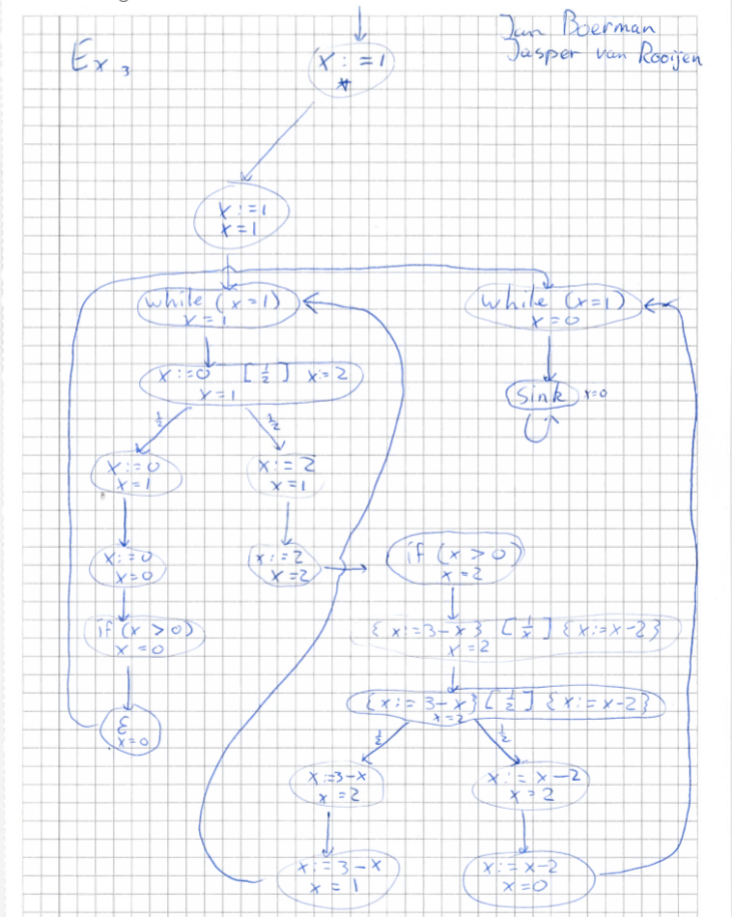

**Exercise 4a**

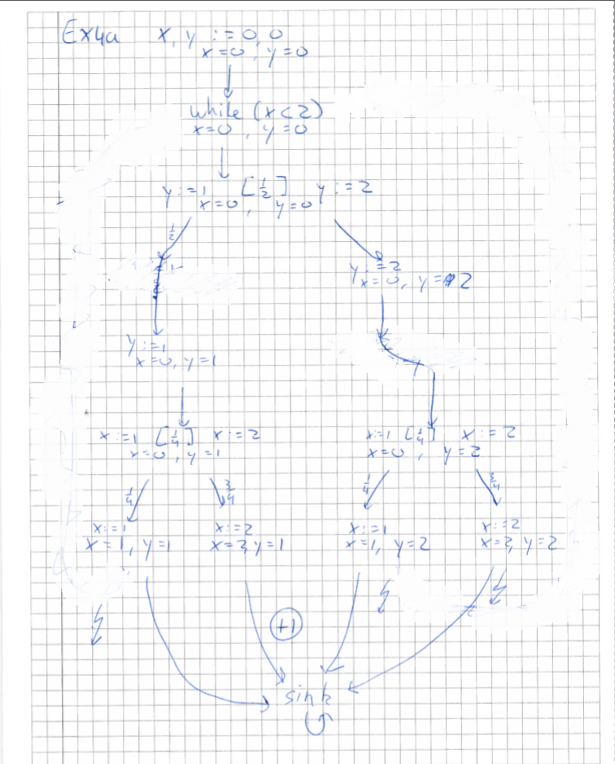

**Exercise 4b**

The expected value is defined as (probability of a valid path * value for that path) / (1 – probability of an invalid path)

Thus the expected value of x + y

= ((1/2)*(3/4)*(2+1)) / (1 – ((1/2)*(1/4) + (1/2)*(1/4) + (1/2)*(3/4)))

= ((3/8)*3) / (1 – (1/8 + 1/8 + 3/8)) = (3*(3/8)) / (1 – 5/8)

= (3 * (3/8)) / (3/8)

= 3