Evolutionary Computation

Assignment 7

Antoni Lasik 148287

Daniel Jankowski 148257

<https://github.com/JankowskiDaniel/evolutionary-computation/tree/AL/assignment7>

**Problem description**

The task involves analyzing three columns of integers, each row corresponding to a single node. The initial two columns designate the x and y coordinates, pinpointing the nodes' locations on a plane, while the third column specifies the cost associated with each node. The objective is to meticulously choose an exact half of the total nodes (in cases where the total node count is an odd number, the count of nodes to be selected is adjusted upward to the nearest whole number) to construct a Hamiltonian cycle, which is essentially a continuous loop that passes through each member of the selected set of nodes. The criterion for this selection is that the aggregate of the complete path's length and the cumulative cost of the chosen nodes should be as low as possible.

To quantify the distances between nodes, we employ the Euclidean distance formula, and the resulting figures are rounded off to the nearest integer in a standard mathematical fashion. Moreover, as part of the distance between nodes, we consider the cost of the destination node. This ensures that cost has a significant impact on the final results.

In this assignment, we implement the Hybrid Evolutionary Algorithm. The approach is based on the steady state algorithm, in each iteration a new offspring solution is created based on the randomly selected two parents, and added to the population only if some constraints are met. All the algorithm parameters are provided in the report below.

**Pseudocode of implemented algorithms**

**calculate_distance_matrix(coords, costs):**

dist_matrix = [][]

**FOR** i **IN** **RANGE**(len(coords)):

**FOR** j **IN** **RANGE**(len(coords)):

dist_matrix[i][j] = round(sqrt((coords[i].x – coords[j].x)**2 + (coords[i].y – coords[j].y)**2)

**RETURN** dist_matrix

**objective_function(solution, dist_matrix, costs):**

total_score = 0

n = len(solution)

**FOR** x in range(n):

total_score += dist_matrix[solution[x - 1]][solution[x]]

total_score += costs[solution[x]]

**RETURN total_score**

**generate_random_solution(n):**

**RETURN** random.sample(range(0, n * 2), n)

**generate_init_population(n, size):**

population = [generate_random_solution(n) **FOR** _ **IN** **RANGE**(size)]

**RETURN** population

**select_random_parents(population):**

parents = random.sample(population, 2)

return parents[0], parents[1]

We’ve decided to implement a custom recombination operator. The logic is that we select at random subpaths from both parents that are then inserted to the offspring solution.

**recombine_subpath_operator(parent1, parent2):**

offspring = []

n = len(parent1)

num_nodes = 20

**WHILE** len(offspring) < n:

random_start = random.randint(0, len(parent1) – num_nodes)

random_subpath = parent1[random_start : random_start + num_nodes]

# remove already selected nodes from both parents

parent1 = [el **FOR** el **IN** parent1 **IF** el **NOT IN** random_subpath]

parent2 = [el **FOR** el **IN** parent2 **IF** el **NOT IN** random_subpath]

parent1, parent2 = parent2, parent1

**RETURN** offspring

The population size has been set to 30. The offspring solution was added to the population only if its score was better than the score of the current worst solution and if the offspring’s score wasn’t already present in the population (to diverse solutions inside the population)

**run_algorithm(dist_matrix, costs, avg_runtime):**

population = generate_init_population(100, 30)

population = [(sol, objective_function(sol, dist_matrix, costs)) **FOR** sol **IN**

population]

all_scores = [x[1] **FOR** x **IN** population]

worst_solution = max(population, key=lambda x: x[1])

epochs = 0

start_time = time()

**WHILE** time.time() – start_time < avg_runtime:

epochs += 1

parent1, parent2 = **select_random_parents**(population)

offspring = **recombine_subpath_operator**(parent1[0], parent2[0])

solution, score = **SteepestLocalSearch**(offspring)

**IF** score < worst_solution[1] **AND** score **NOT** **IN** all_scores:

population.remove(worst_solution)

population.append((solution, score))

all_scores.remove(worst_solution[1])

all_scores.append(score)

worst_solution = max(population, key=lamda x: x[1])

end_time = time.time()

runtime = end_time – start_time

best_solution, best_score = min(population, key=lambda x: x[1])

**RETURN** best_solution, best_score, runtime, epochs

**Results**

|  |  |  |  |  |
| --- | --- | --- | --- | --- |
| **Method** | **Instance A** | **Instance B** | **Instance C** | **Instance D** |
| Greedy LS, random solution, two-edges + inter route | 77,014(74,663-79,803) | 69,990(67,877-74,141) | 50,998 (49,340-53,141) | 48,068 (45,336-51,629) |
| Greedy LS, random solution, two-nodes + inter route | 90,940(84,816-99,390) | 85,570(77,908-97,299) | 63,929 (58,135-70,886) | 62,175 (54,310-71,108) |
| Greedy LS, best solution from 2-regret with weighted sum, two-edges + inter route | 75,792 (74,221-79,688) | 71,266 (67,384-77,120) | 52350,15(48,931-55,758) | 51,013 (45,212-59,478) |
| Greedy LS, best solution from 2-regret with weighted sum, two-nodes + inter route | 75,932(74,344-79,315) | 71,839 (67,384-77,565) | 52,638 (49,649-56,472) | 51,248(45,097-60,185) |
| Steepest LS, best solution from 2-regret with weighted sum, two-edges + inter route | 75,728(74,091-79,220) | 71,233 (67,384-77,057) | 52,299 (49,098-5,5665) | 50,977(45,097-59,478) |
| Steepest LS, best solution from 2-regret with weighted sum, two-nodes + inter route | 75,880(74,280-79,220) | 71,894(67,384-77,420) | 52,607 (49,460-56,472) | 51,247 (45,097-60,185) |
| Candidates LS, random solution, two-edges + inter route | 81,129(76,609-86,447) | 73,977(69,300-80,189) | 51,588(49,120-54,801) | 48,429(45,385-51,392) |
| Steepest LS, random solution, two-nodes + inter route | 92,714(84,218-103,034) | 87,666(79,356-97,895) | 65,679(59,604-73,386) | 64,162(54,716-75,351) |
| Steepest LS, random solution, two-edges + inter route | 78,017 (74,874-82,619) | 71,337(67,909-76,199) | 51,485 (49,235-53,755) | 48,225 (45,673-51,639) |
| Deltas from previous iteration, random solution, two-edges + inter route | 78,192(75,149-82,556) | 71,709(68,307-76,210) | 51,940(49,347-55,591) | 48,509(45,966-52,016) |
| **Multi Start Local Search**  **random solution, two-edges + inter route** | 75,447(74,773-76,051) | 68,523(67,810-69,028) | 49,567(49,141-50,190) | 45,267(45,870-46,275) |
| **Iterated Local Search**  **random solution, two-edges + inter route** | 73,114(72,894-73,445) | 66,239(66,137-66,422) | **47,259(46,805-47,686)** | 44,131(43,690-44,784) |
| **Large Scale Search**  **without LS** | 78,788(76,120-81,680) | 72,062(70,211-75,098) | 51,986(50,094-53,606) | 48,619(46,564-50,932) |
| **Large Scale Search**  **with LS** | 76,682(74,766-79,213) | 70,725(68,804-73,873) | 51,275(49,389-53,318) | 48,453(46,008-50,428) |
| **Hybrid Evolutionary Algorithm** | **73,087(72,864- 73,462)** | **66,270(66,136- 66,548)** | 47,392(46,998- 47,929) | **43,307(43,062- 43,598)** |

**Runtimes**

|  |  |  |  |  |
| --- | --- | --- | --- | --- |
| **Method** | **Instance A** | **Instance B** | **Instance C** | **Instance D** |
| Greedy LS, random solution, two-edges + inter route | 1.56(1.06-2.63) | 1.95(1.19-3.48) | 1.25(0.77-2.28) | 1.18(0.72-1.99) |
| Greedy LS, random solution, two-nodes + inter route | 1.68(1.03-2.98) | 1.95(0.81-6.66) | 1.38(0.79-2.21) | 1.37(0.77-2.36) |
| Greedy LS, best solution from 2-regret with weighted sum, two-edges + inter route | 0.67(0.51-0.97) | 0.7(0.5-1.18) | 0.66(0.5-0.93) | 0.65(0.51-0.89) |
| Greedy LS, best solution from 2-regret with weighted sum, two-nodes + inter route | 0.63(0.46-0.89) | 0.69(0.53-1.15) | 0.68(0.49-1.24) | 0.67(0.54-1.18) |
| Steepest LS, best solution from 2-regret with weighted sum, two-edges + inter route | 0.85(0.55-1.53) | 0.95(0.53-1.78) | 0.94(0.57-1.6) | 1(0.58-1.38) |
| Steepest LS, best solution from 2-regret with weighted sum, two-nodes + inter route | 0.88(0.58-1.71) | 0.83(0.53-1.57) | 0.89(0.5-1.58) | 1.03(0.67-1.5) |
| Candidate LS, random solution, two-edges + inter route | 4.43(3.95-6.41) | 4.52(3.99-5.70) | 4.53(3.83-6.44) | 4.58(4.06-5.88) |
| Steepest LS, random solution, two-nodes + inter route | 6.82(5.46-8.96) | 6.63(4.89-10.51) | 6.8(5.41-9.2) | 0.69(0.5-1.18) |
| Steepest LS, random solution, two-edges + inter route | 5.46(4.47-7.46) | 5.64(4.51-7.16) | 5.41(4.72-6.54) | 5.64(4.76-6.88) |
| Deltas from previous iteration, random solution, two-edges + inter route | 1.34(1.06-2.13) | 1.80(0.80-2.31) | 1.82 (1.05-2.51) | 1.88(1.23-2.44) |
| **Multi Start Local Search**  **random solution, two-edges + inter route\*\*** | 379.31(338.99-403.86) | 308.32(294.82-326.69) | 301.18(290.45-320.35) | 334.86(320.82-346.04) |
| **Iterated Local Search**  **random solution, two-edges + inter route\*\*** | 379.40(379.32-379.60) | 308.42(308.32-308.70) | 301.29(301.20-301.44) | 334.98(334.86-335.23) |
| **Large Scale Search**  **without LS** | 379.36(379.31-379.46) | 308.38(308.33-308.45) | 301.23(301.18-301.30) | 334.91(334.88-334.96) |
| **Large Scale Search**  **with LS** | 379.50(379.32-379.77) | 308.48(308.34-308.83) | 301.35(301.19-301.78) | 335.03(334.88-335.28) |
| **Hybrid Evolutionary Algorithm** | 379.43(379.32- 379.58) | 308.42(308.32- 308.55) | 301.35(301.35- 301.90) | 334.96(334.86- 335.13) |

**Runtimes are different from the previous report because all experiments have been parallelized and rerun on another machine.

**Iterations**

|  |  |  |  |  |
| --- | --- | --- | --- | --- |
| **Iterated Local Search**  **random solution, two-edges + inter route** | 1923(1878-1986) | 1534(1478-1579) | 1517(1448-1556) | 1668(1520-1798) |
| **Large Scale Search**  **without LS** | 3499(2726-5522) | 2794(2248-4449) | 2849(2365-4436) | 3393(2712-5659) |
| **Large Scale Search**  **with LS** | 1184(771-1987) | 1171(519-2411) | 1039(504-1803) | 1142(509-2294) |
| **Hybrid Evolutionary Algorithm** | 1388(1179-1553) | 1211(918-1485) | 1050(510-1346) | 1344(1122-1591) |

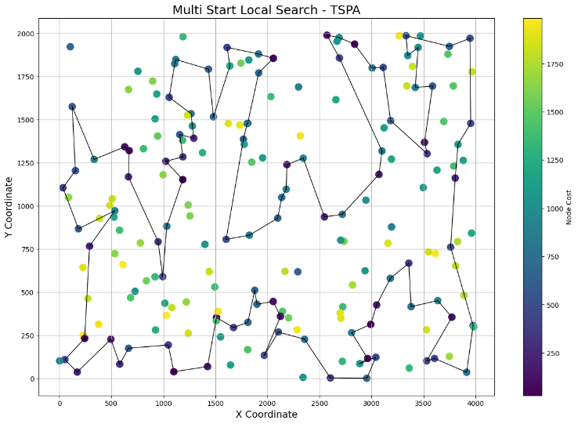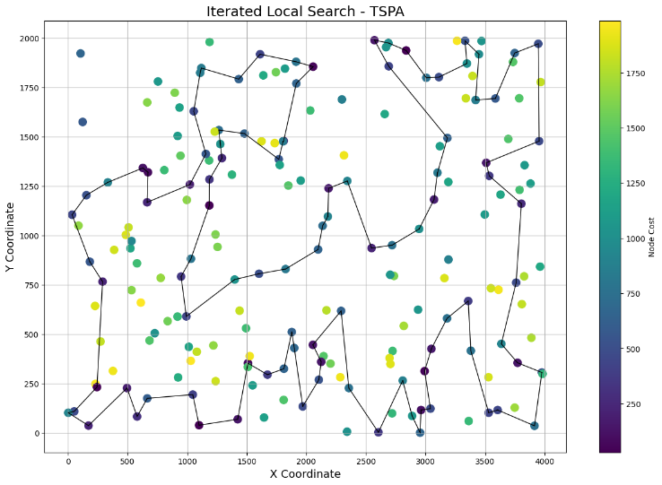

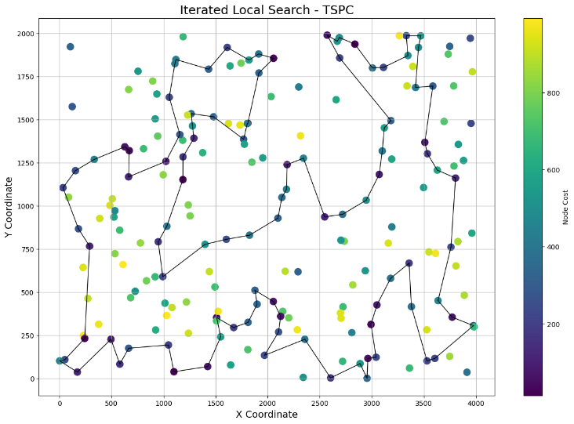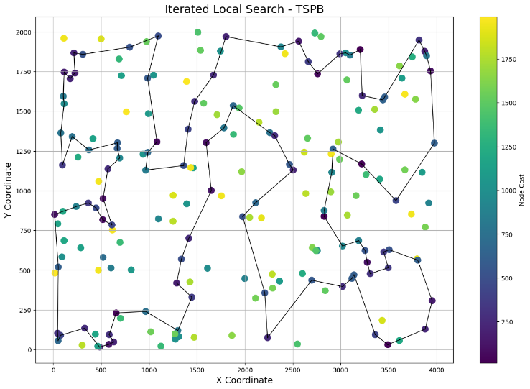 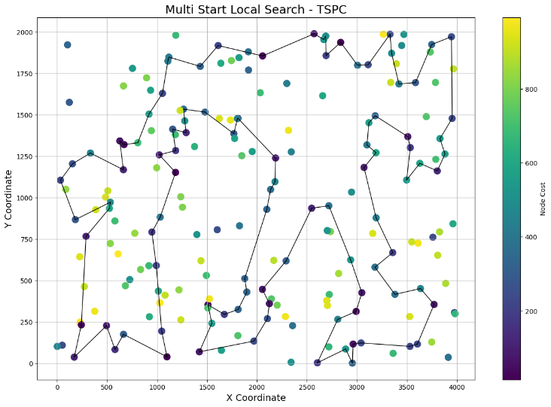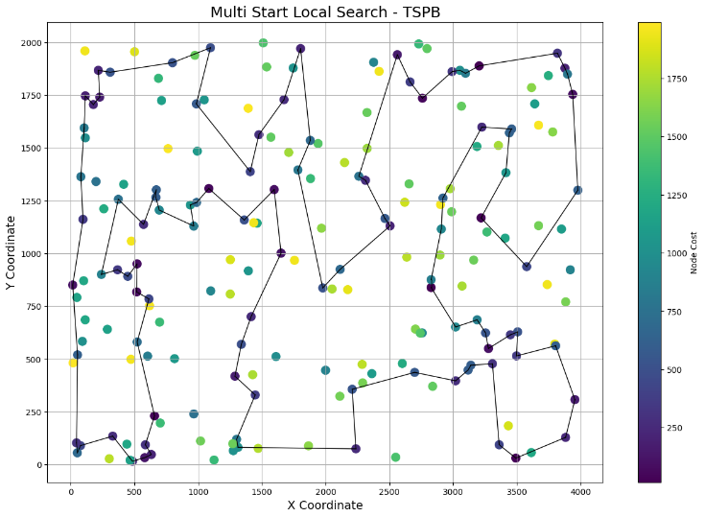

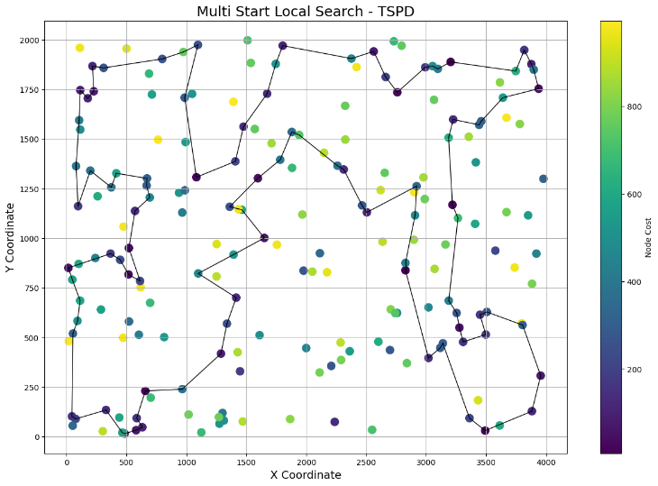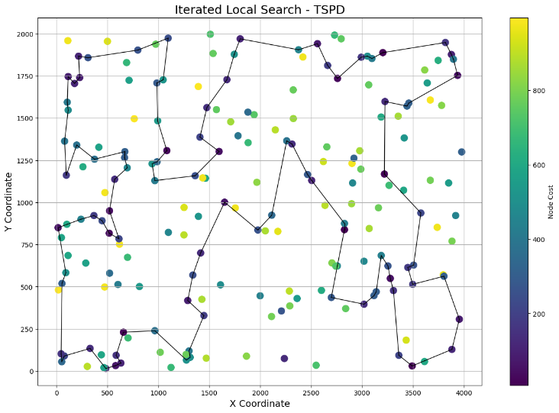

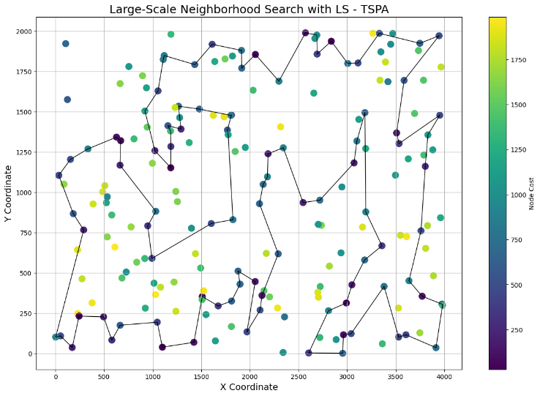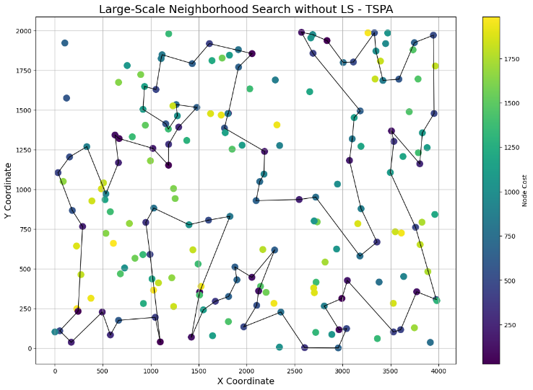

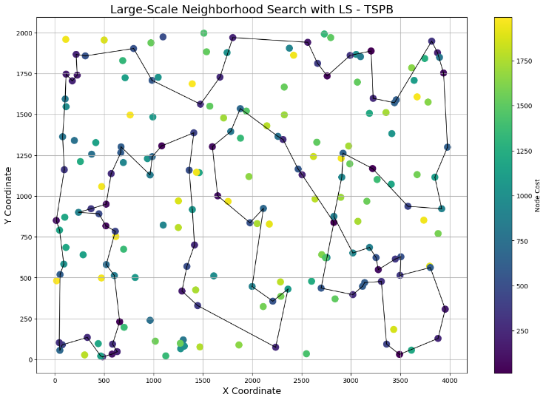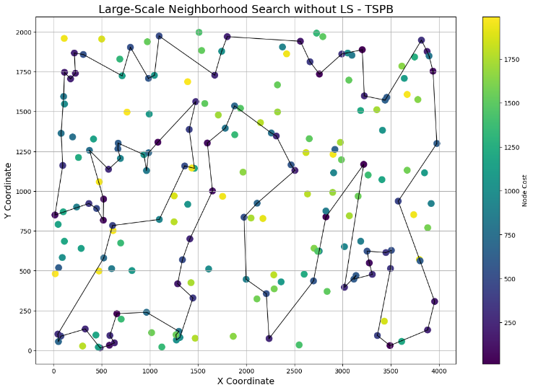

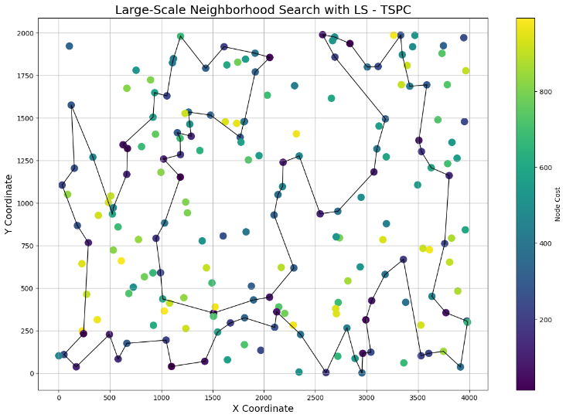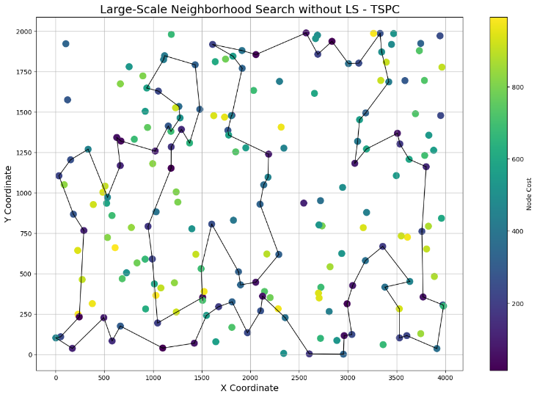

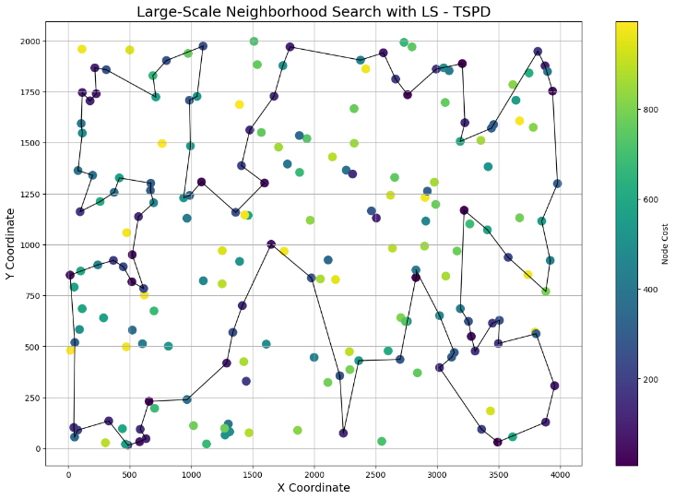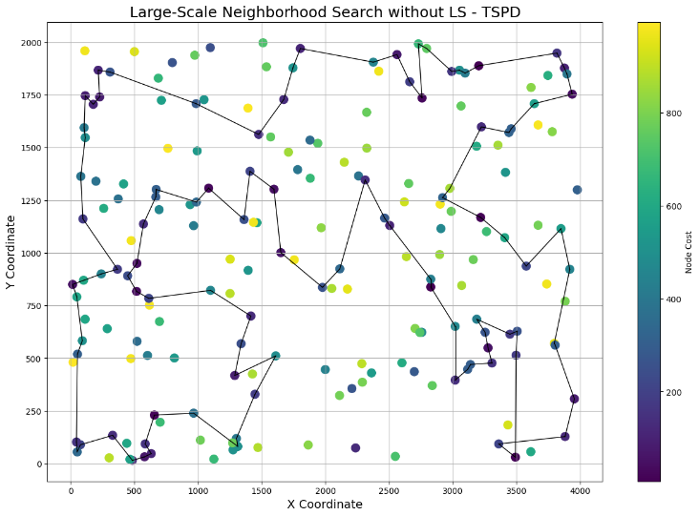

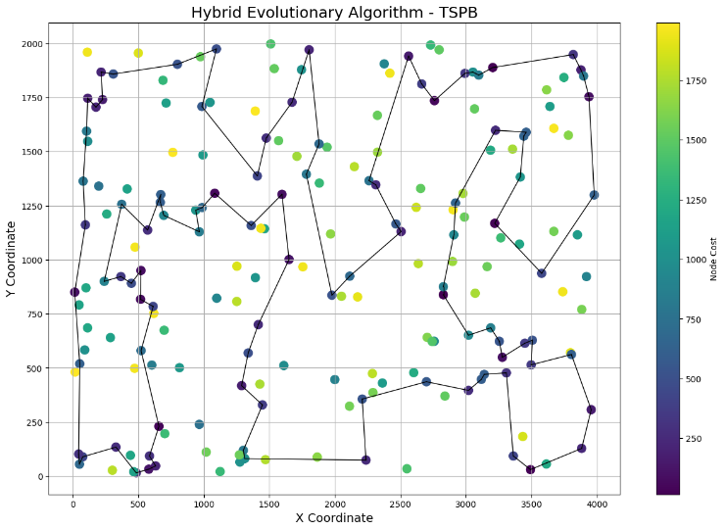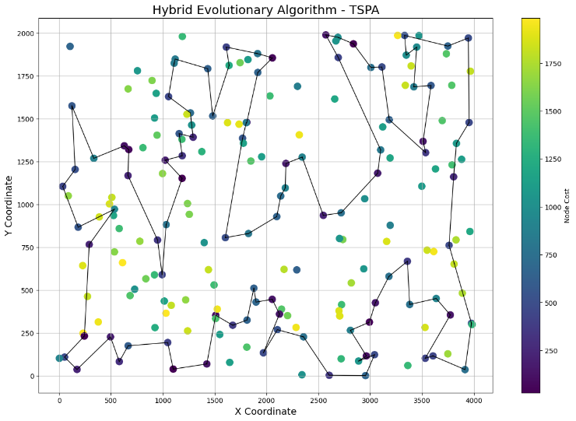

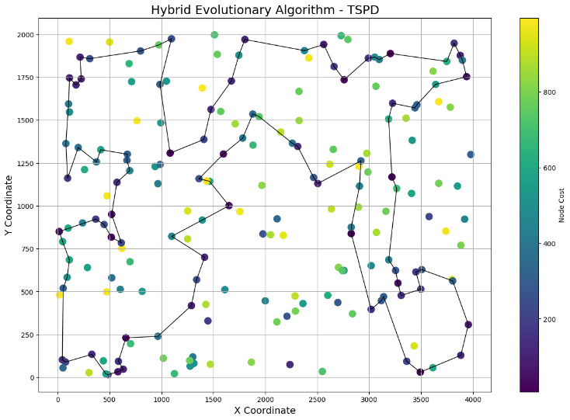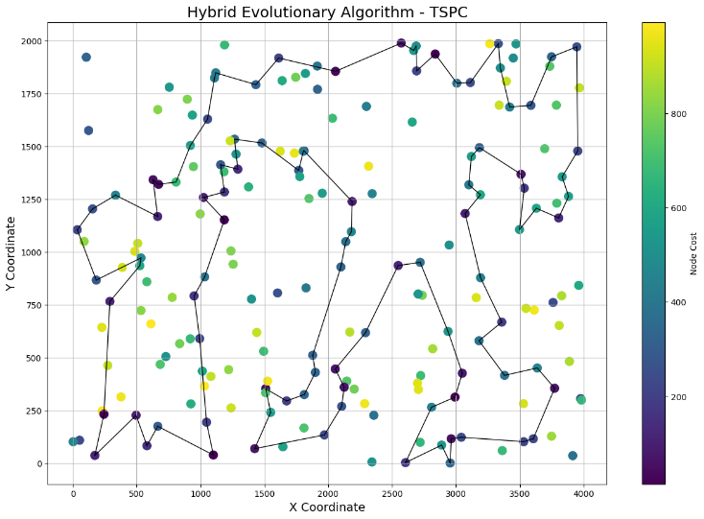

**MSLS:**

**A:**

[178, 19, 0, 149, 50, 91, 121, 114, 4, 43, 77, 192, 199, 41, 1, 137, 177, 174, 75, 189, 109, 119, 130, 92, 48, 152, 11, 160, 106, 26, 8, 124, 80, 14, 111, 94, 12, 89, 73, 31, 95, 169, 112, 72, 190, 98, 156, 6, 66, 51, 135, 101, 167, 45, 186, 127, 88, 153, 161, 76, 21, 194, 79, 87, 141, 144, 154, 133, 171, 81, 180, 32, 62, 108, 15, 117, 53, 22, 195, 55, 36, 128, 132, 113, 74, 163, 61, 183, 71, 20, 64, 181, 185, 96, 27, 147, 59, 143, 159, 164]

**B:**

[139, 193, 119, 59, 71, 166, 158, 162, 150, 44, 117, 196, 192, 142, 130, 141, 148, 140, 174, 51, 70, 91, 156, 67, 114, 72, 58, 89, 129, 64, 159, 147, 181, 170, 189, 132, 185, 73, 136, 33, 29, 172, 95, 135, 198, 190, 19, 145, 157, 80, 153, 4, 55, 88, 36, 25, 134, 154, 112, 50, 99, 102, 37, 165, 137, 57, 0, 169, 66, 26, 92, 122, 143, 127, 24, 121, 131, 103, 38, 101, 31, 179, 197, 183, 34, 5, 182, 2, 113, 69, 115, 82, 63, 8, 16, 18, 52, 12, 107, 97]

**C:**

[79, 194, 21, 171, 108, 15, 117, 53, 22, 195, 55, 36, 132, 128, 164, 178, 159, 143, 59, 147, 96, 185, 25, 181, 64, 20, 71, 61, 113, 163, 74, 138, 155, 62, 32, 180, 81, 154, 141, 6, 172, 156, 66, 98, 190, 72, 94, 12, 73, 31, 111, 14, 80, 124, 123, 8, 110, 139, 169, 95, 112, 5, 51, 196, 135, 134, 119, 109, 130, 92, 48, 11, 152, 1, 177, 41, 137, 199, 174, 75, 189, 126, 101, 167, 175, 114, 4, 77, 43, 19, 69, 0, 149, 50, 121, 91, 153, 88, 127, 186]

**D:**

[79, 136, 61, 73, 185, 132, 12, 189, 170, 100, 181, 147, 159, 64, 129, 89, 58, 72, 114, 85, 166, 28, 59, 119, 193, 71, 44, 196, 117, 150, 162, 67, 45, 78, 3, 156, 91, 51, 174, 188, 140, 148, 141, 130, 142, 53, 82, 63, 8, 84, 14, 16, 65, 52, 18, 29, 33, 6, 19, 190, 198, 135, 57, 0, 169, 66, 34, 183, 197, 31, 101, 38, 103, 131, 24, 127, 121, 179, 143, 122, 92, 116, 99, 146, 137, 37, 165, 123, 154, 134, 25, 36, 194, 88, 55, 4, 153, 80, 157, 145]

**ILS:**

**A:**

[32, 180, 81, 154, 144, 141, 87, 79, 194, 21, 171, 108, 15, 117, 22, 55, 36, 132, 128, 145, 76, 161, 153, 88, 127, 186, 45, 167, 101, 99, 135, 51, 112, 66, 6, 156, 98, 190, 72, 12, 94, 89, 73, 31, 111, 14, 80, 95, 169, 8, 26, 92, 48, 106, 160, 11, 152, 130, 119, 109, 189, 75, 1, 177, 41, 137, 174, 199, 192, 175, 114, 4, 77, 43, 121, 91, 50, 149, 0, 19, 178, 164, 159, 143, 59, 147, 116, 27, 96, 185, 64, 20, 71, 61, 163, 74, 113, 195, 53, 62]

**B:**

[70, 51, 174, 140, 148, 141, 130, 142, 53, 69, 115, 82, 63, 8, 16, 18, 29, 33, 19, 190, 198, 135, 95, 172, 182, 2, 5, 34, 183, 197, 31, 101, 38, 103, 131, 24, 127, 121, 179, 143, 122, 92, 26, 66, 169, 0, 57, 99, 50, 112, 154, 134, 25, 36, 165, 37, 137, 88, 55, 4, 153, 80, 157, 145, 79, 136, 73, 185, 132, 52, 139, 107, 12, 189, 170, 181, 147, 159, 64, 129, 89, 58, 171, 72, 114, 85, 166, 59, 119, 193, 71, 44, 196, 117, 150, 162, 158, 67, 156, 91]

**C:**

[112, 5, 51, 135, 99, 101, 167, 45, 186, 127, 88, 153, 161, 76, 145, 128, 132, 36, 55, 22, 117, 15, 108, 171, 21, 194, 79, 87, 141, 144, 102, 154, 81, 180, 32, 62, 53, 195, 113, 74, 163, 61, 71, 20, 64, 185, 96, 27, 116, 147, 59, 143, 159, 164, 178, 19, 69, 0, 149, 50, 121, 91, 114, 4, 77, 43, 192, 199, 137, 41, 177, 1, 75, 189, 109, 119, 130, 152, 11, 106, 48, 92, 26, 8, 110, 169, 95, 31, 73, 89, 42, 94, 12, 72, 190, 98, 156, 172, 6, 66]

**D:**

[91, 70, 51, 174, 140, 148, 141, 130, 142, 53, 32, 113, 69, 115, 82, 63, 8, 16, 172, 95, 19, 190, 198, 135, 169, 66, 128, 5, 34, 183, 197, 92, 122, 143, 179, 31, 101, 38, 103, 131, 121, 127, 24, 50, 99, 137, 37, 165, 154, 134, 25, 36, 88, 55, 4, 153, 80, 157, 145, 79, 136, 61, 73, 185, 132, 18, 52, 139, 97, 107, 12, 109, 189, 47, 170, 181, 147, 159, 64, 129, 89, 58, 171, 72, 114, 85, 166, 59, 119, 193, 71, 44, 196, 117, 150, 162, 158, 67, 3, 156]

**LSNS without LS:**

**A:**

[50, 121, 91, 114, 175, 4, 77, 43, 192, 199, 41, 1, 177, 174, 75, 189, 152, 11, 48, 106, 26, 139, 169, 95, 8, 124, 80, 14, 111, 31, 73, 12, 94, 72, 190, 98, 156, 6, 66, 112, 5, 51, 135, 134, 119, 109, 101, 167, 153, 88, 127, 186, 21, 194, 79, 87, 141, 154, 81, 180, 32, 62, 93, 155, 53, 18, 15, 108, 171, 117, 22, 55, 195, 74, 163, 113, 181, 61, 71, 20, 64, 185, 96, 27, 147, 59, 143, 159, 164, 178, 128, 132, 36, 145, 76, 161, 0, 19, 69, 149]

**B:**

[69, 53, 142, 130, 141, 148, 140, 174, 51, 70, 91, 192, 196, 84, 52, 65, 132, 185, 12, 107, 139, 97, 59, 119, 193, 71, 166, 44, 117, 150, 162, 67, 114, 72, 58, 89, 129, 64, 159, 147, 87, 181, 189, 47, 170, 73, 61, 136, 145, 157, 80, 153, 88, 137, 37, 165, 36, 25, 134, 154, 112, 50, 131, 103, 38, 101, 31, 121, 24, 127, 122, 143, 179, 183, 197, 34, 99, 66, 128, 5, 2, 182, 163, 172, 95, 135, 198, 190, 19, 33, 29, 18, 16, 8, 63, 82, 115, 113, 32, 184]

**C:**

[92, 119, 109, 189, 75, 1, 177, 41, 199, 192, 4, 77, 43, 50, 149, 69, 19, 178, 159, 143, 59, 147, 116, 27, 96, 185, 64, 20, 71, 61, 181, 113, 163, 74, 195, 53, 18, 15, 108, 62, 93, 32, 180, 81, 171, 28, 117, 22, 55, 132, 128, 40, 164, 0, 115, 49, 76, 91, 121, 114, 175, 153, 88, 127, 186, 157, 21, 194, 79, 87, 102, 154, 144, 141, 6, 66, 98, 190, 72, 94, 12, 73, 112, 5, 51, 135, 196, 95, 169, 110, 8, 26, 48, 106, 198, 160, 11, 152, 16, 130]

**D:**

[180, 80, 157, 145, 79, 136, 61, 73, 185, 189, 147, 159, 64, 129, 89, 58, 171, 72, 114, 162, 158, 67, 45, 3, 156, 91, 70, 51, 174, 140, 148, 141, 130, 142, 53, 113, 69, 115, 40, 82, 63, 8, 84, 196, 117, 150, 44, 71, 119, 59, 107, 12, 52, 132, 18, 16, 172, 95, 190, 198, 135, 169, 66, 26, 34, 183, 197, 179, 143, 122, 92, 127, 24, 121, 101, 31, 38, 103, 131, 93, 152, 94, 50, 43, 99, 57, 62, 137, 37, 165, 123, 154, 134, 25, 36, 88, 55, 4, 153, 160]

**LSNS with LS:**

**A:**

[119, 109, 189, 75, 174, 199, 41, 177, 1, 130, 152, 11, 160, 198, 106, 48, 92, 26, 8, 124, 80, 169, 95, 31, 14, 111, 94, 72, 190, 98, 66, 156, 6, 24, 141, 87, 144, 154, 81, 180, 32, 62, 155, 195, 55, 22, 18, 53, 117, 15, 108, 171, 194, 79, 21, 157, 161, 76, 128, 132, 36, 113, 74, 163, 61, 71, 20, 64, 185, 116, 27, 147, 96, 59, 143, 159, 164, 178, 19, 0, 149, 50, 121, 91, 114, 43, 77, 4, 175, 153, 88, 127, 186, 45, 167, 101, 135, 51, 112, 134]

**B:**

[169, 0, 57, 99, 50, 152, 94, 112, 154, 25, 36, 165, 37, 137, 88, 153, 80, 157, 145, 136, 73, 185, 189, 181, 147, 159, 64, 129, 89, 58, 72, 114, 67, 45, 3, 156, 91, 70, 51, 174, 188, 140, 148, 141, 130, 142, 21, 192, 196, 117, 150, 158, 162, 44, 71, 119, 59, 139, 107, 12, 132, 52, 14, 8, 63, 82, 115, 2, 133, 182, 163, 95, 172, 16, 18, 29, 33, 19, 190, 198, 135, 66, 128, 5, 34, 183, 197, 179, 31, 101, 38, 103, 131, 121, 24, 127, 143, 122, 92, 26]

**C:**

[96, 27, 147, 59, 143, 159, 164, 178, 19, 69, 149, 50, 77, 4, 192, 199, 174, 137, 41, 177, 1, 75, 189, 109, 119, 152, 11, 162, 160, 198, 106, 48, 92, 26, 8, 110, 169, 95, 31, 73, 12, 94, 72, 190, 98, 156, 6, 66, 112, 51, 135, 101, 167, 45, 186, 127, 88, 153, 175, 114, 121, 0, 40, 128, 132, 36, 55, 195, 22, 18, 53, 117, 15, 108, 171, 21, 194, 79, 87, 141, 144, 154, 81, 131, 180, 32, 62, 93, 155, 163, 74, 113, 181, 25, 61, 183, 71, 20, 64, 185]

**D:**

[187, 181, 170, 47, 189, 109, 97, 107, 12, 52, 18, 132, 185, 73, 61, 136, 79, 145, 157, 80, 153, 88, 137, 146, 37, 165, 36, 25, 154, 112, 94, 152, 125, 50, 43, 99, 92, 122, 143, 179, 127, 24, 121, 131, 103, 38, 101, 31, 34, 183, 197, 26, 169, 66, 128, 5, 133, 2, 182, 172, 16, 8, 63, 82, 53, 142, 130, 141, 148, 140, 174, 51, 70, 91, 156, 67, 158, 162, 150, 117, 196, 44, 71, 193, 119, 59, 28, 166, 110, 114, 85, 72, 171, 58, 89, 129, 64, 159, 147, 87]

**HEA:**

**A:**

[180, 81, 154, 144, 141, 87, 79, 194, 21, 171, 108, 15, 117, 22, 55, 36, 132, 128, 145, 76, 161, 153, 88, 127, 186, 45, 167, 101, 99, 135, 51, 112, 66, 6, 172, 156, 98, 190, 72, 94, 12, 73, 31, 111, 14, 80, 95, 169, 8, 26, 92, 48, 106, 160, 11, 152, 130, 119, 109, 189, 75, 1, 177, 41, 137, 174, 199, 192, 175, 114, 4, 77, 43, 121, 91, 50, 149, 0, 19, 178, 164, 159, 143, 59, 147, 116, 27, 96, 185, 64, 20, 71, 61, 163, 74, 113, 195, 53, 62, 32]

**B:**

[134, 25, 36, 165, 37, 137, 88, 55, 4, 153, 80, 157, 145, 79, 136, 73, 185, 132, 52, 12, 107, 189, 170, 181, 147, 159, 64, 129, 89, 58, 171, 72, 114, 85, 166, 59, 119, 193, 71, 44, 196, 117, 150, 162, 158, 67, 156, 91, 70, 51, 174, 140, 148, 141, 130, 142, 53, 69, 115, 82, 63, 8, 16, 18, 29, 33, 19, 190, 198, 135, 95, 172, 163, 182, 2, 5, 34, 183, 197, 31, 101, 38, 103, 131, 24, 127, 121, 179, 143, 122, 92, 26, 66, 169, 0, 57, 99, 50, 112, 154]

**C:**

[96, 27, 116, 147, 59, 143, 159, 164, 178, 19, 69, 0, 149, 50, 121, 91, 114, 4, 77, 43, 192, 199, 137, 41, 177, 1, 75, 189, 109, 119, 130, 152, 11, 160, 198, 106, 48, 92, 26, 8, 169, 95, 31, 73, 89, 42, 94, 12, 72, 190, 98, 156, 172, 6, 66, 112, 5, 51, 135, 99, 101, 167, 153, 88, 127, 186, 170, 157, 21, 194, 79, 87, 141, 144, 102, 154, 81, 180, 32, 62, 108, 171, 15, 117, 53, 22, 195, 55, 36, 132, 128, 181, 113, 74, 163, 61, 71, 20, 64, 185]

**D:**

[51, 70, 91, 156, 3, 67, 158, 162, 150, 117, 196, 44, 71, 193, 119, 59, 166, 85, 114, 72, 171, 58, 89, 129, 64, 159, 147, 181, 170, 47, 189, 109, 12, 107, 139, 52, 18, 132, 185, 73, 61, 136, 79, 145, 157, 80, 153, 4, 55, 88, 36, 25, 134, 154, 123, 165, 37, 137, 99, 50, 24, 127, 121, 131, 103, 38, 101, 31, 34, 183, 197, 179, 143, 122, 92, 26, 66, 169, 135, 198, 190, 19, 95, 172, 16, 8, 63, 82, 115, 69, 113, 32, 53, 142, 130, 141, 148, 140, 188, 174]

**Conclusions**

The results obtained from the Hybrid Evolutionary Algorithm (HEA) are so far the best for most of the problem instances. The differences in comparison with Iterated Local Search are very small, however, only for instance C the minimal objective function value was better for the ILS; for all other instances, the HEA was better, despite the fact, that the number of epochs was significantly lower than for ILS algorithm.

In the first iteration of experiments, the recombination operator proposed in the assignment description was implemented. However, due to algorithm complexity, which caused a decreased epoch number, it was decided to implement the simpler operator that creates the offspring solution. Thanks to the fast recombination operator, the algorithm was able to perform many more epochs in the same running time. It significantly improved the results obtained by the HEA algorithm.