Evolutionary Computation

Assignment 5

Antoni Lasik 148287

Daniel Jankowski 148257

**Problem description**

The task involves analyzing three columns of integers, each row corresponding to a single node. The initial two columns designate the x and y coordinates, pinpointing the nodes' locations on a plane, while the third column specifies the cost associated with each node. The objective is to meticulously choose an exact half of the total nodes (in cases where the total node count is an odd number, the count of nodes to be selected is adjusted upward to the nearest whole number) to construct a Hamiltonian cycle, which is essentially a continuous loop that passes through each member of the selected set of nodes. The criterion for this selection is that the aggregate of the complete path's length and the cumulative cost of the chosen nodes should be as low as possible.

To quantify the distances between nodes, we employ the Euclidean distance formula, and the resulting figures are rounded off to the nearest integer in a standard mathematical fashion. Moreover, as part of the distance between nodes, we take into account the cost of the destination node. This ensures that cost has a significant impact on the final results.

In this report we implement the steepest version of a local search with deltas from previous iteration. While the results should be almost the same, the purpose of the modification is to reduce the runtime of a classical algorithm version.

**Pseudocode of implemented algorithms**

**calculate_distance_matrix(coords, costs):**

dist_matrix = [][]

**FOR** i **IN** **RANGE**\(len(coords)):

**FOR** j **IN** **RANGE**(len(coords)):

dist_matrix[i][j] = round(sqrt((coords[i].x – coords[j].x)**2 + (coords[i].y – coords[j].y)**2)

**RETURN** dist_matrix

**objective_function(solution, dist_matrix, costs):**

total_score = 0

n = len(solution)

**FOR** x in range(n):

total_score += dist_matrix[solution[x - 1]][solution[x]]

total_score += costs[solution[x]]

**RETURN total_score**

The methods for checking the applicability of a given move. The methods returns the following values:

* -1 if a move is not applicable and should be removed from LM
* 0 if a move is not applicable now, but shouldn’t be removed from LM
* 1 if a move is applicable and will be accepted

**is_intra_move_applicable(solution, move):**

# for the intra moves changes affects only nodes that are inside a given solution, # therefore first we check if all nodes in edges, that a move introduced, are # present in the current solution

**FOR** edge **IN** move.added_edges:

**IF** edge.source_node **NOT IN** solution **OR**

edge.dest_node **NOT IN** solution:

**RETURN -1**

# check if all edges that a move removed are present in a solution

all_edges_match = True

**FOR** edge **IN** move.removed_edges:

reversed_edge = edge[-1] # reverse the edge

**IF** edge **NOT IN** solution **AND** reversed_edge **NOT IN** solution:

**RETURN -1**

**IF** edge **NOT** **IN** solution **AND** reversed_edge **IN** solution:

all_edges_match = False

**RETURN 1 IF** all_edges_match **ELSE 0**

**is_inter_move_applicable(solution, move):**

# added edges by a move have shape:(old_node_1, NEW_NODE),(NEW_NODE, old_node_2)

# therefore first we check if all old nodes are present in the current solution

**IF** move.added_edges[0].source_node **NOT IN** solution **OR**

move.added_edges[1].dest_node **NOT** **IN** solution:

**RETURN -1**

# if the node that will be inserted is not in the list of currently unselected # nodes, a move can’t be applied

**IF** move.added_edges[0].dest_node **NOT IN** unselected_nodes:

**RETURN -1**

# check if all edges that a move removed are present in a solution

all_edges_match = True

**FOR** edge **IN** move.removed_edges:

reversed_edge = edge[-1] # reverse the edge

**IF** edge **NOT IN** solution **AND** reversed_edge **NOT IN** solution:

**RETURN -1**

**IF** edge **NOT** **IN** solution **AND** reversed_edge **IN** solution:

all_edges_match = False

**RETURN 1 IF** all_edges_match **ELSE 0**

To control moves that has been already discovered and evaluated the heap has been implemented using built-in python package. The heap stores information about discovered moves and their delta score, always sorted in a descending order by the score. We have used three basic methods:

* heap.add_move() – add a new move to the heap
* heap.heappop() – take the first element from the heap (with the best score)
* heap.move_exists() – check if a given move already exists in a heap

**two_edges_exchange(solution, heap, dist_matrix):**

n = len(solution.nodes)

# iterate through the neighborhood

**FOR** i **IN RANGE(**n-2**):**

**FOR** j **IN RANGE(**i+2, n**):**

# construct a move

removed_edges = (Edge(solution.nodes[j], solution.nodes[i+1]),

Edge(solution.nodes[j], solution.nodes[(j+1)%n]))

added_edges = (Edge(solution.nodes[i], solution.nodes[j]),

Edge(solution.nodes[i+1], solution.nodes[(j+1)%n])

move = Move(removed_edges, added_edges)

# check if a move already exists in LM, if yes skip it

**IF** heap.move_exists(move):

**CONTINUE**

**ELSE:**

# compute the delta score of a move

score_delta = (

-dist_matrix[solution.nodes[i]][solution.nodes[i+1]

-dist_matrix[solution.nodes[j]][solution.nodes[(j+1)%n]]

+dist_matrix[solution.nodes[i]][solution.nodes[j]]

+dist_matrix[solution.nodes[i+1]][solution.nodes[(j+1)%n]]

)

**IF** score_delta < 0:

heap.add_move(move, score_delta)

**two_nodes_exchange(solution, heap, dist_matrix):**

n = len(solution.nodes)

index_pairs = [(x, y) **FOR** x **IN** range(n) **FOR** y **IN** range(x+1, n)]

**FOR** (i, j) **IN** index_pairs:

# special case: the last and the first node are exchanged

**IF** i == 0 **AND** j == n-1:

removed_edges = (Edge(solution.nodes[j], solution.nodes[0]),

Edge(solution.nodes[j-1], solution.nodes[j]),

Edge(solution.nodes[0], solution.nodes[1]))

added_edges = (Edge(solution.nodes[j], solution.nodes[1]),

Edge(solution.nodes[j-1], solution.nodes[0]),

Edge(solution.nodes[0], solution.nodes[j]))

move = Move(removed_edges, added_edges)

**IF** heap.move_exists(move):

**CONTINUE**

**ELSE:**

score_delta = (

-dist_matrix[solution.nodes[j]][solution.nodes[0]]

-dist_matrix[solution.nodes[j-1]][solution.nodes[j]]

-dist_matrix[solution.nodes[0]][solution.nodes[1]]

+dist_matrix[solution.nodes[j]][solution.nodes[1]]

+dist_matrix[solution.nodes[j-1][solution.nodes[0]]

+dist_matrix[solution.nodes[0][solution.nodes[j]]

**IF** delta_score < 0:

heap.add_move(move, delta_score)

**ELIF** j == i + 1:

# case when nodes are adjacent

removed_edges = (Edge(solution.nodes[i-1], solution.nodes[i]),

Edge(solution.nodes[j], solution.nodes[(j+1)%n]),

Edge(solution.nodes[i], solution.nodes[(i+1)%n]))

added_edges = (Edge(solution.nodes[i-1], solution.nodes[j]),

Edge(solution.nodes[i], solution.nodes[(j+1)%n]),

Edge(solution.nodes[(i+1)%n], solution.nodes[i]))

move = Move(removed_edges, added_edges)

**IF** heap.move_exists(move):

**CONTINUE**

**ELSE:**

score_delta = (

-dist_matrix[solution.nodes[i-1][solution.nodes[i]]

-dist_matrix[solution.nodes[j]][solution.nodes[(j+1)%n]]

-dist_matrix[solution.nodes[i]][solution.nodes[(i+1)%n]]

+dist_matrix[solution.nodes[i-1]][solution.nodes[j]]

+dist_matrix[solution.nodes[i]][solution.nodes[(j+1)%n]]

+dist_matrix[solution.nodes[(i+1)%n]][solution.nodes[i]]

**IF** score_delta < 0:

heap.add_move(move, score_delta)

**ELSE:**

# most common case, nodes are not adjacent

removed_edges = (Edge(solution.nodes[i-1], solution.nodes[i]),

Edge(solution.nodes[j-1], solution.nodes[j]),

Edge(solution.nodes[i], solution.nodes[(i+1)%n]),

Edge(solution.nodes[j], solution.nodes[(j+1)%n]))

added_edges = (Edge(solution.nodes[i-1], solution.nodes[j]),

Edge(solution.nodes[j-1], solution.nodes[i]),

Edge(solution.nodes[i], solution.nodes[(j+1)%n]),

Edge(solution.nodes[j], solution.nodes[(i+1)%n])

move = Move(removed_edges, added_edges)

**IF** heap.move_exists(move):

**CONTINUE**

**ELSE:**

score_delta = (

-dist_matrix[solution.nodes[i-1][solution.nodes[i]]

-dist_matrix[solution.nodes[j-1]][solution.nodes[j]]

-dist_matrix[solution.nodes[i]][solution.nodes[(i+1)%n]]

-dist_matrix[solution.nodes[j]][solution.nodes[(j+1)%n]]

+dist_matrix[solution.nodes[i-1]][solution.nodes[j]]

+dist_matrix[solution.nodes[j-1]][solution.nodes[i]]

+dist_matrix[solution.nodes[i]][solution.nodes[(j+1)%n]]

+dist_matrix[solution.nodes[j]][solution.nodes[(i+1)%n]]

**IF** score_delta < 0:

heap.add_move(move, score_delta)

**inter_route_exchange(solution, unselected, heap, dist_matrix):**

n_selected = len(solution)

n_unselected = len(unselected)

index_pairs = [(i, j) **FOR** i **IN** range(n_selected) **FOR** j **IN** range(n_uselected)]

**FOR** i, j **IN** index_pairs:

selected_node = solution.nodes[i]

new_node = unselected.nodes[j]

new_solution = solution.copy()

new_solution[i] = new_node

prev_node_index = (i-1)%n_selected

next_node_index = (i+1)%n_selected

removed_edges = (Edge(solution.nodes[prev_node_index], selected_node),

Edge(selected_node, solution.nodes[next_node_index]))

added_edges = (Edge(solution.nodes[prev_node_index], new_node),

Edge(new_node, solution.nodes[next_node_index]))

move = Move(removed_edges, added_edges)

**IF** heap.move_exists(move):

**CONTINUE**

**ELSE:**

score_delta = (

-dist_matrix[solution.nodes[prev_node_index]][selected_node]

-dist_matrix[selected_node][solution.nodes[next_node_index]]

+dist_matrix[solution.nodes[prev_node_index]][new_node]

+dist_matrix[new_node][solution.nodes[next_node_index]]

-selected_node.cost

+new_node.cost

**IF** score_delta < 0:

heap.add_move(move, score_delta)

In our implementation, when a given move was accepted, we just removed edges that where provided to be removed by a move, and append edges that a given move introduced. However, this haven’t ensured us, that a new list of edges is in a proper order. Therefore, the following method has been implemented.

**order_edges(edges):**

ordered_edges = [edges.pop(0)]

**WHILE** edges:

last_destination = ordered_edges[-1].destination

**FOR** i **IN** **RANGE**(len(edges):

**IF** edges[i].source == last_destination:

ordered_edges.append(edges.pop(i))

**BREAK**

**RETURN** ordered_edges

**apply_move(solution, current_score, move, delta_score)**

**//TODO**

**run_algorithm(start_solution, dist_matrix, costs, moves)**

current_score = objective_function(start_solution, dist_matrix, costs)

progress = True

**WHILE** progress:

**FOR** move_method **IN** moves:

# perform a given move, called move was adding deltas to heap

# to which class has access, therefore it was enough to call a method

# to explore new moves

move_method()

# a list for storing moves that won’t be accepted, but at the same time # shouldn’t be removed from LM

temp_moves = []

progress = False

**WHILE** moves exists **IN** LM:

delta, move = heap.heappop() # take the best move

**IF** move.type == INTER_ROUTE_EXCHANGE:

applicability = is_inter_move_applicable(solution, move)

**ELSE:**

applicability = is_intra_move_applicable(solution, move)

**IF** applicability == -1:

**CONTINUE**

**ELIF** applicability == 0:

temp_moves.append((score, move))

**ELSE:**

# Since each method was implemented inside a class, the # apply_move method overwrites the current solution with a

# new one. It was enough to call a function

apply_move(solution, current_score, dist_matrix, move, delta)

progress = True

**BREAK**

**FOR** move **IN** temp_moves:

heap.add_move(move)

**RETURN** solution, score

|  |  |  |  |  |
| --- | --- | --- | --- | --- |
| Method | Instance A | Instance B | Instance C | Instance D |
| Random solution | 264,028(237,941-288,302) | 266,665(243,288-295,269) | 214,929(192,705-241,451) | 219,678(191,218-242,515) |
| Nearest Neighbor | 87,679(84,471-95,013) | 79,282(77,448-82,631) | 58,290(56,304-63,697) | 54,290.68(50,335-59,846) |
| Greedy Cycle | 76,711(75,136-80,025) | 70,464(67,896-76,096) | 55,859(53,020-58,499) | 54,931(50,288-60,208) |
| 2-regret GC | 116,772(106,734-124,404) | 116,871(104,997-125,925) | 68,444(63,247-72,558) | 68,585(62,852-74,184) |
| 2-regret with weighted sum | 76,980(74,708-82,990) | 73,067(67,490-80,001) | 53,795(50,158-58,173) | 52,930(46,549-62,321) |
| Greedy LS, random solution, two-edges + inter route | 77,014(74,663-79,803) | 69,990(67,877-74,141) | 50,998 (49,340-53,141) | 48,068 (45,336-51,629) |
| Greedy LS, random solution, two-nodes + inter route | 90,940(84,816-99,390) | 85,570(77,908-97,299) | 63,929 (58,135-70,886) | 62,175 (54,310-71,108) |
| Greedy LS, best solution from 2-regret with weighted sum, two-edges + inter route | 75,792 (74,221-79,688) | **71,266 (67,384-77,120)** | **52350,15(48,931-55,758)** | 51,013 (45,212-59,478) |
| Greedy LS, best solution from 2-regret with weighted sum, two-nodes + inter route | 75,932(74,344-79,315) | **71,839 (67,384-77,565)** | 52,638 (49,649-56,472) | 51,248(45,097-60,185) |
| Steepest LS, best solution from 2-regret with weighted sum, two-edges + inter route | **75,728(74,091-79,220)** | **71,233 (67,384-77,057)** | 52,299 (49,098-5,5665) | **50,977(45,097-59,478)** |
| Steepest LS, best solution from 2-regret with weighted sum, two-nodes + inter route | 75,880(74,280-79,220) | **71,894(67,384-77,420)** | 52,607 (49,460-56,472) | **51,247 (45,097-60,185)** |
| Candidates LS, random solution, two-edges + inter route | 81,129(76,609-86,447) | 73,977(69,300-80,189) | 51,588(49,120-54,801) | 48,429(45,385-51,392) |
| Steepest LS, random solution, two-edges + inter route | 78,017 (74,874-82,619) | 71337.98(67,909-76,199) | 51,485 (49,235-53,755) | 48,225 (45,673-51,639) |
| Steepest LS, random solution, two-nodes + inter route | 92,714(84,218-103,034) | 87,666(79,356-97,895) | 65,679(59,604-73,386) | 64,162(54,716-75,351) |
| Deltas from previous iteration, random solution, two-edges + inter route | 78,003(74,745-81,695) | 71,335(68,691-75,555) | 51,498(49,130-54,727) | 48,311(44,942-52,111) |
| Deltas from previous iteration, random solution, two-nodes + inter route |  |  |  |  |

**Results**

*\*the structure of values in the table: avg(min-max)*

*\*\*in bold there are the best minimal solutions founded by a given method*

**Runtimes**

|  |  |  |  |  |
| --- | --- | --- | --- | --- |
| Method | Instance A | Instance B | Instance C | Instance D |
| Greedy LS, random solution, two-edges + inter route | 1.56(1.06-2.63) | 1.95(1.19-3.48) | 1.25(0.77-2.28) | 1.18(0.72-1.99) |
| Greedy LS, random solution, two-nodes + inter route | 1.68(1.03-2.98) | 1.95(0.81-6.66) | 1.38(0.79-2.21) | 1.37(0.77-2.36) |
| Greedy LS, best solution from 2-regret with weighted sum, two-edges + inter route | 0.67(0.51-0.97) | 0.7(0.5-1.18) | 0.66(0.5-0.93) | 0.65(0.51-0.89) |
| Greedy LS, best solution from 2-regret with weighted sum, two-nodes + inter route | 0.63(0.46-0.89) | 0.69(0.53-1.15) | 0.68(0.49-1.24) | 0.67(0.54-1.18) |
| Steepest LS, best solution from 2-regret with weighted sum, two-edges + inter route | 0.85(0.55-1.53) | 0.95(0.53-1.78) | 0.94(0.57-1.6) | 1(0.58-1.38) |
| Steepest LS, best solution from 2-regret with weighted sum, two-nodes + inter route | 0.88(0.58-1.71) | 0.83(0.53-1.57) | 0.89(0.5-1.58) | 1.03(0.67-1.5) |
| Candidate LS, random solution, two-edges + inter route | 4.43(3.95-6.41) | 4.52(3.99-5.70) | 4.53(3.83-6.44) | 4.58(4.06-5.88) |
| Steepest LS, random solution, two-edges + inter route | 5.46(4.47-7.46) | 5.64(4.51-7.16) | 5.41(4.72-6.54) | 5.64(4.76-6.88) |
| Steepest LS, random solution, two-nodes + inter route | 6.82(5.46-8.96) | 6.63(4.89-10.51) | 6.8(5.41-9.2) | 0.69(0.5-1.18) |
| Deltas from previous iteration, random solution, two-edges + inter route | 20.10(16.65-24.66) | 21.24(17.95-25.17) | 20.80(16.46-23.18) | 21.83(17.51-23.97) |
| Deltas from previous iteration, random solution, two-nodes + inter route |  |  |  |  |

***\*****the format is: avg(min-max)*

***\*\*****all runtimes are provided in seconds.*

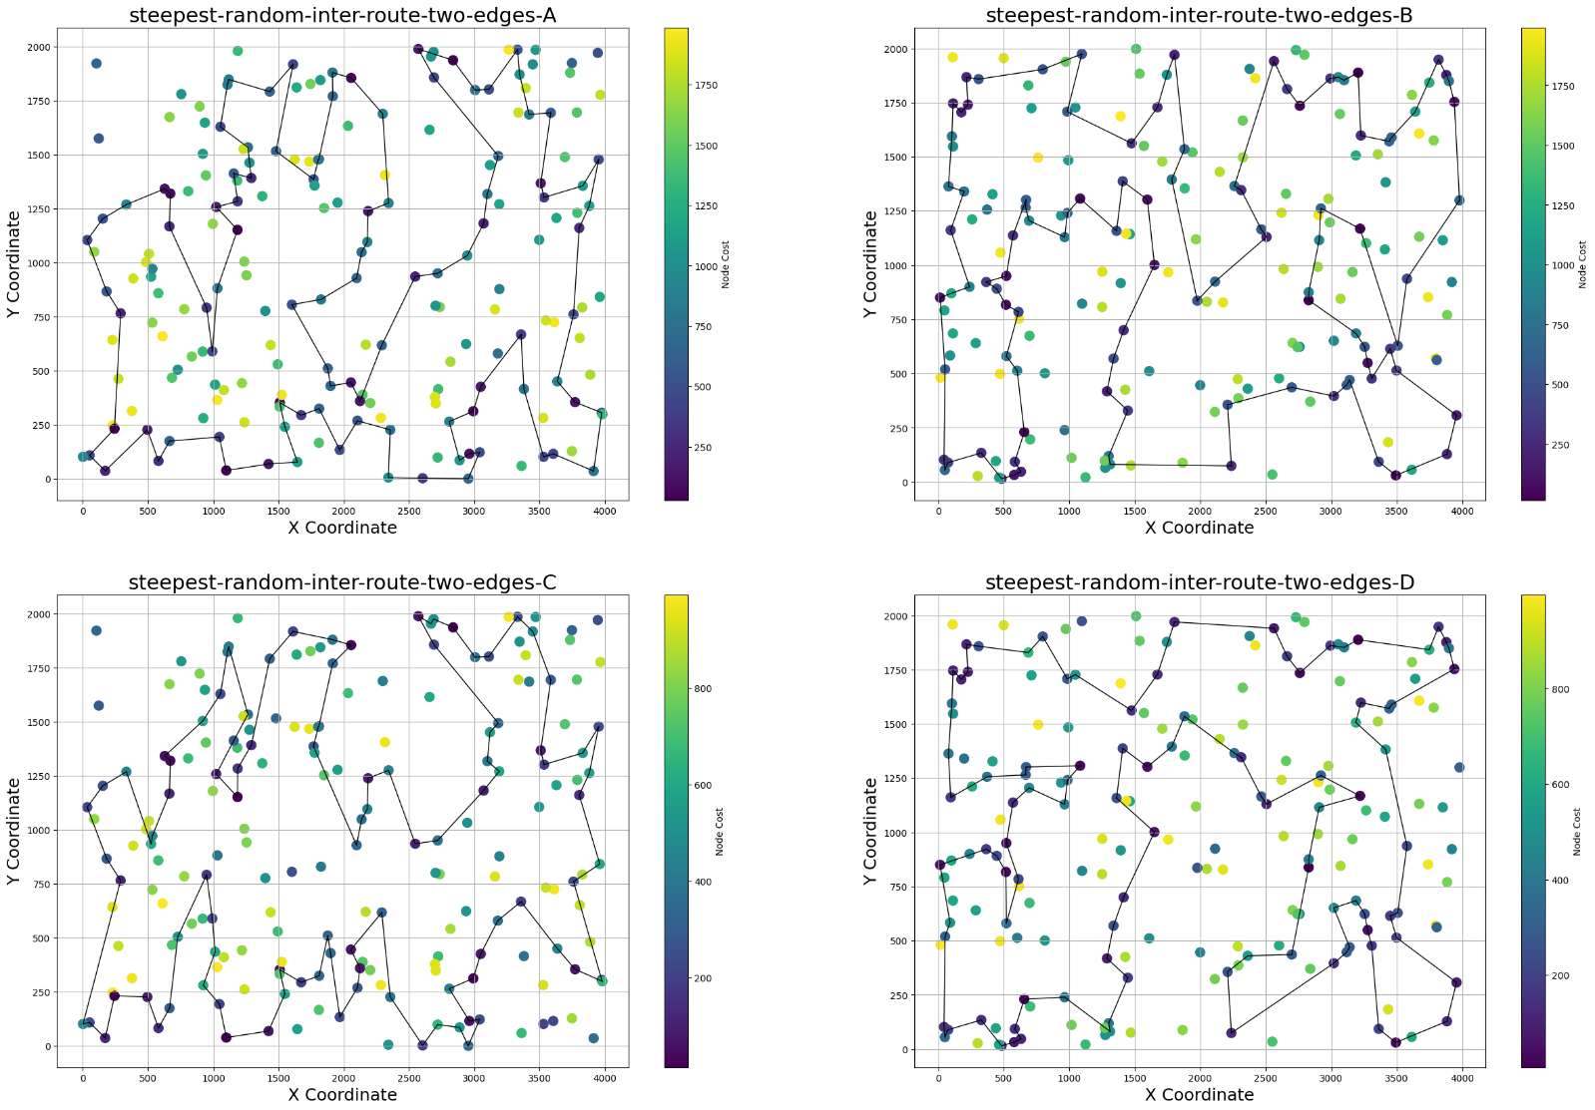

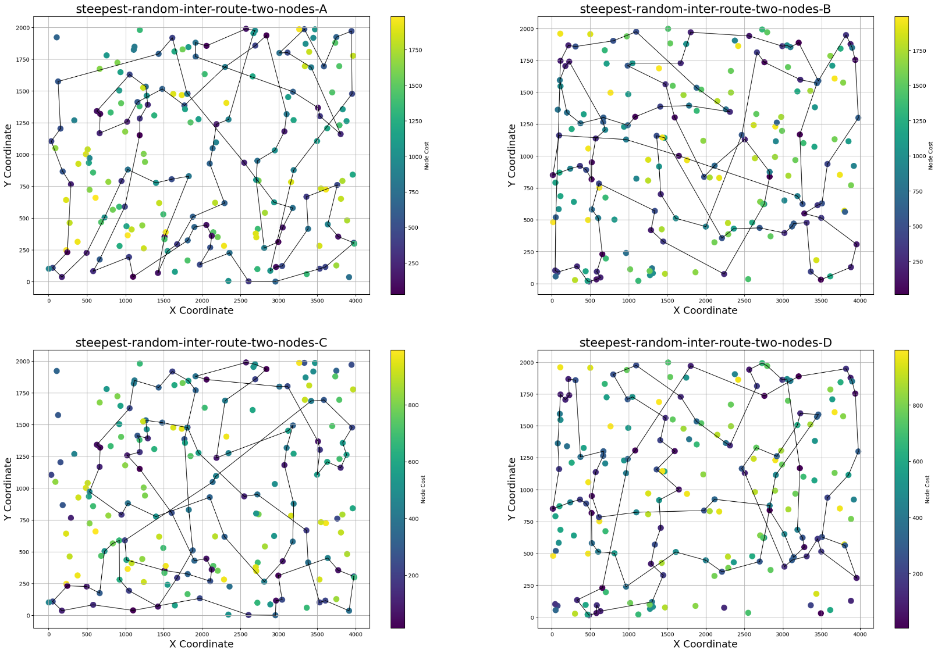

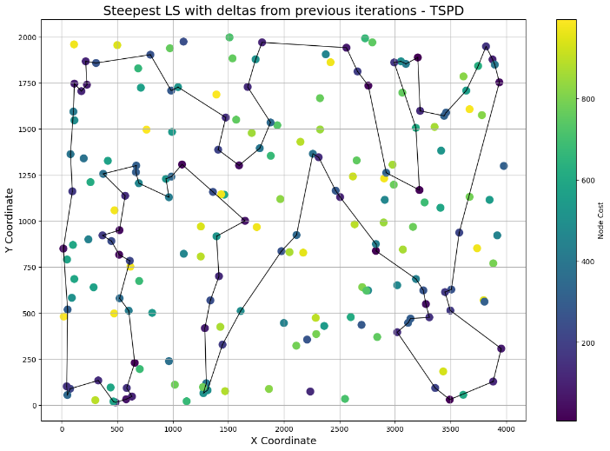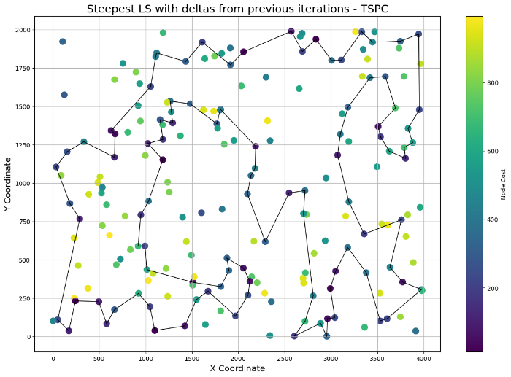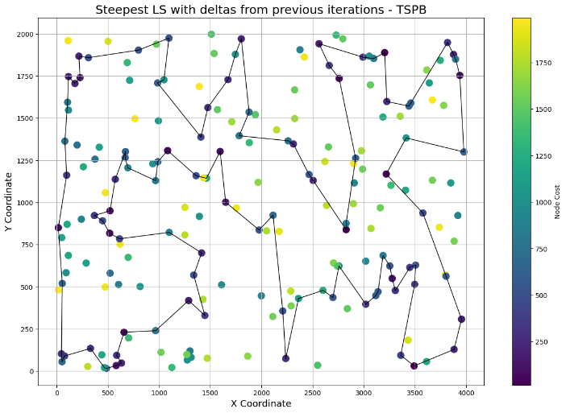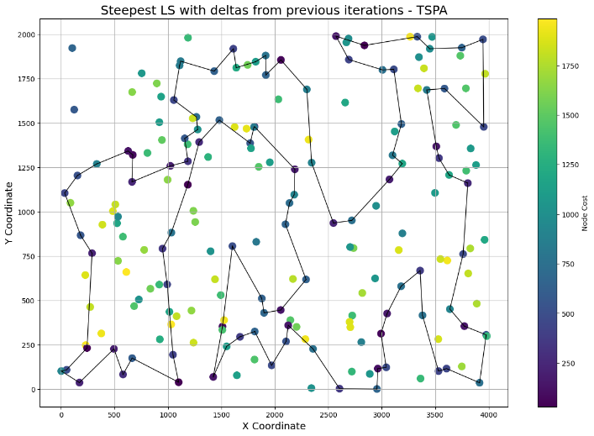

**Conclusions**

TODO