Evolutionary Computation

Assignment 8

Antoni Lasik 148287

Daniel Jankowski 148257

<https://github.com/JankowskiDaniel/evolutionary-computation/tree/AL/assignment8>

**Problem description**

In this report, we are checking the global convexity of a function. For test purposes, we’ve generated 1000 random local optima solutions obtained from a greedy local search with inter-route and two-edge exchange moves. The best solution used for similarity comparison was chosen as the best one out of all local optima for each instance, however, this solution itself was not taken into account in plots.

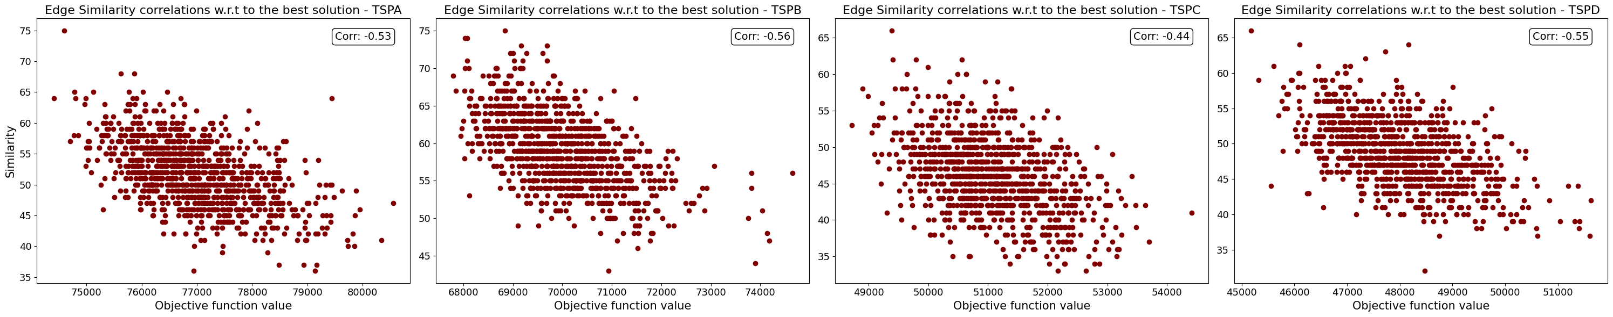**Plots**

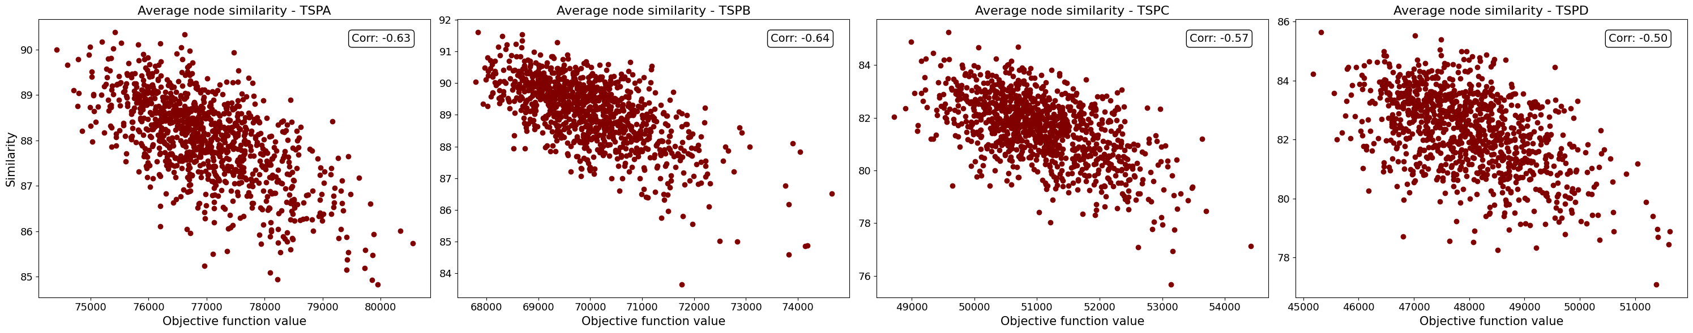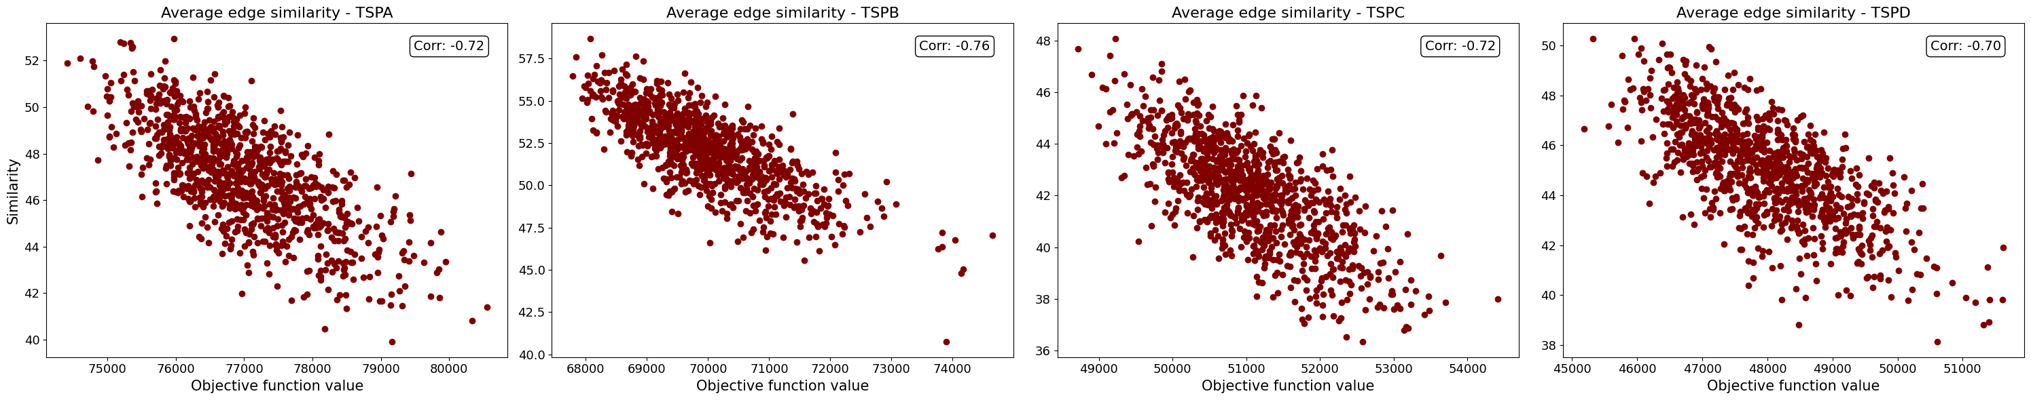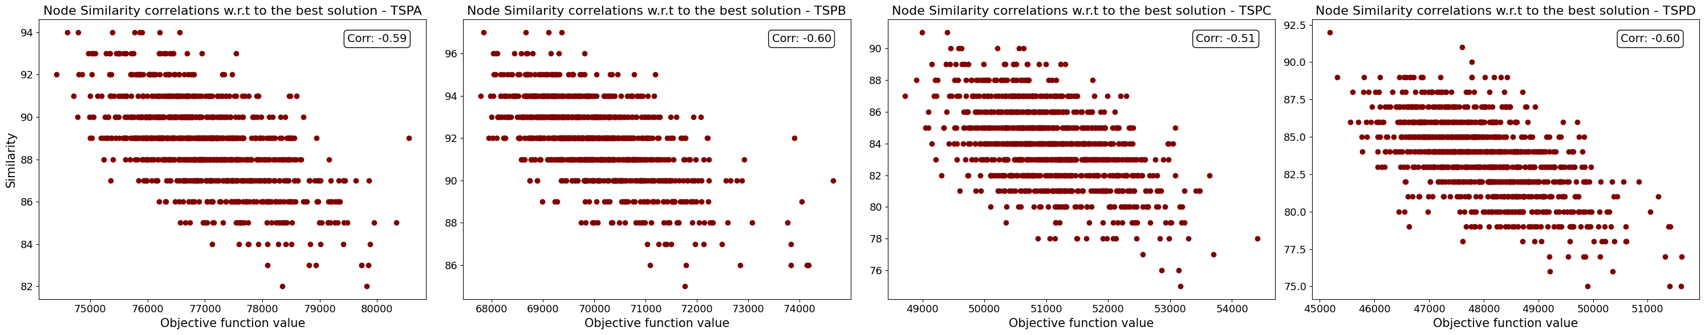

**Conclusions**

As expected, there exists a strong correlation between the similarity of solutions and their quality. It might be observed that good solutions are similar to each other, proving the function's global convexity. As in mathematics, a function is globally convex if it can be reduced to a convex function after adding or subtracting a given value, here, it means, that there exists a trend that is somehow violated by a noise. In the case of our TSP problem, the source of this trend might be, e.g. choosing short edges over longer ones, while the mentioned noise could be forcing us to choose longer edges to create a Hamiltonian cycle.

Moreover, as seen in the plots, the correlation is stronger for average similarity to all other solutions than to the best one. It might be explained that the best solution might be sensitive to noise or small perturbations, while the average similarity to all other solutions might provide a more stable measure that is less affected by noise.   
  
The above tests, clearly show why the Local Search (or generally evolutionary or metaheuristics algorithms) works well for such problems as TSP. This is the implication of a global convexity property, where from the practical point of view, algorithms such Local Search may discover better solutions near to the other already known good solutions.