Forward diffusion
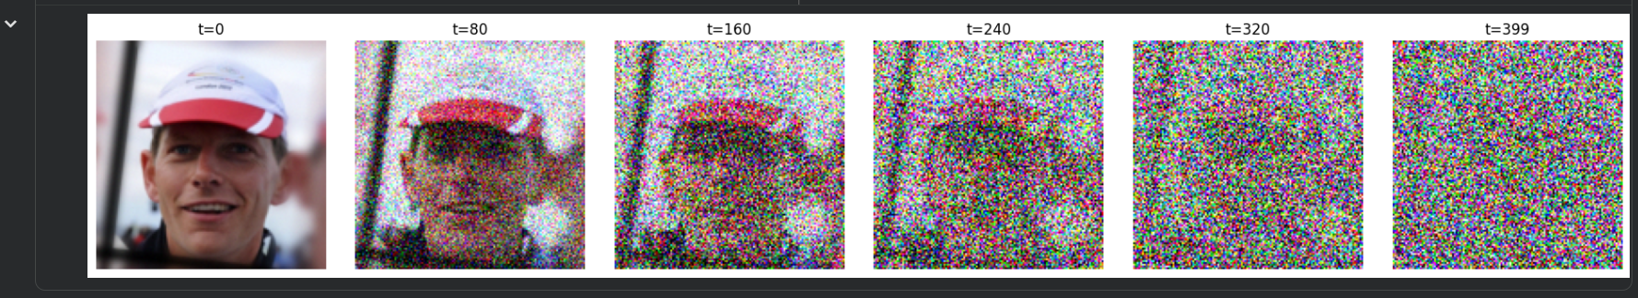
Training
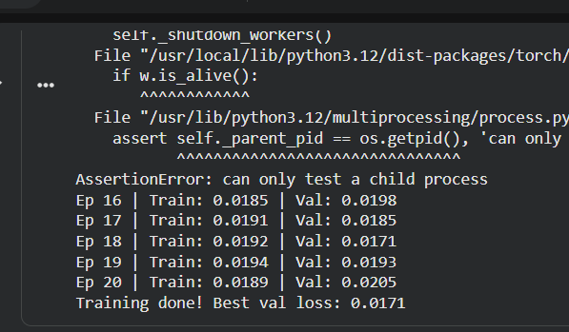
Reverse diffusion
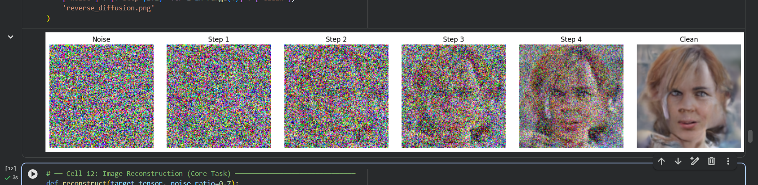
Example display
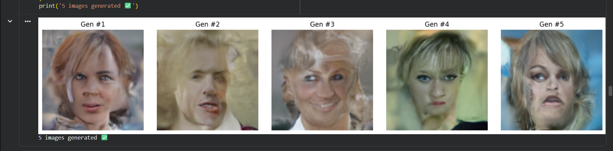
Loss plot

Reconstruction
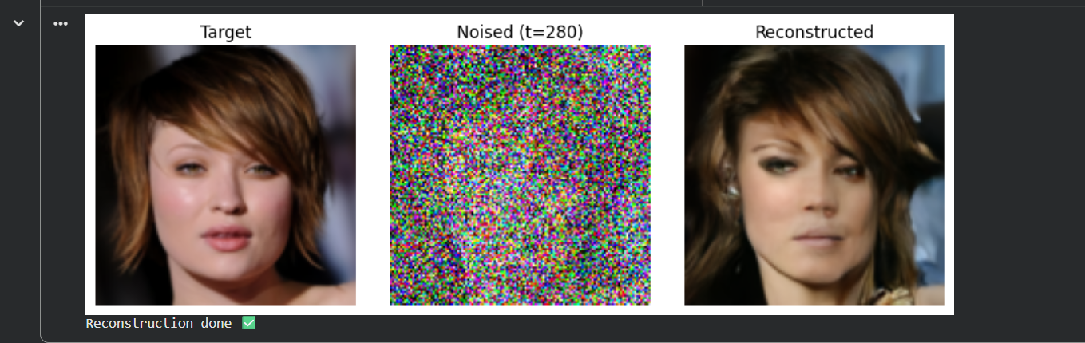
Gradio App

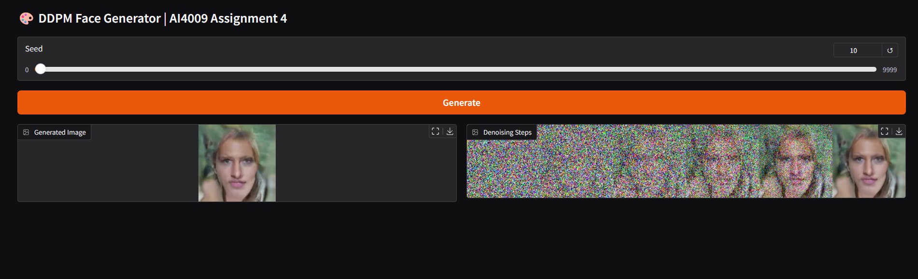
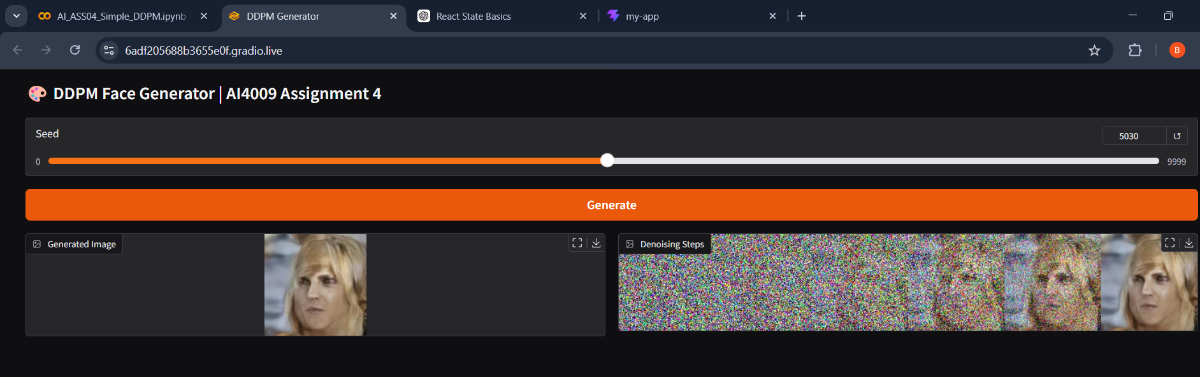
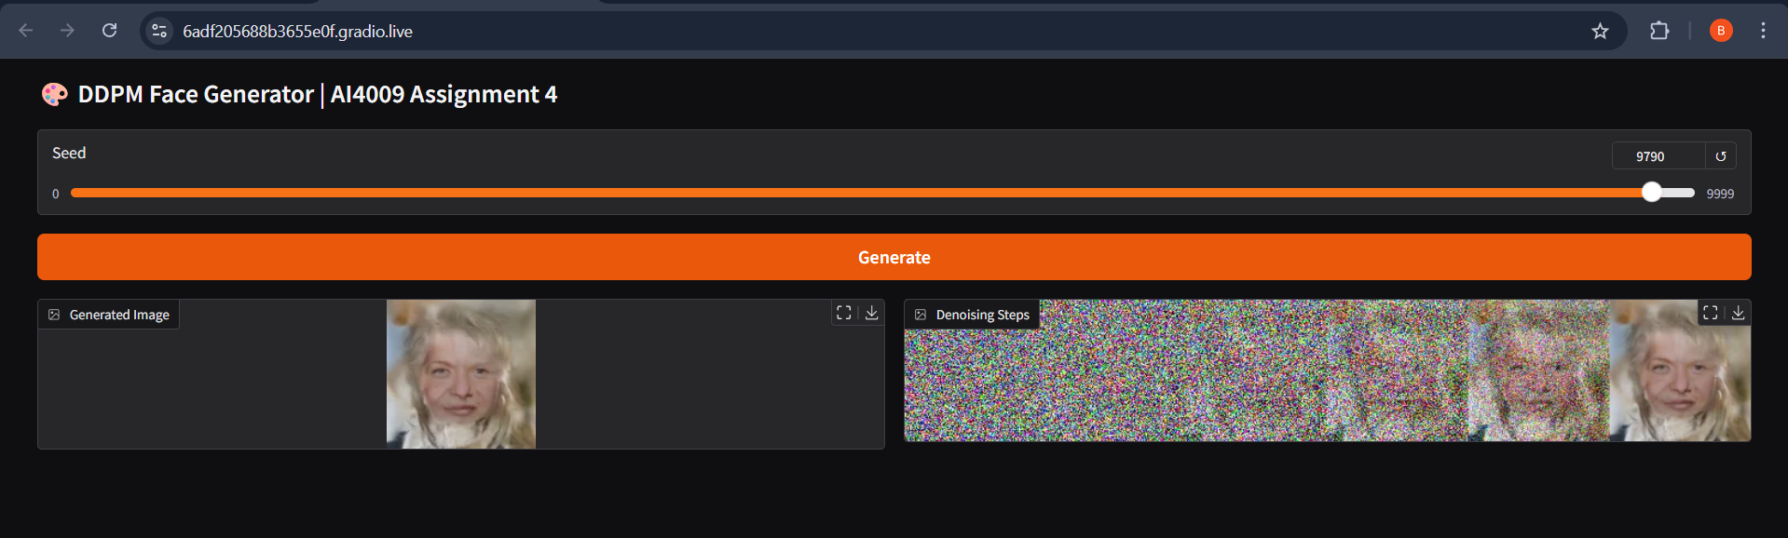
Loss
