Academic Calendar of Activities AY 2026-2027
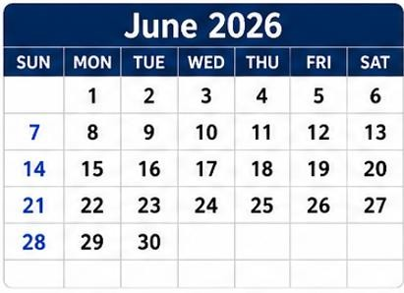 | Target Date Activity/Event InvolvedParties  JUNE 2026  1-5 1-19 Enrollment of Summer Classes Review of Subject Loading and Encoding of Assigned Faculty Students, Registrars, Deans College Deans, SSC, Registrar  5 Deadline of Submission of Grades for Undergraduate Students Faculty, Deans, Registrar  8 First Day of Classes for Summer AY 20252026 Students, Faculty  World Ocean’s Day Selected Faculty  8-20 1st Trimester Enrolment SGS  9-11 Recognition Ceremonies San Enrique – June 9 (AM) Dingle – June 15 (PM) Dumangas – June 10 (AM) Tiwi Site – June 11 (AM) Poblacion Site – June 11(PM) Students, Faculty, Key Officials  10 Midyear Assessment and Review of IZN partners IAL Office  15-17 Pre- Enrollment for Waitlisted Applicants College Deans, SSC, Registrar  16 16 & 18 Baccalaureate Mass (AM) (University-Wide per Campus) Graduation Rehearsals Students, Faculty, Key Officials Students, Graduation Committee  19 Graduation Ceremony (University-Wide) Students, Faculty, Key Officials  22-25 22-26 First Year Enrollment Changing/Dropping and enrollment of comprehensive examination Students, Deans, Registrar, SSC, Accounting, MDU,Cashier SGS  27 Orientation Program and Enrollment of comprehensive examination SGS  28 SGS Graduation Ceremony and Regalia Hooding SGS, Students, Faculty  29 Second Year Enrollment Students, Deans, Registrar, SSC, Accounting, MDU,Cashier

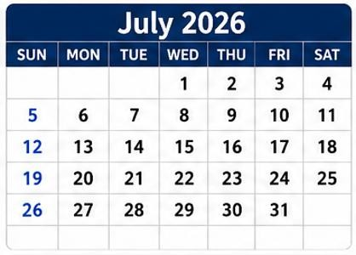 | Target Date Activity/Event InvolvedParties  JULY 2026  1-2 Second Year Enrollment Students, Deans, Registrar, SSC, Accounting, MDU,Cashier  3 Revision of the Constitution and By-laws of the University Student Council Students, SSC Chairs  4,5,11,12,18,19 1st subject for the 1st trimester SGS  6-9 Third Year Enrollment Students, Deans, Registrar, SSC, Accounting, MDU,Cashier  7-9 New Auditor’s Training Faculty, Staff, QAMC  13-16 Fourth- Year Enrollment Students, Deans, Registrar, SSC, Accounting, MDU, Cashier  25- 26 2nd subject for the 1st trimester SGS  13 Homeroom Guidance Class (ISDA: Individual Self-Development Activities) Guidance Office Personnel 1st Year students (Undergraduate)  15 Mock Accreditation-Phase 1 Dingle Campus - Bachelor of Secondary Education (Biological Science, English, Filipino, Mathematics) - BS Agriculture (Crop Science and Animal Science) - BS Information Technology Dean, Program Chair, Accreditation Task Force, Internal Accreditors, Staff, QAMC  16–17 SSC Strategic Planning SSC Chairs, Student Leaders  18 Meetings on Higher Level of Accreditation Deans, QAMC, VP Acad  24 Peer Facilitators’ Orientation and First Meeting Guidance Office Personnel Peer Facilitator Applicants  21-23 CHED Program Evaluation Visit Deans, Program chairs, Admin  23 First Federated USC Monthly Meeting (Main Tiwi Site) SSC, USC, Students  27 First Day of Classes for the First Semester Changing and Dropping of Subjects First Day of Faculty Service Student Orientation and Campus Tour Sug-alaw Students Orientation Tiwi (morning), BN (Afternoon) Internal Quality Audit Phase 2 - Main Campus - Poblacion Site Faculty, Students, Key Officials Faculty Office of Instruction, SSC Students, Deans, Registrar, SSC, Accounting, MDU,Cashier SSC, Faculty, Admin, Students Staff, Head of Office, QAMC, Internal Auditors

27-28 | Foundation Day - ISUFST Dingle (Alumni Homecoming) | Administration, Alumni  Members
28 | Internal Quality Audit Phase 2 (San Enrique Campus) | Staff, Head of Office, QAMC
28-29 | In-Service Training for Faculty  Club/ Organization Days | DI, College, Faculty  USC
29 | Internal Quality Audit Phase 2 - Dumangas Campus | Staff, Head of Office, QAMC, Internal Auditors
30 | Students orientation San En (morning), Dingle (afternoon)  Internal Quality Audit Phase 2 - Main  Campus - Tiwi Site | Faculty, Students  Staff, Head of Office, QAMC,  Internal Auditors
30-31 | SSC Strategic Planning | SSC, USC Advisers, Guidance Counselors
31 | Deadline of Submission of IPCR (target)  Internal Quality Audit Phase 2 - Dingle  Campus | Faculty, Deans  Staff, Head of Office, QAMC,  Internal Auditors

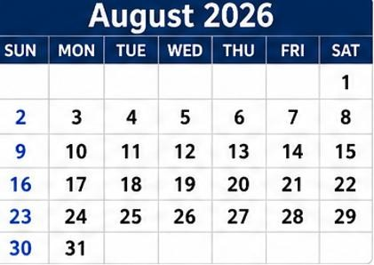 | Target Date Activity/Event Involved Parties  AUGUST 2026  1 1,2,8,9 First day of Classes Orientation Program, Election of Officers 2nd subject for the 1st trimester NSTP adviser, Students SGS  3 Students Orientation Dumangas Campus Mock Accreditation Phase 1 MIT - Main Campus Poblacion Site SSC, Guidance Office Personnel, Deans University Student Council, Program Committee, Freshmen and New Students, Key Officials Dean, program chair, & area committee, Internal Accreditors & QAMC  4 Mock Accreditation Main Campus - MHM & BSED Sci & Soc. Sci Dingle Campus - BSED , BSA & BSIT Dean, program chair, & area committee, Internal Accreditors & QAMC  5 Management Review San Enrique Campus - AM Dingle Campus - PM Head of Office/Staff, QAMC, Key officials  6 Management Review (Main Campus Poblacion Head of Office/Staff,QAMC, Key officials  7 Second Federated USC Monthly Meeting Pang abi-abi 2026 SSC, USC, Students  8 Clean-Up Drive Universidad Namon Lipyuhan kag Patahumon NSTP Adviser, Students  8,9,15,16 Comprehensive Examination Students, program chairs  10 10-12 ASEAN Celebration (University-Wide) Management Review (Main Campus - Tiwi Site Comprehensive Examination for Board Programs Cultural, DI, Linkages Head of Office/Staff, QAMC, Key officials ULAC, Colleges  11 Management Review (Dumangas Campus) Head of Office/Staff, QAMC, Key officials  14 Mock Accreditation Phase 2 Dingle Campus (Bachelor of Secondary Education, BS Agriculture BS Information Technology) Dean, program chair, & area committee, Internal Accreditors & QAMC  20 Pag abi-abi kag Pag kilalahay SSC, USC, Students  21 Ninoy Aquino Day  22 Admission Examination for new students Students  27 Buwan ng Wika Celebration Faculty, Students  27-28 Neuropsychological Testing for College of Education Student Interns Guidance Office Personnel Psychometrician Internship Coordinator Interns  28 Scholars and Grantee Orientation Capacity Building Workshop for Extensionist Faculty Comprehensive Examination for Undergraduate Students SSC, Selected Students Deans, Program Chairs, Faculty Extensionists ULAC office  31 National Heroes Day

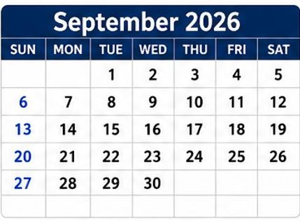 | Target Date Activity/Event Involved Parties  SEPTEMBER 2026  1 Mock Accreditation Phase 2 Poblacion Campus - MIT Dean, program chair, & area committee, Accreditors & QAMC  3 Mock Accreditation Phase 2 Main Campus Tiwi Site - MHM Students’ General Assembly and Dialogue Simultaneous per Capus Dean, program chair, & area committee, Accreditors & QAMC USC, Campus Administrator  4 4,,11, 18, 25 Parents’ Consultative Dialogue per College (University-wide) Financial Literacy & Entrepreneurial Venture (University-Wide) Third Federated USC Monthly Meeting (Dingle Campus) Pre Season Sports Activities SSC, Deans Faculty SSC, USC, and Interested Students SSC, USC, Students Sports Coordinator, Directors, Director for Sports Affairs, USC  7 7-9 7-19 First Day of Wearing the Prescribed University Uniform for First-Year Students Accreditation Survey Visit Dingle Campus - BSA, BSED & BSIT 2nd trimester enrolment Students, SSC Dean, program chair, & area committee, Accreditors & QAMC SGS  10 Mock Accreditation Phase 2 Bachelor of Secondary Education (Science and Social Studies) - Main Campus Tiwi Site Dean, program chair, & area committee, Accreditors & QAMC  11 (EXTENSION) University-Wide Extension Symposium Identification and Finalization of events for SCUAA 2026 Faculty Extensionist (Presenter), Program Chairs, Extension Associates Sports Coordinators, Director for Sports Affairs  12 USC Panugod First Aid Seminar USC, Student Leaders NSTP Students, Adviser  14-17 Fisheries Conservation Week (CFAS) Faculty, Students, Key Officials  15 IAL campus-wide orientation for Academic Year 2026–2027 IAL Office  18 Human Rights & Peace Education Forum Coaches Meeting USC, SSC, Students Coaches, Sports Coordinators, Director for Sports Affairs  21-23 Midterm Examination Faculty, Students  21-25 Changing/dropping and enrolment of comprehensive examination SGS  26 Orientation for new students and pagwaragwag SGS  28 Wellness Break Students Outreach program External Audit (ISO Surveillance 2) Students USC Head of Office, Staff, Auditors, QAMC

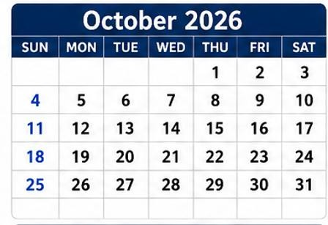 | Target Date Activity/Event Involved Parties  OCTOBER 2026  2 Wellness Break Students EXTENSION) -Systemwide 7th InHouse Review and Presentation of Extension Project Proposals Faculty Extensionists  3,4,10,17,18 1st subject for the 2nd trimester SGS  5 5-9 Start of daily practice of sports events for SCUAA Start of Application Period for University Entrance Examination Accreditation Survey Visit Main Campus Tiwi- MHM, MIT, and BSED Sci and Soc. Sci. Athletes, coaches ASRO Director and staff Dean, program chair, & area committee, Accreditors & QAMC  8 8-9 Statistics Month Celebration Releasing and Discussion of Neuropsychological Test Evaluation Results of College of Education Interns R&D, Students Guidance Office Personnel Internship Coordinator College of Education Interns  9 9, 16, 23, 30 Fourth Federated USC Monthly Meeting (San Enrique Campus) Continuation of Pre- Season Sports Activities SSC, USC, Students Sports Coordinator, Directors, Director for Sports Affairs, USC  11 Disaster Risk Reduction Management Training Advisers, NSTP students  14 Mental and Substance Use Education Lecture/ Wellness Activity Student Support Center and Guidance Office Personnel, GAD  15 Submission of Drafted University Entrance Examination (UEE) ASRO  16 Moral and Spiritual Recovery Program (University-wide) SSC, All Students, RHU  17 Seminar on Building a Safe Campus : Gender Sensitivity and Combating Sexual Harassment GAD, SSC  22 Statistics Month Celebration R&D, Students  24, 25, 31 2nd subject for the 2nd trimester SGS, Students  28 Start of Faculty Evaluation for 1st Semester DI, Deans, Students  30 Dagsa and Dagyaw Validation of University Entrance Examination (UEE) Cultural, USC ASRO

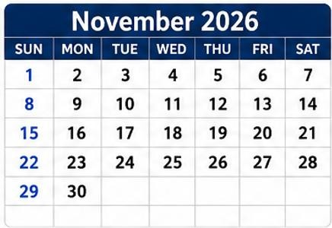 | Target Date Activity/Event Involved Parties  NOVEMBER 2026  1 1, 7, 8 All Saints’ Day 2nd subject for the 2nd trimester SGS, Students  2 All Souls ‘Day  6 6, 13, 20, 27 Fifth Federated USC Monthly Meeting (Dumangas Campus) Continuation of Pre- Season Sports Activities SSC, USC, Students Sports Coordinator, Directors, Director for Sports Affairs, USC  7,8,14,15 Comprehensive Examination SGS  12 Systemwide In-House Review of Completed Research R&D, Faculty  14,15,21,22,29 3rd subject for the 2nd trimester SGS  18 Health & Wellness Seminar and Physical Screenings (International Men’s Day) GAD, Medical Unit  20 Last Day of Faculty Evaluation for 1st Semester DI, Deans, Students  21 Admission examination for new students  23 23-25 23-27 23-29 Kick-off for the 18-Day Campaign to End Vaw Final Examination Week National Book Week Celebration/Library Information Services Month Build a Tree of Love and Hope (Christmas Tree) GAD, Faculty, Students Faculty, Students Faculty, Students, Library Staff NSTP students  24-26 Public Presentation of Research Outputs R&D, Faculty  25 Pilot Testing of University Entrance Examination (UEE) ASRO  26-28 Peer Facilitators’ Training and Retreat Guidance Office Personnel Peer Facilitators (Screened and Selected) Resource Persons  30 Bonifacio Day

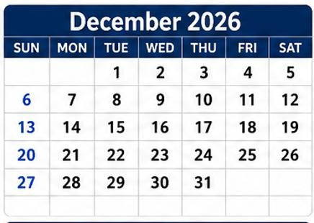 | Target Date Activity/Event Involved Parties  DECEMBER2026  1-4 University Week Celebration (All College Week) College Of Education December 1 College of Business and Management December 2 College of Information and Communications Technology December 3 College of Agriculture and College of Fisheries and Aquatic Sciences December 4 Faclulty, Student, Key Offricials  1-5 Tentative Date of SCUAA 2026 Athletes, Coaches, Sports Coordinators, Directors for Sports Affairs  2 Year-end performance review and target planning for the succeeding year IAL office  3 Last day For UEE application ASRO Director and Staff  7 7-19 End of the First Semester 3rd Trimeter enrolment Students SGS office  8 8-19 Feast of the Immaculate Conception of Mary Semestral Break Students  9 Culminating Activity for the 18-Day Campaign to End VAW GAD, Faculty, Staff  11 Deadline of Submission of Grade Sheets Faculty, Registrar  13 Final Examination and Christmas Party NSTP Students and Adviser  14 14-15 Deadline for Submission of IPCR USC Outreach Program Enrollment for the 2nd Semester AY 26-27 (Second Year) Faculty, Registrar USC Officers and Advisers Registrars, SSC ,Students  16-17 Enrollment for the 2nd Semester AY 26-27 (Third Year) Registrars, SSC ,Students  18 Graciano Lopez Jaena Day (Local Holiday)  21 21-22 21-26 Start of Christmas Break of Faculty Enrollment for the 2nd Semester AY 26-27 (Fourth Year) Changing /Dropping and Enrollment of Comprehensive Examination Faculty Registrars, SSC ,Students SGS,Students  23-29 Enrollment for the 2nd Semester AY 26-27, (First Year) and Irregular Students Registrars, SSC ,Students  24 Christmas Eve  25 Christmas Day  26 Orientation for new students and Pagwaragwag SGS, Students,Program Head  30 Rizal Day

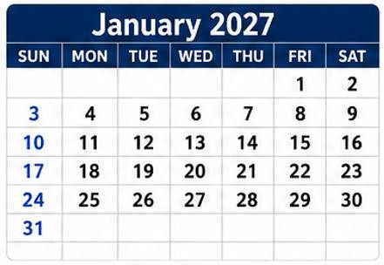 | Target Date Activity/Event Involved Parties  JANUARY 2027  1 New Year's Day  4 4-8 First Day of Classes for the Second Semester Return of Faculty Duty Start of Classes Changing and Dropping of Subjects Faculty Students, Faculty, Registrar  9 9,10,16,17, 23 & 24 First day of Instruction, Orientation Program 1st subject for third trimester NSTP student, Advisers SGS  15 Sixth Federated USC Monthly Meeting (Main Tiwi Site) SSC, USC, Students  16 UEE Examination ASRO Director, Staff, Proctors  17 Verification of the University Entrance Examination (UEE) ASRO Director, Staff, Proctors  18 Validation of the University Entrance Examination (UEE) ASRO Director, Staff, Verifiers  21 Workplace & Internship Readiness: A Seminar-workshop for Interns Students’ General Assembly Meeting and Dialogue Guidance Office Personnel Resource Person Internship Coordinators Interns USC, Campus Administrator  30-31 2nd subject for third trimester SGS

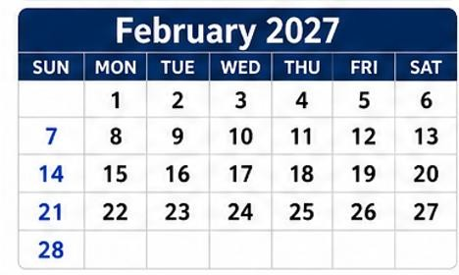 | Target Date Activity/Event Involved Parties  FEBRUARY 2027  4 Release of UEE Results ASRO Director, Staff  5 5, 12, 19, 26 National Arts Month Celebration Continuation of Pre- Season Sports Activities SSC, Students Sports Coordinator, Directors, Director for Sports Affairs, USC  6-15 6,7,13,14 Giving of Aptitude Test for Board Programs Comprehensive Examination 2nd subject for third trimester Guidance Counselors SGS SGS  8 Interview for Non-board UEE Qualifiers Deans, Program Chairs  9 Internal Audit Phase 1 ( Main Campus Tiwi Site) Staff, Head of Office, QAMC  10 Internal Audit Phase 1 (Main Campus Poblacion Site) National Anti-Hazing Prevention Week Staff, Head of Office, QAMC Students, Faculty  11 Evelio Javier Day (Local Holiday)  12 Seventh Federated USC Monthly Meeting (Main Poblacion Site) SSC, USC, Students  15 Internal Audit Phase 1 (San Enrique Campus) Staff, Head of Office, QAMC  16 Internal Audit Phase 1 ( Dingle Campus) Staff, Head of Office, QAMC  17 Internal Audit Phase 1 ( Dumangas Campus) Interview for Aptitude Test Qualifiers for Board Programs Staff, Head of Office, QAMC Deans, Program Chairs  20 20,21,27,28 Admission Examination 3rd subject for third trimester SGS, Students SGS

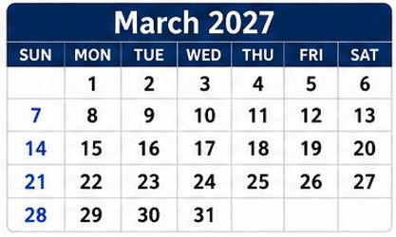 | Target Date Activity/Event Involved Parties  MARCH 2027  1 1-3 Kick-Off for National Women’s Month Celebration Midterm Examination GAD, Faculty, Staff, Students Students  3-5 Student Electoral Board Application SSC  5 5,12, 19 Consultative Dialogue Continuation of Pre- Season Sports Activities SSC, USC, Parents Sports Coordinator, Directors, Director for Sports Affairs, USC  6-7 3rd subject for third trimester SGS  8 8-20 Management Review (Main Campus Tiwi Site) Last day of Interview for Non-board UEE Qualifiers Last day of Interview for Aptitude Test Qualifiers for Board Programs Wellness Break Summer Term enrollment Head of Office, QAMC Deans, Program Chairs Deans, Program Chairs Students  9 Management Review (Main Campus Poblacion Site) Head of Office, QAMC  10-12 Kampsama (San Enrique Campus) SSC, Student Leaders, GAD  15-31 March 16-April 7 Filing of Candidacy SSC  17 Release of First Year Student Qualifiers for AY 2027-28 ASRO Director  18 Liberation of Panay (Local Holiday)  20 & 27 Community Outreach Program -Pag-Ulikid CWTS, LTS students  22-23 22-26 Neuropsychological Testing for CFAS Interns Changing/Dropping and Enrolment for New Students Guidance Office Personnel Psychometrician Internship Coordinator Interns SGS  24 Women’s Month Symposium GAD, Faculty, Staff, Students  25-28 Holy Week

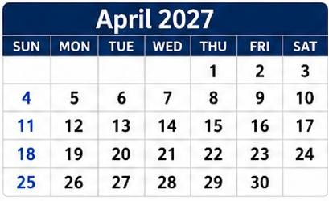 | Target Date Activity/Event Involved Parties  APRIL 2027  1-7 1-19 March 16-April 7 Filing of Candidacy Pre-enrollment for First Year Students SSC Registrars of Different campuses  2 2, 9, 16, 23 Eight Federated USC Monthly Meeting (Dingle Campus) Continuation of Pre-Season Sports Activities SSC, USC, Students Sports Coordinator, Directors, Director for Sports Affairs, USC  3 3, 4, 10, 11, 17, 18 3, 10, 17 Orientation for New Students and Pagwaragwag 1st subject for summer term Community outreach Program Pag -Ulikid SGS SGS CWTS, LTS students  5 5-6 Praise Awards University Days Celebration RA 1012 Poblacion Site HRMO Admin, USC,  9 Araw ng Kagitingan  12 12-21 Announcement of Official Candidates Start of Faculty Evaluation for 2nd Semester Campaign period SSC DI, Deans, Students SSC  15 15, 16, 22, 23, 29, 30 International Research Colloquium 3rd subject for the summer term Research, Extension SGS  16 16-17 Comprehensive Examination for Undergraduate Students Alumni Summer Gathering ISUFST DIngle Campus ULAC Alumni Coordinator, Alumni Officers and Members  19-21 21 Final Examination for Graduating Students Grand Rally SSC  22 USC Election Vote Canvasing & Proclamation of Winners SSC, USC, Students  23 Filing and Hearing of Electoral Protests SSC  24-25 2nd subject for summer term SGS  26 Oath-Taking Program SSC  29 Students’ Research Symposium Homeroom Guidance Class (ISDA: Individual Self-Development Activities) OVPAA, R&D, Students Guidance Office Personnel 1st Year students (Undergraduate)

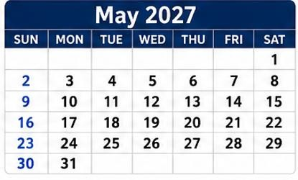 | Target Date Activity/Event Involved Parties  MAY2027  1 1,2,8,9 Labor Day Alumni Homecoming ISUFST Dumangas Campus 2nd subject for summer term Administration, Alumni Members SGS  5-6 Releasing and Discussion Neuropsychological Test Evaluation Results of College of Fisheries and Aquatic Sciences Interns Guidance Office Personnel Internship Coordinator College of Fisheries and Aquatic Sciences Interns  6 Deadline of Submission of Grades of Graduating Students Last day of Faculty Evaluation for 2nd Semester Faculty DI, Deans, Students  8-16 Comprehensive Examination SGS  10-12 Final Examination of Non- graduating Students Student, Faculty  13 Local Deliberation of Academic Awards Faculty, Deans, Registrar  15 Alumni Homecoming ISUFST Main Campus - Tiwi Site Graduation Rites Administration, Alumni Members All NSTP Students  16 Last Day of Faculty Service Faculty  17 Institutional Deliberation of Academic Awards Deans, DI, VPAA, registrar  19 Pasidungog (University Wide) USC and Student Organizations  20 Fed USC Election Last Federated USC Monthly Meeting San Enrique Campus Systemwide In-House Review of Research Proposals (Call for Proposal) SSC, USC, Students R&D, Faculty  21 End of Second Semester Students  24 Mock Accreditation Phase 1 San Enrique Campus BSA & BEEd Dean, Program Chair, Area Task Force, Internal Accreditors, QAMC  27 Deadline of Submission of Grade sheets of Non-Graduating Students Faculty  31 Start of Enrollment for Summer Classes Registrar, SSC, Students

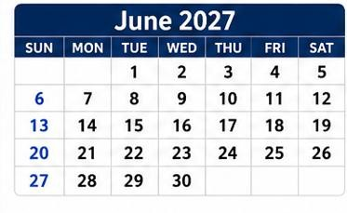 |  | Target Date Activity/Event Involved Parties  JUNE 2027  2 Mock Accreditation Phase 1 San Enrique Campus - BSHM Dean, Program Chair, Area Task Force, Internal Accreditors, QAMC  7 First Day of Classes for the Summer Classes SPES SSC  8-11 11 Recognition Ceremonies Dingle ( June 8 AM) San Enrique ( June 8 PM) Dumangas ( June 9 AM) Poblacion ( June 9 PM) Tiwi ( June 11 AM) JOB FAIR SSC  12 Independence Day  14 Baccalaureate Mass/ Services Students, Advisers  16-17 Graduation Rehearsals Students, Advisers  18 System-Wide Graduation Students, Faculty, Program Chairs  21 Mock Accreditation Phase 2 San Enrique Campus - BSA & BEEd Dean, Program Chair, Area Task Force, Internal Accreditors, QAMC  29-30 Midterm Examination for the Summer Classes Students, Advisers
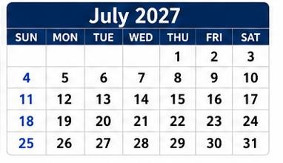 | Target Date Activity/Event Involved Parties  JULY 2027  14-30 Homeroom Guidance Class (ISDA: Individual Self-Development Activities) Guidance Office Personnel 1st Year students (Undergraduate)  19-20 Final Examination for the Summer Classes Accreditation Survey Visit San Enrique Campus - BSA & BEEd Students Dean, Program Chair, Area Task Force, External Accreditors, QAMC  26 Mock Accreditation Phase 2 San Enrique - BSHM Dean, Program Chair, Area Task Force, Internal Accreditors, QAMC

