CS 2001 W10 Practical
180000560
20th November 2019
Tutor: Tom Kelsey

Overview

Implementing the code of merge sort and selection sort respectively, then measuring the amount of time for sorting array with different size by two methods. Finally, analysing how two algorithms’ speed performing with problem size.

Design and Implementation

Merge sort and Selection sort is implemented for testing purpose.
Merge sort
--------------------------------------------------------------------------------------------------------------------------------------
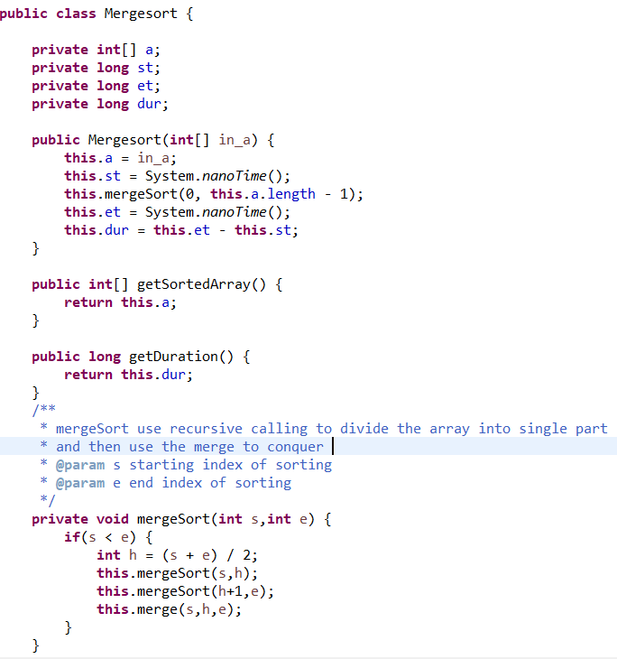
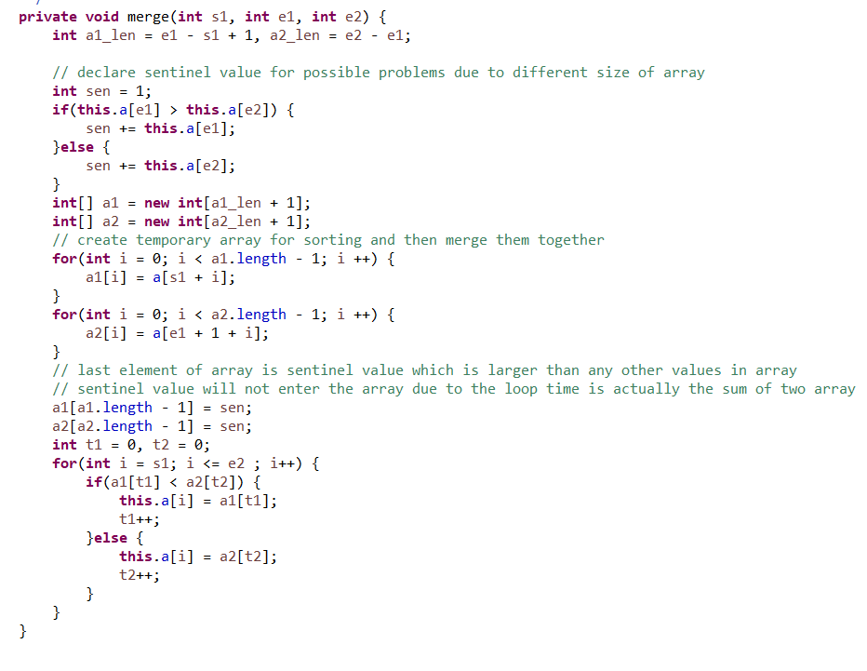

Selection Sort
--------------------------------------------------------------------------------------------------------------------------------------
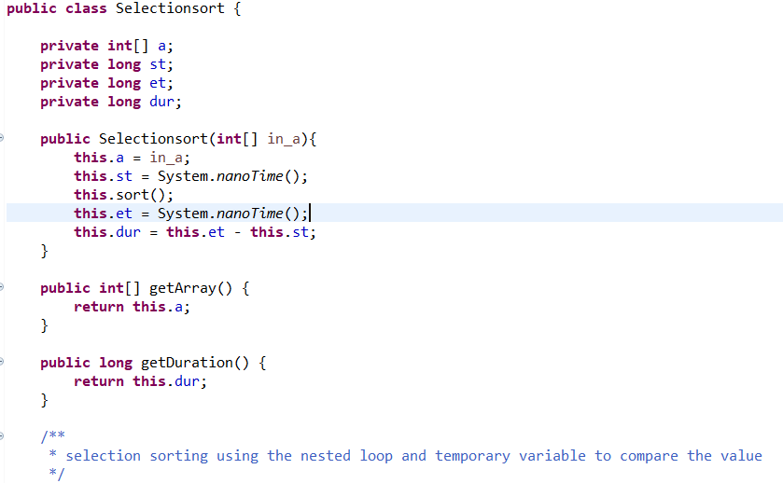
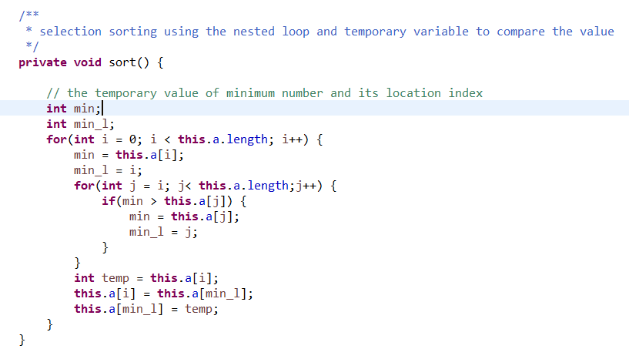

Time complexity is measured for testing their performance over arrays with various sizes.
Nano second timer is considered for testing the amount of time.
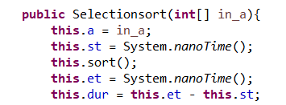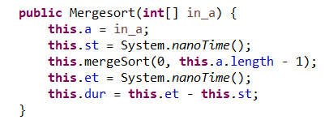

Automatic testing is implemented for identifying the amount of time spent by algorithms to sort arrays with different sizes.
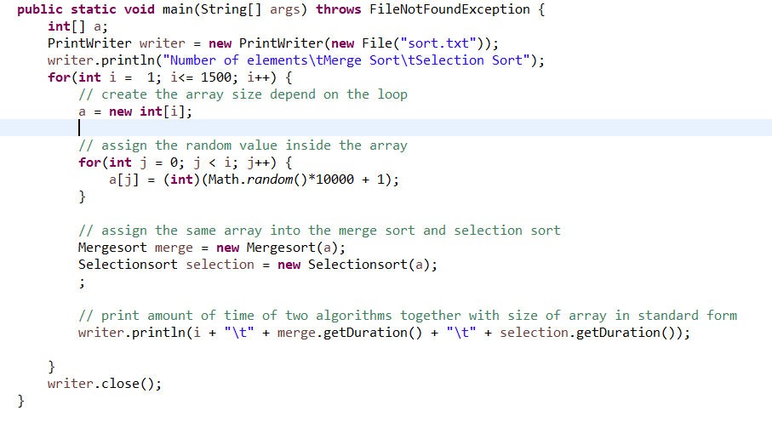
Print writer is used to sore period of time into text file. In the for loop, array’s size will be set up depend on increasing looping time. Then random number will be assigned into the array. After generating a random array, both two sorting algorithms will sort the same array and their amount of time in sorting will be written into a file together with the size of the array they sort.
The file store all the sort time of both two algorithms, the format is implemented automatically for transforming to excel form.
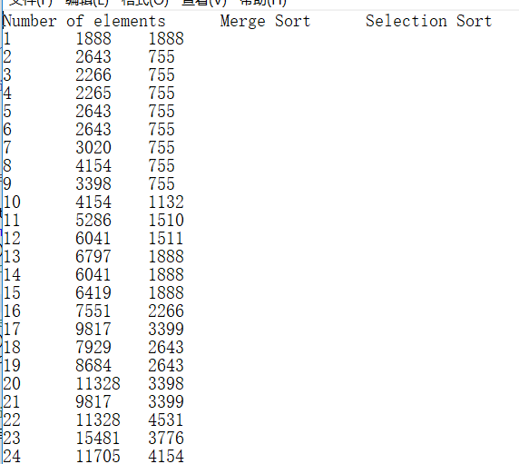
Excel application is considered to collect the data and plot them into visualised graph for analysing.
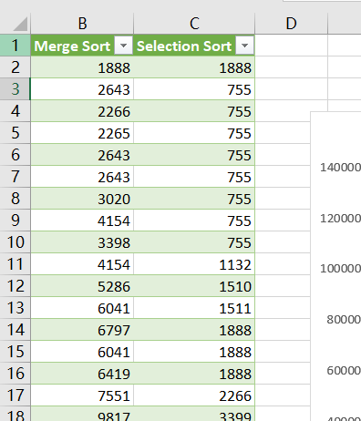

Test and Analyse

To find the crossover point, the array size is changed by changing the loop time in testing program.
Several graphs are plotted by Excel.

This is a graph plotted based on the amount of time two algorithms solves the array to maximum size 10000, more data could be found in Excel attached in the file.

The total execution time is increased due to increasing problem size. Although the crossover might be not cleared in this graph due to large amount of data, merge sort has significantly less amount of time sorting the array compare to selection sort. Therefore, size 10000 is the complexities of “sufficiently large” problem in this case. In conclusion, merge sort is a faster algorithm in large problems.
To analyse time complexity of two algorithms deeper, more trials are needed to provide comprehensive overview.

As diagrams illustrated above, the size of array is decreased to find crossover point, when the array size decreased to 2500, merge sort is generally slower than selection sort when the array size is smaller than around 750. Thus, the array size need to be decreased further more for observation,

Now the array size is 1000, selection sort is faster algorithm is generally faster than merge sort in relatively smaller problem size. There are some exceptional cases in the array which their size is smaller than 250 or it is around 750. There might be the reason of difference in code.

When the array size is relatively small, amount of times of two algorithm spent on sorting array could be observed more precisely. Merge sort spends more time on sorting array when array size is relatively small generally.

