ADV-C89: THE MATH QUIZ-1

Assigned

In This Project, We Will Write The Html Code For The Login Page. And Remember Name Of The File Should Be Index.Html

**INSTRUCTIONS:**

The output of login page.

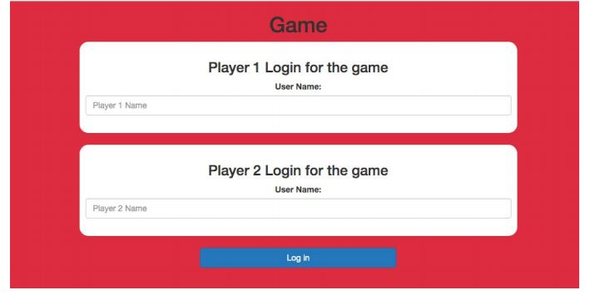

Click on the following link and play with your friend and you will understand the flow of the game. <https://jynyhy9vu5r8xz5zy0utww-on.drv.tw/project_C89_C90_C91_C92.com/game_page.html>  
  
Now we will start making 2 player math quiz web application, as you already know the flow of the game, as you just played it.

In this project, we will write the HTML code for the login page.

This HTML page should have -

1. Bootstrap links
2. Your style sheet link(Make a CSS file and link it inside this HTML file), like this -

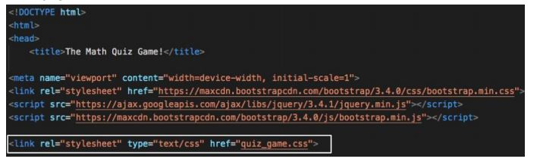

1. Your javascript link **(make a blank JS file and put the name of the file in this HTML file, we will do JS coding of this file in the next class)**, something like this -

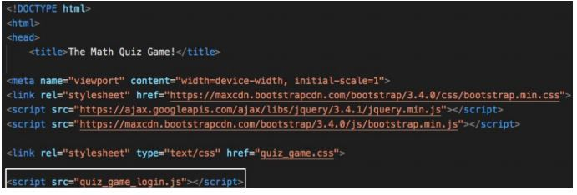

1. Then 2 div one for player 1 and another for player 2.
2. This div’s will have a heading, label and an input box, this -

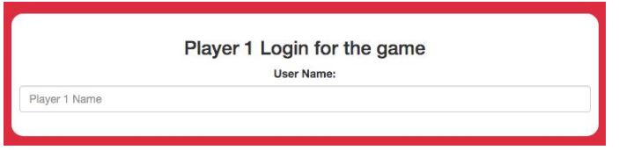

1. And in last there should be a login button, and give an on click function **adduser()** to it, this **adduser()** function we will write in the next class.

If you get stuck somewhere, you can refer to the **game_login.html** file from class 89, because almost everything is the same.  
  
**The style of the login page should not be like the above example, as you are creative make your own design and style for this login page. Only remember it should have all the HTML elements as mentioned above.**  
  
HINT - give classes and id to HTML elements and then refer them for styling that element.  
  
HINT - Use bootstrap classes for making it responsive and look beautiful

**Some design inspiration -**

1. 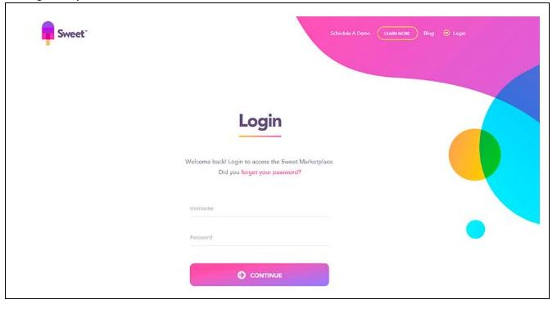
2. 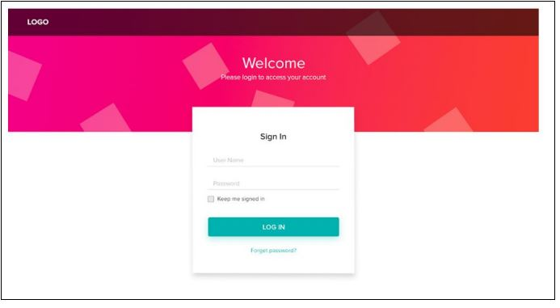
3. 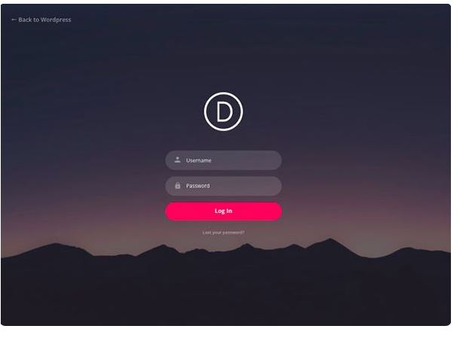
4. 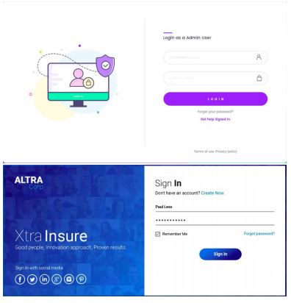
5. 

**Submitting the Project:**

Create a folder **project-math-quiz** and upload all the files related to the **project-math-quiz** project on GitHub. You can get the steps to do this by clicking on this[link](https://s3-whitehatjrcontent.whjr.online/curriculum/ADV+Asset/Hosting+Website-GitHub.pdf).  
  
Copy the hosted link which you will get after uploading all your files on GitHub and submit it in the Student Dashboard Projects panel against the correct class number.

v