ADV-C90: THE MATH QUIZ-2

Assigned

The Math Quiz

**INSTRUCTIONS:**

The output of login game page.

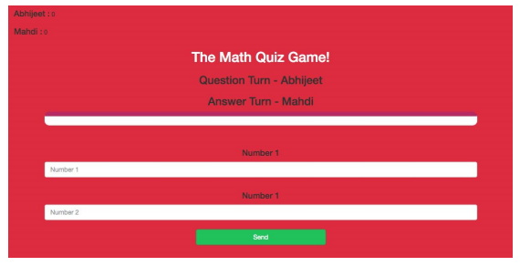

The output for the game page after giving the input

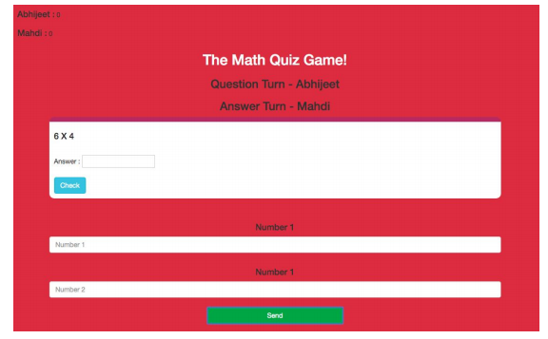

Click on the following link and play with your friend and you will understand the flow of the game. <https://jynyhy9vu5r8xz5zy0utww-on.drv.tw/project_C89_C90_C91_C92.com/game_page.html>

In this project, we will

1. Write a javascript code for the login page, which you had created in the last project. You need to write the JS code in the same JS file which is **quiz_game_login.js** file. This JS file we had created and linked it inside the game login HTML file in the previous project, like this -

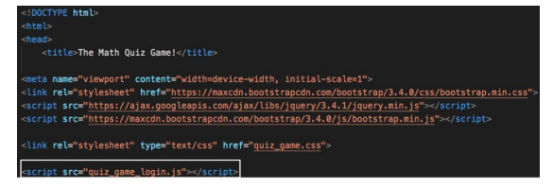

1. Create the **quiz_game_page.html**file for the game page.  
   So start coding in **quiz_game_login**.js file -  
   Add the addUser() function which is been called onclick of the login button from the login page.  
   So addUser() function takes value from the input boxes of player 1 and player 2 and add’s it in the local storage, and redirects to the **quiz_game_page.html**. This is already done in class 90 so it should not be difficult for you to do it.  
   **If you get stuck somewhere, you can refer to the game_login.js file from class 90, because almost everything is the same.**  
   After completing JS code for the game login page, start writing HTML code for **quiz_game_page.html**, which you just created.  
   This HTML page should have -  
   1. Bootstrap links  
   2. Your style sheet link, which you had created in the previous project. Like this

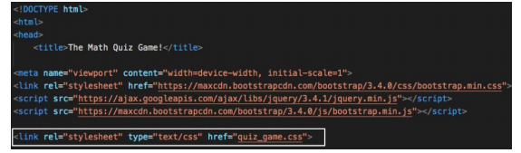

1. Your javascript link **(make a blank JS file and put the name of the file in this HTML file, we will do JS coding of this file in the next class)**, something like this -

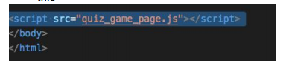  
Before the body ends

1. Now add HTML elements with id for holding the player 1 and player 2 name and their scores. Like this -  
   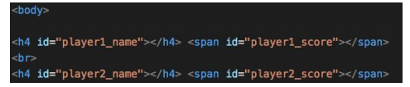

1. Create a div with the bootstrap class**container**, and create a**center** tag, and put all the HTML elements inside this.

1. Now add heading tag which is holding the heading of the game, this -  
     
   like this 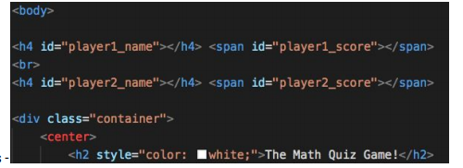
2. Then add heading elements with id, which will be used to hold the name of questioner and answer turn
3. Then a div with**id=’output’**, which will be used to store the question, input box for the answer and the check button, this -  
   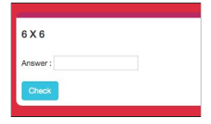  
   CSS for the above div  
   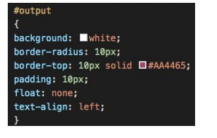

1. Then two headings and two input boxes for the numbers, like this - 

1. And in last there should be a send button, and give an on click function **send()** to it, this**send()** function we will write in the next class

For CSS you can refer to the**game.css** which has been downloaded by you in class 89.  
**If you get stuck somewhere, you can refer to the game_page.html file which has been downloaded by you in class 90, because almost everything is the same.**  
  
**Use you creativity and make this page look good.  
Style it your own way. Only remember it should have all the HTML elements as mentioned above**  
  
HINT - - Use bootstrap classes for making it responsive and look beautiful.

**Submitting the Project:**

- If you have created **project-math-quiz**folder on github then -  
  
Reupload all the files on which you have worked in the current project, in the **project-math-quiz** folder(this folder has been created by you in the previous project) on GitHub. You can get the steps to do this by clicking on this[link](https://s3-whitehatjrcontent.whjr.online/curriculum/ADV+Asset/Hosting+Website-GitHub.pdf)  
  
- If you have not created **project-math-quiz**folder on github then -  
  
Create a folder project-C89 and upload all the files related to the **project-math-quiz**project on GitHub. You can get the steps to do this by clicking on this[link](https://s3-whitehatjrcontent.whjr.online/curriculum/ADV+Asset/Hosting+Website-GitHub.pdf).  
  
Copy the hosted link which you will get after uploading all your files on GitHub and submit it in the Student Dashboard Projects panel against the correct class number.

**Start Your Project**

Read all the instructions carefully to understand the project

Click on "Start Project" to go to the project playground and start your project

[**Start Project**](https://code.whitehatjr.com/s/my-projects/view/d74a6377-dad5-4d65-af70-a8e9facb34f3)

**Submit Your Project**

Learn how to submit your project

Top of Form



Submit Project

Bottom of Form

**Class Summary**

This project is based on your last class ADV-C90