ADV-C91: THE MATH QUIZ-3

Pending Feedback

The Math Quiz

**INSTRUCTIONS:**

The output for the game page.

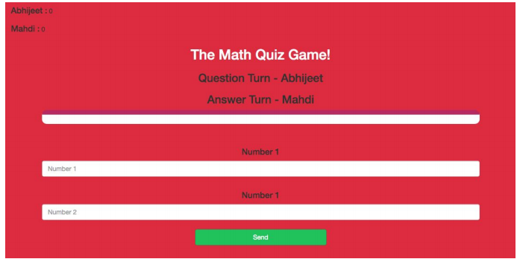

The output for the game page after giving the input

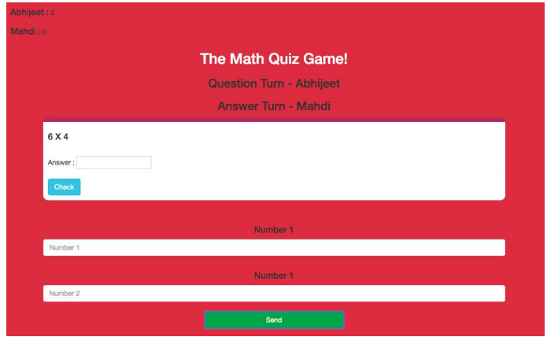

Click on the following link and play with your friend and you will understand the flow of the game. <https://jynyhy9vu5r8xz5zy0utww-on.drv.tw/project_C89_C90_C91_C92.com/game_page.html>

In this project, we will-

1. Write javascript code for the send() function, this function is called when send button is clicked from **quiz_game_page.html**
2. You need to write JS code in**quiz_game_page.js**, which you had created and gave a link in **quiz_game_page.html** like this -

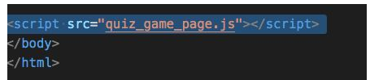  
In the previous project. Send function -

1. First, define the send() function



1. . Get the 2 numbers from the input box.

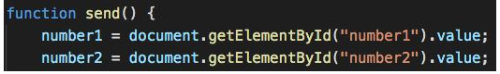

1. And do multiplication of this 2 number and store it inside a variable  
   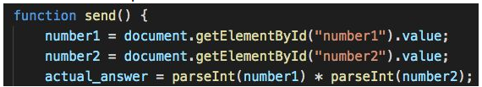

**parsInt()** is used to convert a String to Integer.  
Syntax of **parsInt()** - **parsInt(variable)** // This variable will contain a string.  
**String** means it’s a sentence.  
**Integer** means it’s a number.  
When we take value from an input box it’s a string, so first we will convert this string to an integer using **parsInt()**. Then we will multiply these 2 numbers.  
Now create the question div as per the image below -  
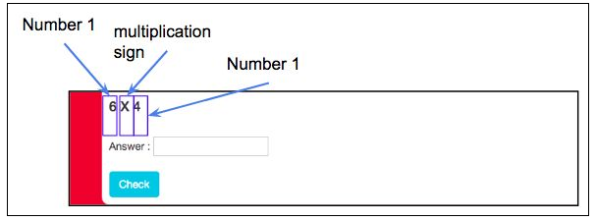

1. So first create a heading tag with will hold “ **Number1 X Number2”**, and store it inside a variable.



1. Then an input box for the answerer, and store it inside a variable. br> 
2. Then a check button, and store it inside a variable.  
   

1. Now put all these variables inside a single variable  
   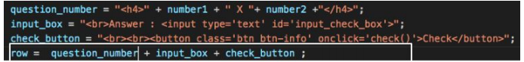

1. Now update the HTML element who has id=’output’, with this row variable 

1. Now make the value null of the two input boxes  
   

**If you get stuck somewhere, you can refer to the game_page.js file from class 91, because almost everything is the same.**

**Submitting the Project:**

- If you have created **project-math-quiz** folder on github then -  
  
Reupload **all the** files on which you have worked in the current project, in the **project-math-quiz** folder(this folder has been created by you in the previous project) on GitHub. You can get the steps to do this by clicking on this [link.](https://s3-whitehatjrcontent.whjr.online/curriculum/ADV+Asset/Hosting+Website-GitHub.pdf)  
  
- If you have not created **project-math-quiz** folder on github then -  
  
Create a folder project-C89 and upload all the files related to the **project-math-quiz** project on GitHub. You can get the steps to do this by clicking on this[link](https://s3-whitehatjrcontent.whjr.online/curriculum/ADV+Asset/Hosting+Website-GitHub.pdf).  
  
1. Upload this HTML file on google drive. You can get the steps to do this by clicking on the following link. <https://curriculum.whitehatjr.com/ADV+Asset/Project+asset/Hosting+Website.pdf>  
2. Copy the link which you will get after uploading your HTML file on google drive, and submit it in the Student Dashboard Projects panel against the correct class number.