PRACTICAL 9: To perform SQL operations using constraints.
Problem Statement 1: Create Tables using constraints.
Objective: To create different tables using SQL constraints.
Query:

CREATE TABLE Department (
DeptID INT PRIMARY KEY,
DeptName VARCHAR(50) NOT NULL UNIQUE,
HOD VARCHAR(50) NOT NULL
);

CREATE TABLE Student (
StudentID INT PRIMARY KEY,
StudentName VARCHAR(50) NOT NULL,
Email VARCHAR(100) UNIQUE,
Age INT CHECK (Age >= 17),
Gender ENUM('Male','Female','Other') NOT NULL,
City VARCHAR(40) DEFAULT 'Delhi',
DeptID INT,
FOREIGN KEY (DeptID) REFERENCES Department(DeptID)
);

CREATE TABLE Course (
CourseID INT PRIMARY KEY,
CourseName VARCHAR(60) NOT NULL UNIQUE,
Credits INT CHECK (Credits BETWEEN 2 AND 5)
);

CREATE TABLE Enrollment (
EnrollmentID INT AUTO_INCREMENT PRIMARY KEY,
StudentID INT,
CourseID INT,
Semester INT CHECK (Semester BETWEEN 1 AND 8),
Grade CHAR(2) DEFAULT 'NA',
FOREIGN KEY(StudentID) REFERENCES Student(StudentID),
FOREIGN KEY(CourseID) REFERENCES Course(CourseID)
);

Problem Statement 2: Insert Records.
Objective: To insert records into the created tables.
Query:

INSERT INTO Department VALUES
(101,'Computer Science','Dr. Rajesh Kumar'),
(102,'Information Technology','Dr. Anita Sharma'),
(103,'Electronics','Dr. Vivek Singh'),
(104,'Mechanical','Dr. Pooja Verma');

INSERT INTO Student(StudentID,StudentName,Email,Age,Gender,City,DeptID) VALUES
(1,'Aman Gupta','aman@gmail.com',19,'Male','Delhi',101),
(2,'Riya Sharma','riya@gmail.com',20,'Female','Noida',102),
(3,'Karan Singh','karan@gmail.com',18,'Male','Lucknow',101),
(4,'Neha Verma','neha@gmail.com',21,'Female','Delhi',103),
(5,'Arjun Mehta','arjun@gmail.com',22,'Male',DEFAULT,104);

INSERT INTO Course VALUES
(201,'Database Management System',4),
(202,'Operating System',4),
(203,'Computer Networks',3),
(204,'Data Structures',5);

INSERT INTO Enrollment(StudentID,CourseID,Semester,Grade) VALUES
(1,201,3,'A'),
(1,202,3,'B'),
(2,201,4,'A'),
(3,204,2,'B'),
(4,203,5,'A'),
(5,202,6,DEFAULT);

Problem Statement 3: Display all students
Objective: To display all student records.
Query:

Output:
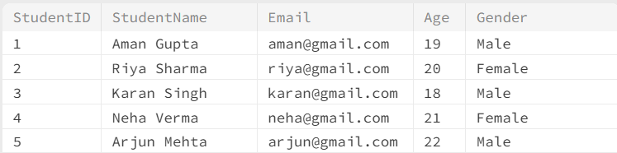

Problem Statement 4: Display only Student Name and Email
Objective: To display student names and email addresses.
Query:

Output:
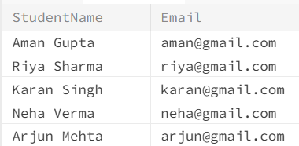

Problem Statement 5: Display students whose age is greater than 20
Objective: To display students whose age is greater than 20.
Query:

Output:

Problem Statement 6: Display students belonging to Computer Science Department
Objective: To display students belonging to the Computer Science department.
Query:

Output:

Problem Statement 7: Display students whose city is Delhi
Objective: To display students whose city is Delhi.
Query:

Output:
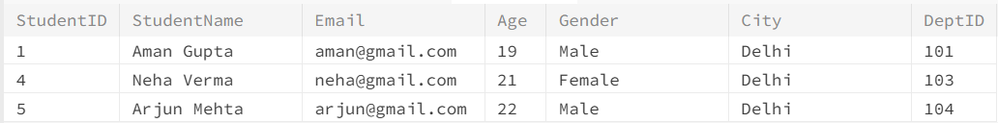

Problem Statement 8: Display students whose names start with 'A'
Objective: To display students whose names start with A.
Query:

Output:

Problem Statement 9: Display students aged between 18 and 21
Objective: To display students whose age is between 18 and 21.
Query:

Output:
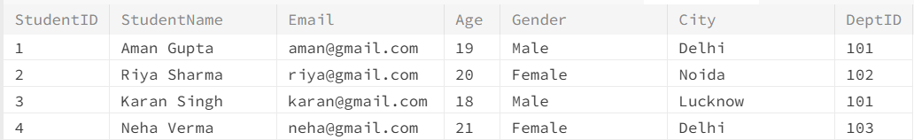

Problem Statement 10: Display students from Department 101 or 102
Objective: To display students from departments 101 or 102.
Query:

Output:
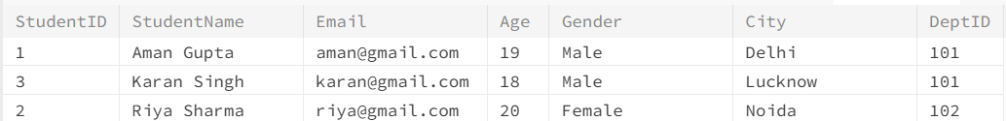

Problem Statement 11: Count the total number of students
Objective: To find the total number of students.
Query:

Output:
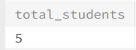

Problem Statement 12: Sort students according to age in descending order
Objective: To display students ordered by age in descending order.
Query:

Output:
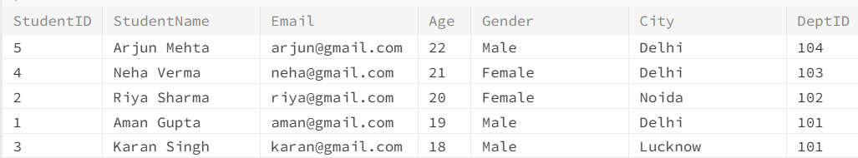

Problem Statement 13: Display maximum, minimum and average age
Objective: To find the maximum, minimum and average age of students.
Query:

Output:
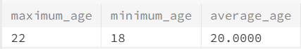

Problem Statement 14: Count number of students in each department
Objective: To find the number of students in each department.
Query:

Output:
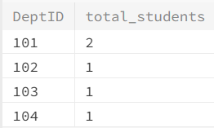

Problem Statement 15: Display departments having more than one student
Objective: To display departments having more than one student.
Query:

Output:
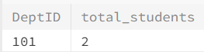

Problem Statement 16: Display student names along with their department names
Objective: To display student names with their department names.
Query:

Output:
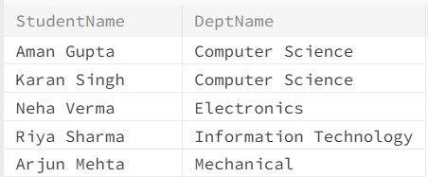

Problem Statement 17: Display student name, course name and grade
Objective: To display student name, course name and grade.
Query:

Output:
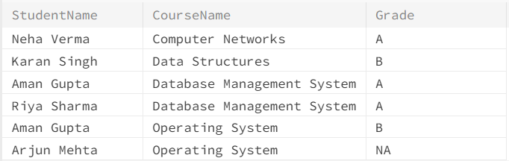

Problem Statement 18: Display all students enrolled in Database Management System
Objective: To display students enrolled in Database Management System.
Query:

Output:
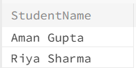

Problem Statement 19: Display students who have secured Grade 'A'
Objective: To display students who have secured Grade A.
Query:

Output:
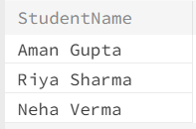

Problem Statement 20: Update city of Aman Gupta to Chandigarh
Objective: To update the city of Aman Gupta to Chandigarh.
Query:

Problem Statement 21: Delete the enrollment record of StudentID = 5
Objective: To delete the enrollment record of StudentID 5.
Query:

Problem Statement 22: Display students whose age is greater than the average age
Objective: To display students whose age is greater than the average age.
Query:

Output:

Problem Statement 23: Display all female students.
Objective: To display all female students.
Query:

Output:

Problem Statement 24: Find the oldest student.
Objective: To find the student with the highest age.
Query:

Output:

Problem Statement 25: Display department names with the number of students.
Objective: To display department names with the number of students.
Query:

Output:
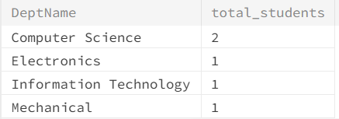

PRACTICAL 10: To perform SQL operations on Investor and Share_Transaction tables.
Problem Statement 1: Create tables Investor and Share_Transaction.
Objective: To create the required investor and share transaction tables.
Query:

CREATE TABLE Investor (
Investor_ID INT PRIMARY KEY,
Investor_Name VARCHAR(50) NOT NULL,
City VARCHAR(30) DEFAULT 'Delhi',
Email VARCHAR(60) UNIQUE,
Age INT CHECK (Age >= 18)
);

CREATE TABLE Share_Transaction (
Transaction_ID INT PRIMARY KEY,
Investor_ID INT NOT NULL,
Company_Name VARCHAR(50) NOT NULL,
Share_Type VARCHAR(20) CHECK (Share_Type IN ('BUY', 'SELL')),
Quantity INT CHECK (Quantity > 0),
Price_Per_Share DECIMAL(10,2) CHECK (Price_Per_Share > 0),
Transaction_Date DATE NOT NULL,
FOREIGN KEY (Investor_ID) REFERENCES Investor(Investor_ID)
);

Problem Statement 2: Insert Records.
Objective: To insert investor and share transaction records into the tables.
Query:

INSERT INTO Investor (Investor_ID, Investor_Name, City, Email, Age) VALUES
(101, 'Amit Sharma', 'Delhi', 'amit@gmail.com', 35),
(102, 'Neha Gupta', 'Mumbai', 'neha@gmail.com', 29),
(103, 'Rahul Verma', 'Dehradun', 'rahul@gmail.com', 42),
(104, 'Priya Singh', 'Pune', 'priya@gmail.com', 31),
(105, 'Karan Mehta', 'Delhi', 'karan@gmail.com', 45),
(106, 'Sneha Kapoor', 'Jaipur', 'sneha@gmail.com', 27);

INSERT INTO Share_Transaction
(Transaction_ID, Investor_ID, Company_Name, Share_Type, Quantity, Price_Per_Share, Transaction_Date)
VALUES
(1001, 101, 'TCS', 'BUY', 50, 3500.00, '2026-08-01'),
(1002, 102, 'Infosys', 'BUY', 100, 1800.00, '2026-08-02'),
(1003, 103, 'Reliance', 'BUY', 75, 2900.00, '2026-08-03'),
(1004, 101, 'Infosys', 'SELL', 30, 1900.00, '2026-08-05'),
(1005, 104, 'TCS', 'BUY', 40, 3600.00, '2026-08-06'),
(1006, 105, 'HDFC Bank', 'BUY', 120, 1700.00, '2026-08-07'),
(1007, 102, 'TCS', 'SELL', 20, 3700.00, '2026-08-08'),
(1008, 103, 'HDFC Bank', 'BUY', 60, 1750.00, '2026-08-09'),
(1009, 104, 'Reliance', 'SELL', 25, 3000.00, '2026-08-10'),
(1010, 105, 'Infosys', 'BUY', 80, 1850.00, '2026-08-11');

Problem Statement 3: Display all investors
Objective: To display all investor records.
Query:

Output:
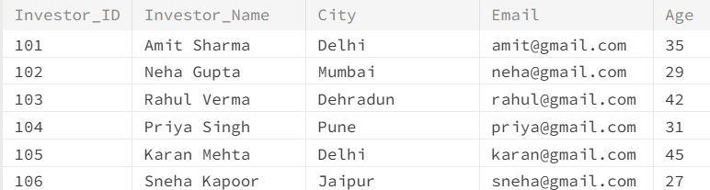

Problem Statement 4: Find the total number of investors
Objective: To find the total number of investors.
Query:

Output:
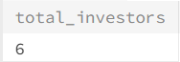

Problem Statement 5: Find the average age of investors
Objective: To find the average age of all investors.
Query:

Output:
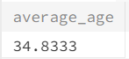

Problem Statement 6: Find the highest and lowest share price
Objective: To find the highest and lowest price per share.
Query:

Output:
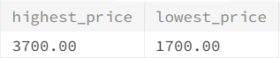

Problem Statement 7: Find total quantity of shares traded by each company
Objective: To find the total quantity of shares traded by each company.
Query:

Output:
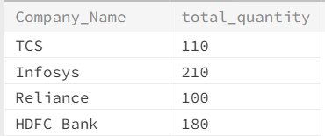

Problem Statement 8: Display investor names along with their share transactions
Objective: To display investor names along with their share transaction details.
Query:

Output:
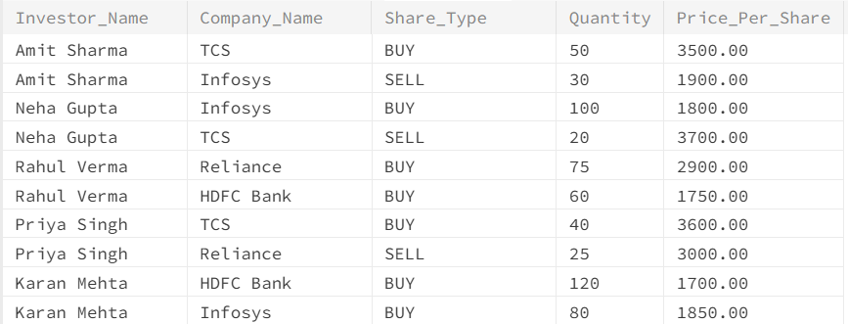
Problem Statement 9: Display all investors, including investors who have not made any transaction
Objective: To display all investors including those without transactions.
Query:

Output:
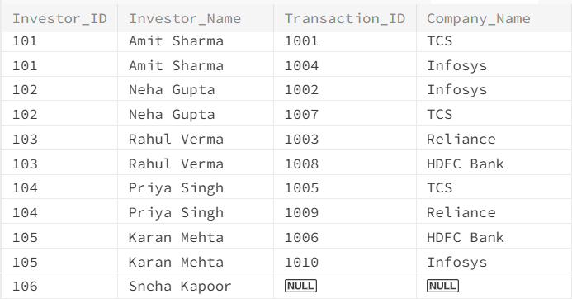

Problem Statement 10: Display all transactions and their corresponding investor information
Objective: To display all transactions with corresponding investor information.
Query:

Output:
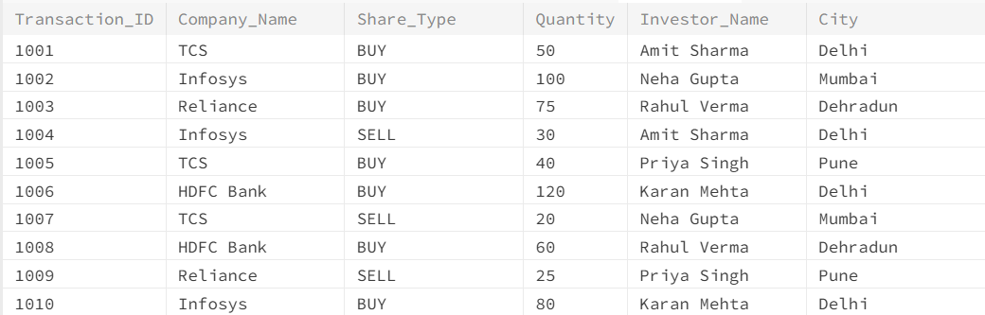

Problem Statement 11: Display all investors and all transactions, whether or not they have a match
Objective: To display all investors and transactions including unmatched records.
Query:

Output:
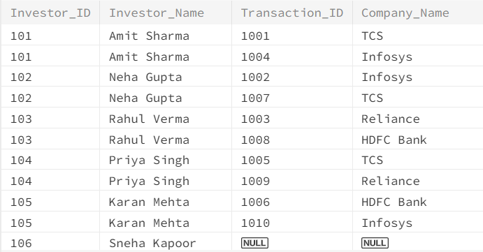

Problem Statement 12: Find the total investment value made by each investor
Objective: To find the total investment value made by each investor.
Query:

Output:
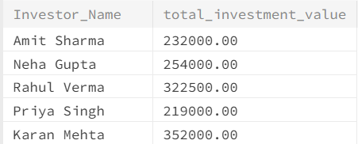

PRACTICAL 11: To perform SQL operations using Nested Queries.
Problem Statement 1: Create Tables Employee and Department.
Objective: To create the required Employee and Department tables.
Query:

CREATE TABLE Employee (
EmpID INT PRIMARY KEY,
Name VARCHAR(50),
Age INT,
Salary DECIMAL(10,2),
DeptID INT
);
CREATE TABLE Department (
DeptID INT PRIMARY KEY,
DeptName VARCHAR(50),
Location VARCHAR(50)
);

Problem Statement 2: Insert Records.
Objective: To insert employee and department records into the tables.
Query:

INSERT INTO Employee VALUES
(1, 'Ramesh', 30, 40000, 101),
(2, 'Suresh', 28, 35000, 102),
(3, 'Priya', 35, 50000, 101),
(4, 'Neha', 40, 60000, 103),
(5, 'Amit', 25, 30000, 102),
(6, 'Kiran', 32, 45000, 101);

INSERT INTO Department VALUES
(101, 'HR', 'Delhi'),
(102, 'IT', 'Mumbai'),
(103, 'Finance', 'Bangalore');

Problem Statement 3: Find employees whose salary is greater than double the average salary of IT department.
Objective: To find employees earning more than twice the average IT department salary.
Query:

Output:
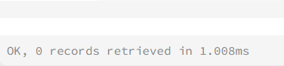
Problem Statement 4: List employees whose age is less than half of the maximum age in HR department.
Objective: To find employees whose age is less than half the maximum HR department age.
Query:

Output:

Problem Statement 5: Find employees earning more than (minimum salary) of Finance department.
Objective: To find employees earning more than the minimum Finance department salary.
Query:

Output:

Problem Statement 6: Find employees whose salary is less than (average salary) of HR department.
Objective: To find employees earning less than the average HR department salary.
Query:

Output:
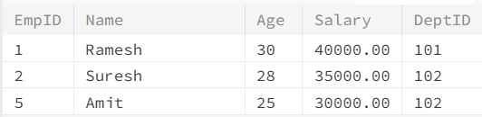

Problem Statement 7: Find employees whose salary is greater than 1.5 times the average salary across all departments.
Objective: To find employees earning more than 1.5 times the overall average salary.
Query:

Output:

Problem Statement 8: List employees older than (minimum age) in IT department.
Objective: To find employees older than the minimum age in the IT department.
Query:

Output:
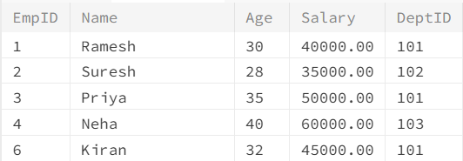

Problem Statement 9: Find employees with salary equal to (average salary) in HR department.
Objective: To find employees whose salary equals the average HR department salary.
Query:

Output:
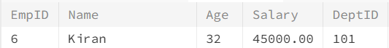

Problem Statement 10: Find employees whose salary is greater than (max salary – min salary) in IT department.
Objective: To find employees earning more than the salary range of the IT department.
Query:

Output:
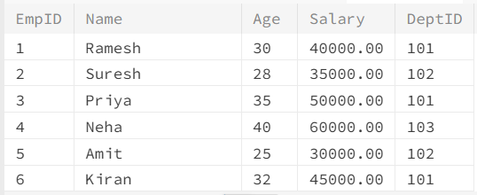

Problem Statement 11: Find employees whose salary is less than (average salary / 2) of all employees.
Objective: To find employees earning less than half of the average salary.
Query:

Output:

Problem Statement 12: Find employees whose age is greater than (average age + 5) in HR department.
Objective: To find employees whose age is more than 5 above the HR department average age.
Query:

Output:
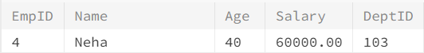

PRACTICAL 12: To perform SQL operations using ANY and ALL nested queries.
Problem Statement 1: Create Tables Department, Employee and Project.
Objective: To create the required Department, Employee and Project tables.
Query:

CREATE TABLE Department (
DeptID INT PRIMARY KEY,
DeptName VARCHAR(30),
Location VARCHAR(30)
);

CREATE TABLE Employee (
EmpID INT PRIMARY KEY,
EmpName VARCHAR(30),
DeptID INT,
Salary INT,
JobTitle VARCHAR(30),
FOREIGN KEY (DeptID) REFERENCES Department(DeptID)
);

CREATE TABLE Project (
ProjID INT PRIMARY KEY,
ProjName VARCHAR(40),
DeptID INT,
Budget INT,
FOREIGN KEY (DeptID) REFERENCES Department(DeptID)
);

Problem Statement 2: Insert Records.
Objective: To insert department, employee and project records into the tables.
Query:

INSERT INTO Department VALUES
(1, 'HR', 'Delhi'),
(2, 'Finance', 'Mumbai'),
(3, 'IT', 'Bangalore'),
(4, 'Sales', 'Chennai'),
(5, 'Marketing', 'Pune');

INSERT INTO Employee VALUES
(101, 'Amit', 1, 35000, 'HR Executive'),
(102, 'Riya', 2, 50000, 'Accountant'),
(103, 'Raj', 3, 70000, 'Developer'),
(104, 'Neha', 3, 80000, 'Team Lead'),
(105, 'Arjun', 4, 45000, 'Sales Executive'),
(106, 'Kiran', 4, 60000, 'Sales Manager'),
(107, 'Simran', 5, 40000, 'Marketing Analyst'),
(108, 'Tina', 2, 65000, 'Financial Analyst'),
(109, 'Vivek', 3, 90000, 'System Architect'),
(110, 'Manoj', 1, 30000, 'HR Assistant');

INSERT INTO Project VALUES
(201, 'Payroll Automation', 3, 120000),
(202, 'Recruitment Portal', 1, 80000),
(203, 'Market Research', 5, 50000),
(204, 'Sales Dashboard', 4, 90000),
(205, 'Finance Audit', 2, 100000);

Problem Statement 3: Employees earning more than ANY HR employee.
Objective: To find employees earning more than at least one HR employee.
Query:

Output:
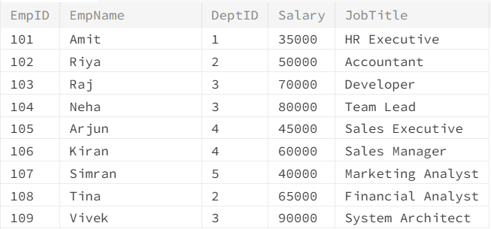

Problem Statement 4: Employees earning more than ALL employees in Sales.
Objective: To find employees earning more than every employee in Sales.
Query:

Output:
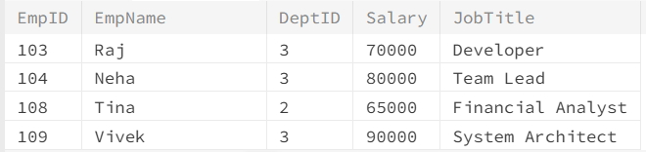

Problem Statement 5: Departments having projects.
Objective: To find departments that have at least one project.
Query:

Output:
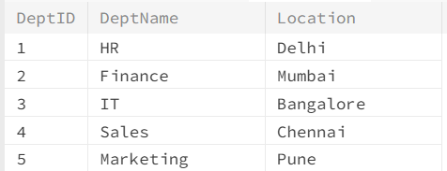

Problem Statement 6: Departments with no projects.
Objective: To find departments that do not have any projects.
Query:

Output:
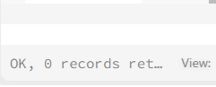

Problem Statement 7: Employees working in departments having projects.
Objective: To find employees working in departments that have projects.
Query:

Output:
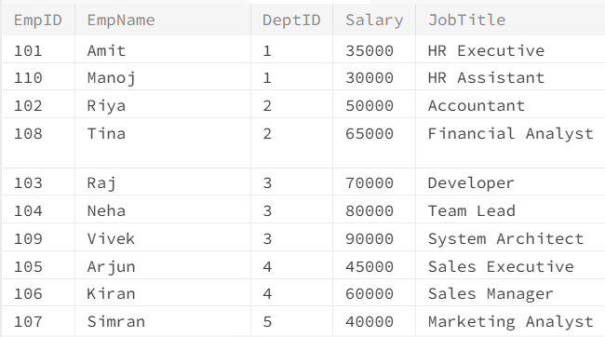

Problem Statement 8: Employees not working in departments having projects.
Objective: To find employees working in departments that have no projects.
Query:

Output:

Problem Statement 9: Employees who earn more than ALL employees in Finance.
Objective: To find employees earning more than every Finance employee.
Query:

Output:
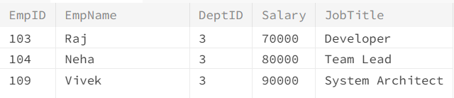

Problem Statement 10: Employees whose salary equals ANY Finance employee’s salary.
Objective: To find employees whose salary matches at least one Finance employee's salary.
Query:

Output:
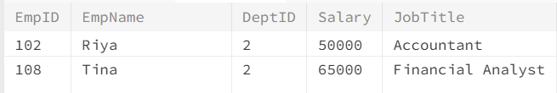

Problem Statement 11: Projects handled by departments that have employees.
Objective: To find projects handled by departments having employees.
Query:

Output:
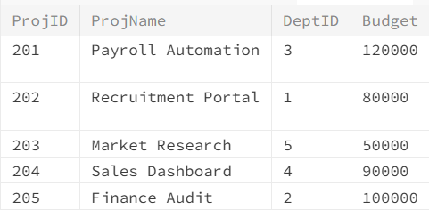

Problem Statement 12: Employees in departments located in Bangalore.
Objective: To find employees working in departments located in Bangalore.
Query:

Output:
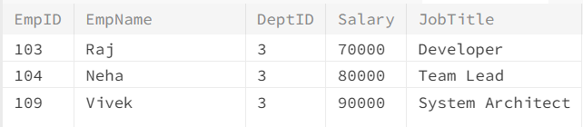

Problem Statement 13: Employees earning less than ANY IT employee.
Objective: To find employees earning less than at least one IT employee.
Query:

Output:
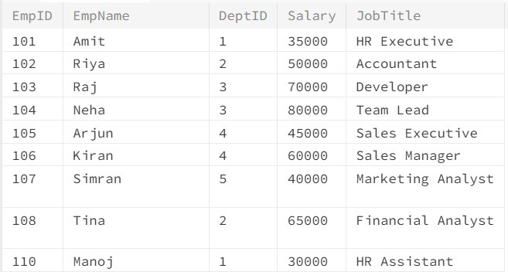
Problem Statement 14: Employees whose department has a project budget > 90000.
Objective: To find employees whose department has a project with budget above 90000.
Query:

Output:
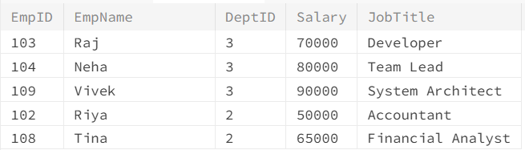

Problem Statement 15: Employees in departments that do NOT have projects > 60000.
Objective: To find employees whose departments have no project with budget above 60000.
Query:

Output:
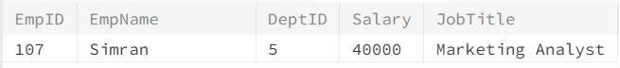

Problem Statement 16: Departments that have employees earning above 75000.
Objective: To find departments having employees with salary above 75000.
Query:

Output:
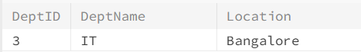

Problem Statement 17: Employees whose salary is greater than ALL average salaries of each department.
Objective: To find employees earning more than every department's average salary.
Query:

Output:
