14. Create a sign up form like below.

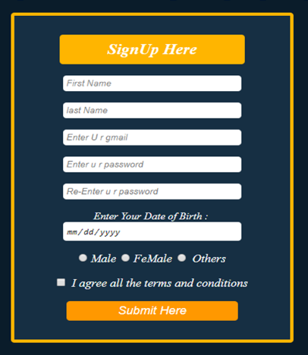

15.Create this UI as it is. Try using same background color and text color. Use FlexBox.

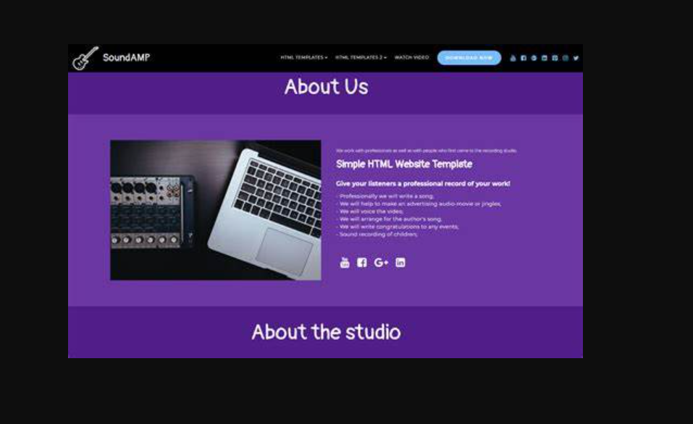

17. Create this page using HTML5 and CSS3.

Q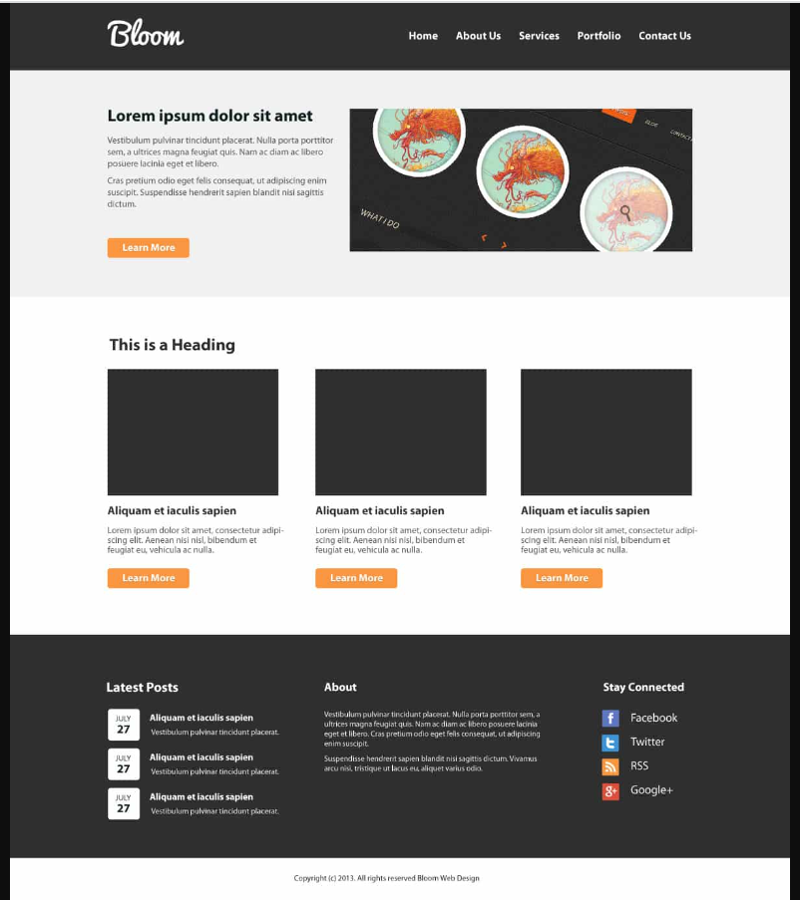

18. Create this page using html5 and css3.

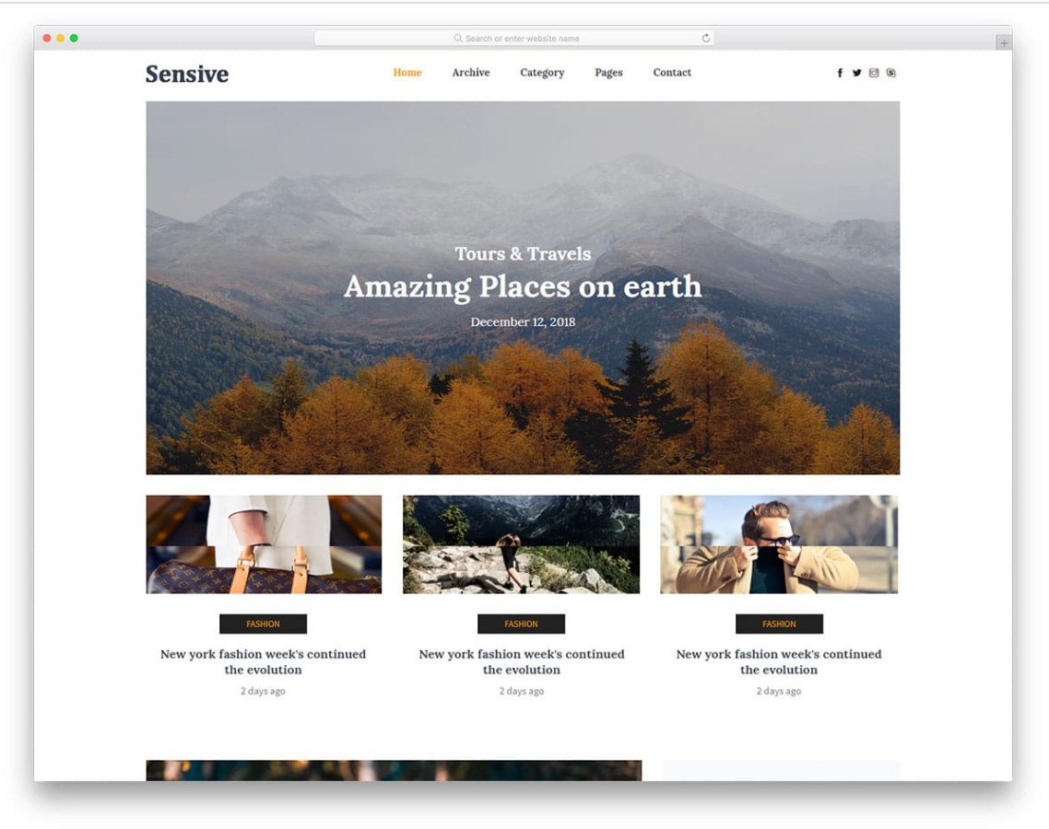

19.Create this page layout using.(Note:4 version of this page should get created)

(i) Using Float

(ii)Using position

(iii)Using Flex

(iv)Using Css Grid

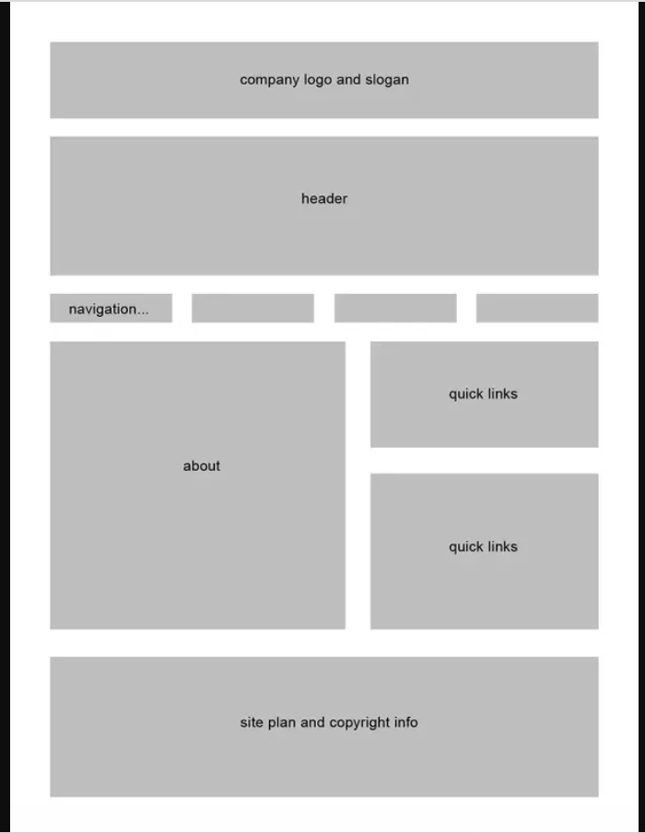

20.Create the layout using HTML5 and CSS3.

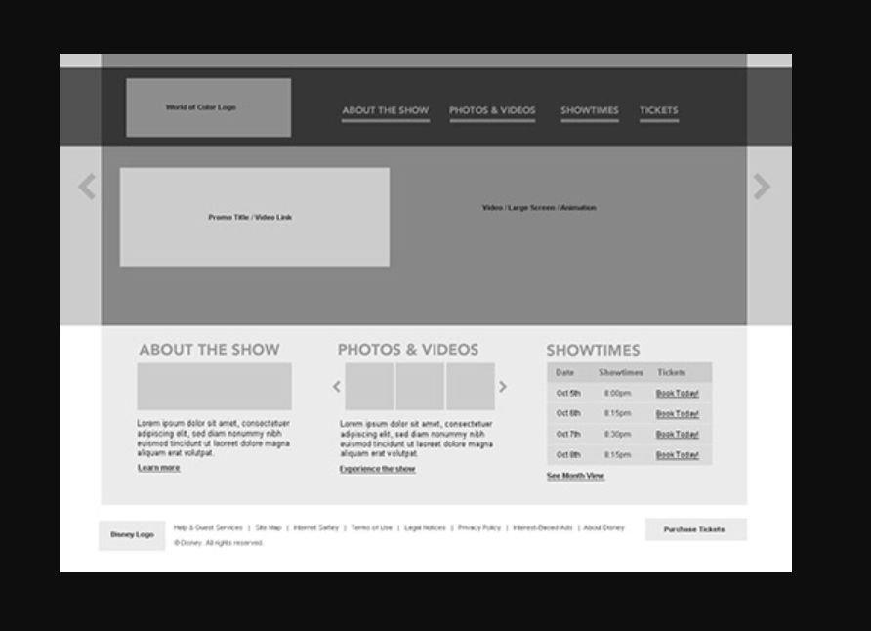

21.Create the below layout as it is. Use all the icons. The UI should be same in your end product.

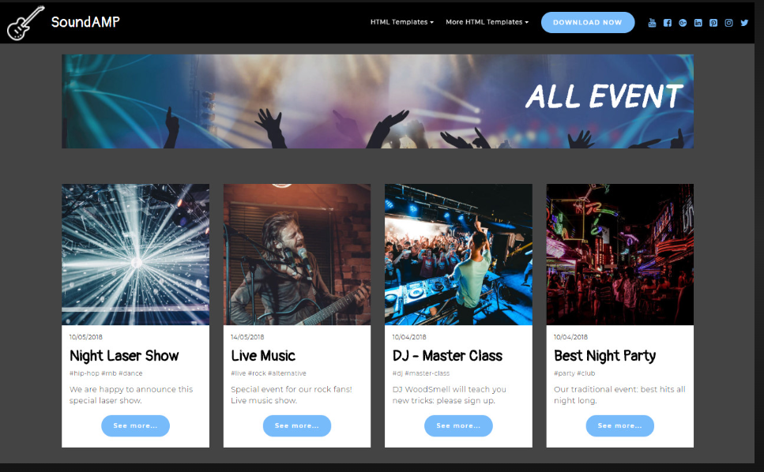

22.Create the layout as it is?



23.Try to imitate the layout .Note(background image can be different. But Laout must be same)

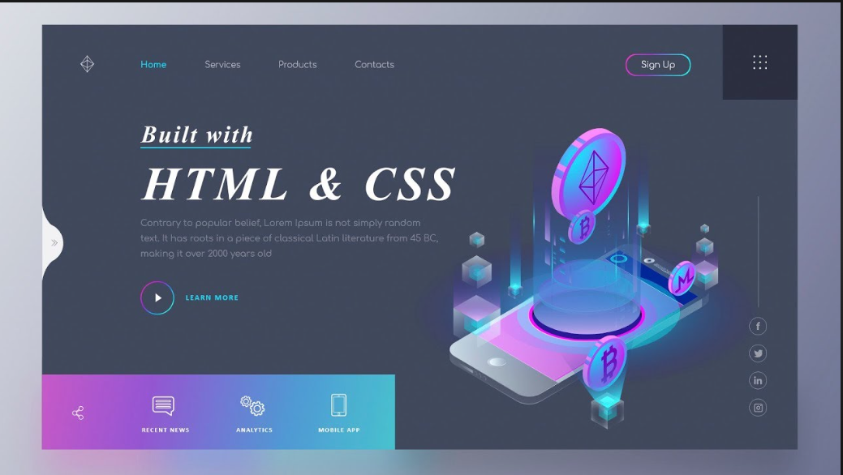

24.Create this layout as it is?

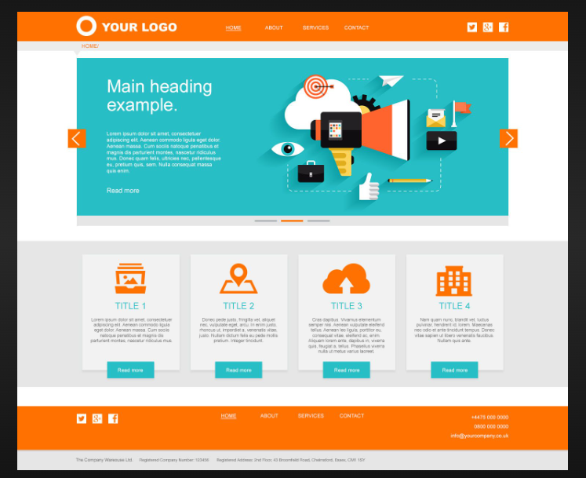

25.Create this layout as it is.

