Problem Description:

XXX University wants to automate the process of registering students to different courses. The CourseRegistration class has been created to help in the process of course registration. The class diagram is given below:

CourseRegistration:

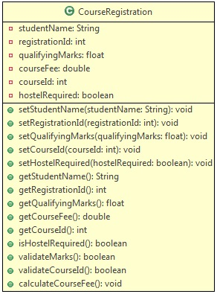

A student is eligible to get admission only if the qualifying marks is in the range of 65 to 100(both inclusive). At present, the university offers five courses with course ids in the range 1001 to 1005(both inclusive). Based on the marks in the qualifying exam, a discount is provided in the course fee. Use the table below to determine the discount:

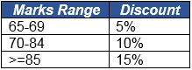

Use the table below to get the base fee of different courses:

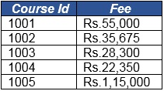

Method Description:

* validateMarks(): Used to validate qualifying exam marks - qualifying marks is in the range of 65 to 100(both inclusive)
* validateCourseId(): Used to validate the course entered, based on the courseId - given in the table above
* calculateCourseFee(): Used to calculate the course fee after applying the discount.

Use the Tester class to set the values and call appropriate methods to display the outputs for the inputs mentioned below:

Sample:

Input 1:

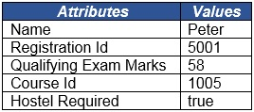

Output:



Input 2:

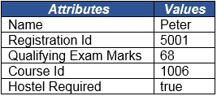

Output:



Input 3:

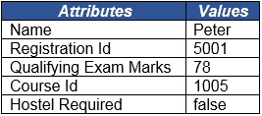

Output:

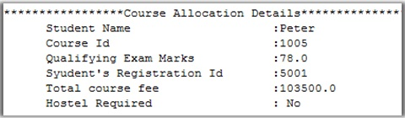

Create a Java Project and implement the given requirements.