Problem Description:

EPay Wallet is a wallet application using which its users can pay various bills. Users can make payments only if they have enough wallet balance.

There are two kinds of users as illustrated by the class diagrams below. General users can make regular payments, whereas KYC users get reward points for every payment.

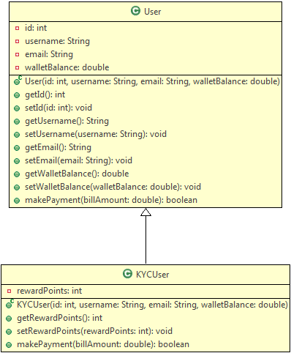

Method Description:

User:

makePayment(double billAmount): This method makes payment by deducting the bill amount from wallet if there is enough balance.

* If the balance is not enough, it returns false
* If the balance is sufficient, it deducts the specified bill amount from the wallet and returns true

KYCUser:

makePayment(double billAmount): This method overrides the parent method to make payment as well as to credit reward points to the user.

* It uses the payment functionality of the parent class
* If payment is successful, it adds 10% of the bill amount as reward points
* It returns true or false depending on whether the payment was successful or not

The primary EPay Wallet operations (currently only one) are to be defined in a separate class as follows:



Method Description:

processPaymentByUser(User user, double billAmount): This is a static method to process the bill payment by any EPay Wallet user.

* It uses the makePayment() method of the user to process payments, and displays success or error messages depending on whether the payment was successful or not.
* It shows the wallet balance of the user
* If the user is a KYC user, it shows the reward points as well

Note:

* Have a look at the sample output to understand the messages to be displayed
* You can use Java's instanceOf operator to check the type of an object

Use the Tester class to test the above functionalities. Create User and KYCUser objects with different values and call the processPaymentByUser() method of EPayWallet class to process payments.

Sample Input:

User:

|  |  |
| --- | --- |
| id | 101 |
| username | Jack |
| email | jack@infy.com |
| walletBalance | 1000 |

KYCUser:

|  |  |
| --- | --- |
| id | 201 |
| username | Jill |
| email | jill@infy.com |
| walletBalance | 3000 |

Sample payments:

|  |  |
| --- | --- |
| Jack | 700 |
| Jill | 1500 |
| Jill | 800 |
| Jill | 1200 |

Sample Output:

1. Congratulations Jack, payment of 700.0 was successful
2. Your wallet balance is 300.0
3. --------------------------------------------
4. Congratulations Jill, payment of 1500.0 was successful
5. Your wallet balance is 1500.0
6. You have 150 reward points
7. --------------------------------------------
8. Congratulations Jill, payment of 800.0 was successful
9. Your wallet balance is 700.0
10. You have 230 reward points
11. --------------------------------------------
12. Sorry Jill, not enough balance to make payment
13. Your wallet balance is 700.0
14. You have 230 reward points
15. --------------------------------------------

Create a new Java project to implement the requirements given above.