深圳大学考试答题纸
(以论文、报告等形式考核专用)
二○二一～二○二二 学年度第 2 学期
课程编号 | 9000020001 |  | 课序号 |  | 01 |  | 课程名称 |  | 国际教育与跨文化交流 |  | 主讲教师 | 彭小刚 |  | 评分
学 号 | 2017303010 |  |  | 姓名 |  | 刘俊楠 |  | 专业年级 |  | 计算机科学与技术 大三
教师评语：
题目： |  | 留学申请

目标学校与选择理由

目标院校

格拉斯哥大学，又称University of Glasgow，qs前100大学，并且计算机专业为强势专业。

选择理由：

Qs排名较高（qs 73名），学校IT相关专业强势，可以学到东西。

格拉斯哥大学的IT课程偏重于编程，旨在研究计算机系统的基本原理，并且鼓励学生通过项目与实习增进理解，这有利于我毕业后快速找到好工作。

我当前绩点在3.5/4.5 左右，所以格拉斯哥属于一个比较稳的学校，所以想充分准备一下。

格拉斯哥大学的一个专业特别契合我的职业规划，也就是COMPUTER SYSTEMS ENGINEERING专业，其面向嵌入式开发，可以让我在嵌入式开发的路上越走越远。

个人声明PS
Personal Statement

My interest in computer and computer systems engineering started at a young age and developed throughout my school years, which had been augmented at every opportunity by hands-on experience on this magic box. Having studied computer science and technology for almost four years, I realize that computer science plays a critical role in the development of science and technology. Pursuing a career in the information industry has been my dream for years. Holding to be an expert in this field, I feel the urgent need to further study in your esteemed program and get a master’s degree. Therefore, I am applying for your MSc Computer Systems Engineering, in the hope of enhancing my systematic understanding of this field, knowing better about its development and evaluation, and acquiring new insights.

Through the studies of BEng of Computer Science and Technology at the Shenzhen University, I was trained in basics courses of University Physics, Linear Algebra, Discrete Mathematics, Automata and Formal Languages, Data Structures, Algorithms, Databases, Operating Systems, Parallel Computing and Computer Systems, which laid a solid base for my further study in engineering and strengthened my logical thinking mind. I have always excelled in mathematics and programming and enjoyed taking up the challenges that constantly presented to me in this field. For example, I won Winner Award in National University Student Operating System Ability Competition. Our project name was Porting of RISC-V operating system based on K210 development Board. In the process, I gained a deeper understanding of RISC-V and the process of setting up a operating system, which ignited my interests to explore more in the field of operating system. My love for math and programming, and my innate gift in these areas, greatly assisted my undergraduate studies. During my undergraduate years, I immersed myself in the process of learning various theories from different subjects such as Computer Networks, Introduction to Computer Security and Introduction to Multimedia Technology. Furthermore, I have learned programming skills like applying C language, C++ and JAVA. Moreover, I honed my analytical thinking in modeling and analysis.

Progressively, with the growing inquisitiveness about computer system, my exploration extended from the classroom to the events outside. For example, I worked as an embedded software developer in Guangzhou Yaoerge Technology Co., Ltd. I actively participated in this internship and developed a smart desktop based on Harmony Operating system and hi3861 chip. Honestly, it was a challenge for me at first, but I really enjoyed it and got integrated into the new environment later. I was involved in the whole process of choosing chips, product design and getting to know ICC agreement and advantages of Harmony OS. The smart desktops were about to go into mass production. Recently I joined the Pacific Business Solutions as an intern of embedded software. The participation of the design of embedded software consolidated my skills in system development. All these experiences should have consolidated my overall competitiveness in facing challenges in future workplaces.

Upon graduation, I will strive to get a position in the area of technical research and development in the IT industry, where I could combine the computer related knowledge I have learned with my professional skills, and apply them to the development of information engineering. I am quite interested in the field of embedded system and I found it is vital for me to gain further knowledge in the embedded development.

I am eager to be admitted into your honoured program of Computer Systems Engineering and I am confident that I have the necessary academic background, capacity, and potential to further my study. I believe this is definitely a promising field. I know your program provides an extensive introduction to state-of-the-art miniaturied and mobile computer systems and smart device technology,which will equip me with the advanced training I vitally need to launch a successful career. Besides, the program will provide essential skills of hardware and software knowledge and developing such systems, which will improve my employment competitiveness. I believe Master of Science program of Computer Systems Engineering at the University of Glasgow will be an ideal choice for me, and I would appreciate it if you would favourably consider my application.

个人简历CV
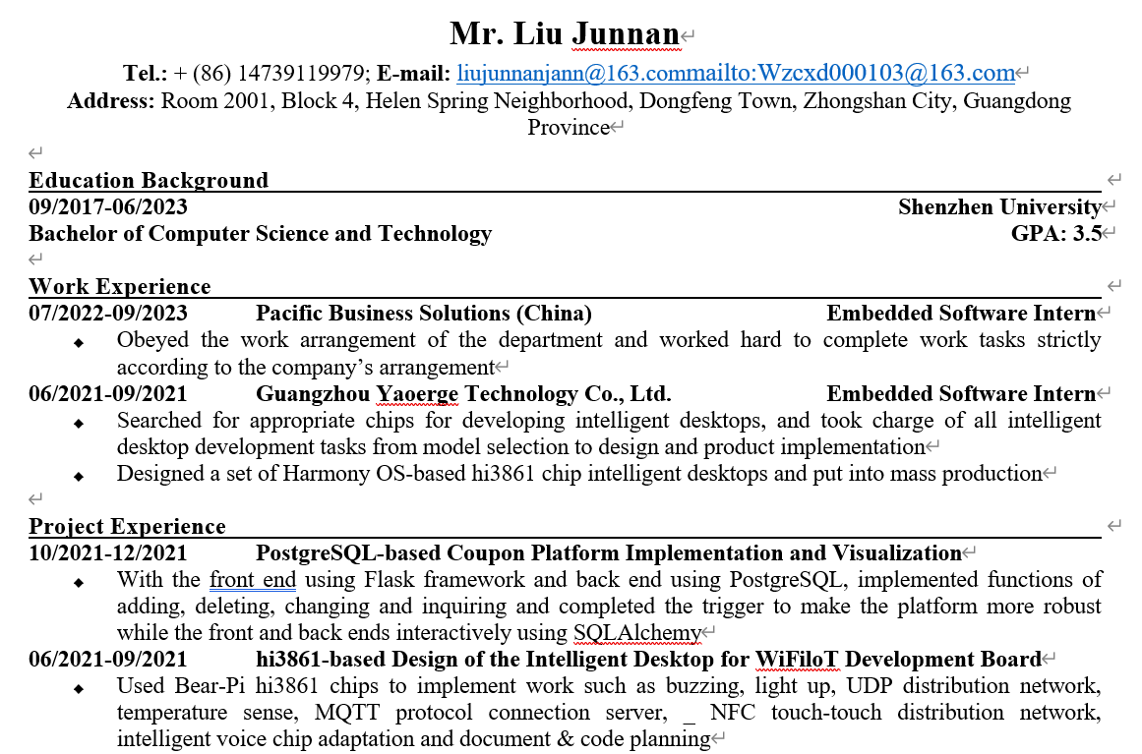
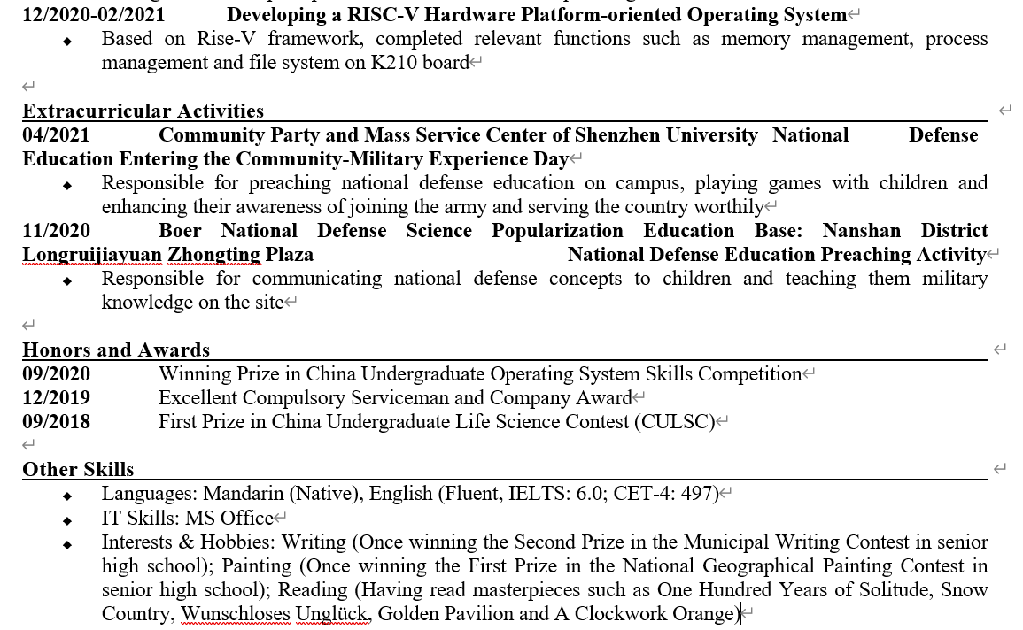

推荐信

罗秋明老师的推荐信
Letter of Recommendation

Dear admission officer，

Mr. Liu Junnan is one of my outstanding students who took the courses of mine: Computer System 2, Computer System 3, and Operating System. He scored A in all of those courses, which could be rated to the top 5% of the students. After knowing him for two years, I’ m clear about his great talent, and I’d like to share my perspective with you.

I got acquainted with him due to his active participation in answering questions in my class. For example, he explained his understanding of the thinking methods about operating system, and didn’t merely recite books. I was deeply impressed by his quick absorption of new knowledge, and nice delivery.

In my course, I asked the students to be brave and take challenges in unknown fields . He cooperated with two of his team members and won the Winner Award in National University Student Operating System Ability Competition. Their project name was Porting of riscv operating system based on K210 development Board. He divided their work and distributed different works to his teammates according to their strengths. I believe he improved his knowledge in the memory management, scheduling, startup of xv6.

Moreover, he showed strong study initiatives. For example, he was relatively weak in his knowledge of operating system. Most students may find the homework was difficult since my classes were fast paced. However, his homework was all completed with high quality in terms of code quality. With time elapsing, I discovered precious qualities in him, such as academic potential and the ability of independent learning.

His excellent grasp of knowledge and learning ability would be a solid foundation for his future studies. Based on his performance here, I think he has shown promising potential in the field, and therefore, I highly recommend him to your graduate program.

Luo Qiuming
Associate Professor
National High Performance Computing Center Shenzhen Branch
Shenzhen University
Email:lqm@szu.edu.cn
Tel: +86-0755-26925370
Address: Room 505, Zhizhen Building, Shenzhen University, Yuehai Street, Nanshan, Shenzhen

秦建斌老师的推荐信
Letter of Recommendation

Dear Admission Committee,

As the distinguished professor of the Shenzhen University, I am happy to recommend Mr. Liu Junnan, an outstanding senior student of our department, to pursue his postgraduate study at your department.

I have known Mr. Liu since Sep 2021, when he took my course of Database System. He drew my attention for the first time when he came to me and consulted about postgresql, which was used in his project of a coupon platform. It appeared to me that he really had some deep thoughts about postgresql. Our discussion for his question seemed to enlighten him a bit. Later on, he kept coming to me for some theoretical questions and had lively discussions with me. In a word, Mr. Liu was very inquisitive in this regard.

Mr. Liu has impressed me a lot with his exploration spirit in the learning process, and I gave him high marks of A for his excellent academic performance in my courses. I recalled that once I put a question in my class about 3NF and BCNF. Mr. Liu raised his hand without hesitation and gave out a very convincing answer. His answer was quite impressive when coming out from a senior student. Later, he told me that he spent a lot of time to understand the underlying principles of each technology. His exploration spirit set a good example for the class, which showed that students should harbor certain curiosity in the learning process, and learn how to satisfy their eager for knowledge that sits deeper than that of textbooks.

He would write a explanation document to help other group members who have no ideas to write the trigger in order to improve the robustness of the database. Moreover, he actively answered other students’ questions in our online discussion group.

With what has been stated above, I deem that Mr. Liu is capable of doing some researches on academic topics independently and his depth of thinking can meet the requirements of postgraduate study. So, I believe he will be a suitable candidate for your program.

Yours sincerely,
Qin Jianbin
Distinguished Professor
National High Performance Computing Center, Shenzhen University
Telephone: +86-0755-26901504
Email: qinjianbin@szu.edu.cn
Address: Room 708, Zhizhen Building, Shenzhen University, Yuehai Street, Nanshan, Shenzhen

