ELEC5566M

FPGA Design for System on Chip

Assignment 1: 2-Bit x 3-Bit Multiplier

**201715540**

**Junnan Liu**

**el23jl2@leeds.ac.uk**

**GitHub username: JannLeo**

# Abstract

* This report illustrates the process and findings of designing a 2-Bit x 3-Bit Binary Multiplier using Gate Level Verilog for the system on a chip. The purpose of the project was to design, implement, and verify a functional binary multiplier. The design was synthesized at a gate level, obeying by a hierarchical system using appropriate analysis and synthesis tools. Post the synthesis, the design was tested and validated on a testbed.

# Introduction

* Digital circuit design and FPGA programming are significant applications in Modern electricity and electronic engineering. Furthermore, the multiplier is the core components among many complex systems and algorithms. And consequently, designing and achieving 2 bits by 3 bits multiplier not only can improve the ability of hardware design and skills of programming, but also can improve the ability to understand the complex algorithms.

# Discussion/analysis

## Discussion about the Implementation principle

* + The describes of following files are provided in Table 1 Description of project-related documents. After knowing the variables of multiplier, we need to know the structure of the 2-Bit by 3-Bit Multiplier. As the figure shown in Figure 1 The mark of 2-Bit by 3-Bit Multiplier Structure, we can see there have 4 parts need us to achieve. Thus, we need to figure out what input and output of these multiplier in submodule.

##### To calculate the p0, the p0 is easy to calculate since it is equal to m0 x q0.

* + To calculate the p1, according to the Figure 2 Submodule for First Row of Multiplier, we can see the Function of this struct is to calculate S and Cout through Table 2 The meanings of different variable in Submodule for First Row of Multiplier.
    - According to the principle of above figure, the picture shown in the Figure 3 The process of the 1st.First Row of Multiplier illustrates the theory of the 1st.First Row of Multiplier. The red frame is just like the function of 1st.First Row of Multiplier (Also it generates the carry to 2nd.First Row of Multiplier).
  + The main function of 2nd.First Row of Multiplier is to add the carry of last part (calculate P1) and m1 x q1 to generate the S and carry to 3rd.Remaining Rows of Multiplier to calculated (As the figure shown in Figure 4 The process of the 2nd.First Row of Multiplier).
  + To calculate the p3 and p4, we need to see the structure of Remaining Rows of Multiplier in Figure 5 The structure of Remaining Rows of Multiplier.
  + We can see the Function of this struct is to calculate S and Cout through Table 3 The meanings of different variable in Remaining Rows of Multiplier.

##### According to the principle of Table 3 The meanings of different variable in Remaining Rows of Multiplier, the picture shown in Figure 6 The theory of the 3rd.Remaining Rows of Multiplier illustrate the theory of the 3rd.Remaining Rows of Multiplier. The red frame shown is to show the main function of 3rd.Remaining Rows of Multiplier is to calculate p2 = carry + m1 x q1 + m0 x q2.

* As for p3 and p4, it is be calculated in 4th. Remaining Rows of Multiplier. The 4th. Remaining Rows of Multiplier function is mainly using the carry calculated from 3rd. Remaining Rows of Multiplier and m1 x q2 to calculate p3 and generate the carry to act as p4 (as figure shown in Figure 7 The theory of the 4th.Remaining Rows of Multiplier).

## Analysis of code

### MultiplierFirstRow.v

- After knowing the principle of this component, according to the variables in this module, we can write the code to implement the function (As shown in Figure 10 The Program flow chart of MultiplierFirstRow.v). It first use A and B to calculate q[1] & m[0] and q[0] & m[1], and then load it into Adder1Bit to calculate s and Cout.

### MultiplierRemainRow.v

* The principle of MultiplierRemainRow is similar to MultiplierFirstRow.v (As shown in Figure 11 The Program flow chart of MultiplierRemainRow.v). Both of them are based on Adder1Bit and to record the carry and result of adder.

### Multiplier2x3.v

* Based on MultiplierRemainRow.v and MultiplierFirstRow.v, we can instantiate them to implement the function of multiplier, the architecture as shown in Figure 12 Overall code execution architecture of Multiplier2x3.v.

### simulation/Multiplier2x3_tb.v

* This file is to simulate and test the result of the multiplier. As there are only 32 possible inputs, we can perform an exhaustive test of all possible combinations of m and q. After Instantiating the Multiplier2x3, we use 2 levels of nested for loop to traverse all possible input.

# Conclusions

According to Figure 8 The RTL viewer output of simulation, it shows the code matches the function of the design task diagrams.

* The 1st. First Row of Multiplier as shown in Figure 13 The hierarchical design of 1st. First Row of Multiplier, as expected it calculated the s and cOut:
  + The 2nd. First Row of Multiplier as shown in Figure 14 The hierarchical design of 2nd. First Row of Multiplier, as expected it calculated the s and cOut:
  + The 3rd.Remaining Rows of Multiplier as shown in Figure 15 The hierarchical design of 3rd.Remaining Rows of Multiplier, as expected it calculated the s and cOut:
  + The 4th.Remaining Rows of Multiplier as shown in Figure 16 The hierarchical design of 4th.Remaining Rows of Multiplier, as expected it calculated the s and cOut:
  + The mainly function of the test bench of the code is to simulation the process of 2 bits by 3 bits multiplier. According to Figure 9 The output of simulation using the code of test bench. We can see when i = 2 and j = 5, the m would be equal to 2 , q would be equal to 5 and it can be calculated that both of the p and expected value are 10, which shows that the algorithm of multiplier2x3 is correct.

**APPENDIX- For Assignment 1: 2-Bit x 3-Bit Multiplier**

**Table of Diagrams, Images and Source code**

|  |  |
| --- | --- |
| **File** | **Purpose** |
| **Multiplier2x3.v** | Main Module for 2bit x 3bit Multiplier |
| **MultiplerFirstRow.v** | Submodule which comprises first row of multiplier |
| **MultiplerRemainingRow.v** | Submodule which comprises remaining rows of multiplier |
| **Multiplier2x3.sdc** | Generic timing constraints file |
| **Structure/\*** | Diagrams of the multiplier structure |
| **simulation/Multiplier2x3_tb.v** | Test bench of the 2bit x 3bit Multiplier |
| **Adder1Bit.v** | Submodule which comprises 1-bit Adder |

Table 1 Description of project-related documents

|  |  |
| --- | --- |
| **Variable** | **How to calculate** |
| **A** | q1 x mk |
| **B** | q0 x mk+1 |
| **S** | A + B = q1 x mk + q0 x mk+1 |
| **Cout** | Carry of S |

Table 2 The meanings of different variable in Submodule for First Row of Multiplier

|  |  |
| --- | --- |
| **Variable** | **How to calculate** |
| **A** | qj x mk |
| **B** | ppi = S in the previous line |
| **S** | A+B=(qj x mk) + ppi |
| **Cout** | carry of the S |

Table 3 The meanings of different variable in Remaining Rows of Multiplier

Figure 1 The mark of 2-Bit by 3-Bit Multiplier Structure

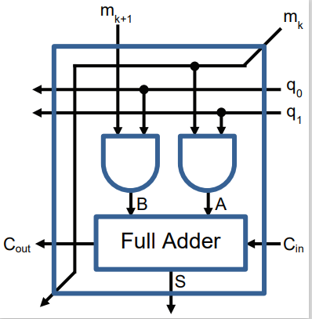

Figure 2 Submodule for First Row of Multiplier

Figure 3 The process of the 1st.First Row of Multiplier

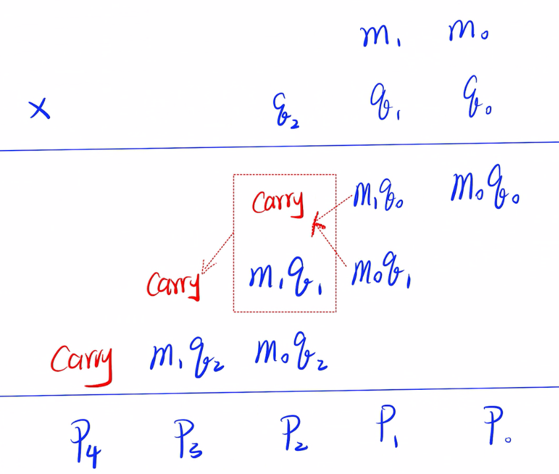

Figure 4 The process of the 2nd.First Row of Multiplier

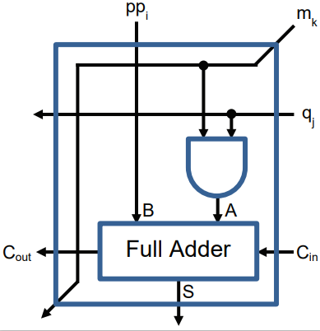

Figure 5 The structure of Remaining Rows of Multiplier

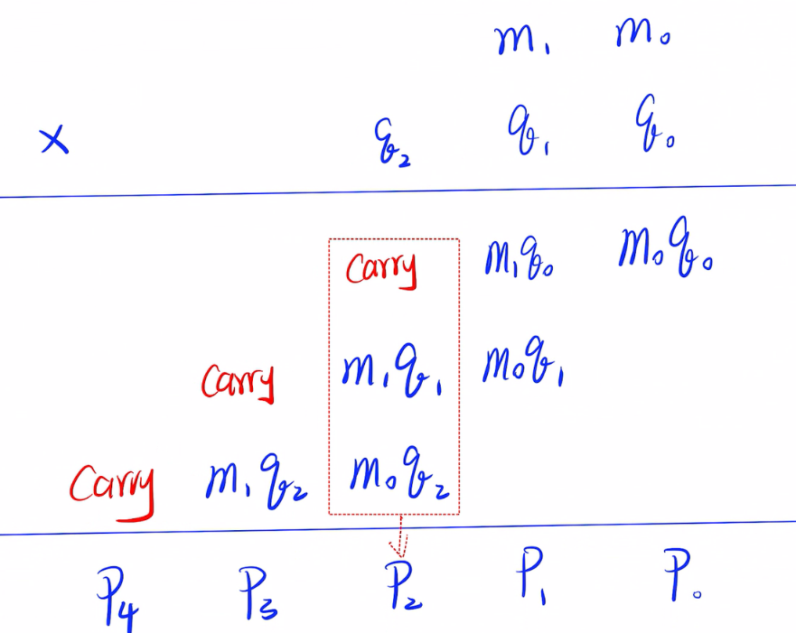

Figure 6 The theory of the 3rd.Remaining Rows of Multiplier

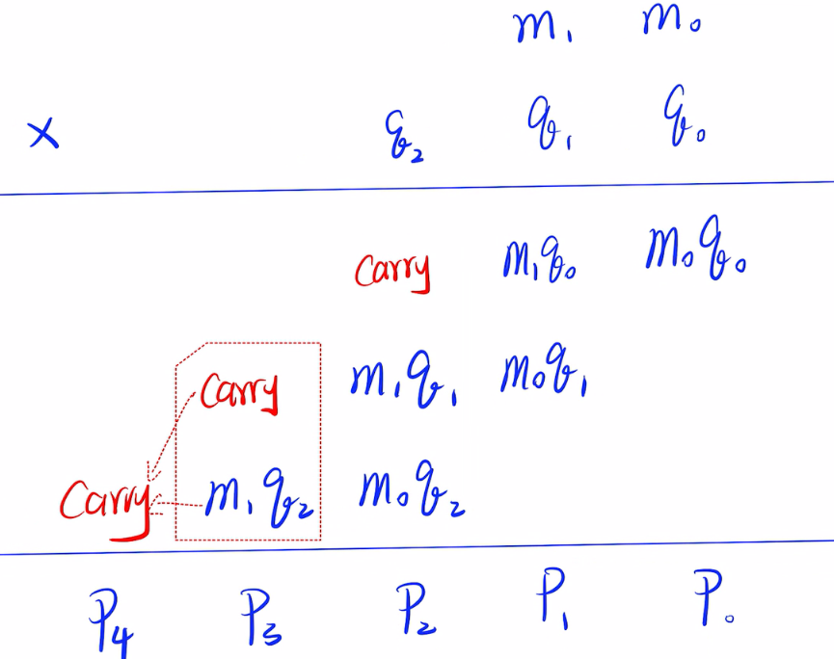

Figure 7 The theory of the 4th.Remaining Rows of Multiplier

图表

Figure 8 The RTL viewer output of simulation.

Figure 9 The output of simulation using the code of test bench.

Figure 10 The Program flow chart of MultiplierFirstRow.v

Figure 11 The Program flow chart of MultiplierRemainRow.v

Figure 12 Overall code execution architecture of Multiplier2x3.v

Figure 13 The hierarchical design of 1st. First Row of Multiplier

Figure 14 The hierarchical design of 2nd. First Row of Multiplier

Figure 15 The hierarchical design of 3rd.Remaining Rows of Multiplier

Figure 16 The hierarchical design of 4th.Remaining Rows of Multiplier

MultiplierFirstRow.v

/*

* MultiplierFirstRow

* ----------------------------

* By: Junnan Liu

* For: University of Leeds

* Date: 2th March 2024

*

* Description

* ------------

* The module is a submodule which comprises first row of multiplier

*

*/

**module** MultiplierFirstRow **(**

**input** **[**1**:**0**]** m**,**

**input** **[**1**:**0**]** q**,**

**input** cIn**,**

**output** **[**1**:**0**]** qOut**,**

**output** cOut**,**

**output** mOut**,**

**output** s

**);**

//The A and B is the variable used in Adder1Bit to add each other.

**wire** A**,**B**;**

// Instantiate A and B to calculate Two addends of 1-bit adder

**and(**A**,**q**[**1**],**m**[**0**]);**

**and(**B**,**q**[**0**],**m**[**1**]);**

//Instantiate the Adder1Bit to act as Full Adder

Adder1Bit adder0 **(**

**.**cin **(**cIn**),**

**.**a **(**A**),**

**.**b **(**B**),**

**.**sum **(**s**),**

**.**cout**(**cOut**)**

**);**

// According to the Submodule for First Row of Multiplier

//The qOut is equal to the q0 and q1.

assign qOut[1:0]=q[1:0];

// According to the Submodule for First Row of Multiplier

// The mOut is equal to m[0]

assign mOut=m[0];

endmodule

**MultiplierRemainingRow.v**

/*

* MultiplierFirstRow

* ----------------------------

* By: Junnan Liu

* For: University of Leeds

* Date: 2th March 2024

*

* Description

* ------------

* The module is a submodule which comprises remaining rows of multiplier

*

*/

**module** MultiplierRemainRow **(**

**input** pp**,**

**input** m**,**

**input** q**,**

**input** cIn**,**

**output** qOut**,**

**output** cOut**,**

**output** mOut**,**

**output** s

**);**

//The A and B is the variable used in Adder1Bit to add each other.

**wire** A**,**B**;**

// Instantiate A and B to calculate Two addends of 1-bit adder

**and(**A**,**q**,**m**);**

// The B is equal to the pp

**assign** B **=** pp**;**

//Instantiate the Adder1Bit to act as Full Adder

Adder1Bit adder1 **(**

**.**cin **(**cIn**),**

**.**a **(**A**),**

**.**b **(**B**),**

.sum (s),

.cout(cOut)

);

// According to the Submodule for Remaining Rows of Multiplier

//The qOut is equal to the q.

assign qOut = q;

// According to the Submodule for Remaining Rows of Multiplier

//The mOut is equal to the m.

assign mOut = m;

endmodule

**Adder1Bit.v**

/*

* Single Bit Adder

* ----------------------------

* By: Thomas Carpenter

* For: University of Leeds

* Date: 28th December 2017

*

* Description

* ------------

* The module is a simple 1-bit Adder using Gate Level Verilog

*

*/

**module** Adder1Bit **(**

// Declare input and output ports

**input** a**,**

**input** b**,**

**input** cin**,**

**output** cout**,**

**output** sum

**);**

// Declare several single-bit wires that we can

// use to interconnect the gates. You can use

// any name you like as long as it contains only

// a-z, A-Z, underscore (_), and 0-9. Names can't

// start with a digit.

**wire** link1**,**link2**,**link3**;**

// Instantiate gates to calculate sum output

**xor(**link1**,**a**,**b**);**

**xor(**sum**,**link1**,**cin**);**

// Instantiate gates to calculate carry (cout) output

**and(**link2**,**a**,**b**);**

**and(**link3**,**cin**,**link1**);**

**or** **(**cout**,**link2**,**link3**);**

**endmodule**

**Multiplier2x3.v**

/*

* Main Module for 2bit x 3bit Multiplier

* ----------------------------

* By: Junnan Liu

* For: University of Leeds

* Date: 2th March 2024

*

* Description

* ------------

* The module is a main Module for 2bit x 3bit Multiplier

*

*/

// The Multiplier2x3 module

// conatins 2 input: 2 bits multiplier m and 3 bits multiplier q

// It also contains the 5 bits output named p

**module** Multiplier2x3 **(**

**input** **[**1**:**0**]** m**,**

**input** **[**2**:**0**]** q**,**

**output** **[**4**:**0**]** p

**);**

// These are the variables for each submodule of the cOut multiplier.

**wire** cOut_1**,**cOut_2**,**cOut_3**;**

// This variable represents the count

// of '1's in the MultiplierFirstRow of qOut.

**wire** **[**1**:**0**]** qOut1**;**

//This variable represents the count

// of '2's in the MultiplierFirstRow of qOut.

**wire** **[**1**:**0**]** qOut2**;**

// This variable represents the count

// of '3's in the MultiplierRemainRow of qOut.

**wire** qOut3**;**

// This variable represents the count

// of '4's in the MultiplierRemainRow of qOut.

**wire** qOut4**;**

// This variable represents the count

// of '2's in the MultiplierFirstRow of s.

**wire** s_2**;**

// These are the variables for each submodule of the mOut multiplier.

**wire** mOut_1**,**mOut_2**,**mOut_3**,**mOut_4**;**

// This variable represents the count of '2's

// in the MultiplierFirstRow of m.

**wire** **[**1**:**0**]**m_2**;**

// assign the value to m_2

**assign** m_2**[**0**]=**m**[**1**];**

**assign** m_2**[**1**]=**1'b0**;**

// Calculate the p[0] through q[0] & m[0]

**and(**p**[**0**],**q**[**0**],**m**[**0**]);**

// Instantiate MultiplierFirstRow1

// to calculate qOut1, cOut_1, mOut_1 and p[1]

MultiplierFirstRow MultiplierFirstRow1**(**

**.**m**(**m**[**1**:**0**]),**

**.**q**(**q**[**1**:**0**]),**

**.**cIn**(**1'b0**),**

**.**qOut**(**qOut1**),**

**.**cOut**(**cOut_1**),**

**.**mOut**(**mOut_1**),**

**.**s**(**p**[**1**])**

**);**

// Instantiate MultiplierFirstRow2

// to calculate qOut2, cOut_2, mOut_2 and s_2

MultiplierFirstRow MultiplierFirstRow2**(**

**.**m**(**m_2**),**

**.**q**(**qOut1**),**

**.**cIn**(**cOut_1**),**

**.**qOut**(**qOut2**),**

**.**cOut**(**cOut_2**),**

**.**mOut**(**mOut_2**),**

**.**s**(**s_2**)**

**);**

// Instantiate MultiplierRemainRow3

// to calculate qOut3, cOut_3, mOut_3 and p[2]

MultiplierRemainRow MultiplierRemainRow3**(**

**.**pp**(**s_2**),**

**.**m**(**mOut_1**),**

**.**q**(**q**[**2**]),**

**.**cIn**(**1'b0**),**

**.**qOut**(**qOut3**),**

**.**cOut**(**cOut_3**),**

**.**mOut**(**mOut_3**),**

**.**s**(**p**[**2**])**

**);**

// Instantiate MultiplierRemainRow4

//to calculate qOut4, p[4], mOut_4 and p[3]

MultiplierRemainRow MultiplierRemainRow4**(**

**.**pp**(**cOut_2**),**

**.**m**(**mOut_2**),**

**.**q**(**qOut3**),**

**.**cIn**(**cOut_3**),**

.qOut(qOut4),

.cOut(p[4]),

.mOut(mOut_4),

.s(p[3])

);

endmodule

**simulation/Multiplier2x3_tb.v**

// /*!\notex{

// Multiplier2x3 Test Bench

// ---------------------------

// By: Junnan Liu

// For: University of Leeds

// Date: 2th March 2024

//

// Short Description

// -----------------

// This is a simple test bench module to test the Multiplier2x3.

// module with a few stimulii.

//

// }!*/

// Timescale indicates unit of delays.

// `timescale unit / precision

// Where delays are given as:

// #unit.precision /*!\notex{

//

// Let's stick with a "unit" of 1ns. You may choose the "precision".

//

// e.g for `timescale 1ns/100ps then:

// #1 = 1ns

// #1.5 = 1.5ns

// #1.25 = 1.3ns (rounded to nearest precision)

// }!*/

`timescale 1 ns**/**100 ps

// Test bench module declaration

// Always end test bench module names with _tb for clarity,

//and use no port list

**module** Multiplier2x3_tb**;**

// Test Bench Generated Signals

**reg** **[**1**:**0**]** m**;**

**reg** **[**2**:**0**]** q**;**

// DUT Output Signals

**wire** **[**4**:**0**]** p**;**

// Device Under Test. Instance typically named "dut", or "ModuleName_dut".

Multiplier2x3 Multiplier2x3_dut**(**

**.**m**(**m**),**

**.**q**(**q**),**

**.**p**(**p**)**

**);**

//We can then calculate the expected value using alternate method to the DUT.

//1-bit wider than sum to include the carry out.

**wire** **[**4**:**0**]** expected_value**;**

//In this case we use the behavioural + operator

**assign** expected_value **=** m**\***q**;**

// Integer for-loop

**integer** i**;**

**integer** j**;**

// Test Bench Logic

**initial** **begin**

//Print to console that the simulation has started.

//$time is the current sim time.

$display**(**"%d nstsimulation started"**,**$time**);**

//Monitor changes to any values listed,

//and automatically print to the console

//when they change. There can only be one $monitor per simulation.

$monitor**(**"%d ns\tm=%b\tq=%h\tp=%h\t Expected:\tvalue=\%h\t"**,**

$time**,**m**,**q**,**p**,**expected_value**);**

// Loop for 2bit multiplier m

**for(**i**=**0**;**i**<**4**;**i**=**i**+**1**)begin**

// Loop for 3bit multiplier q

**for(**j**=**0**;**j**<**8**;**j**=**j**+**1**)begin**

m**=**i**[**1**:**0**];**

q**=**j**[**2**:**0**];**

**#**10**;**//wait 1o units.end

$display**(**"%d ns\tsimulation Finished"**,**$time**);** //Finished

**end**

**end**

**end**

**endmodule**

**Reference:**

**Adder1Bit.v**

/*

* Single Bit Adder

* ----------------------------

* By: Thomas Carpenter

* For: University of Leeds

* Date: 28th December 2017

*

* Description

* ------------

* The module is a simple 1-bit Adder using Gate Level Verilog

*

*/

[1] S. Freear, D. D. Cowell, D. T. Carpenter, and D. H. Clegg, ‘Assignment 1: 2-Bit x 3-Bit Multiplier’.