29/01/2024 Week Summarize

# Items purchased.

## SparkFun RedBoard Plus

### Picture

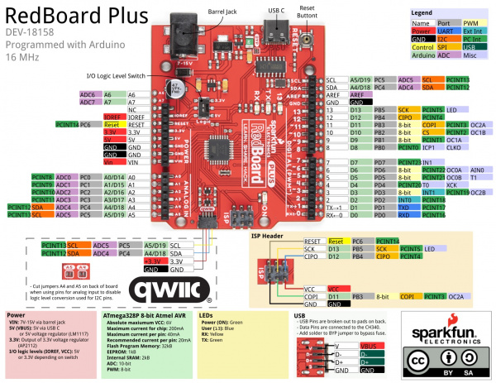

### function

Connect with the MyoWare 2.0 Arduino Shield and thus can directly connect with more than 6 muscle groups through Arduino.

## MyoWare 2.0 Arduino Shield

### Picture

### function

Connect with the 1.1 SparkFun RedBoard Plus.

## Bluetooth Low Energy Module

### Picture

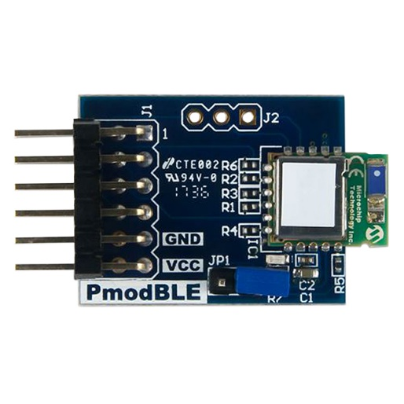

### function

Because the SparkFun RedBoard Plus does not have the Bluetooth function, we need to buy this module to connect with the SparkFun RedBoard Plus through UART.

## Other items

# Methods of connecting devices

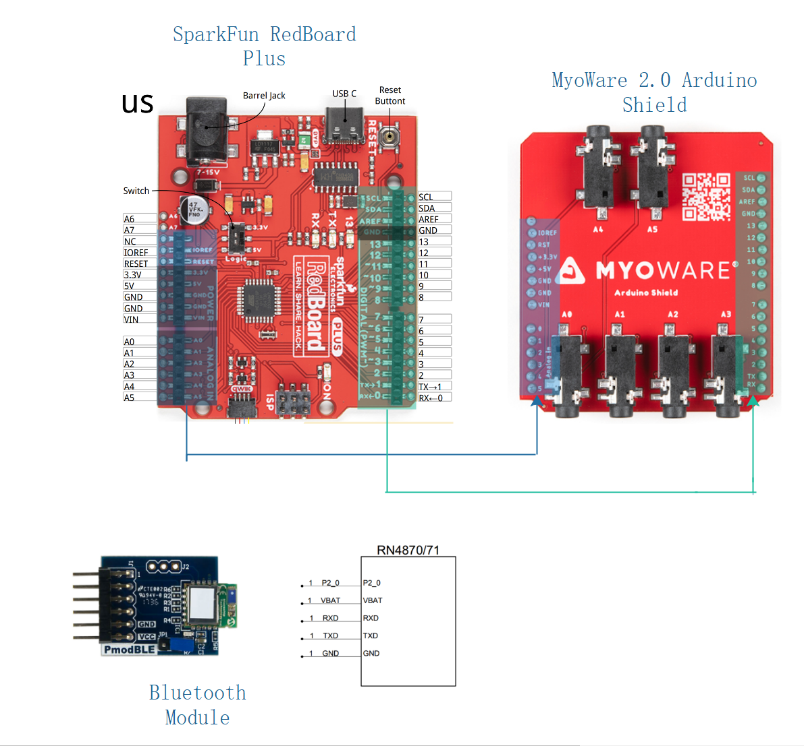

In the above image, we can see that the SparkFun RedBoard Plus is connected to the MyoWare 2.0 Arduino Shield, physically occupying the interfaces shaded in blue and green. However, in reality, they are only utilizing the interfaces shaded in black.

电子设备的截图

In the above image, the Bluetooth module connects to the SparkFun RedBoard Plus by following UART and communicates with the Raspberry Pi 4B by implementing Arduino Bluetooth functionality. Additionally, a GUI is implemented on the Raspberry Pi 4B.

# Current status

## Compare the differences between STM32 and Arduino

|  |  |  |
| --- | --- | --- |
|  | **STM32 Nucleo** | **SparkFun RedBoard Plus** |
| Architecture | STM32 | Arduino |
| Compatibility | Need to consider connecting to muscle groups | Can directly connect to six muscle groups through the MyoWare 2.0 Arduino Shield expansion board |
| Bluetooth | Built-in | Requires external modules. |
| Wifi | Built-in | Requires external modules. |
| Microcontroller | NUCLEO series | ATmega328P series |

In conclusion, The Arduino R3 Shield has a compatible slot, allowing it to be used with expansion boards. It can be directly connected for testing. However, the current board purchased does not have Bluetooth functionality, so an external Bluetooth module is needed. In contrast, STM32 does not have this concern, as Bluetooth and Wi-Fi are built-into be on the safe side, it's recommended to try both options, with a preference for Arduino.

## Conduct a simple test to assess the device's usability

The diagram shows the results obtained by connecting the SparkFun RedBoard Plus to the MyoWare 2.0 Arduino Shield and then using a Sensor Cable to connect to muscle groups. This proves the feasibility of Arduino. However, since the Bluetooth module is still being purchased, it may not be possible to test its connection to the Raspberry Pi 4B via Bluetooth for the time being.