1. 假定***A***3×3=和***B***3×3=都已加载到3×3×3处理器阵列上，试描述DNS算法的执行过程。

(1)初始分布

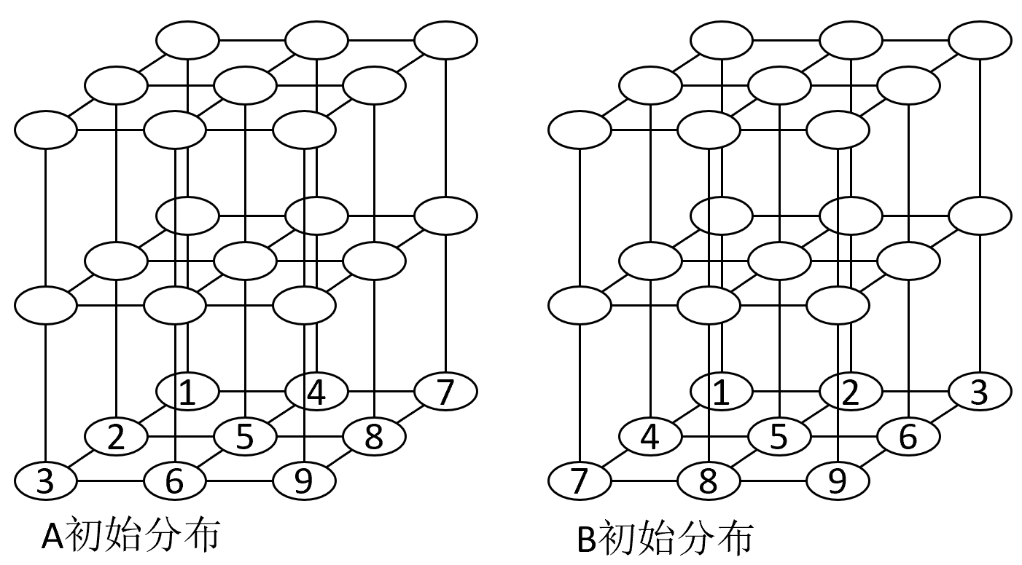

(2)数据复制

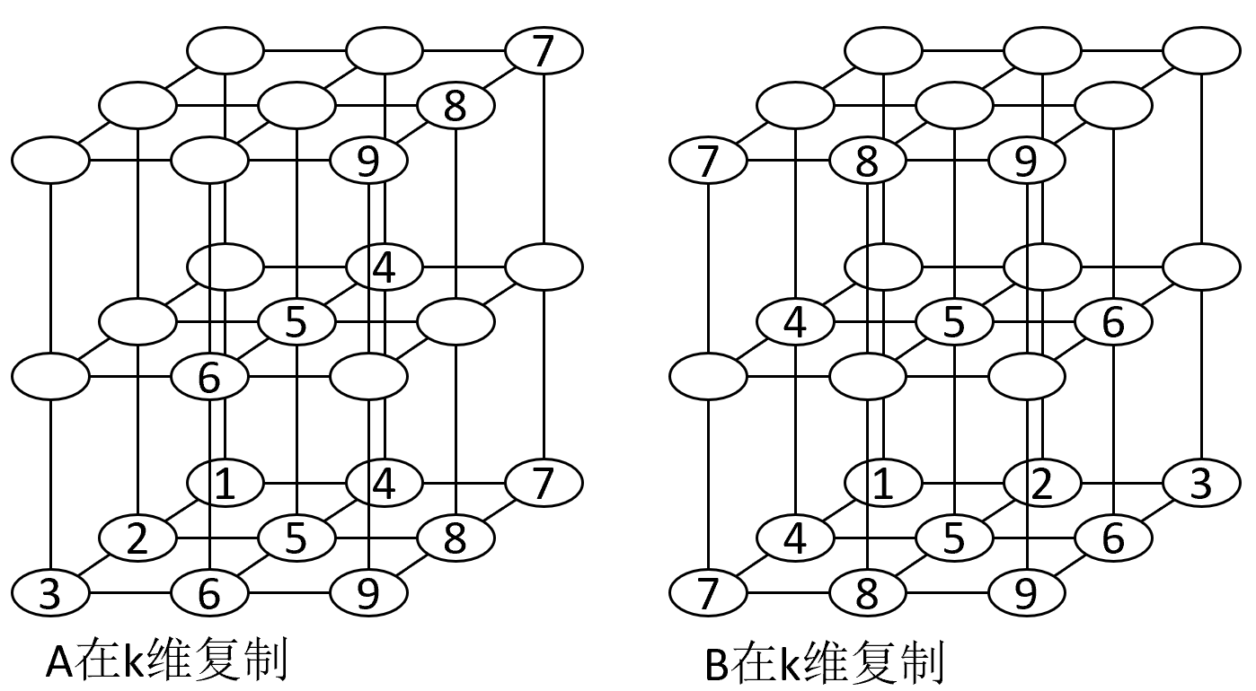

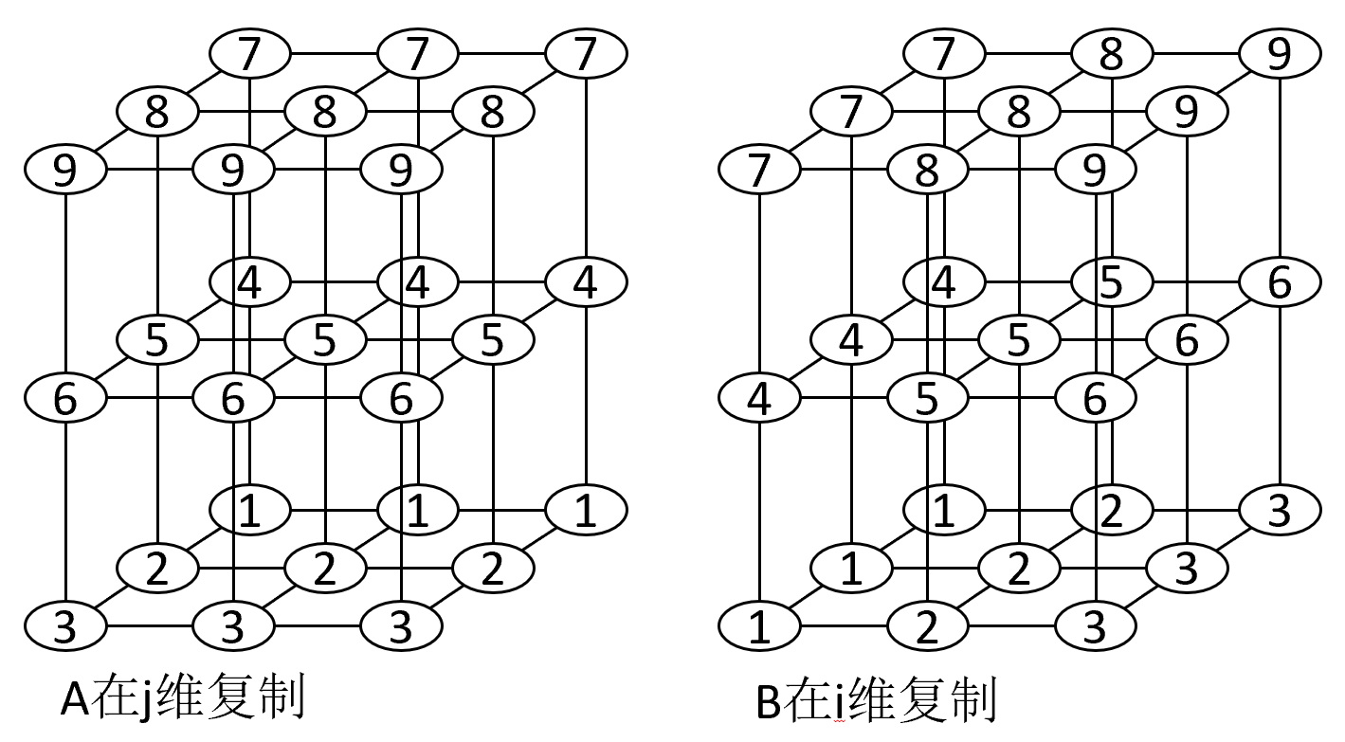

(3)相乘和求和

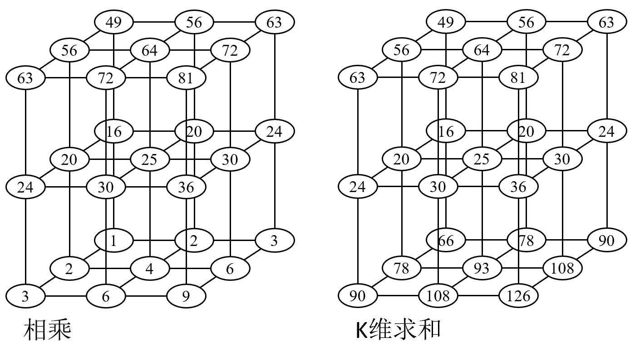

2. 描述用奇偶归约法并行求解如下三对角方程组的过程。

|  |  |  |  |  |  |  |
| --- | --- | --- | --- | --- | --- | --- |
| 2*x*1 | +*x*2 |  |  |  | =5 | ➀ |
| 4*x*1 | +2*x*2 | -2*x*3 |  |  | =4 | ➁ |
|  | 3*x*2 | -2*x*3 | +3*x*4 |  | =12 | ➂ |
|  |  | 2*x*3 | -3*x*4 | +4*x*5 | =7 | ➃ |
|  |  |  | 5*x*4 | -2*x*5 | =17 | ➄ |

第1步并行计算：

|  |  |  |  |  |  |  |  |  |  |  |
| --- | --- | --- | --- | --- | --- | --- | --- | --- | --- | --- |
| ➀-➁: | |  | | *x*3 | |  | | =3 | | ➅ |
| -➁+➂+➃: | | -6*x*1 | | +3*x*3 | | +4*x*5 | | =13 | | ➆ |
| ➃+➄: | |  | | 10/3*x*3 | | +14/3*x*5 | | =86/3 | | ➇ |
| -2➀+➁-➂: | -3*x*2 | | -3*x*4 | | =-18 | | ➈ | |
| ➂+➃+2➄: | 3*x*2 | | +10*x*4 | | =53 | | ➉ | |

第2步并行计算：

|  |  |  |  |  |  |  |  |  |  |  |  |  |  |  |
| --- | --- | --- | --- | --- | --- | --- | --- | --- | --- | --- | --- | --- | --- | --- |
| ➅-➆: | | | |  | | | 2*x*1 | | | -4/3*x*5 | | | =-4/3 | ⑪ |
| -➆+➇: | | | |  | | | 20/3*x*1 | | | +2/9*x*5 | | | =128/9 | ⑫ |
| ➈+➉: | | |  | | | -2.1*x*2 | | | =-2.1 | | ⑭ |
| ➈+➉: | 7*x*4 |  | | | =35 | | | ⑮ |

第3步并行计算：

|  |  |  |  |  |  |  |  |
| --- | --- | --- | --- | --- | --- | --- | --- |
| ⑪+6⑫: | | | 42*x*1 | | =84 | | ⑯ |
| -⑪+⑫: | 7/3*x*5 | =28/3 | | ⑰ | |