1、若待排序的数组*a*如下，且并行快,…../树，试说明此次排序的执行过程。

|  |  |  |  |  |  |  |  |
| --- | --- | --- | --- | --- | --- | --- | --- |
| *i* | 0 | 1 | 2 | 3 | 4 | 5 | 6 |
| *a* | 3 | 9 | 5 | 8 | 0 | 1 | 4 |
| *LC* | 7 | 7 | 7 | 7 | 7 | 7 | 7 |
| *RC* | 7 | 7 | 7 | 7 | 7 | 7 | 7 |
| *f* | 7 | 7 | 7 | 7 | 7 | 7 | 7 |

构造树的第1层后：

|  |  |  |  |  |  |  |  |
| --- | --- | --- | --- | --- | --- | --- | --- |
| *i* | 0 | 1 | 2 | 3 | 4 | 5 | 6 |
| *a* | 3 | 9 | 5 | 8 | 0 | 1 | 4 |
| *LC* | 7 | 7 | 7 | 7 | 7 | 7 | 7 |
| *RC* | 7 | 7 | 7 | 7 | 7 | 7 | 7 |
| *f* | 6 | 6 | 6 | 6 | 6 | 6 | 6 |

构造树的第2层后：

|  |  |  |  |  |  |  |  |
| --- | --- | --- | --- | --- | --- | --- | --- |
| *i* | 0 | 1 | 2 | 3 | 4 | 5 | 6 |
| *a* | 3 | 9 | 5 | 8 | 0 | 1 | 4 |
| *LC* | 7 | 7 | 7 | 7 | 7 | 7 | 5 |
| *RC* | 7 | 7 | 7 | 7 | 7 | 7 | 3 |
| *f* | 5 | 3 | 3 | 6 | 5 | 6 | 6 |

构造树的第3层后：

|  |  |  |  |  |  |  |  |
| --- | --- | --- | --- | --- | --- | --- | --- |
| *i* | 0 | 1 | 2 | 3 | 4 | 5 | 6 |
| *a* | 3 | 9 | 5 | 8 | 0 | 1 | 4 |
| *LC* | 7 | 7 | 7 | 2 | 7 | 4 | 5 |
| *RC* | 7 | 7 | 7 | 1 | 7 | 0 | 3 |
| *f* | 5 | 3 | 3 | 6 | 5 | 6 | 6 |

2、若待排序的数组*a*=(16,10,6,4,14,8,5,13,11,18,17,12,9,2,3,7,1,15)，处理器数*p*=3，试说明PSRS排序算法的执行过程。

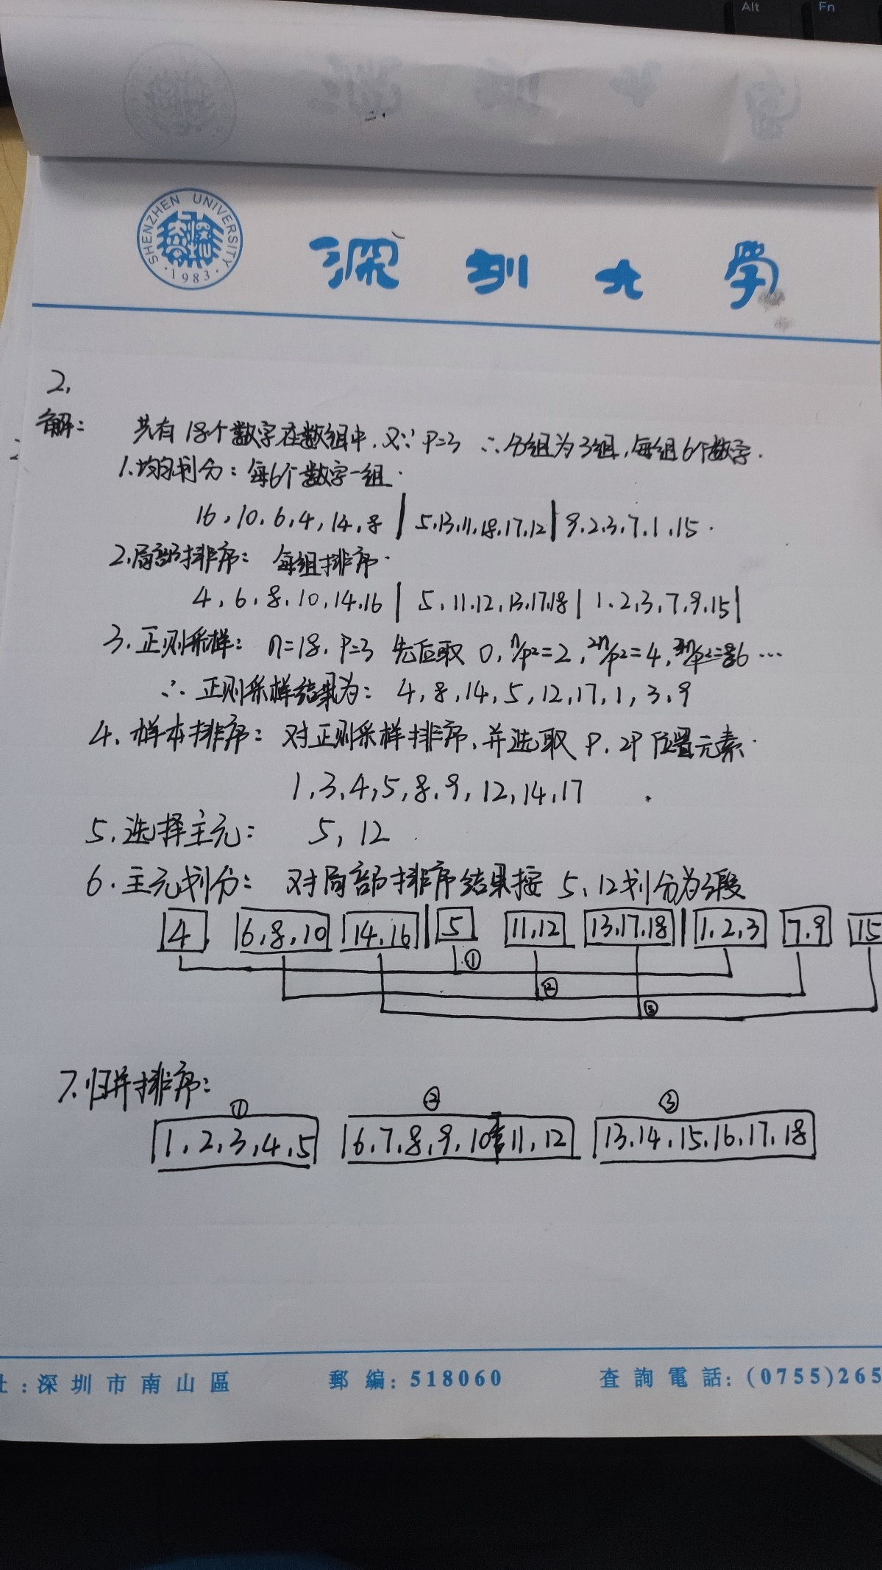

3、若*p*= $\sqrt[3]{n}$，分析PSRS排序算法的平均时间复杂度和加速比。

①每个处理器将自己的n/p个数据进行串行快排，所以时间为O（$\frac{n}{p}logn$）

②取样间隔为n/ $p^{2}$，所以样本总数为n/n/ $p^{2}$ = $p^{2}$,对 $p^{2}$ 个样本进行快速排序，所以时间为O($2p^{2}logp$)

③对每段n/p个求p-1个主元的秩，由于段内串行二分求秩，所以时间为O((p-1)*log(n/p))

④并行归并时间为O($p^{2}$)

所以，综上所述，平均时间复杂度= $\frac{n}{p}logn+2p^{2}logp+\left(p-1\right)*log\left(\frac{n}{p}\right)+p^{2}$ ≈ $\frac{n}{p}logn$ = $\sqrt[3]{p^{2}}logn$

相比于普通的串行PSRS算法，加速比为 $\sqrt[3]{p}$