5.13

(a) 0001 011 010 1 00000 (ADD R3, R2, #0 )  
(b) 1001 011 011 111111 (NOT R3, R3 )  
0001 011 011 1 00001 (ADD R3, R3, #1 )  
0001 001 010 0 00011 (ADD R1, R2, R3 )  
(c) 0001 001 001 1 00000 (ADD R1, R1, #0 ) or 0101 001 001 1 11111 (AND R1, R1, #-1)

(d) 是不可能发生的。N=1, Z=1和P=0的条件要求寄存器的内容同时为负数和零。

(e) 0101 010 010 1 00000 (AND R2, R2, #0)

5.15

1110 001 000100000 ( LEA R1, 0x20 ) R1 <- 0x3121  
0010 010 000100000 ( LD R2, 0x20 ) R2 <- Mem[0x3122] = 0x4566  
1010 011 000100001 ( LDI R3, 0x20 ) R3 <- Mem[Mem[0x3123]] = 0xabcd  
0110 100 010 000001 ( LDR R4, R2, 0x1 ) R4 <- Mem[R2 + 0x1] = 0xabcd  
1111 0000 0010 0101 ( TRAp 0x25 )

5.16

(a) PC-relative mode (PC 相对寻址)  
(b) Indirect Mode（间接模式）  
(c) Base+offset mode（基址偏移寻址）

5.25

1001 100 011 111111 ;(NOT R4, R3)  
0001 100 100 1 00001 ;(ADD R4, R4, #1)  
0001 001 100 0 00 010 ;(ADD R1, R4, R2)  
0000 010 000000101 ; (BRz Done)  
0000 100 000000001 ; (BRn Reg3)  
0000 001 000000010 ; (BRp Reg2)  
0001 001 011 1 00000 ; (Reg3 ADD R1, R3, #0)

0000 111 000000001 ; (BRnzp Done)  
0101 001 010 1 00000 ; (Reg2 ADD R1, R2, #0)  
1111 0000 0010 0101 ; (Done TRAP 0x25)

6.9

x3100 0010 000 0 0000 0101 ( LD R0, Z )  
x3101 0010 001 0 0000 0101 ( LD R1, C )  
x3102 1111 0000 0010 0001 ( L TRAP x21 )  
x3103 0001 001 001 1 11111 ( ADD R1, R1, #-1 )  
x3104 0000 001 1 1111 1101 ( BRp L )  
x3105 1111 0000 0010 0101 ( TRAP x25 )  
x3106 0000 0000 0101 1010 ( Z .FILL x5A )  
x3107 0000 0000 0110 0100 ( C .FILL #100 )

6.12

(a) x3100 1111 0000 00100011 ( IN )

x3101 1111 0000 00100001 ( OUT )

x3102 0000 111 111111101 ( BRnzp x3100 )

(b)

x3000 0010 001 00001 0001 ( LD r1, nl )

x3001 1001 001 001 111111 ( NOT r1, r1 )

x3002 0001 001 001 1 00001 ( ADD r1, r1, #1 )

x3003 0010 010 0 0000 1111 ( LD r2, strg )

x3004 1111 0000 00100011 (iput IN )

x3005 0111 000 010 000000 ( STR r0, r2, #0 )

x3006 0001 011 001 0 00 000( ADD r3, r1, r0 )

x3007 0000 010 0 0000 0010 ( BRz oput )

x3008 0001 010 010 1 00001 ( ADD r2, r2, #1 )

x3009 0000 111 1 1111 1010 ( BRnzp iput )

x300a 0010 010 0 0000 1000 (oput LD r2, strg )

x300b 0110 000 010 000000 (oputl LDR r0, r2, #0 )

x300c 1111 0000 00100001 ( OUT )

x300d 0001 011 001 0 00 000 ( ADD r3, r1, r0 )

x300e 0000 010 0 0000 0010 ( BRz done )

x300f 0001 010 010 1 00001 ( ADD r2, r2, #1 )

x3010 0000 111 1 1111 1010 ( BRnzp oputl )

x3011 1111 0000 00100101 (done HALT )

x3012 0000 0000 0000 1010 (nl .FILL x0A )

x3013 0100 0000 0000 0000 (strg .FILL x4000 )

6.18

x3000 0101 0000 0010 0000 ( ADD R0, R0, #0 )

x3001 1010 0010 0000 1011 ( LDI R1, PDIVIDEND )

x3002 1010 0100 0000 1011 ( LDI r2, PDIVISOR )

x3003 1001 0110 1011 1111 ( NOT R3, R2 )

x3004 0001 0110 1110 0001 ( ADD R3, R3, #1 )

x3005 0001 0010 0100 0011 ( LOOP ADD R1, R1, R3 )

x3006 0000 1000 0000 0010 ( BRn REMN )

x3007 0001 0000 0010 0001 ( ADD R0, R0, #1 )

x3008 0000 1111 1111 1100 ( BRnzp LOOP )

x3009 0001 0010 0100 0010 ( REMN ADD R1, R1, R2

x300a 1011 0000 0000 0100 ( STI R0, PQUO )

x300b 1011 0010 0000 0100 ( STI R1, PREM )

x300c 1111 0000 0010 0101 ( HALT )

x300d 0100 0000 0000 0000 ( PDIVIDEND .FILL x4000)

x300e 0100 0000 0000 0001 ( PDIVISOR .FILL x4001)

x300f 0101 0000 0000 0000 ( PQUO .FILL x5000)

x3010 0101 0000 0000 0001 ( PREM .FILL x5001)

7.1，

0xA7FE

7.4，

Symbol Address  
Test x301F  
Finish x3027  
Save3 x3029  
Save2 x302A

7.5，

(a)程序计算地址M0和M1的值的乘积。结果存储在address RESULT。

mem[RESULT] = mem[M0] \* mem[M1]

(b) x200C

7.11

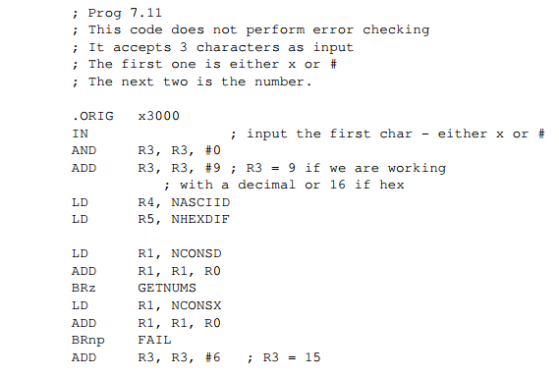

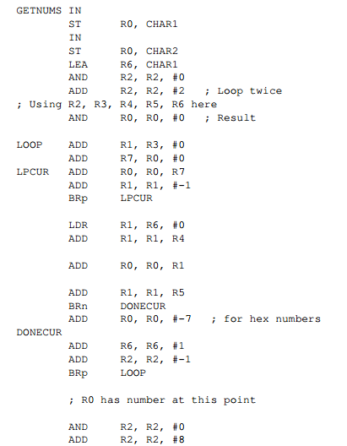

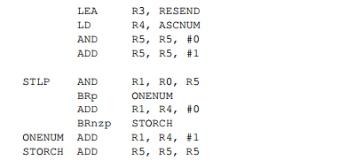

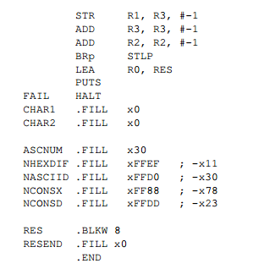

可选

7.16

这个程序计算偶数和奇数的数量。它在R3中存储偶数的个数，在R4中存储奇数的个数。

7.23

(a) ADD R1, R1, #-1  
(b) LDR R4, R1, #0  
(c) ADD R0, R0, #1  
(d) ADD R1, R1, #-1  
(e) BR LOOP