**VISUALIZATION PLOTS’ DOCUMENT OF INFO SEC. ASSIGNMENT**

**Class Distributions Map:**

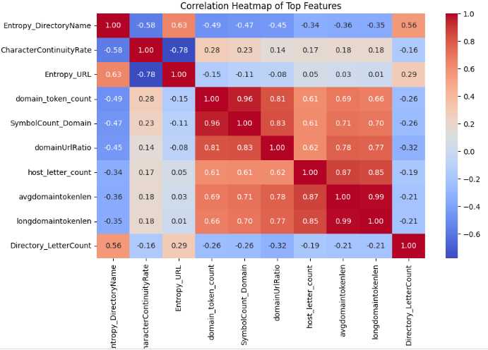

**MODELS COMPARISON:**

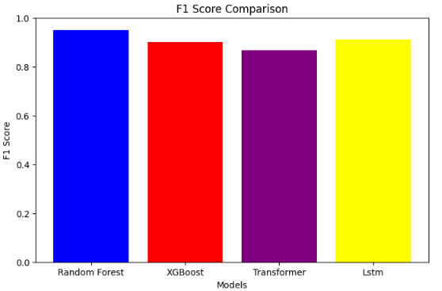

**Results Visualization**

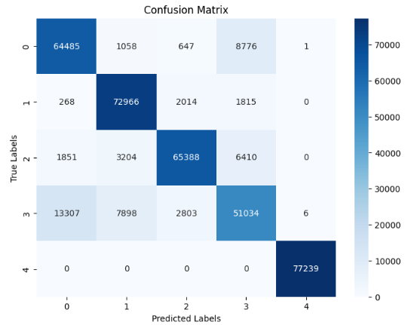

**Useful Features:**



**Transformer Training:**

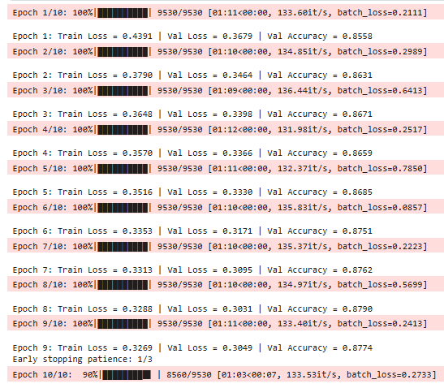

**Pairplot of features:**

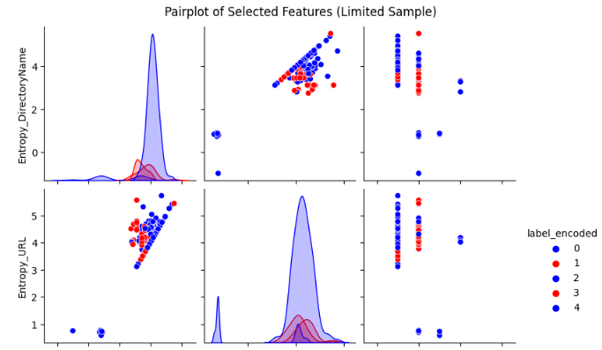

**Line Plot:**

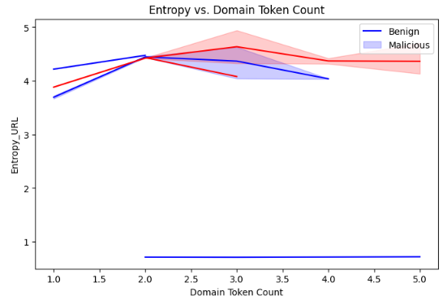

**Bar plots:**

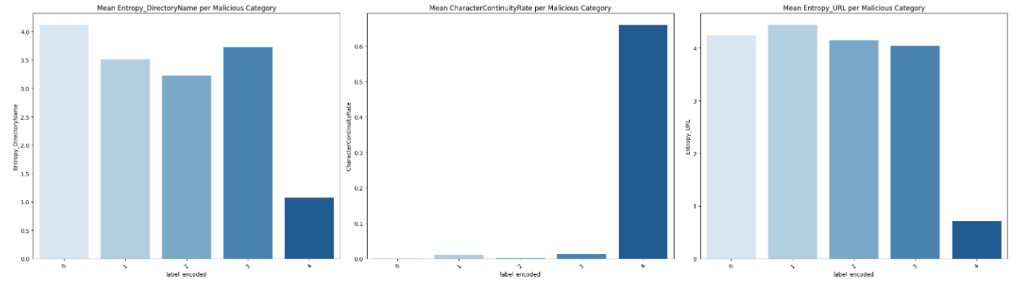

**Violin Graph:**

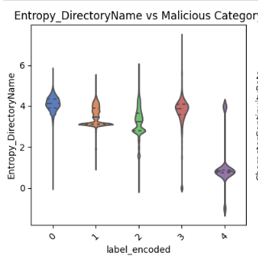

**Histograms of Features:**

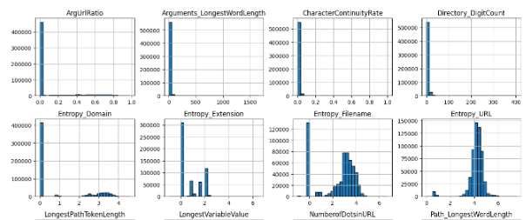

**Heat Map:**

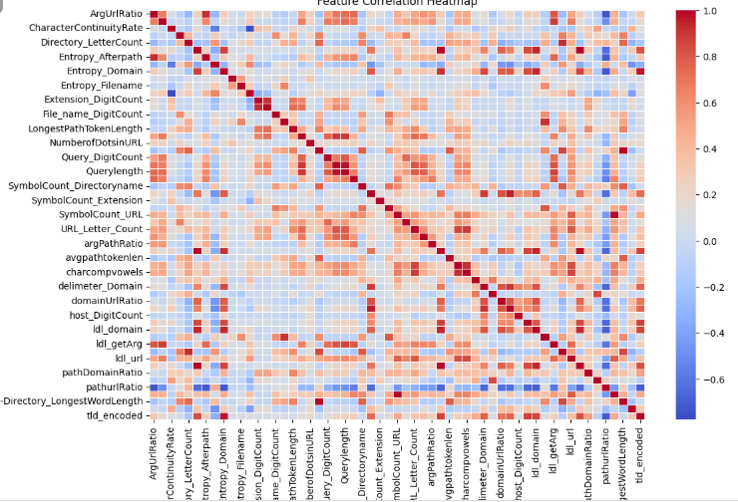

**KDE Plot:**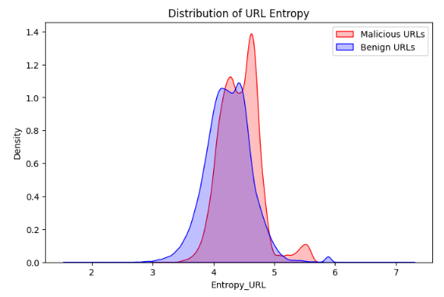

**Box Plot:**

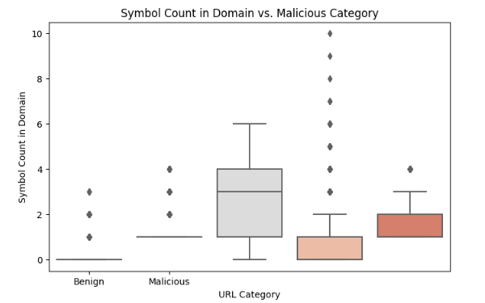

**Violin Plot:**



**Data distribution (before balancing):**

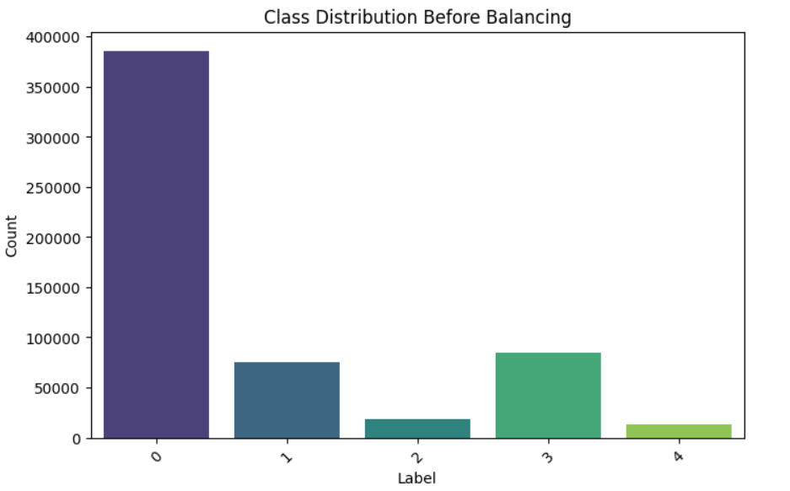

**Data distribution (After balancing):**

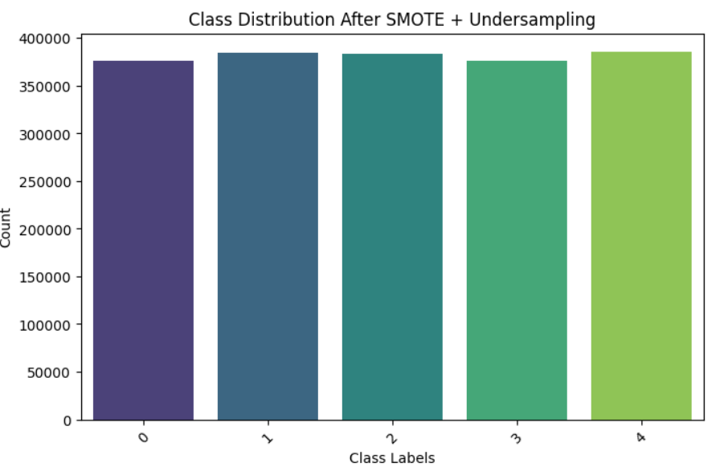

**ROC Lstm:**

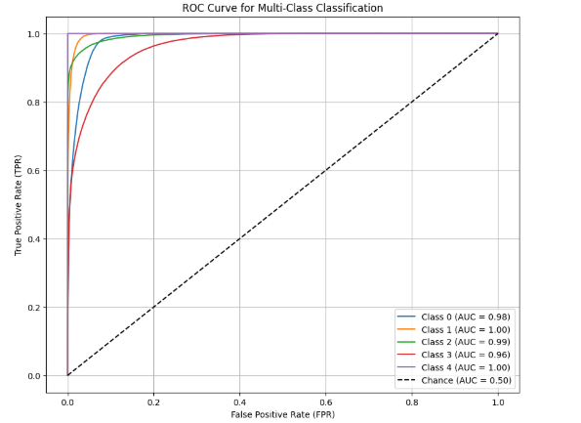

**ROC ML:**

