Ping: Ping is a computer network administration software utility used to test the reachability of a host on an Internet Protocol network. It is available for virtually all operating systems that have networking capability, including most embedded network administration software

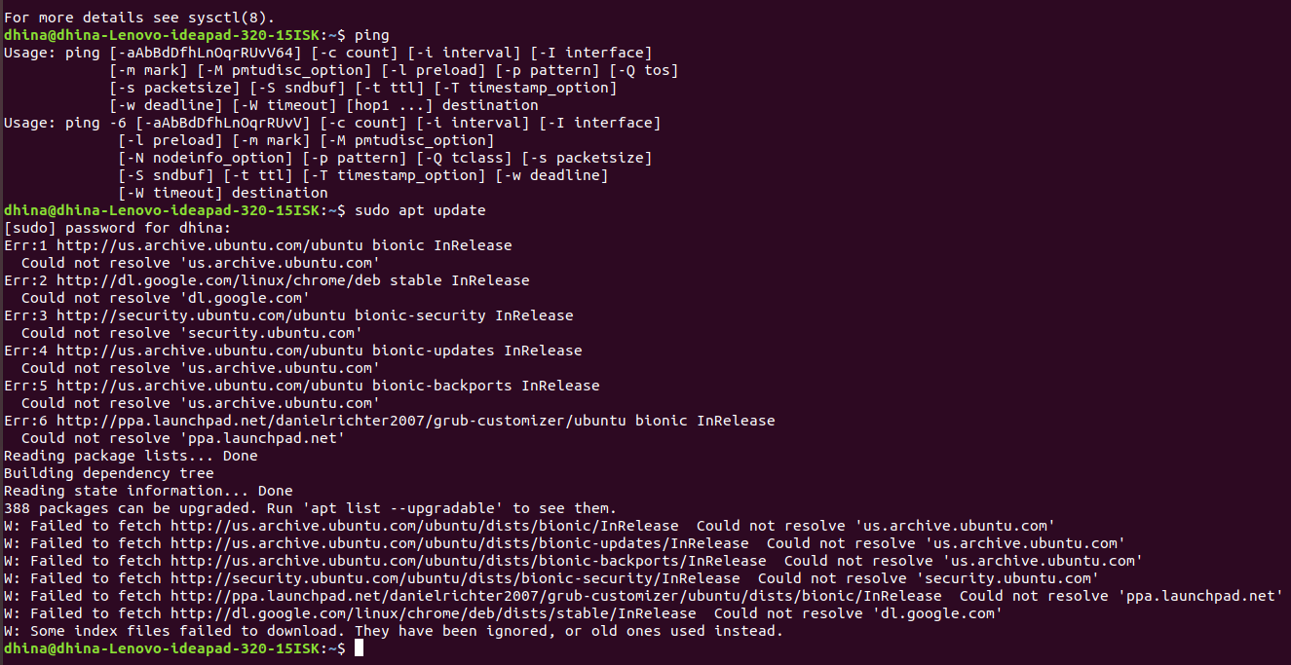

Sudo apt upgrade: The sudo apt-get update command is used to download package information from all configured sources. The sources often defined in /etc/apt/sources. List file and other files located in /etc/apt/sources. … So when you run update command, it downloads the package information from the Internet.

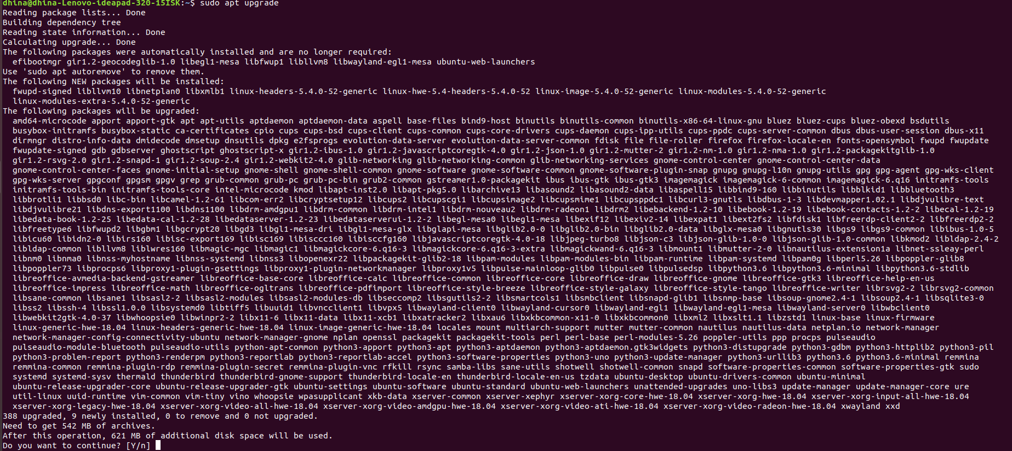

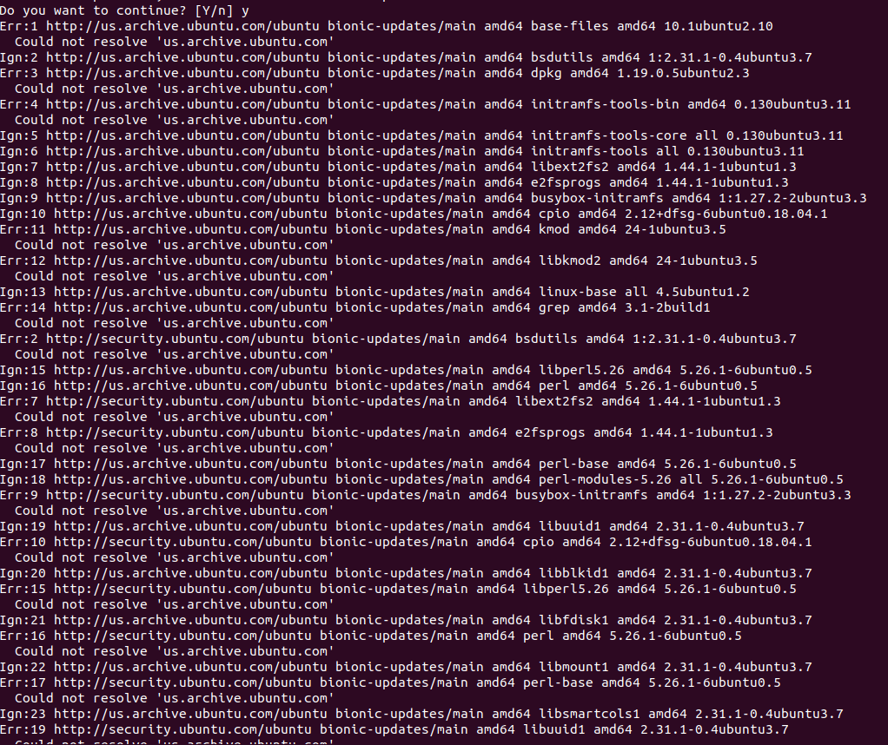

Curl-version: To check whether the Curl package is installed on your system, open up your console, type curl and press enter. If you have curl installed, the system will print curl: try 'curl --help' or 'curl -manual' for more information. Otherwise, you will see something like curl command not found

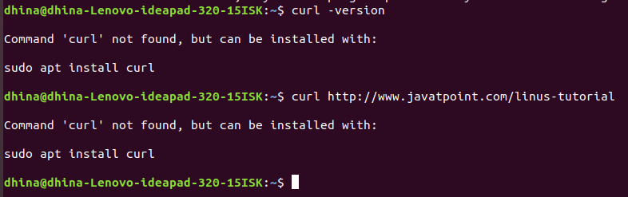

Wget: wget is a free utility for non-interactive download of files from the web. It supports HTTP, HTTPS, and FTP protocols.

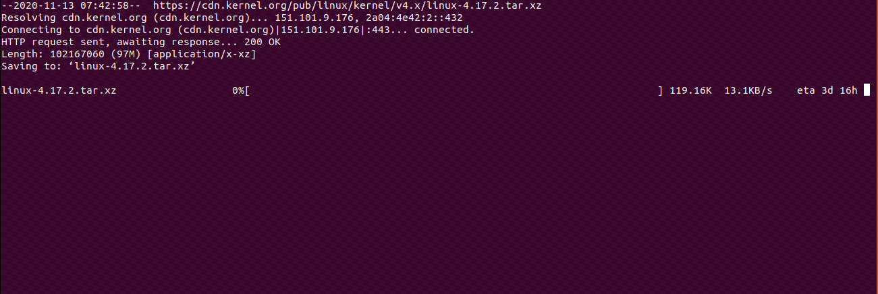

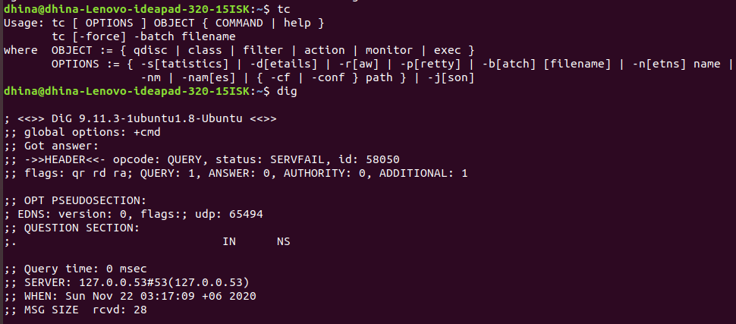

Tc: Tc is used to configure Traffic Control in the Linux kernel. Traffic Control consists of the following: SHAPING when traffic is shaped, its rate of transmission is under control. Shaping may be more than lowering the available bandwidth - it is also used to smooth out bursts in traffic for better network behavior

Whois: In Linux, the who is command line utility is a WHOIS client for communicating with the WHOIS server (or database host) which listen to requests on the well-known port number 43, which stores and delivers database content in a human-readable format

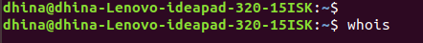

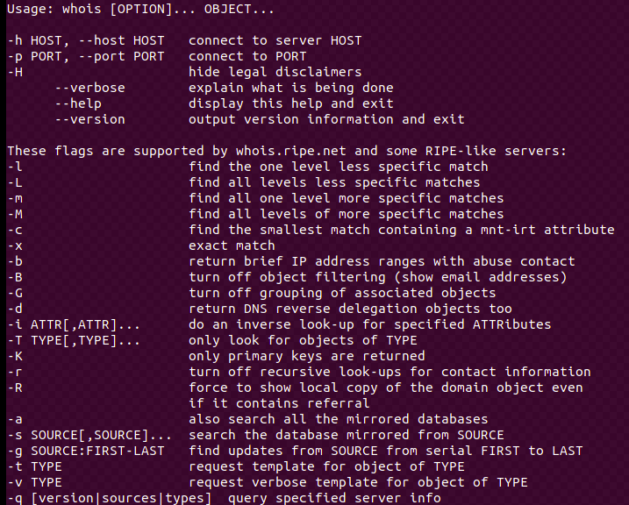

SSH:
SSH Command in Linux- the SSH command provides a secure encrypted connection between two hosts over an insecure network. This connection can also be used for terminal access, file transfer, and for tunneling other applications. Graphical X11 applications can also be run securely over SSH from a remote location

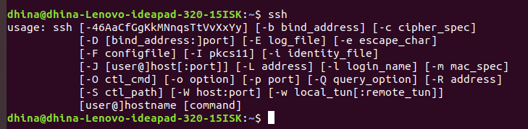

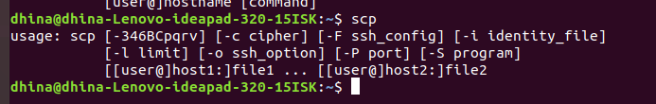

Rsync:
Rsync is a fast and versatile command-line utility for synchronizing files and directories between two locations over a remote shell, or from/to a remote Rsync daemon. It provides fast incremental file transfer by transferring only the differences between the source and the destination.
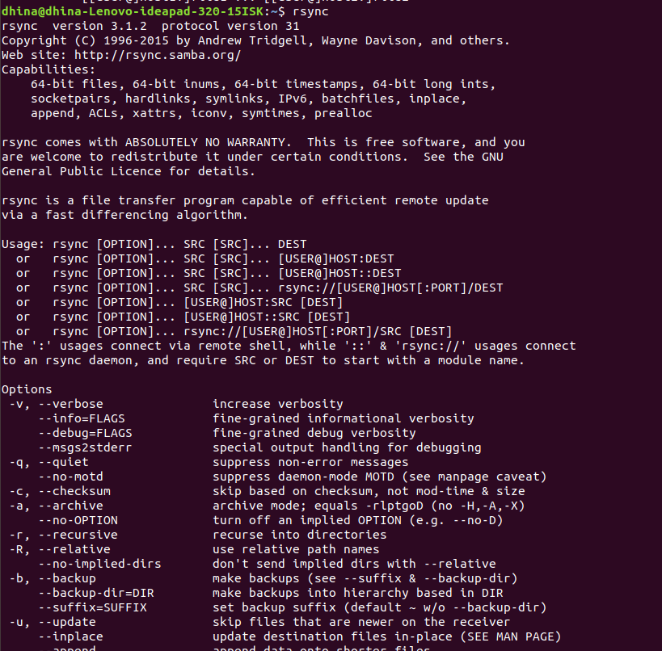

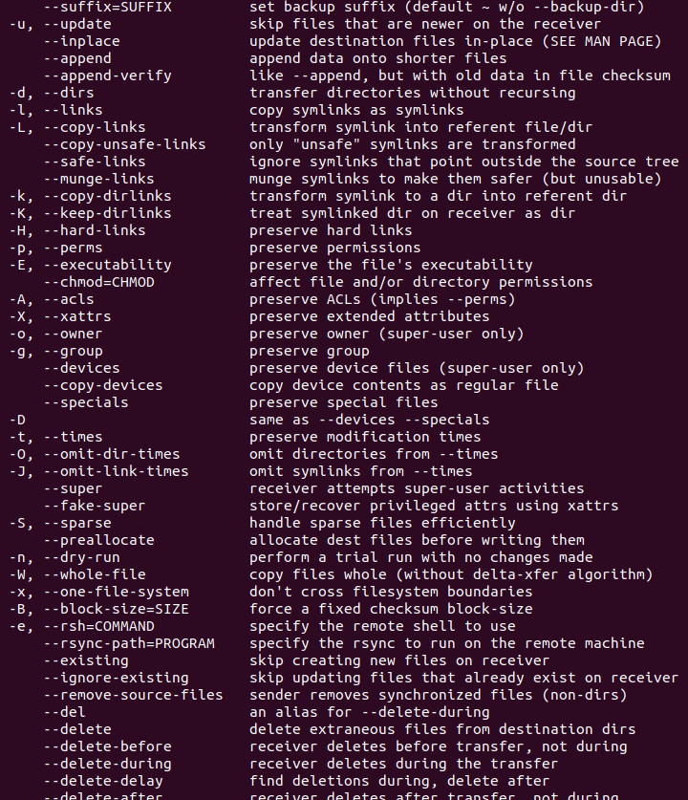

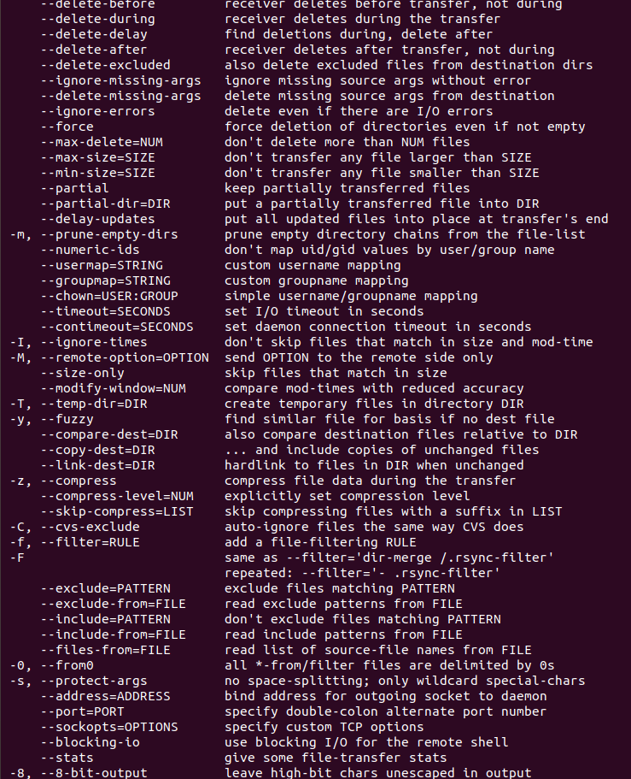

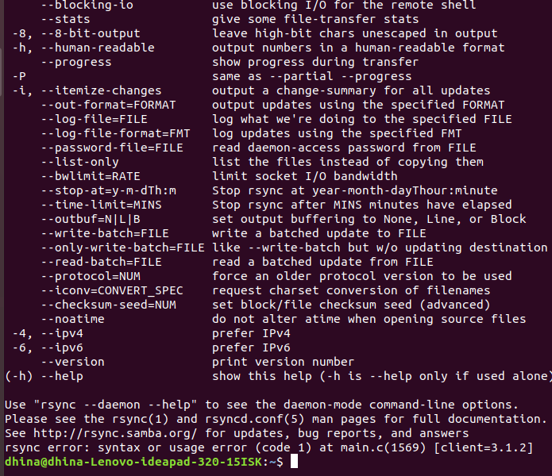

Ngrep:
Ngrep (network grep) is a simple yet powerful network packet analyzer. It allows you to specify an extended regular or hexadecimal expression to match against data payloads (the actual information or message in transmitted data, but not auto-generated metadata) of packets

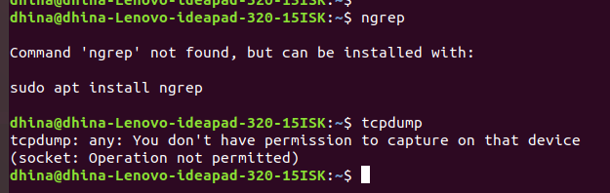

Update:

The sudo apt-get update command is used to download package information from all configured sources. The sources often defined in /etc/apt/sources. List file and other files located in /etc/apt/sources. ... So when you run update command, it downloads the package information from the Internet.

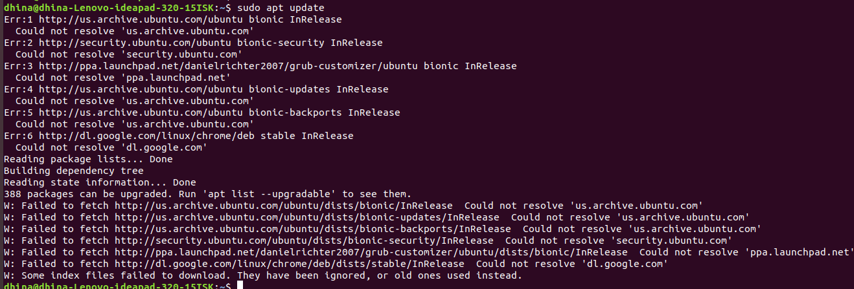

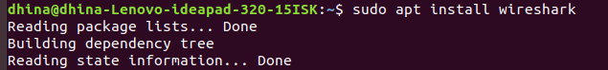

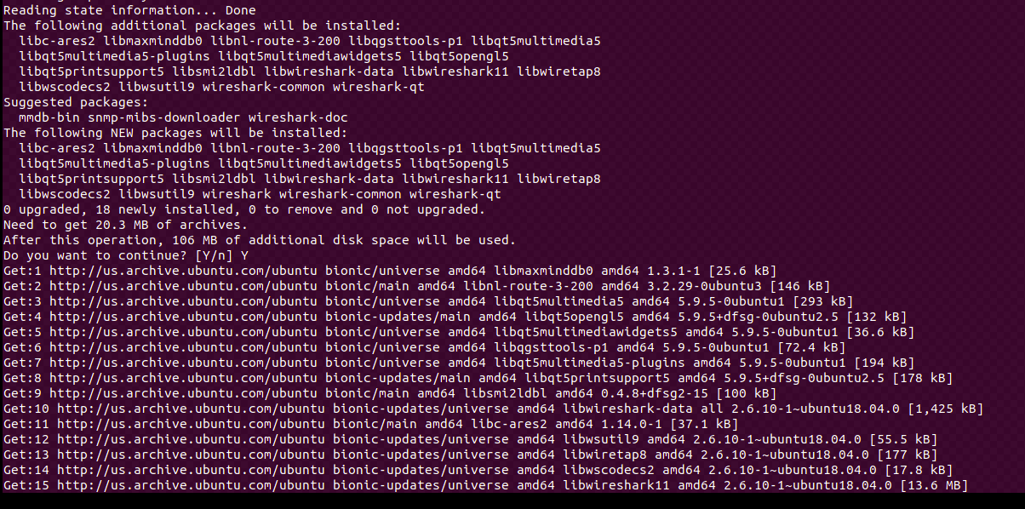

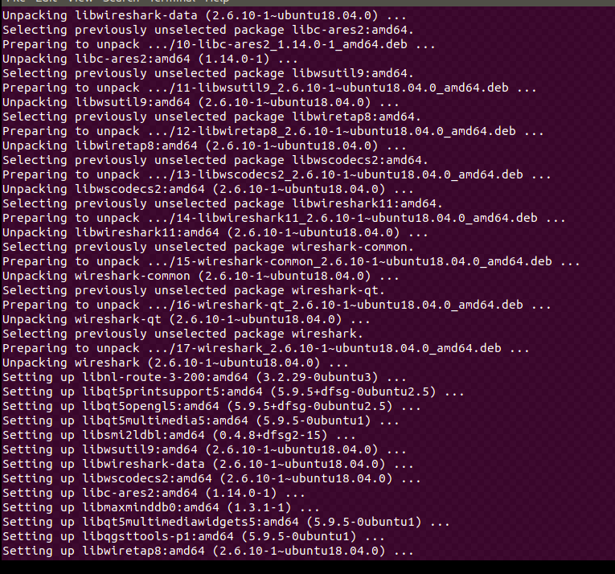

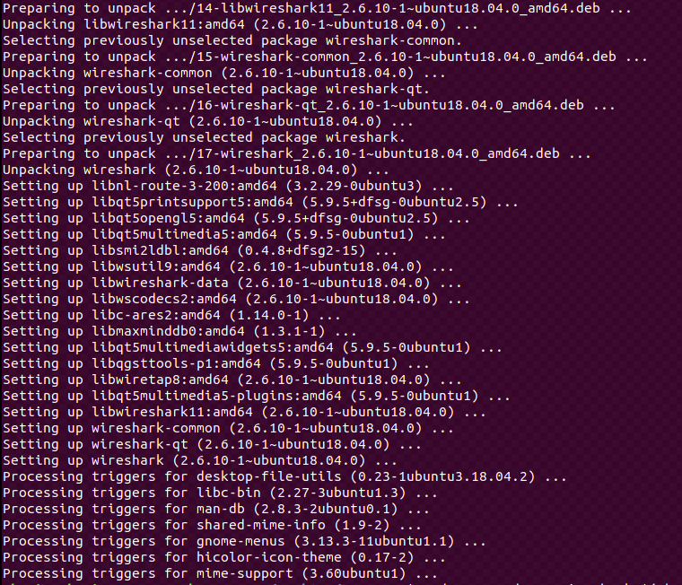

ifconfig: stands for "interface configuration." It is used to view and change the configuration of the network interfaces on your system.
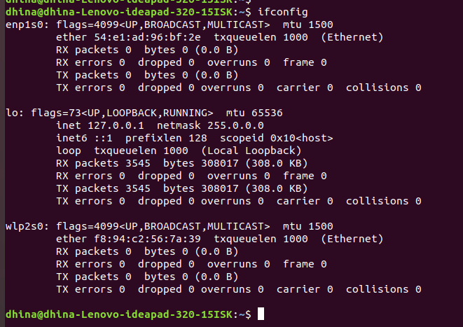

Route:
Route command in Linux is used when you want to work with the IP/kernel routing table. It is mainly used to set up static routes on specific hosts or networks via an interface. It is used for showing or update the IP/kernel routing able.





