1. Ifconfig: stands for "interface configuration." It is used to view and change the configuration of the network interfaces on system.
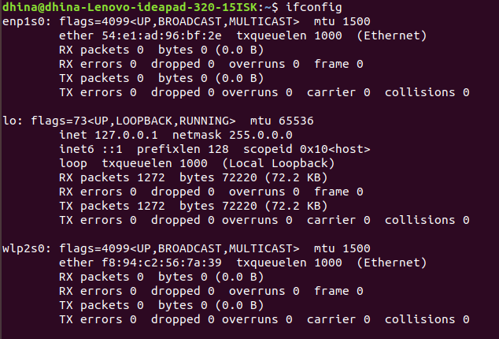
Ifconfig -a: Displays the configuration of all interfaces, both active and inactive.
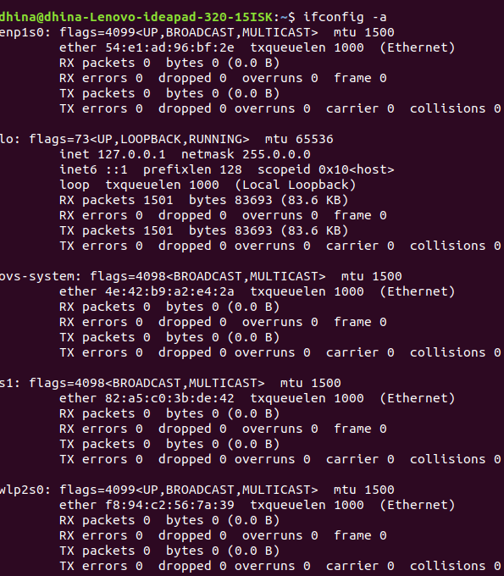
Create Virtual Network:

We will be using CLI (sudo mn command) to manage our virtual network. The default topology includes two hosts (h1,h2), Open Flow Switch(s1) and Open Flow controller(c0).
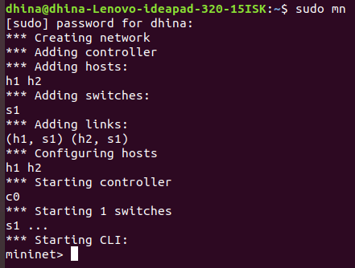

This command launches a simple 2 host, 1 controller, 1 switch topology. The following diagram outlines the topology.
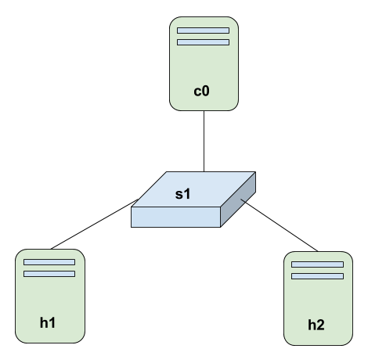

Help command: Run the help option to view the list of commands available:
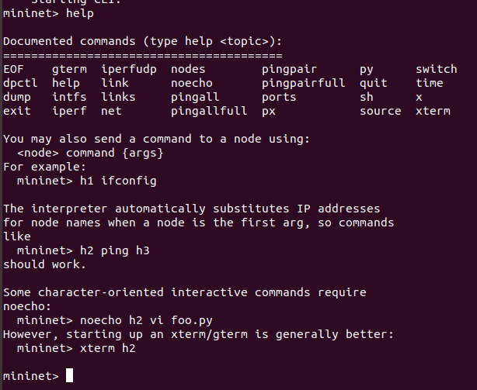
Nodes command: Shows the nodes we created with the simple Mininet command:
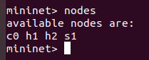

Net command: This command shows the links of all nodes
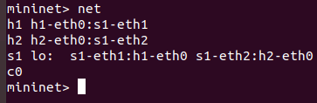

Dump command: which displays summary information about all devices:

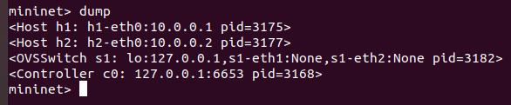
h1 ifconfig -a: This command will display the IP address, broadcast address and MAC address of the host h1. The command h2 ifconfig -a are also as the command
h1 ifconfig -a.
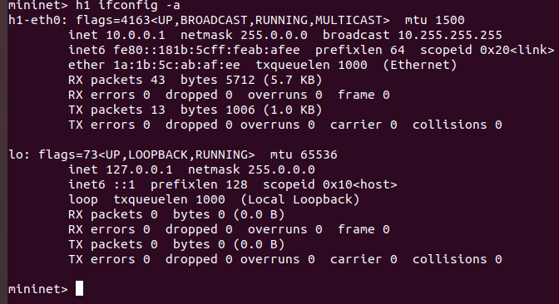

Ping command: We can test connectivity between the hosts by using ping command.
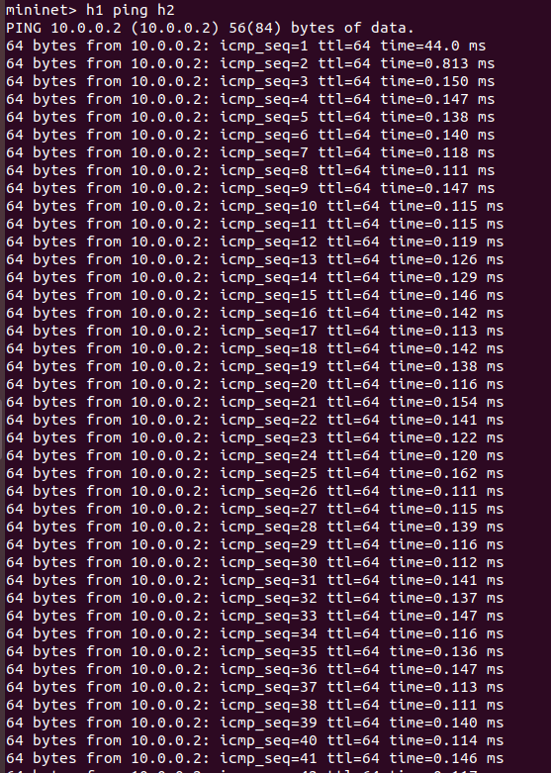
Pingall command: This command will make each host in the network ping every other host in the network. In the network that we have, h1 will ping h2, and h2 will ping h1.
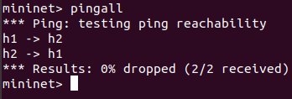

Create topology: topo=single, 4 that means controller, switch is one and host are 4 like h1,h2,h3,h4
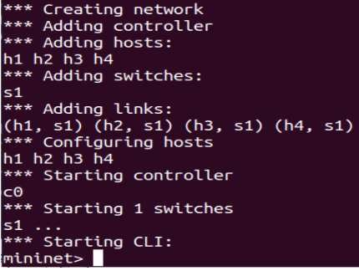

Sudo mn -x command:
One node one new corresponding terminal.
Exit command:
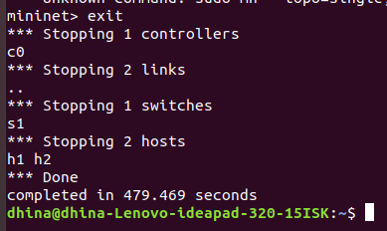

Cleanup command: If Mininet crashes for some reason, clean it up:




