

**Project Report**

|  |  |
| --- | --- |
| **Course Code and Name:**  CSE412- Software Engineering | |
| **EduCollab** | |
| **Semester and Year:**  Summer 2025 | **GROUP NO: 08** |
| **Name of Student & ID:**  **1.** Ishmat Zaman  2022-1-60-102  **2**. Jannat Milky  2023-1-60-042  **3.** Md.Asikur Rahaman  Id:2022-1-60-389  **4.** Ankon Saha  2022-1-60-319  **5.** Md. Saeikh Abdullah  2022-1-60-304 | **Course Instructor information:**    **Name :** Nishat Tasnim Niloy  **Designation:** Lecturer  **Department of CSE**  **East West University** |

**Project Report: EduCollab - A Collaborative Learning**

**Management System**

# 1. Introduction

EduCollab is a web-based collaborative learning platform designed to streamline group-based projects in an academic environment. It bridges the gap between students and professors by providing a structured, transparent, and efficient system for course management, group formation, task delegation, peer review, and file sharing. The system ensures accountability by tracking individual contributions and providing professors with a clear overview of group progress and final submissions.

The core philosophy is to move beyond simple file repositories (like the initial Lab-03) into a full-fledged collaboration hub that enforces workflow, minimizes free-riding, and integrates automated group management based on student data.

# 2. Functional Requirements

The system's functionality is divided into two primary user roles:

**A. Professor/Instructor:**

* Authentication: Secure login with a university email.
* Course Creation: Create new courses by providing a name and uploading a CSV file containing student IDs and CGPAs.
* Automated Group Formation: System automatically creates groups based on the uploaded CSV, assigning the student with the highest CGPA as the leader.
* Custom Group Management: Ability to view custom group requests from students and manually create groups before the automated process runs.
* Monitoring: View all groups, their members, their shared repositories, and a color-coded task board showing the status of all assigned work.
* Grading: Review and grade final group submissions.

**B. Student:**

* Authentication: Secure login with university email, ID, and password.
* Course Enrollment: Join a course by entering a unique code provided by the professor. The system validates if the student's ID is in the professor's CSV.
* Group Dashboard: View their assigned group, identify the leader, and see all group members.
* Task Management: View tasks assigned by the leader, accept/reject them, upload completed work, and participate in peer review by approving teammates' submissions.
* File Repository: Access a personal repository (with public/private files) and a group-shared repository for collaborative work.
* Custom Group Request: Request to form a custom group with specific peers before the professor finalizes groups.

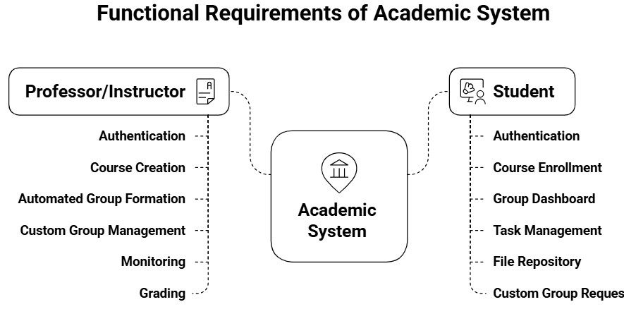

## Register

The register implements a functional registration system with good security fundamentals like password hashing and SQL injection prevention. The main areas for improvement are adding CSRF protection, enhancing validation, improving error handling, and making the student email validation more flexible.

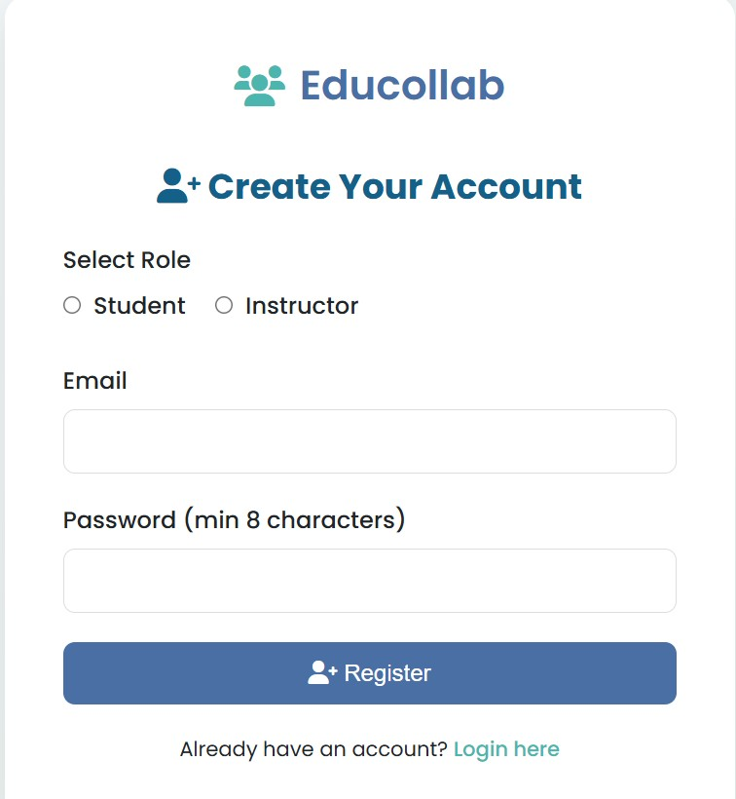

## Login

User selects role (student/professor)

1. User provides identifier (email or phone) and password
2. System verifies credentials against database
3. Successful login creates session variables and redirects to appropriate dashboard
4. Failed login displays descriptive error messages

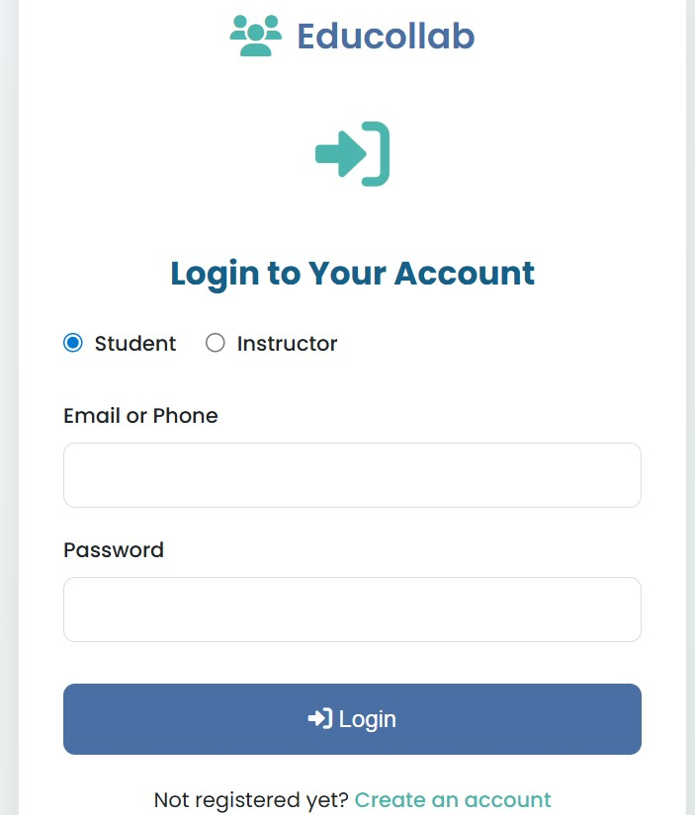

## Professor_dashboard and course_dashboard

1. Course Management: Displays professor's courses with student counts
2. Statistics Overview: Shows total courses and student counts
3. Course Creation: Form to create new courses with CSV enrollment
4. Responsive Design: Works well on both desktop and mobile devices 5. User Feedback: Clear error and success messages course_dashboard

* Shows enrolled students in a table with their status (Assigned/Unassigned).
* Provides tools for auto-grouping (with configurable group size) and manual custom group creation.
* Displays all groups in a grid, allowing the professor to rename, delete, change leaders, and remove members for each group.

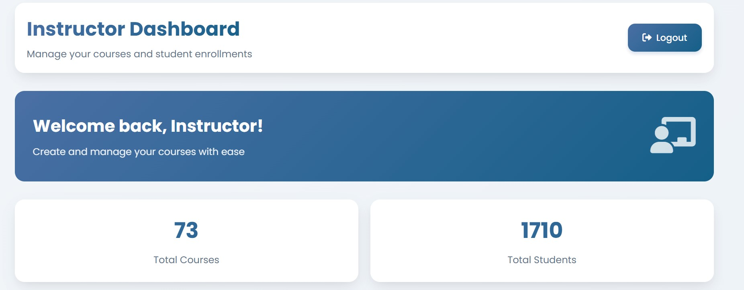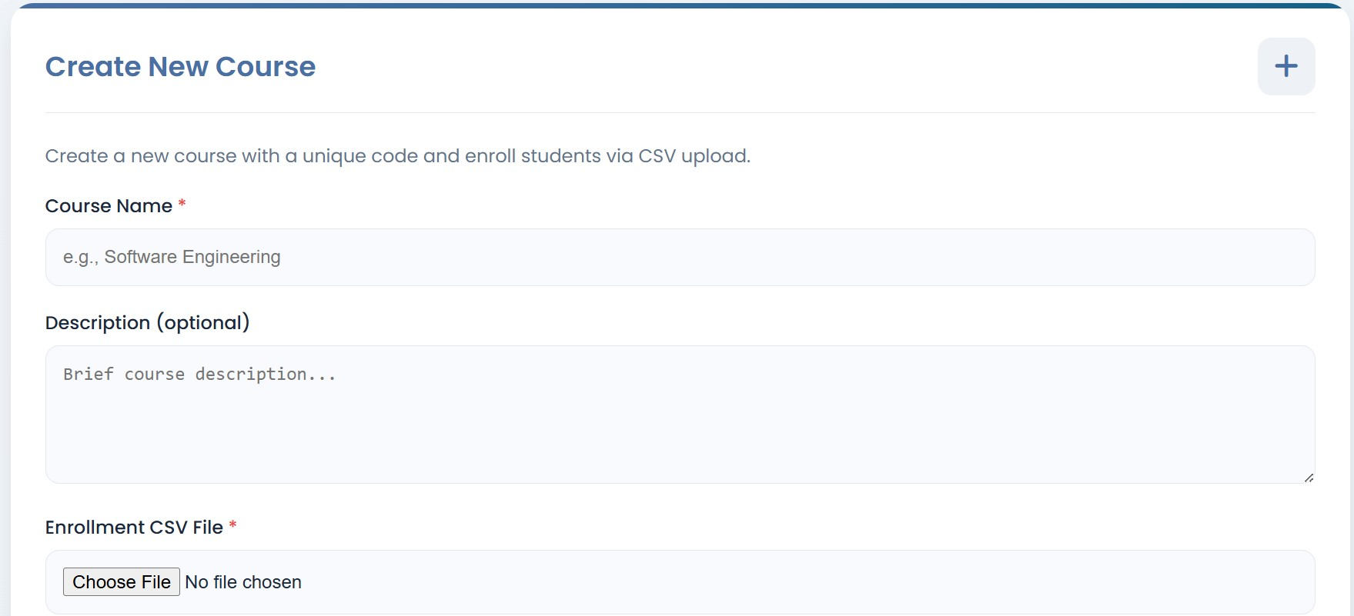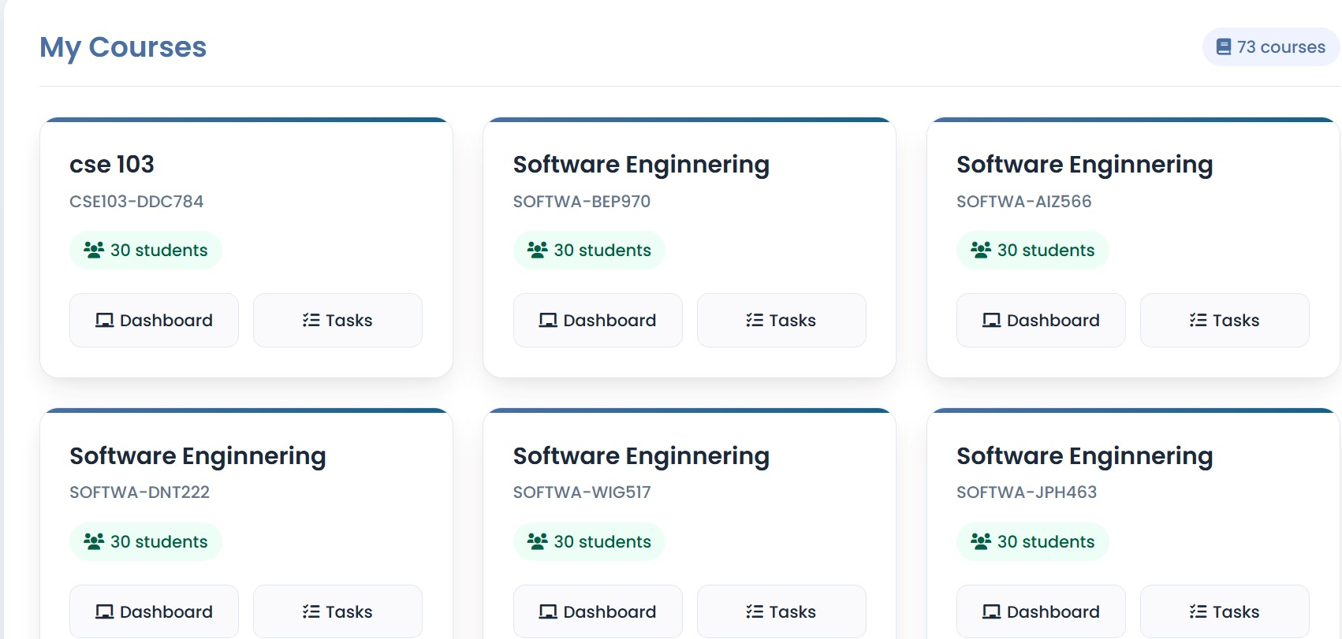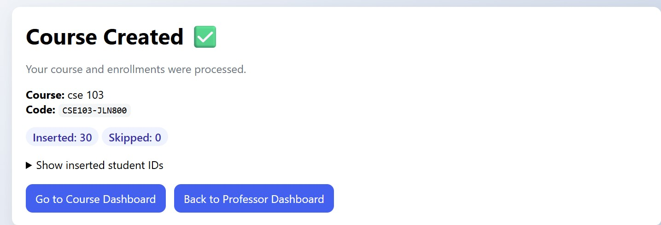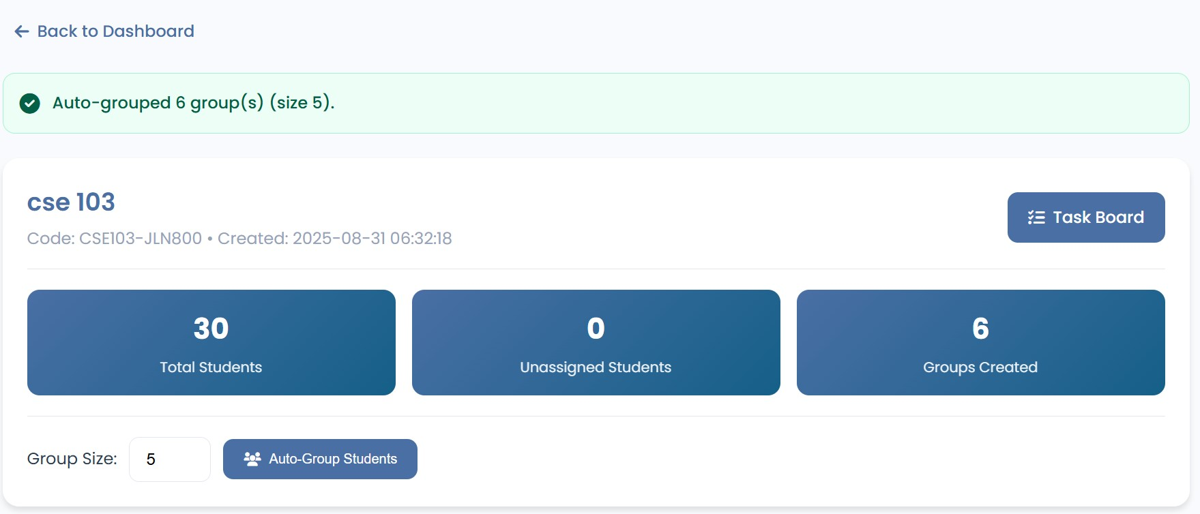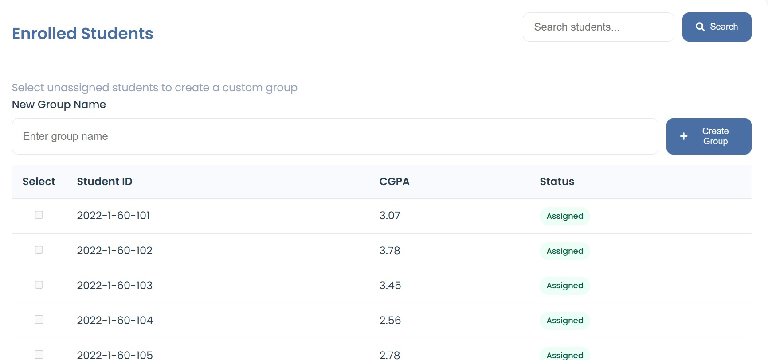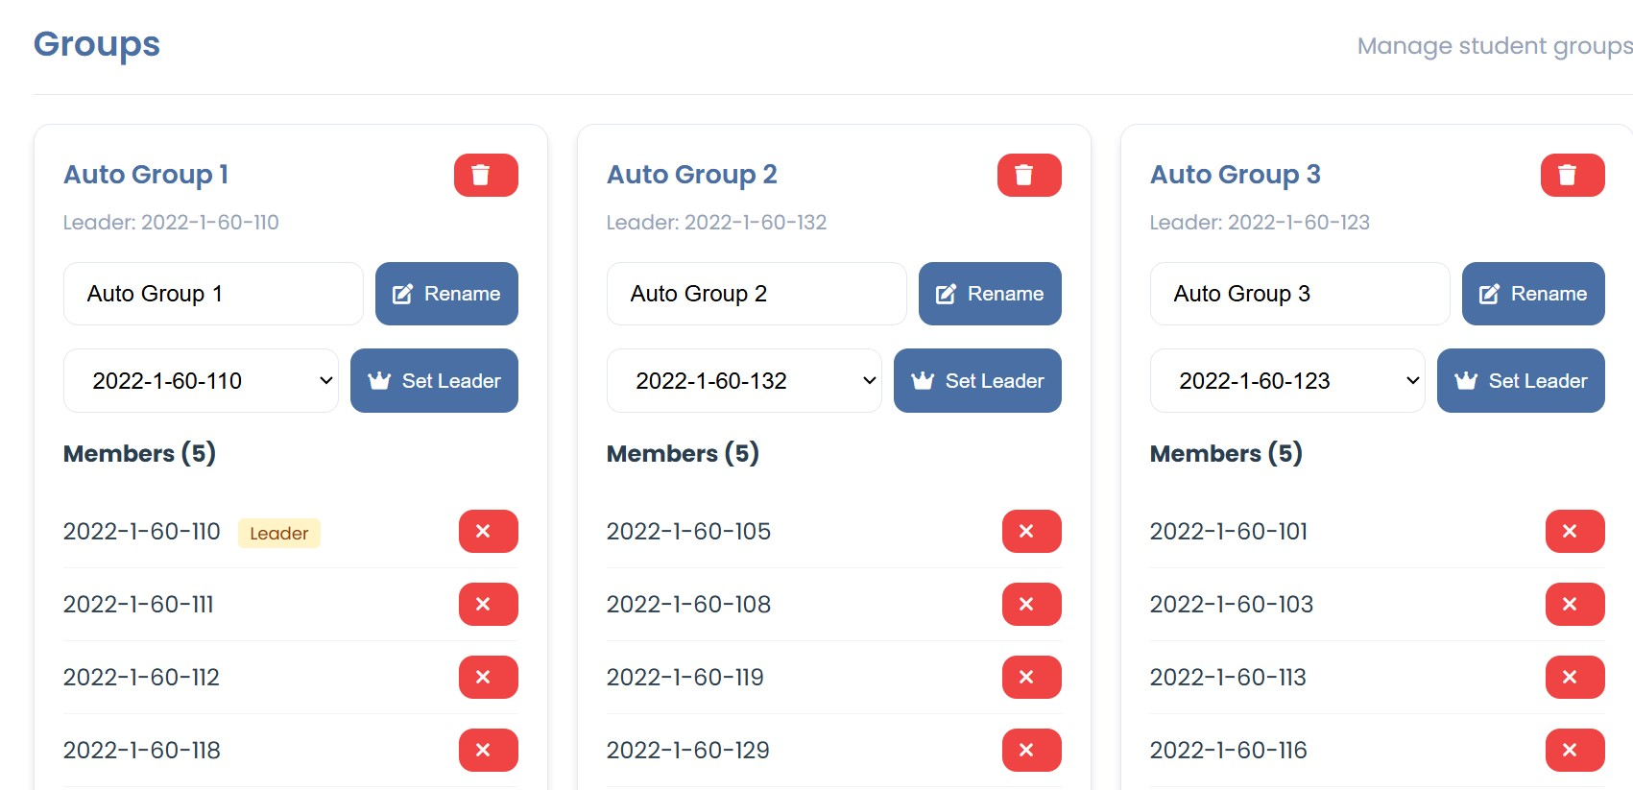

## Student _ Dashboard

1. Course Verification: Validates course existence and student enrollment
2. Group Information: Displays group details including members and leader
3. Student Information: Shows student ID and CGPA if available
4. Navigation: Provides clear navigation back to the home page
5. Responsive Design: Works well on both desktop and mobile devices

**Home Page:**

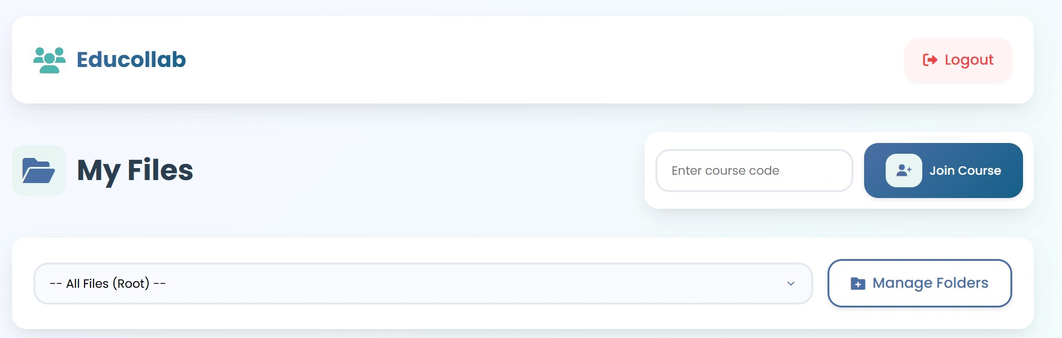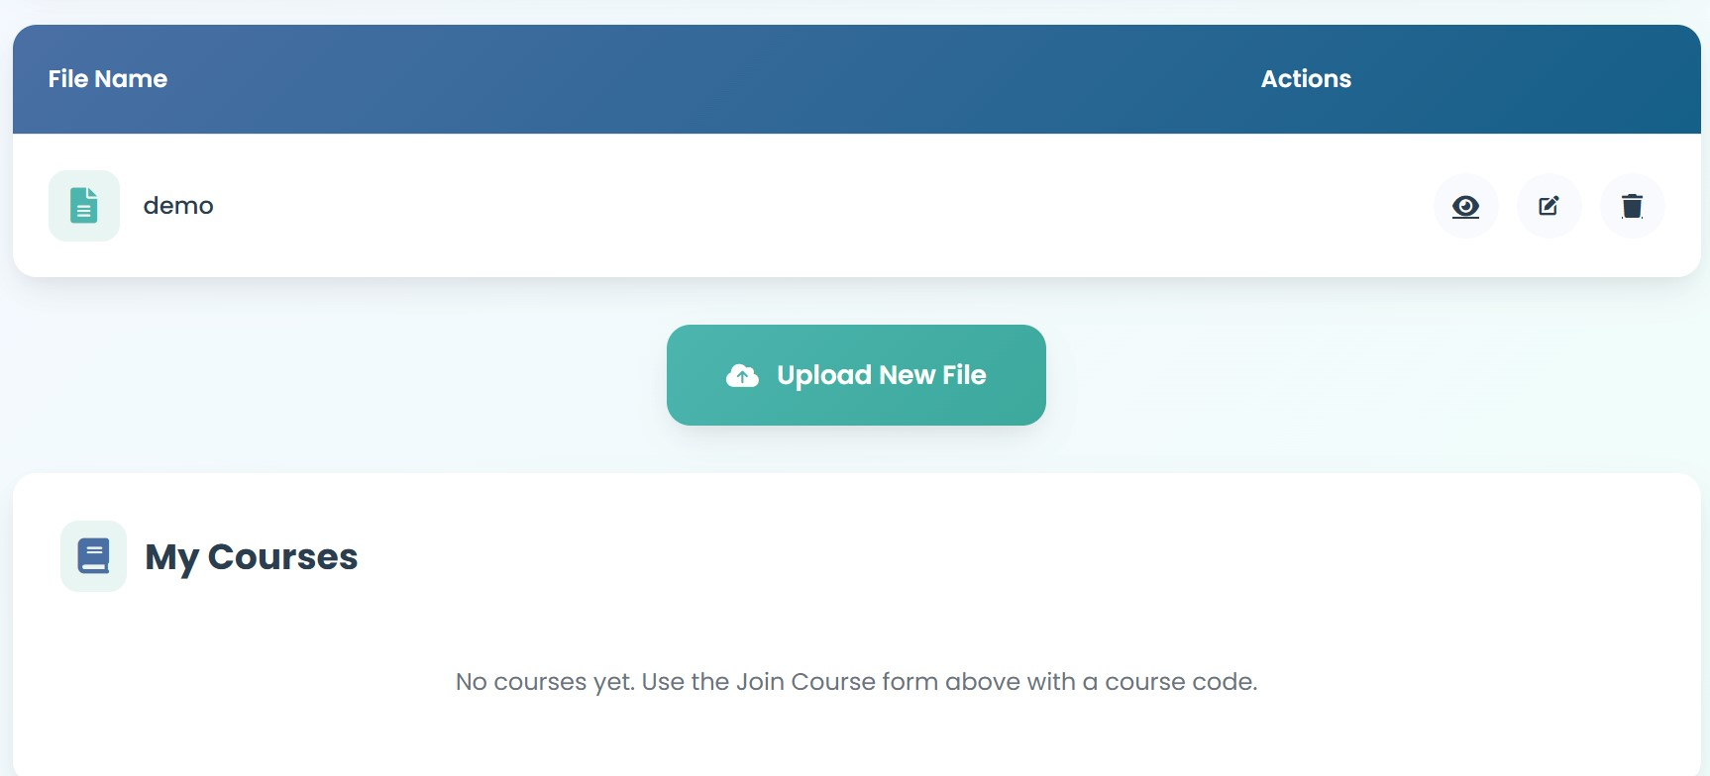

**Group Information:**

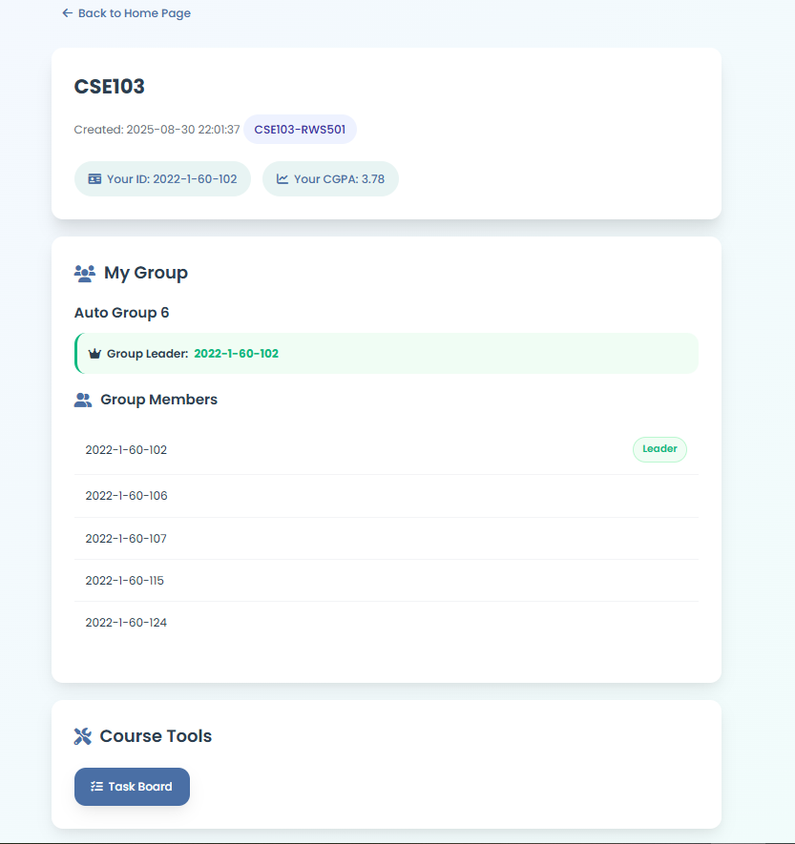

## TaskBoard

* Student View: Lists tasks assigned to them with buttons to Accept/Reject or Upload work. Shows status badges (Red, Yellow, Green).
* Leader View: Adds an "Assign Task" form and a "Final Submission" upload area. Shows all group tasks with options to approve/reject submitted work.
* Professor View: Allows filtering by course and group. Shows the task status for all members and the group's final submission for grading.

**Student View:**

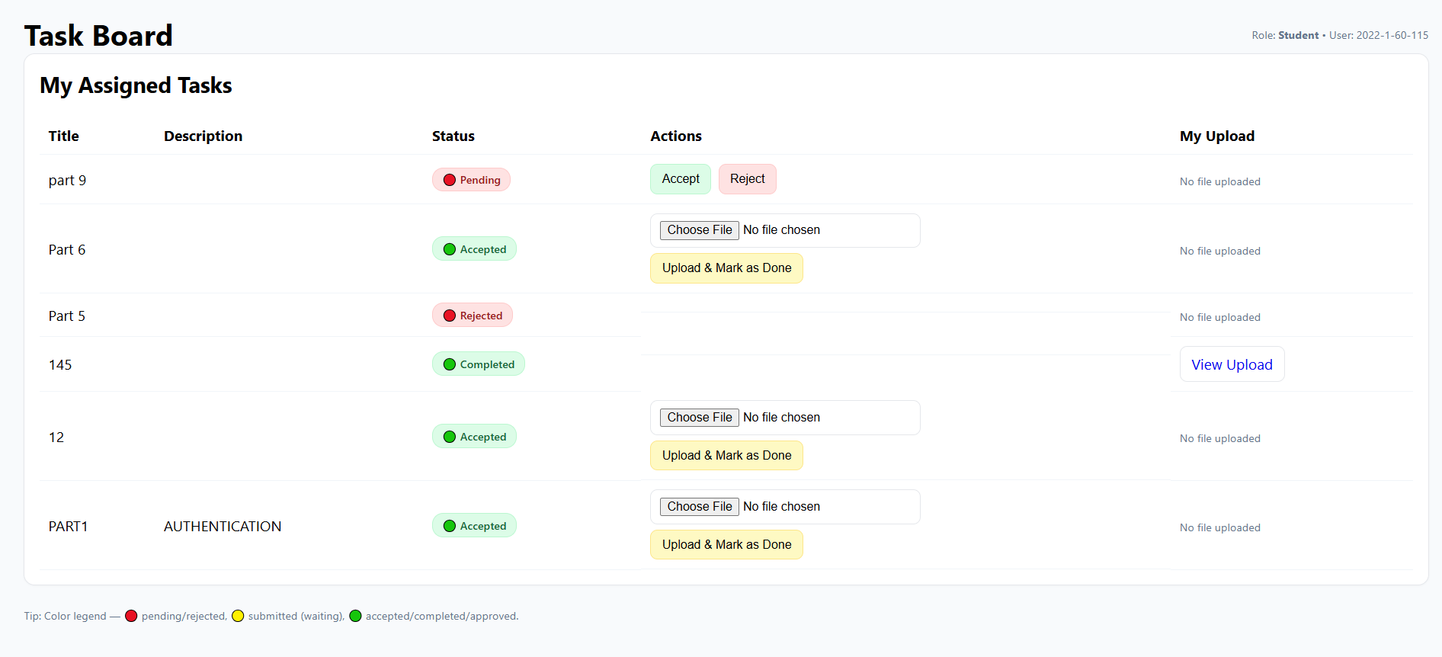

**Leader View:**

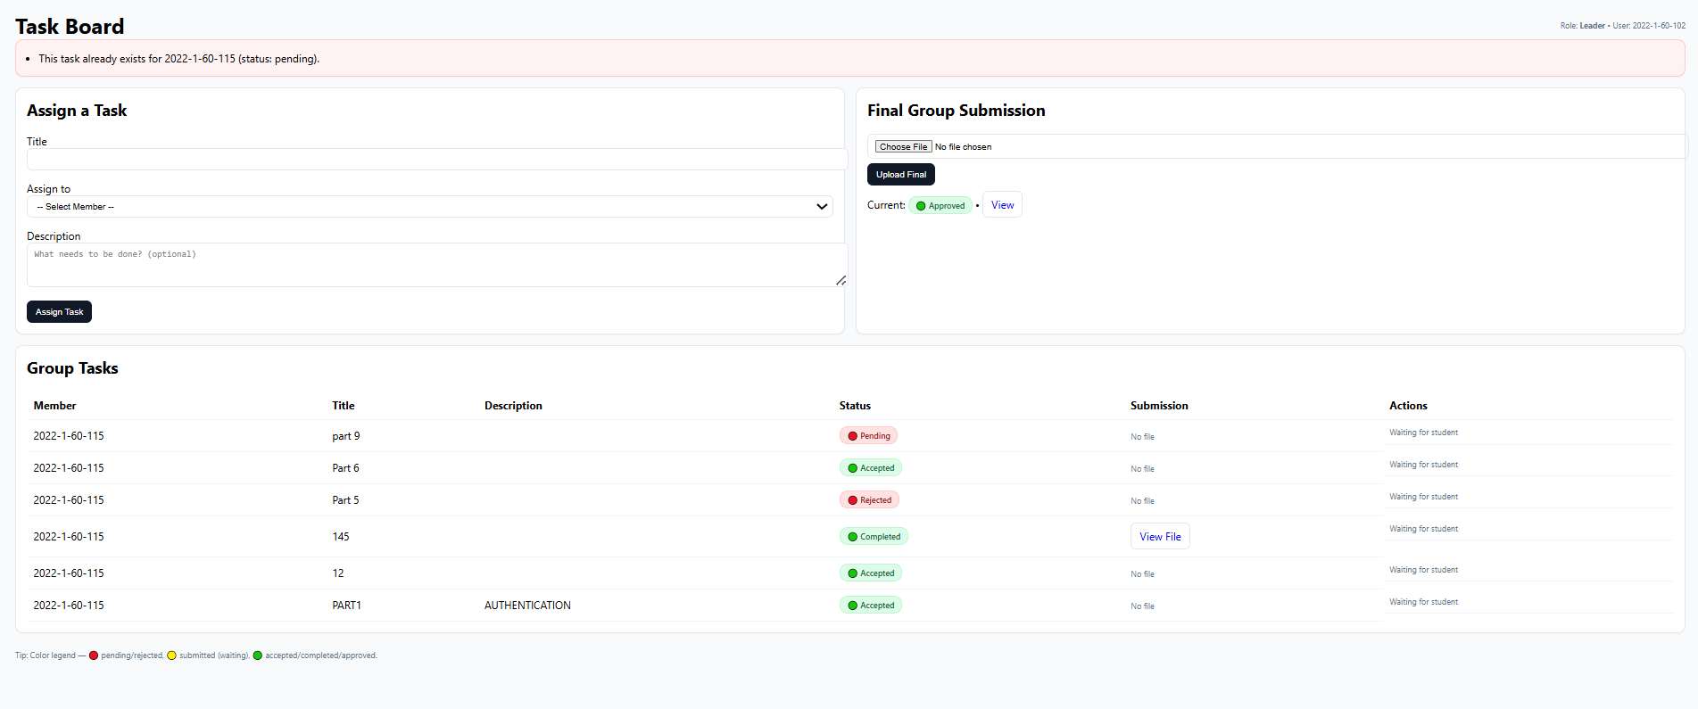

**Instructor View:**

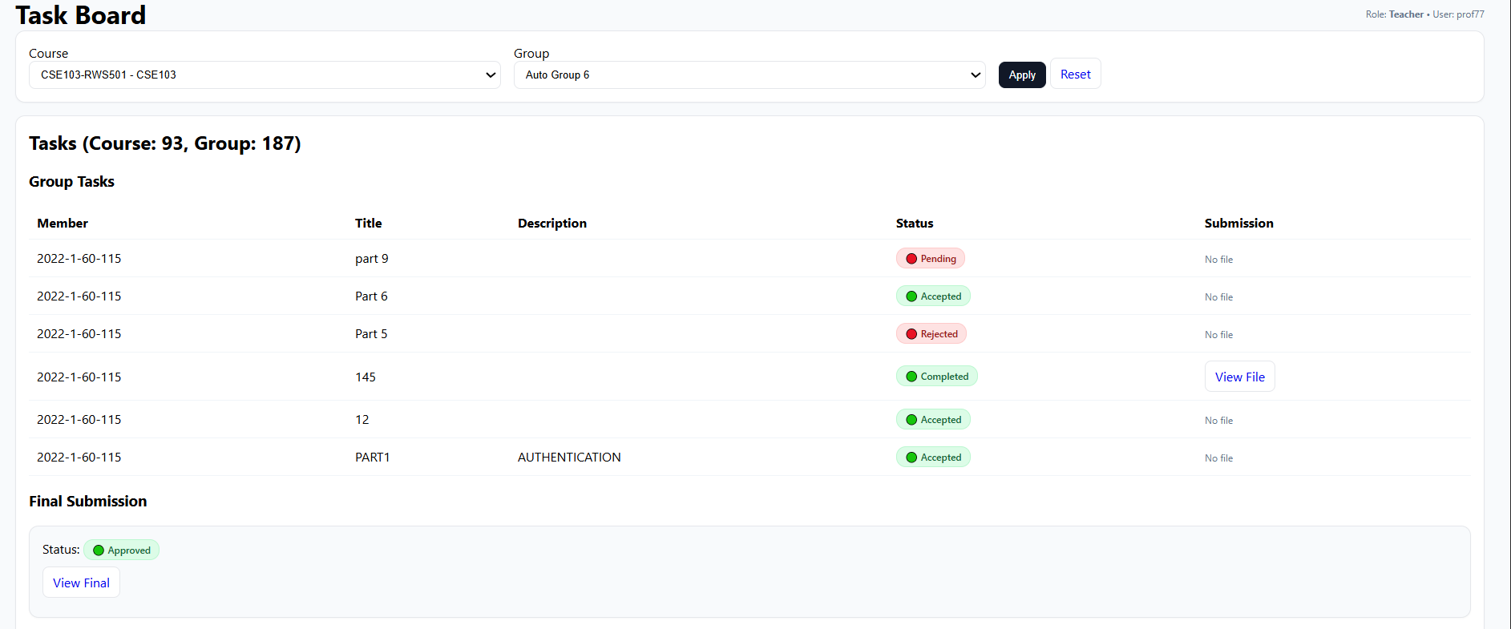

# 3. Basic Design Diagrams

## A. Use Case Diagram

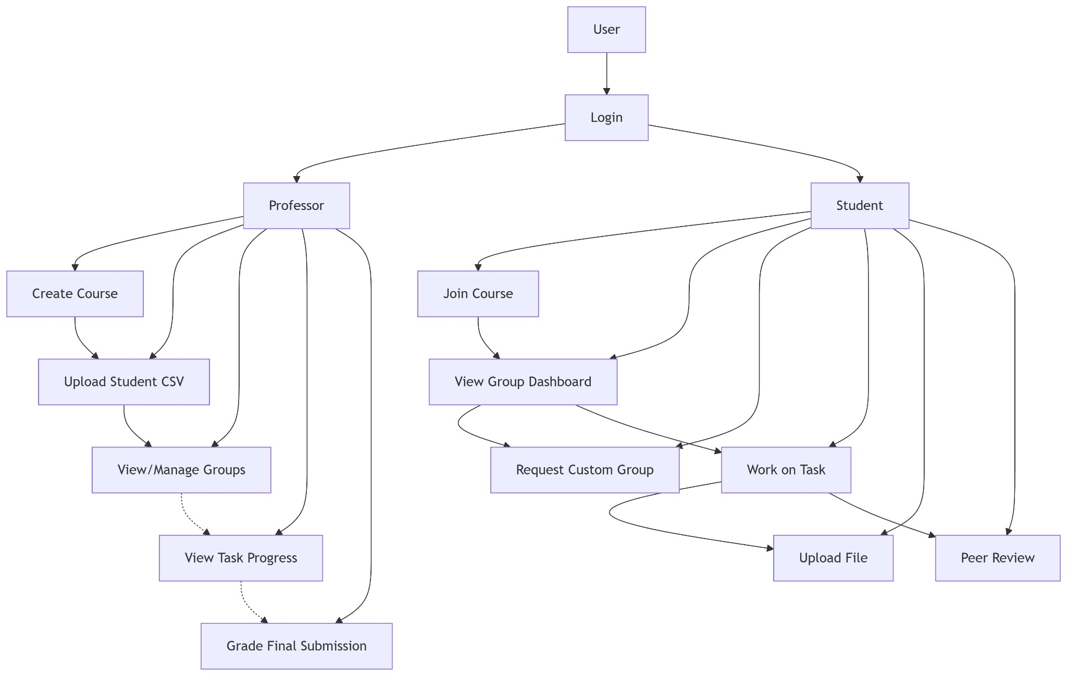

## B. Activity Diagram: Student Task Workflow

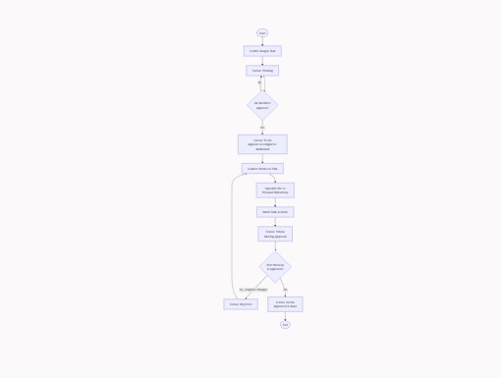

# 4. Technology Details

* Frontend: HTML5, CSS3, JavaScript (Vanilla JS for DOM manipulation and form validation).
* Backend: PHP (Procedural with prepared statements for database interaction).
* Database: MySQL.
* Security: Password hashing using password_hash(), SQL injection prevention via prepared statements, session-based authentication.

|  |
| --- |
| --educollab-primary |

* Styling: Custom CSS with a cohesive color scheme (,

--educollab-accent) and modern UI components (cards, grids, buttons).

Font Awesome for icons and Google Fonts (Poppins) for typography.

* Key Features: File upload handling, CSV parsing, dynamic group generation algorithms, role-based access control (RBAC).

# 5. Team Responsibilities .

**Team Member 1 (**Ishmat Zaman **) – User Verification & Authentication**

* Implemented secure login/registration for Student and Professor roles.
* Added role-based access control and CSV-based enrollment validation.
* Develop the student group dashboard with group details and leader view.

### **Team Member 2 (Ankon Saha) – Course & Group Management (Professor Side)**

* Developed course creation with CSV upload.
* Built group formation logic based on CGPA with leader assignment.
* Develop the professor and student dashboards.

### **Team Member 3 (Jannat Milky) – Final Submission & Task Board**

* Implemented the final group submission system with professor approval workflow.
* Developed a role-based task board for leaders (assign/approve tasks), students (submit work), and professors (monitor progress).
* Added task status tracking and file uploads for smooth collaboration.

### **Team Member 4 (**Md.Asikur Rahaman**) – Student Course Flow & Group Dashboard**

* Built the Join Course feature using course codes.
* Designed the student group dashboard with group details and leader view.

**Team Member 5 (**Md. Saeikh Abdullah**) – UI Integration & Navigation**

* Integrated repository, task board, and dashboards into a unified system.
* Designed the front-end layout for professor and student dashboards.

# 7. Conclusion

The EduCollab project successfully delivers a robust and functional collaborative learning platform. It meets all its core objectives: secure role-based access, efficient course and group management, a structured task and review workflow, and a transparent file repository system.

The use of fundamental web technologies (PHP, MySQL, JS, CSS) demonstrates a strong understanding of full-stack development principles. The modular division of work allowed for parallel development and integration of complex features. The system is ready for demonstration, showcasing a complete flow from professor course creation to student collaboration and final grading. Future enhancements could include real-time notifications, in-app messaging, and more advanced file preview capabilities.