|  |  |  |
| --- | --- | --- |
|  | **Military College of Signals, NUST** |  |

**Complex Engineering Activity Report**

**Course:** Computer Networks

**Submitted to:** Dr. Javed Iqbal

**Submitted by: (BESE 29 C)**

* Fatima Aleem
* Jannat Shaheer
* Zoiba Tabassum

**Date: 31-12-2024**

Activity Overview:

Simulated Network Infrastructure and Fault-Tolerant Routing

Objective:

To Design and implement a fault-tolerant routing algorithm in a simulated network environment.

# Designing the Network Topology:

### Topology Design:

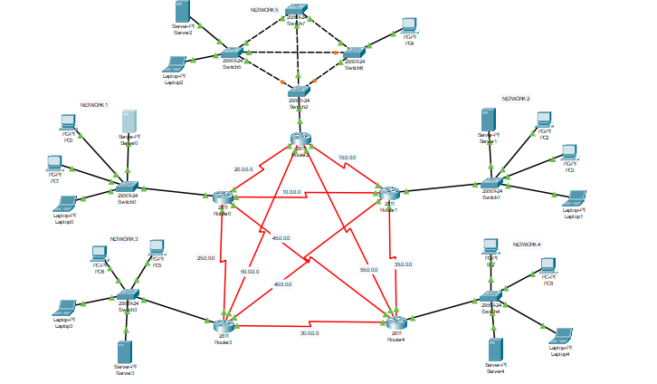

### Configuration Protocol:

* DHCP (Dynamic Host Configuration Protocol) is a protocol used to dynamically assign IP addresses to devices (such as computers, servers etc.) on a network, allowing them to communicate with other devices and systems effectively.

### Devices used:

* Routers
* Switches
* Servers
* PCs

### Networks:

**Network 1:**

* networkIP: *192.168.0.0*
* Default Gateway: *192.168.0.1*.
* Server IP: 192.168.0.2
* Usable IP Range : 192.168.0.3 – 192.168.0.254
* IP Range in use: 192.168.0.3 – 192.168.0.5
* Free IP range : 192.168.0.6– 192.168.0.254

**Network 2:**

* networkIP: *192.168.1.0*
* Default Gateway: *192.168.1.1*.
* Server IP: 192.168.1.2
* Usable IP Range : 192.168.1.3 – 192.168.1.254
* IP Range in use: 192.168.1.3 – 192.168.1.5
* Free IP range : 192.168.1.6– 192.168.1.254

**Network 3:**

* networkIP: *192.168.3.0*
* Default Gateway: *192.168.3.1*.
* Server IP: 192.168.3.2
* Usable IP Range : 192.168.3.3 – 192.168.3.254
* IP Range in use: 192.168.3.3 – 192.168.3.5
* Free IP range : 192.168.3.6– 192.168.3.254

**Network 4:**

* networkIP: *192.168.4.0*
* Default Gateway: *192.168.4.1*.
* Server IP: 192.168.4.2
* Usable IP Range : 192.168.4.3 – 192.168.4.254
* IP Range in use: 192.168.4.3 – 192.168.4.5
* Free IP range : 192.168.4.6– 192.168.4.254

**Network 5:**

* networkIP: *192.168.2.0*
* Default Gateway: *192.168.2.1*.
* Server IP: 192.168.2.2
* Usable IP Range : 192.168.2.3 – 192.168.2.254
* IP Range in use: 192.168.0.3 – 192.168.0.4
* Free IP range : 192.168.0.5 – 192.168.0.254

### Connections and redundancy:

* Ethernet cables are used to connect devices inside each network in the topology.
* Serial ports are used to connect routers of all devices to each other.
* Network 5 uses four switches within a single network which result in redundancy.

# Implementing Initial Routing:

### Protocol used:

* OSPF (Open Shortest Path First) is a **link-state routing protocol** used in **IP networks** to determine the best path for data packets within an autonomous system (AS). It is one of the most widely used interior gateway protocols (IGPs) and operates based on the shortest path first (SPF) algorithm, specifically **Dijkstra's algorithm**.

### Configuration:

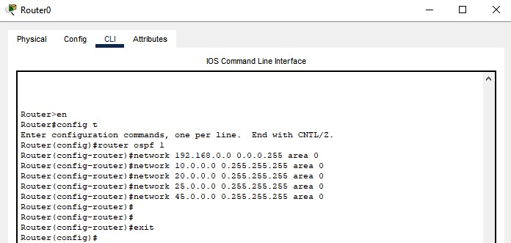

* All possible paths for a router are configured manually.
* Once the OSPF protocol is setup the routing table is updated automatically with each data transfer.

### Communication among networks:

* Routing table :

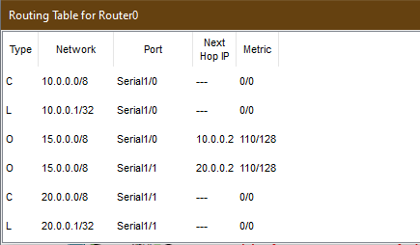 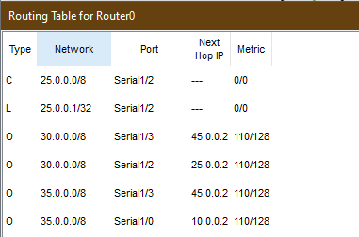 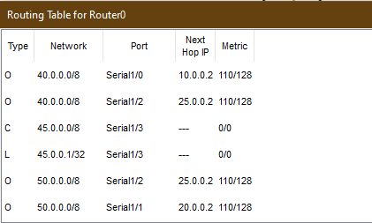 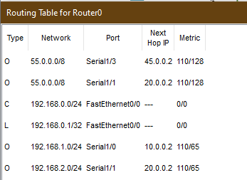 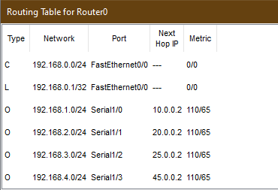

* Header of the data packet that is to be sent among two devices on the network:

### 

* Path of data packet:

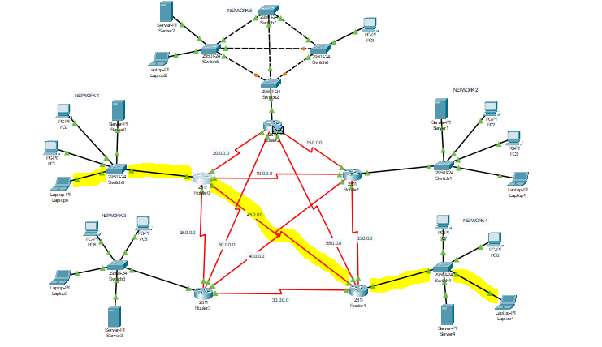

* Route from source to destination:

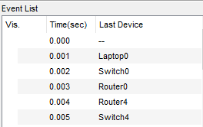 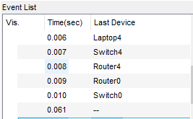

# Introduction of Faults:

### Link failure:

The above example illustrates how a data packet travels from laptop 0 to laptop 4 when the network is working perfectly. Now we check how data transmission is affected in case of link failure.

* Failed link:

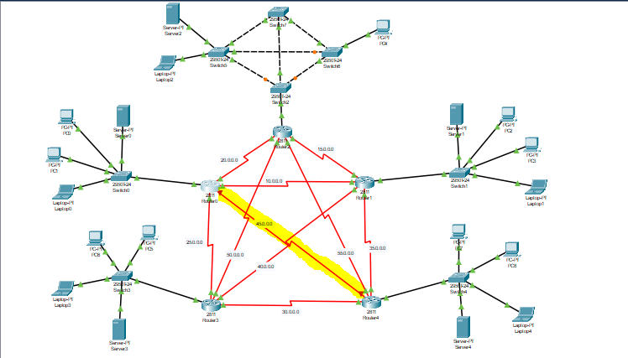

* Routing table after link failure:

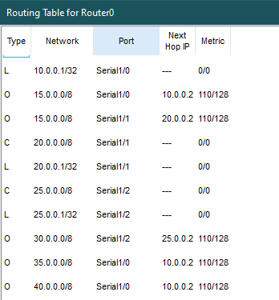 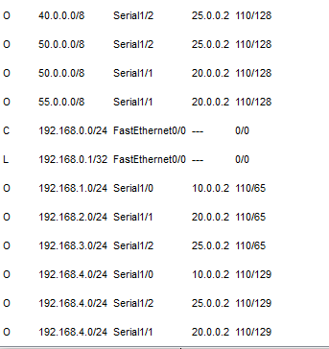

* New path:

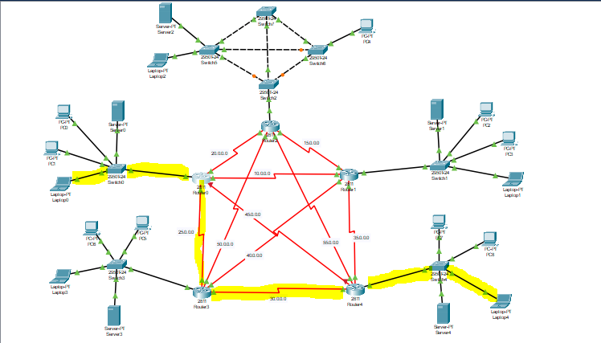

* Route from source to destination:

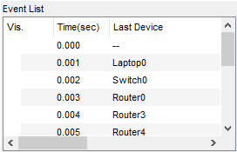 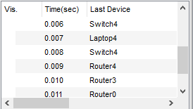

### Observations:

* Failure in a link triggers router to reroute the data
* The data of failed link is automatically deleted from routing table, and new path for packet transmission is stored.
* Ideally, the router sends data through the smallest path but if the link for this path fails the router transmits data through a longer path
* In above example when there is a delay of 0.002 secs in case of link failure.

### Node failure:

We compare how data is transmitted from laptop0 to PC4 without any node failure and then in case one of node failure.

* Routing table:

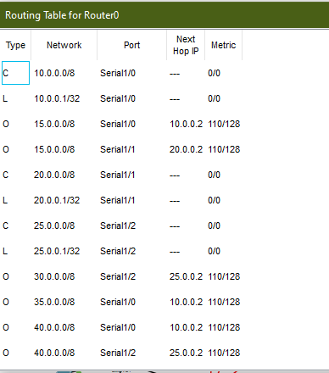 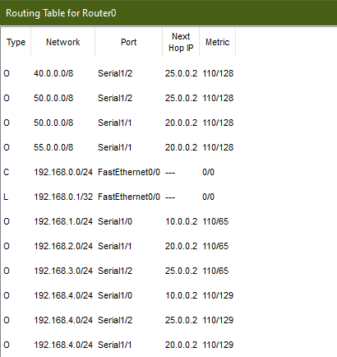

* Mac table:

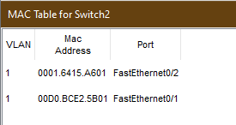

* Packet header:

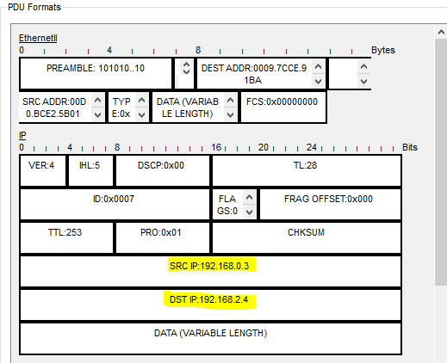

* Path of data packet:

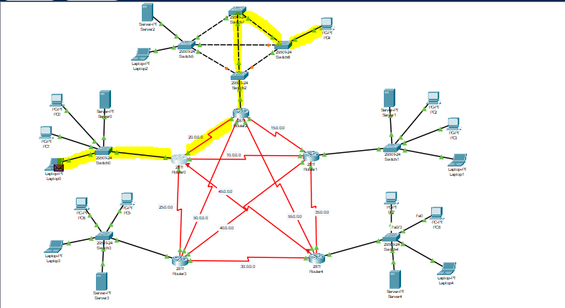

* Route from source to destination:

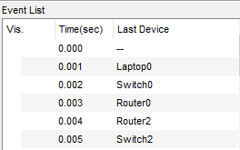 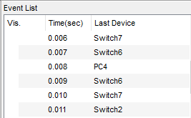

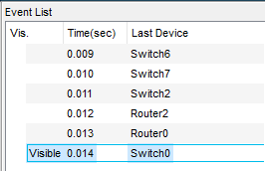

### Node failure:

* Failed node:

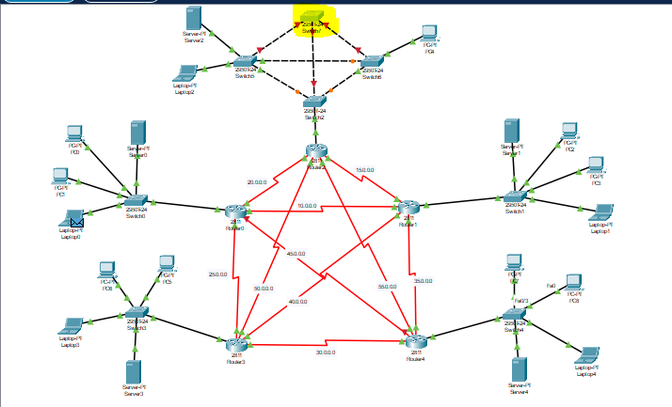

* Routing table:

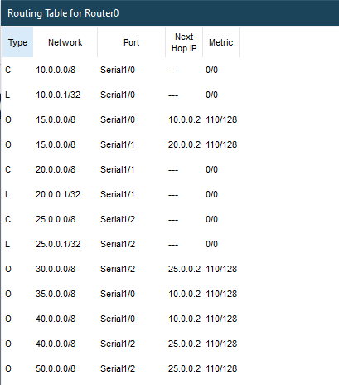 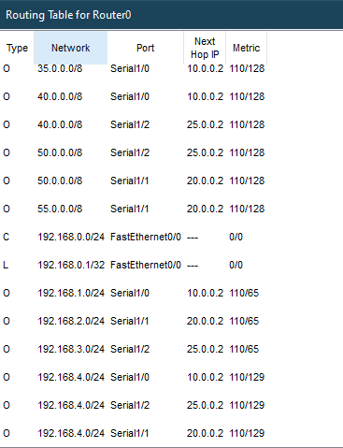

* Mac table:

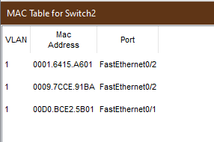

* Path of data from source to destination:

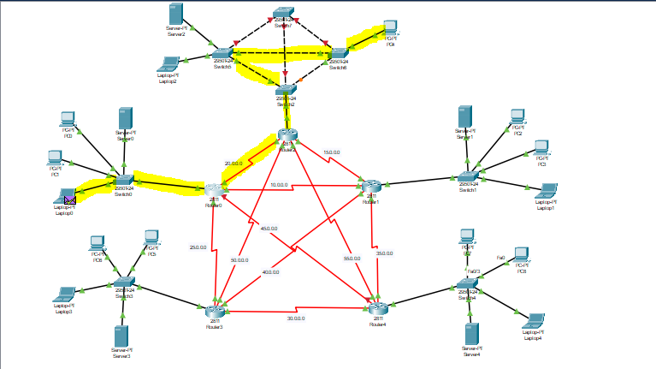

* Data path of packet:

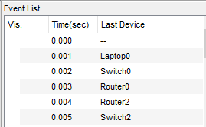 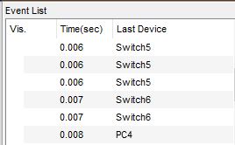

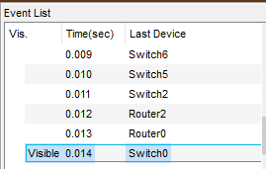

### Observations:

* In case of node failure, the time for packet transmission remains same but data is rerouted.
* Since the node that failed was in another network, there is no change in the routing table for router0.
* The mac table of switch2 is reroutes the data.

# Analysis:

### Without link failure:

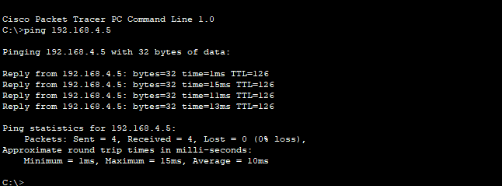

### With link failure:

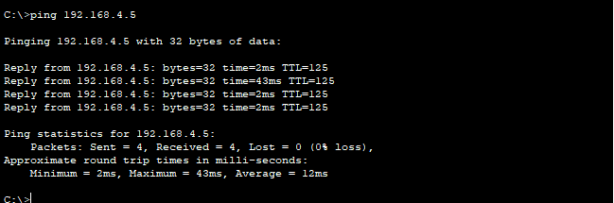

### Without node failure:

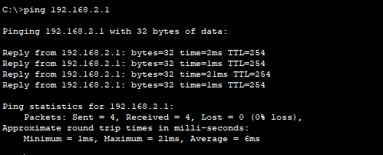

### With node failure:

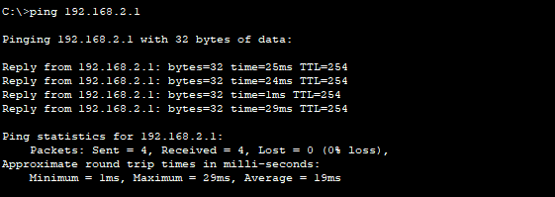

### Latency :

### Observations:

* Link failure affects latency of the system with an increase of 2ms.
* Node failure causes an increase in latency by 13ms.
* Due to OSPF protocol, there is no loss of packets and they are simply rerouted.

### Conclusion:

The simulation demonstrated the effectiveness of fault-tolerant routing using OSPF, which efficiently rerouted traffic during failures, ensuring minimal downtime and packet loss. While latency increased during faults, the network maintained stability and reliability, emphasizing the importance of fault-tolerant mechanisms in enhancing network resilience and performance. Future work could explore advanced algorithms to further optimize efficiency and reduce latency.

### 