

Image Segmentation in Medical Imaging
Course Code: CS-251
Course Title: Design and Analysis of Algorithms

Group Members:
Jannat Shaheer (472248)
Zoiba Tabassum (478562)
Hassan Iftikhar (486855)
Muhammad Talha (486869)
Tanveer Haider (486873)

Course: BESE 29-B

Project Supervisor: Dr Samra Kanwal

May 2, 2025

Contents:
- Introduction 5

- Problem Statement 5

- Objective 5

- Methodology 5
  - Algorithm Description and Implementation ………………………………… 5
    - Step 1: Data Preprocessing …………………………………………… 6
    - Step 2: Image Flattening ……………………………………………… 7
    - Step 3: Tumor Identification using K-Means Clustering ……………... 7
    - Step 4: Generate Binary Mask from pixels …………………………… 8
    - Step 5: Noise removal by Morphological Closing ……………………. 9

- Big-O Notation Summary 10
- Conclusion 10
- Future Enhancements 10

Project Rubrics:
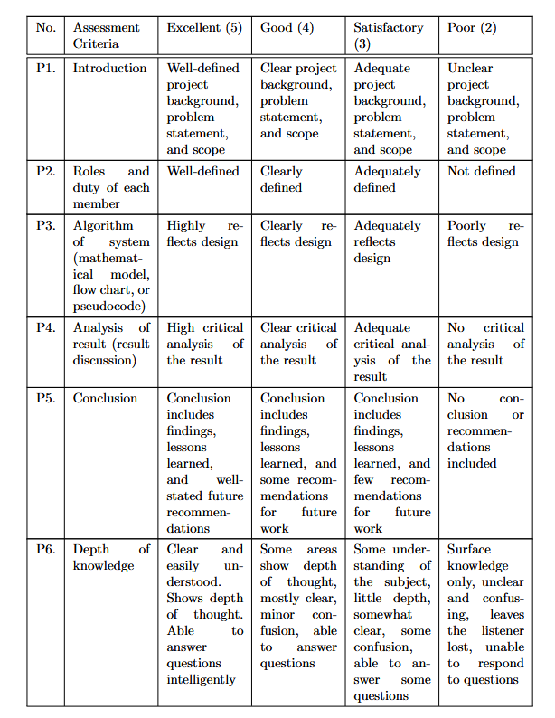

Assessment Results:

Student Name | P1 | P2 | P3 | P4 | P5 | P6 | Total
Jannat Shaheer
Zoiba Tabassum
Hassan Iftikhar
Muhammad Talha
Tanveer Haider

- Introduction
Tumor detection in MRI scans is a critical task in medical diagnostics, requiring accurate and timely identification of abnormal regions. Manual segmentation by radiologists is time-consuming and subject to variability. This project aims to automate tumor segmentation in MRI images using efficient algorithmic techniques within the Design and Analysis of Algorithms (DAA) framework. By employing classical image processing and clustering algorithms, the project seeks to enhance diagnostic support through reliable and computationally feasible methods.

- Problem Statement
Given a dataset of MRI scans (such as brain scans), the objective is to develop an efficient algorithm that automatically segments tumor regions from the images with high accuracy. The algorithm should use classical image processing and clustering techniques to differentiate tumor tissue from healthy regions, enabling reliable and computationally efficient support for medical diagnosis.

- Objective
The proposed approach employs Gaussian blur for noise reduction, K-Means clustering for grouping pixel intensities to distinguish tumor tissue, and morphological operations to refine the segmentation mask by removing small artifacts and smoothing region boundaries. The classical approach is suitable for image analysis in resource-constrained environments that limit the use of deep learning models.

- Methodology
  - Algorithm Description and Implementation
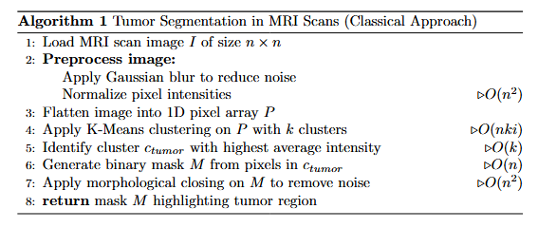

Assume an image of pixel size n x n.
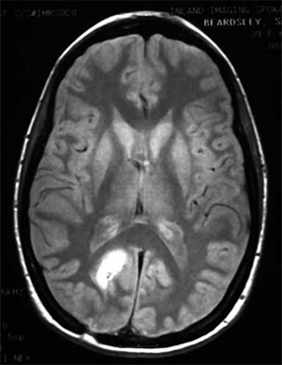
    - Step 1: Data Preprocessing
- Apply Gaussian Blur to reduce noise
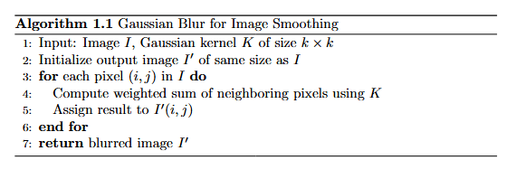
- Normalize the pixel intensities by scaling pixel values

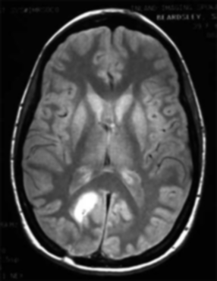

Time Complexity: O$(n^{2} x k^{2})$
A convolution operation is applied over each pixel in the image with kernel of size k x k. This leads to O$(k^{2})$ operations per pixel, so total time complexity is O$\left(n^{2} x k^{2}\right).$
Space Complexity: $O$($n^{2})$
The blurred image is stored in a new array of the same size as the input, i.e. n x n, so space complexity is $O$($n^{2})$

    - Step 2: Image Flattening
- Convert the 2D image into 1D pixel array
- Required format for clustering algorithms
Time Complexity: $O(n^{2})$
Converting a 2D image into a 1D array requires reading each pixel once, resulting in a linear-time operation proportional to the number of pixels, i.e. $n^{2}$.
Space Complexity: $O(n^{2})$
A new array of size $n^{2}$is created to store the flattened version.

    - Step 3: Tumor Identification using K-Means Clustering
- Group pixels into k clusters based on intensity similarity
- Assign each pixel to the cluster with the closest centroid

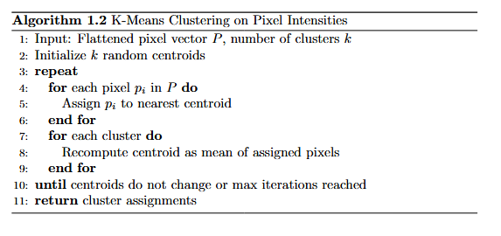
- Identify tumor as highest intensity cluster
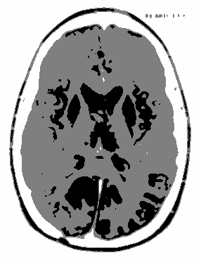
Time Complexity: $O(n^{2} x k x i)$
For each iteration, each of the $n^{2}$pixels is compared to $k$ cluster centers, and this is repeated for $i$ iterations until convergence.
Space Complexity: $O(n^{2}+k)$
- Requires space for the label assignment array (size $n^{2}$) and cluster centers (size $k$).

    - Step 4: Generate Binary Mask from pixels
- Convert clusters into usable image form
- Pixels assigned to the tumor clusters are marked as 1 (foreground) and all others as 0 (background)

Time Complexity: $O\left(n^{2}\right)$
Each pixel’s intensity is compared against a fixed threshold to assign binary values (0 or 1), leading to time complexity proportional to pixel number ($n^{2}$)
Space Complexity: $O(n^{2})$
A new binary mask of the same size as the image ($n^{2}$) is generated.
    - Step 5: Noise removal by Morphological Closing
- Apply dilation and erosion to remove small holes and noise in the segmented mask to improve region connectivity and shape.
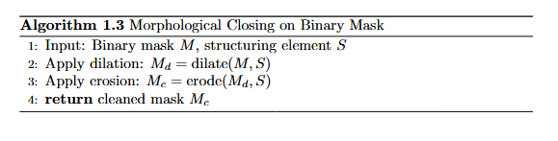
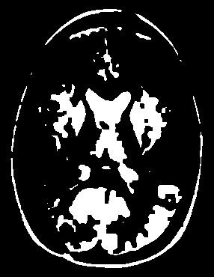
Time Complexity: $O(n^{2} x k^{2})$
Each morphological operation applies a structuring element (kernel) over every pixel. For a $k x k$kernel, this results in $O(k^{2})$ operations per pixel, so total complexity is $O(n^{2} x k^{2})$.
Space Complexity: $O(n^{2})$
A new binary image is produced as the result of closing, hence space complexity is proportional to number of pixels, $n^{2}$.

Final image after mask overlay:
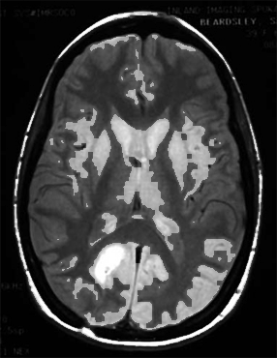

- Big-O Notation Summary

Step | Algorithm | Time Complexity | Space Complexity
Data Preprocessing | Gaussian Blur | O$(n^{2} x k^{2})$ | $O$($n^{2})$
Image Flattening | Array Traversal | $$O(n^{2})$$ | $$O(n^{2})$$
Tumor Identification | K-Means Clustering | $$O(n^{2} x k x i)$$ | $$O(n^{2}+k)$$
Binary Mask Generation | Thresholding | $$O(n^{2})$$ | $$O(n^{2})$$
Noise Removal | Dilation and Erosion | $$O(n^{2} x k^{2})$$ | $$O(n^{2})$$

K-means clustering is usually dominant, so time complexity is dependent on it. The time complexity of k-means is $O(n^{2} x k x i)$; however, $k$ and $i$ are small in practice, so time complexity becomes $O(n^{2})$.
Since each step processes an entire $n x n$ image and stores intermediate outputs separately, the overall space complexity remains $O(n^{2})$.

- Conclusion
The proposed tumor segmentation algorithm combines multiple classical image processing techniques to achieve efficient and interpretable results. Gaussian Blur reduces noise, K-Means Clustering segments tissue regions based on intensity, and Morphological Closing refines the segmented tumor mask. The approach is lightweight, scalable, and well-suited for deployment in environments with limited computational resources.

- Future Enhancements

- Integrate Otsu’s Method for adaptive thresholding in tumor detection.
- Replace K-Means with DBSCAN or Mean Shift to handle non-spherical tumor patterns.
- Extend the algorithm for 3D MRI volumes to capture tumor structures across slices.
- Combine classical techniques with deep learning for hybrid segmentation models.
- Deploy the system in real-time medical diagnostic tools with GPU acceleration.

