[Date]
refa022ja@gmail.com
[company name]
[Document title]
[Document subtitle]

Final Assignment
Data Warehouse and Data Mining

Assignment submitted by:
Name: Bristy, Mushfika Jannat
ID : 17-35530-3
Section: C

Course Supervisor:
Dr. Md. Mahbub Chowdhury Mishu

Title: Predict the early stage of Chronic Kidney Disease (CKD) using k-Nearest Neighbors (KNN) Classification.
Contribution: Classification is popular and one of the most common data mining techniques. The objective of classification is to precisely anticipate the target class for each case in the data. In this project, I used a widely utilized classification procedure called “K-nearest neighbors (KNN)”. It is additionally called a lazy learner algorithm. In Weka, it is defined as “IBK”. By utilizing K-NN, it will effortlessly recognize the category or class of a specific dataset. In this project, I used a medical data set that is based on “chronic kidney disease (CKD)”. It means the abnormal function of the kidney. The method will help to predict the early stage of Chronic Kidney Disease. This calculation guarantees to help doctors to form near-perfect analysis, select the finest drugs for their patients, spot patients at high-risk for pitiable results, and particularly improving patients’ physical condition whereas minimizing costs.
Methods - Description of process and Setup:
In this project I used KNN algorithm in Weka .KNN algorithm at the preparing stage just stores the dataset and when it gets unused data, at that point it classifies that data into a category that's much comparable to the new data. The information set for constant kidney disease was accumulated and applied on the classifier to foresee the disease and the execution of the classifier is assessed based on precision, exactness.
KNN method:

Description of data sets:
Early stage of Chronic Kidney Disease (CKD). Data collected from online source UCI.
1. Number of Instances: 400 (250 CKD, 150 notckd)
2. Number of Attributes: 24 + class = 25 (11 numeric, 14 nominal)
3. Class Distribution: (2 classes)
Class Number of instances
ckd 250
notckd 150

4. Attributes Name:
age - age
bp - blood pressure
sg - specific gravity
al - albumin
su - sugar
rbc - red blood cells
pc - pus cell
pcc - pus cell clumps
ba - bacteria
bgr - blood glucose random
bu - blood urea
sc - serum creatinine
sod - sodium
pot - potassium
hemo - hemoglobin
pcv - packed cell volume
wc - white blood cell count
rc - red blood cell count
htn - hypertension
dm - diabetes mellitus
cad - coronary artery disease
appet - appetite
pe - pedal edema
ane - anemia
class - class

5. Attribute Information:
- Age(numerical)
age in years
- Blood Pressure(numerical)
bp in mm/Hg
- Specific Gravity(nominal)
sg - (1.005,1.010,1.015,1.020,1.025)
- Albumin(nominal)
al - (0,1,2,3,4,5)
- Sugar(nominal)
su - (0,1,2,3,4,5)
- Red Blood Cells(nominal)
rbc - (normal,abnormal)
- Pus Cell (nominal)
pc - (normal,abnormal)
- Pus Cell clumps(nominal)
pcc - (present,notpresent)
- Bacteria(nominal)
ba - (present,notpresent)
- Blood Glucose Random(numerical)
bgr in mgs/dl
- Blood Urea(numerical)
bu in mgs/dl
- Serum Creatinine(numerical)
sc in mgs/dl
- Sodium(numerical)
sod in mEq/L
- Potassium(numerical)
pot in mEq/L
- Hemoglobin(numerical)
hemo in gms
16. Packed Cell Volume(numerical)
17. White Blood Cell Count(numerical)
wc in cells/cumm
18. Red Blood Cell Count(numerical)
rc in millions/cmm
19. Hypertension(nominal)
htn - (yes,no)
20. Diabetes Mellitus(nominal)
dm - (yes,no)
21. Coronary Artery Disease(nominal)
cad - (yes,no)
22. Appetite(nominal)
appet - (good,poor)
23. Pedal Edema(nominal)
pe - (yes,no)
24. Anemia(nominal)
ane - (yes,no)
25. Class (nominal)
class - (ckd,notckd)

Dataset
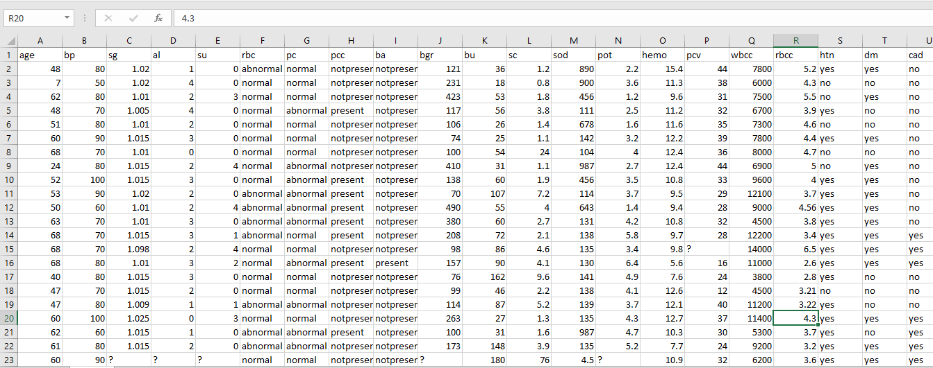

Data Mining Techniques:
“Weka” is a machine learning software used for data mining tasks. I used “Weka” for this project.


For preparing the data set, first the arff data file was loaded in Weka.
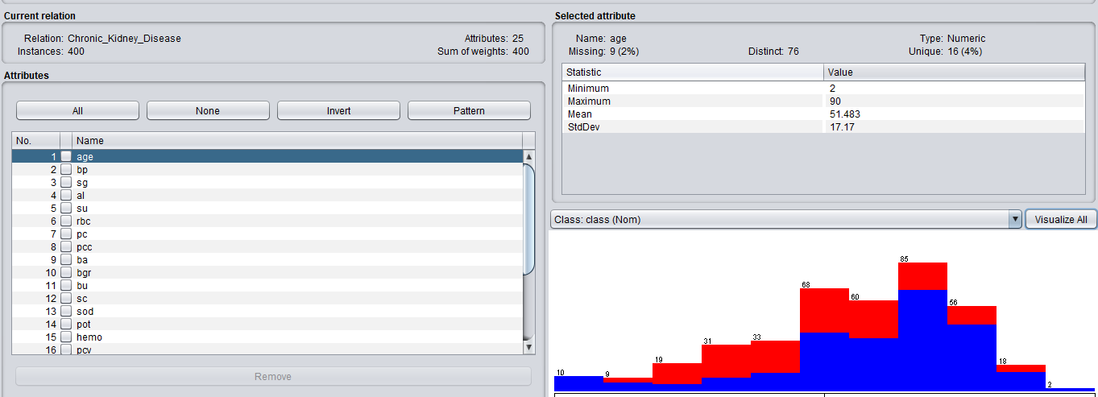
Full dataset loaded in Weka and the graph
After loading the data use filter option to resample the data. In resample process data was split in two parts, they are training set and test set. 66% data used for training, randomSeed was kept 1,and noReplacement=”True”. After that apply the process and save the file as trainset.

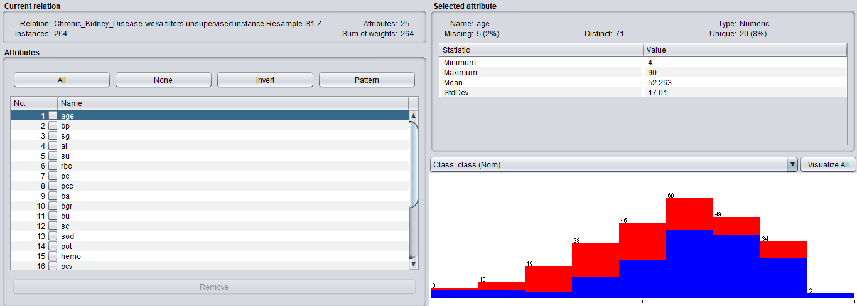
Training data set Graph

I used 34% data used for testing, here randomSeed was also 1, noReplacement=”False” and invertSelection=”True”. After that apply the process and save the file as testset.

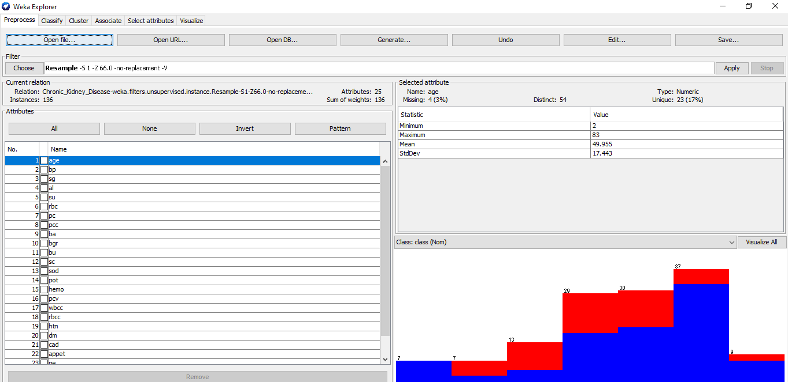
Test data set Graph
This project intends to predict the early stage of kidney disease. To find out the accuracy I used the KNN algorithm and train the data set. For training the data set I have to resample them and used 66% data. The total instance was 400, 264 instance used for training the data. The rest 136 instances (34%) were used to test the data. In the data set, the class attribute is nominal. The model predicts the value of class using a data set. Before testing, I have trained the data set. After that, I used a test set to find out the accuracy. In the training time, I loaded the train data set in the Weka and applied the KNN algorithm from classification. I used randomSeed 1 for training the data set.
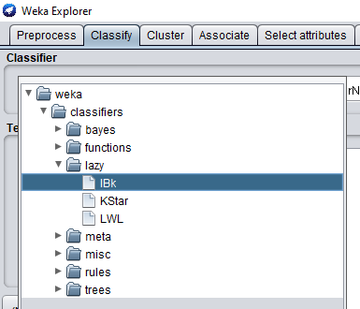
Choosing the classification method

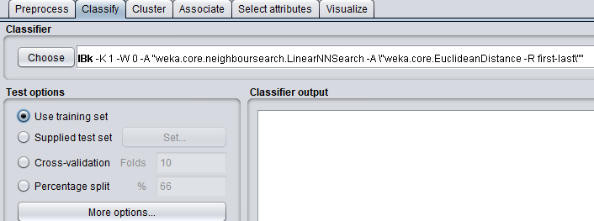

After choosing the training set I click on the start button to find out the result.
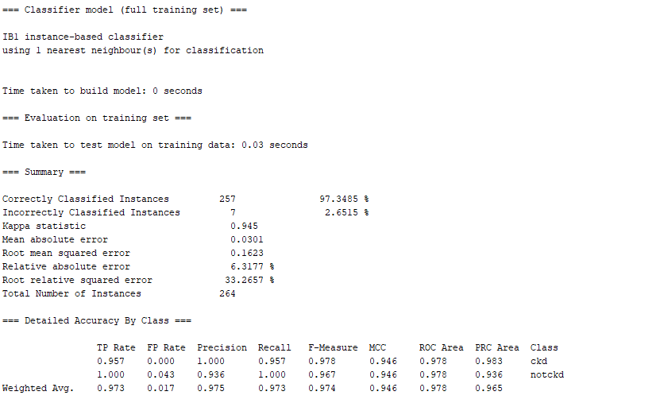

Here the accuracy of training set is 97.3485%

For testing the data, Test data set was loaded
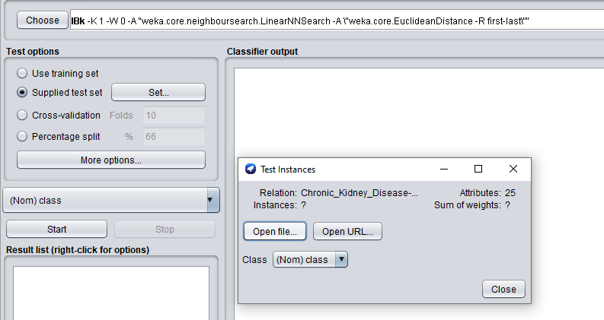

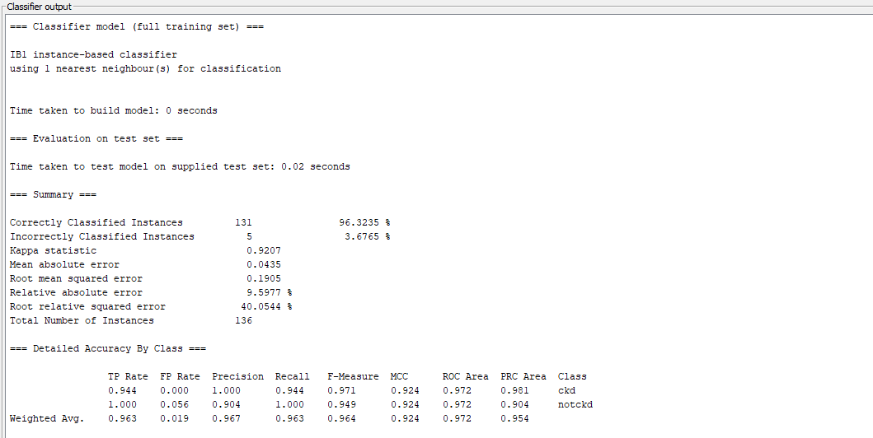

Here the accuracy of the test set is 96.3235%

Result and Discussion:

For this project, “KNN” is the right choice because it gives accuracy above 95%.I also applied “Naïve Bayes” but the accuracy was less than 95%. “KNN” is simple, easy to use, and is also a versatile algorithm. That's why I used the KNN algorithm

Here I found the accuracy of the training set is 97.3485% and the test set is 96.3235%. Here the test data set accuracy is 96.3235%. Which is above 95%. That means the model is acceptable to predict Chronic Kidney Disease (CKD). If the result was below 95% then the model was not appropriate to predict the disease. Because in medical science we cannot take a value which is less than 95%.Now it can be said that the model will be very helpful for medical science. Tt will give 96% correct prediction. This calculation ensures to assist specialists to make near-perfect investigation, select the finest drugs for their patients, spot patients at high-risk for pitiable comes about, and especially progressing patients’ physical condition though minimizing costs.

Conclusion and Future Work:
In this project I used real life data set to solve real life problem which is based on medical science. Revealing modern biomedical and healthcare-related information in order to support clinical choice making, is another measurement of data mining. Through an enormous writing overview, it is found that early illness prediction is the foremost requested region of inquiring about in the wellbeing care sector. As the health care domain is a bit more extensive space and having distinctive illness characteristics, distinctive procedures have they possess prediction efficiencies, which can be improved and changed in order to urge into the most optimized way. In this inquire about work, creators have comprehensively compared distinctive information classification methods and their expectation precision for chronic kidney infection.

The utilizations of Weka can be stretched out further to the clinical field for a finding of various illnesses like malignant growth and numerous others. It can likewise help in tackling the issues of clinical examination utilizing various uses of Weka. Another preferred position of utilizing Weka for the expectation of sicknesses is that it can without much of a stretch analyze an infection even in the event that when the number of patients for whom the expectation must be done is gigantic or in the event of exceptionally huge informational indexes traversing lakhs of patients. The proposed approach is utilized with Chronic Kidney Disease information set but we arrange to expand this approach in future for prediction of other disease such as cancer etc.

