Answer to the question no: 1
Acceptance Criteria:
Feature 1:
1. Customer must login to their Easypay account for transactions.
2. Merchants should be registered to the Easypay app.
3. Customer must have enough balance to pay.
4. A service charge equal to 1% of the total payment amount should be taken from the customer's account for every merchant bill payment.
5. Transaction fee should be a minimum of 5 tk regardless of the transaction amount.
6. Customers should earn 10% cashback on merchant bill payments above 5000 TK.
7. Customer should earn 20% cashback on merchant bill payments above 10000tk.
8. The maximum cashback a customer should receive for one transaction is 3000 TK.
9. Cashback should not be applied for any utility bill payments.

Feature 2:
1. Customer must login to the system.
2. Customer balance should be less than 100 tk to apply for a loan.
3. Customer should be able to apply for a maximum of 20,000 tk loan.
4. No interest should be charged for full repayment of the loan within 30 days.
5. 1.8% interest should be added using compound interest on the remaining loan amount if the loan isn’t fully repaid within 30 days.
6. Customers should be eligible to apply for another loan after repaying 50% of their loan taken before.
Answer to the Question no: 4
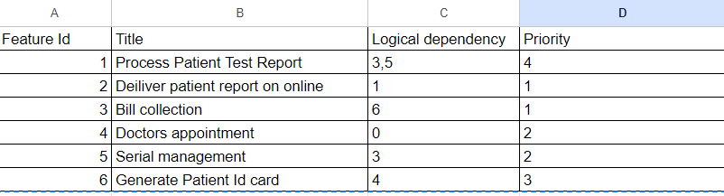

Priority level Sequence: 4 > 6 > 3 > 5 > 1 > 2
I have prioritized the features considering their logical dependency on each other. We'll begin with targeting and finishing the tasks without any dependencies. After those are finished, we'll go back then identify and handle features that depend on the ones we've already finished, going step by step in this way.
From the table, we can see that
- Every feature is logically dependent on every other feature except for feature id 4- the doctors appointment. So we can take care of feature id 4 first.

- Then, we need to find which feature depends on feature id 4, from the table, we see that, id 6-Generate Patient Id card, depends on id 4. As we have already done with id 4, we can now do the job of id 6.

- Next, we check again for features that depend on id 6, which is id 3-Bill Collection, so we can do it next.

- Then we can take care of id 5- Serial management as it was depending on id 3 which is now finished.

- Then we can do the job in id 1- Process Patient Test Report, in the sequence as it depends on both id 3 and id 5 which we have taken care of previously.

- Finally, we can do the id 2- Deliver patient report online, as it was depending on id 1.

Answer to the Question no: 5

Checklist based on the test cases on Feature 1 is given bellow:

SL | Checkpoint | Yes | No
1. | Can users pay merchant fees and utility bills?
2. | Does the service charge equal 1% of the total payment merchant bill amount debited from the customer's account?
3. | Is transaction fee a minimum of 5 tk regardless of the transaction amount debited from the customer's balance?
4. | Do customers receive 10% cashback on merchant bill payments above 5000 tk?
5. | Do customers receive 20% cashback on merchant bill payments above 10000tk?
6. | Is the maximum cashback a customer can receive for one transaction 3000 tk?
7. | Does cashback apply for any utility bill payments?

Checklist based on the test cases of feature 2:

SL | Checkpoint | Yes | No
1. | Is the customer balance <100 tk to be considered eligible to apply for a loan?
2. | Is the maximum amount of loan a customer can apply for 20,000 tk?
3. | Can customers repay the loan without any interest within 30 days of the loan initiation day?
4. | Is 1.8% interest added using compound interest on the remaining loan amount if the loan isn’t fully repaid within 30 days?
5. | Can customers apply for another loan after repaying 50% of their previous loan?

