Interpretation of Results
The fraud detection analysis was carried out using Hierarchical Clustering, Decision Tree, and Naive Bayes techniques to identify suspicious transaction behavior and predict fraud likelihood. The models used behavioral features such as transaction amount, time gap, and device risk score to analyze transaction patterns.

1. Hierarchical Clustering Interpretation
The Hierarchical Clustering algorithm grouped the transactions into three clusters based on similarity in behavioral characteristics.
Cluster Distribution
Cluster | Number of Transactions
0 | 3277
1 | 926
2 | 797
The majority of transactions belong to Cluster 0, indicating that most customer activities follow normal transaction behavior.
Cluster Summary
Cluster | Amount | Time Gap | Device Risk | Fraud Rate
0 | 215.99 | 6.37 | 0.00 | 0.00
1 | 191.52 | 6.96 | 1.00 | 0.10
2 | 131.22 | 26.23 | 0.13 | 0.00
Interpretation
- Cluster 0 represents normal transactions:
  - moderate transaction amounts,
  - low time gaps,
  - zero device risk,
  - no fraud cases detected.
- Cluster 1 appears to be the most suspicious cluster:
  - high device risk score of 1.00,
  - fraud rate of approximately 10%.
  - This indicates that risky devices strongly contribute to fraudulent activity.
- Cluster 2 contains transactions with:
  - very high time gaps,
  - lower transaction amounts,
  - minimal fraud occurrence.
  - These transactions may represent infrequent but legitimate customer behavior.
The clustering analysis successfully isolated suspicious transaction patterns without directly using fraud labels.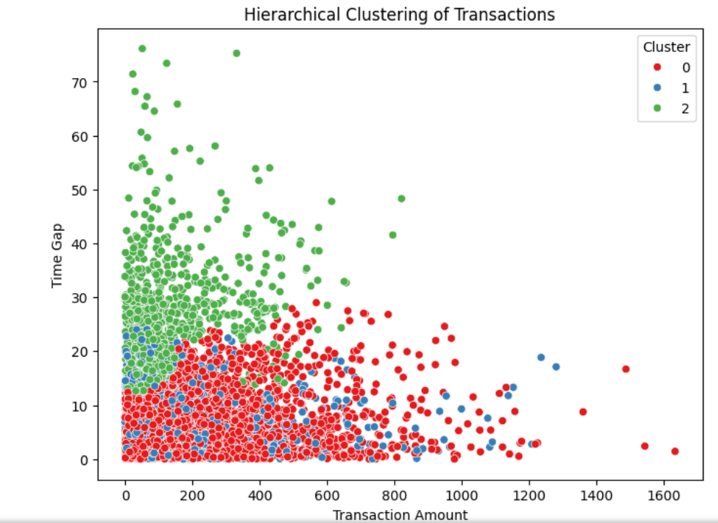

2. Decision Tree Interpretation
The Decision Tree model was used to explain cluster behavior and identify the most influential fraud-related features.
Model Accuracy
Decision Tree Accuracy = 98.47%
This very high accuracy indicates that the model effectively learned the behavioral patterns that distinguish transaction clusters.
Classification Performance
The precision, recall, and F1-scores are all above 0.94 for every cluster, demonstrating excellent classification capability.
Interpretation
- Cluster 0 and Cluster 1 were identified with extremely high precision and recall.
- Cluster 2 had slightly lower recall (94%), indicating a few misclassifications due to overlapping transaction behavior.
Feature Importance
Feature | Importance
device_risk | 0.497
time_gap | 0.396
amount | 0.105
Interpretation
The Decision Tree identified:
- Device Risk as the strongest fraud indicator.
  - Nearly 50% contribution to classification.
  - High-risk devices are strongly associated with suspicious activity.
- Time Gap as the second most important feature.
  - Irregular timing between transactions may indicate abnormal user behavior.
- Transaction Amount had lower importance.
  - This suggests fraud detection in this dataset depends more on behavioral risk patterns than transaction value alone.
The decision tree provides strong interpretability, helping financial institutions understand why transactions are classified as suspicious.
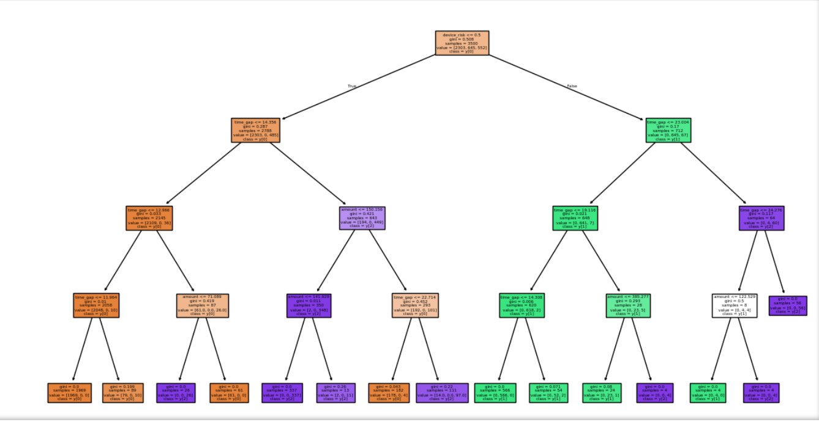

3. Naive Bayes Interpretation
The Gaussian Naive Bayes model was used to predict fraud likelihood based on transaction characteristics.
Model Accuracy
Naive Bayes Accuracy = 89.13%
The model achieved good overall accuracy for fraud prediction.

Confusion Matrix Interpretation
Actual / Predicted | Genuine | Fraud
Genuine | 1313 | 163
Fraud | 0 | 24
Interpretation
- 1313 genuine transactions were correctly classified.
- 24 fraud transactions were successfully detected.
- 163 genuine transactions were incorrectly flagged as fraud (False Positives).
- No fraud cases were missed (False Negatives = 0).
This is highly important in fraud detection because missing fraudulent transactions can lead to financial loss. The model prioritized detecting all fraud cases, even at the cost of more false alarms.

Classification Report Interpretation
Metric | Fraud Class
Precision | 0.13
Recall | 1.00
F1-Score | 0.23
Interpretation
- Recall = 1.00
  - The model detected every fraud transaction.
  - Excellent for fraud-sensitive applications.
- Low Precision = 0.13
  - Many normal transactions were flagged as suspicious.
  - Indicates higher false positives.
This behavior is common in fraud detection systems where fraud cases are rare and the model prioritizes security over convenience.

Overall Conclusion
The analysis demonstrates that behavioral transaction features are highly effective for fraud detection.
- Hierarchical Clustering successfully uncovered hidden suspicious transaction groups.
- Decision Tree provided highly interpretable insights and identified device risk as the strongest fraud driver.
- Naive Bayes achieved strong fraud recall, ensuring that fraudulent transactions were not missed.
The results indicate that:
- device-related risk,
- abnormal timing behavior,
- and transaction characteristics
play a major role in identifying potentially fraudulent financial activity.

