LOBSTERBALL

- 2D

- Crash Ball (Crash Bash)

- Local or online play

- Local 1v1

- Server and up to 4 connected clients

- No AI planned

- Balls 0-10 spawn with a few second interval

- Ball start direction random (or +90 degrees from previous?)

- Balls can be deflected by blocking with the pad or knocking them back with increased speed using an ability

- Balls can be grabbed on the pad (1-3)

- Letting go launches balls out with increased speed

- Players have 10-20 HP (TBD)

- HP reaches 0

-- > Player side is replaced with a wall

- The game ends when all but one player have no lives left

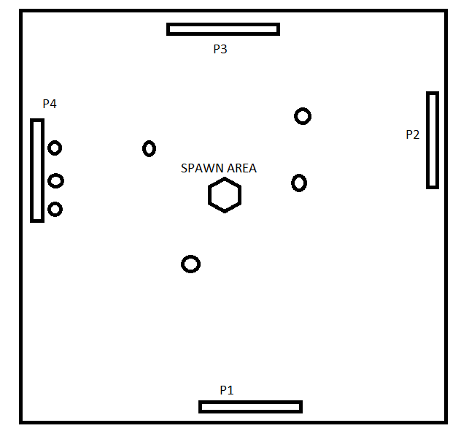

# CLASSES

## MainMenuScreen

* Keyboard input
  + Movement: W + S/Up + Down
  + Confirm selection: Enter
* Buttons
  + Local game

🡪 Start game

* + Online game

🡪 Online menu

* + Exit
  + (Options)

## OnlineMenuScreen

* Keyboard input
  + W/Up: Button Selection Up
  + S/Down: Button Selection Down
  + Enter: Button Select Confirm
  + Escape: Return to MainMenuScreen
* Buttons
  + Host game
    - Goes to Lobby
    - Waits for every player to be ready
    - Game starts when every player is ready

🡪 Start game

* + Join game
    - Asks for the IP of the Host
    - (Nickname)
    - Goes to Lobby
  + Lobby (could be own state?)
    - List of connected players (and their nicknames when implemented)
    - Game starts when every connected player is ready

🡪 Start game

* + - Keyboard input
      * Enter: Player is ready
  + Back
    - 🡪 Main menu

## GameScene

* Local game settings
  + 1v1
  + Left and right sides blocked by walls
* Online game settings
  + 2-4 players
  + One player on each side
  + If less than 4 players or player has no lives
    - Block side with a wall
  + Rotate view for each players so that their own pad is at the bottom of the screen

## BallManager

* Balls (0-10) in a vector?
* Updates active balls
* Every 3s (TBD) spawn a new ball in the middle of the arena
* Launch ball towards a random direction (or +90 degrees from previous?) at a slow speed
  + Every collision adds speed
  + Launching from a player pad sets ball speed at 2.5x default ball speed

## Ball

* Variables
  + Speed
  + ID?
  + Position
  + isOnPad?

## PlayerManager

* Vector of players
* Updates players

## Player

* Players can move left and right along their side of the arena and either grab balls by holding space/shift or launch them by tapping space/shift
* Variables:
  + Position
  + Speed
  + Acceleration
  + HP
  + (Direction)
  + Balls on pad
* Keyboard input
  + Local controls (TBD)
    - P1: Arrows + RShift
    - P2: WASD + LShift
  + Online controls
    - Arrows + Space

# Notes

* Server
  + 1-4 clients
* Client