MCH CONNECT
Maternal and Child Health Connect
A Unified Digital Platform for Community Health Workers and Clinics
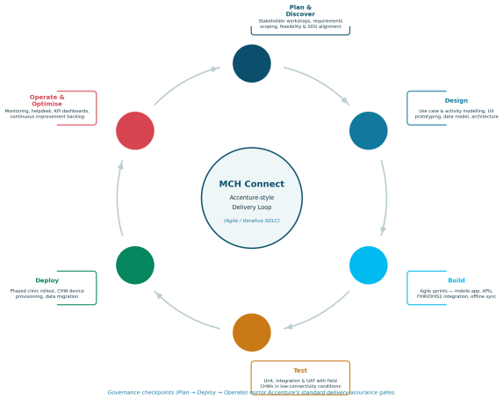

Document type | Final project presentation report
Prepared by | Group 6 (BSEM 1205)— Project Manager(Ahmed Janneh), MCH Connect Programme
Presented to | Mr S Kamara FICT
Course | Software Engineering & Multi Media
Version | 1.0 — Final Presentation
Date | 2 July 2026

Table of Contents
Right-click the field below and choose "Update Field" (or Update Table) in Microsoft Word to populate live page numbers once formatting is finalised.
Table of Contents 2
1. Abstract 3
2. Introduction 4
3. Problem Definition 5
4. Use Case Diagram 6
5. Activity UML Diagram 8
6. System Description 10
7. SDG Link 13
8. Screen-by-Screen Analysis 14
9. Functional & Non-Functional Requirements 18
10. Conclusion 19
11. References 20

1. Abstract
Maternal and newborn mortality remains disproportionately high across resource-limited settings, driven not by a lack of clinical knowledge but by fragmented, paper-based tracking of antenatal, delivery and postnatal care. MCH Connect is proposed as a unified digital platform that equips Community Health Workers (CHWs) and clinic staff with mobile-first tools to register patients, schedule and track antenatal/postnatal visits, capture clinical vitals, and automatically flag danger signs for urgent follow-up.
This report documents the system as presented to the capstone review panel: its problem definition, UML modelling (use case and activity views), system architecture and database design, alignment with the United Nations Sustainable Development Goals, a screen-by-screen walkthrough of the working prototype, and the functional and non-functional requirements that bound its scope. The system was planned using an Accenture-style, agile delivery methodology — Plan & Discover, Design, Build, Test, Deploy, and Operate & Optimise — structured around a nineteen-week delivery timeline. The prototype demonstrates offline-first data capture, automated SMS alerting, and HL7 FHIR-based interoperability with DHIS2, Sierra Leone's national health information system.

2. Introduction
Community Health Workers are the backbone of primary maternal and child health delivery in low-resource settings: they conduct home visits, run outreach clinics, and are frequently the first — and sometimes only — point of contact a pregnant woman has with the health system between formal antenatal appointments. Yet in most district health systems, the tools available to CHWs have not kept pace with this responsibility. Patient information is recorded in paper registers that are difficult to search, easy to lose, and impossible to aggregate in real time. Danger signs identified during a home visit rely entirely on the CHW's memory and judgement to escalate, with no automated safety net.
MCH Connect responds to this gap directly. It is a mobile- and web-based platform purpose-built for the maternal and child health (MCH) care pathway: patient registration, antenatal/postnatal visit scheduling, clinical data capture, automated risk alerting, and real-time reporting for clinic and district administrators. The platform is designed offline-first, so that CHWs working in areas with unreliable connectivity can continue registering patients and recording vitals without interruption, with data synchronising automatically once a connection becomes available.
This report was prepared as the formal presentation document for the university capstone review. It follows the project through the standard systems-development lifecycle: problem framing, UML modelling, system and database design, alignment with global development priorities, a walkthrough of the built prototype, and the requirements and testing approach that will guide the system into production.

3. Problem Definition
District-level consultations with CHWs and clinic nurses (conducted during the Plan & Discover phase of this project — see Section 6.3) surfaced five recurring, compounding problems with the current paper-based approach to maternal and child health tracking:
- Delayed detection of danger signs. High blood pressure, fever and other risk indicators are recorded on paper with no automatic threshold check, so escalation depends entirely on an individual CHW noticing a problem in the moment.
- High loss-to-follow-up. Without automated reminders, antenatal, postnatal and immunization visits are frequently missed, and there is no systematic way to identify which patients have fallen off schedule.
- Fragmented, delayed reporting. Coverage statistics reach clinic and district administrators only after manual data entry and collation, often weeks after the fact — too late to inform operational decisions.
- No interoperability with national systems. Clinic-level data cannot be exchanged with DHIS2, Sierra Leone's national health information platform, forcing duplicate data entry and undermining national-level visibility.
- Connectivity is not guaranteed. Many catchment areas served by CHWs have unreliable or no mobile network coverage, which existing purely online tools cannot accommodate.
Framed as a design problem, the project therefore asked: how might a single digital platform let a CHW capture accurate clinical data in the field — connected or not — while giving clinic and district administrators the real-time, standards-based visibility needed to close the maternal and newborn care gap?

4. Use Case Diagram
The use case model below defines the functional boundary of MCH Connect and the actors who interact with it. Five actors were identified during requirements analysis: the Community Health Worker and Clinic Nurse/Doctor as primary internal users, the Patient as an external recipient of SMS communication, the System Administrator responsible for platform configuration and reporting, and the National Health Information System (DHIS2) as an external system consuming interoperable data.
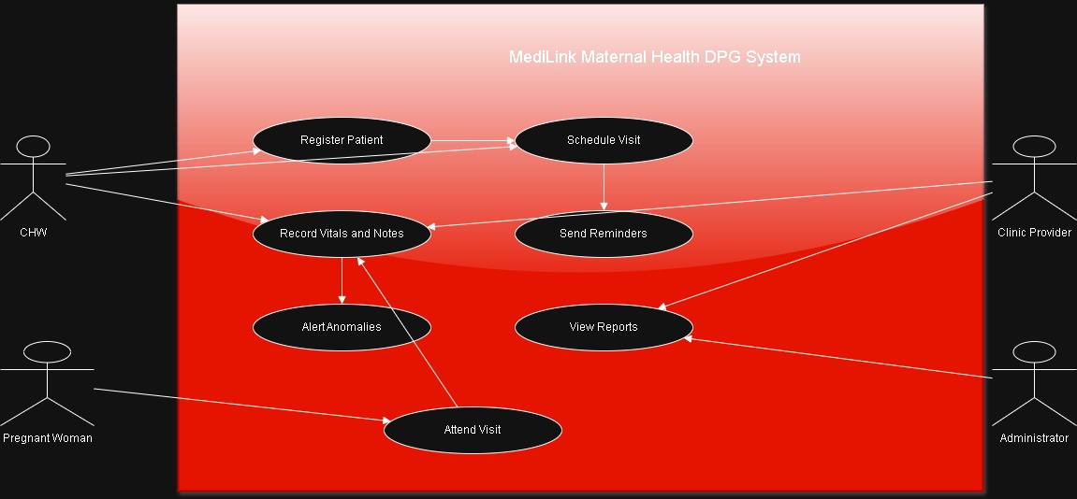
Figure 1 — Use case diagram for MCH Connect, showing actor interactions with core system functions.

4.1 Actor and Use Case Summary
Actor | Primary use cases
Community Health Worker | Register patient; record clinical vitals; schedule appointments; check in patients; view own patient dashboard.
Clinic Nurse / Doctor | Receive and act on high-risk alerts; record vitals; check in patients; view dashboard and coverage reports.
Patient | Receive SMS appointment reminders and danger-sign follow-up messages (via CHW/clinic-initiated flow).
System Administrator | Authenticate and manage role-based access; view aggregate dashboards and reports; configure alert thresholds.
National HIS (DHIS2) | Consume/exchange coverage and indicator data via HL7 FHIR-based synchronisation.

Two relationship types extend the base flows: Trigger High-Risk Alert «extends» both Record Clinical Vitals and Check In Patient whenever a captured value breaches a configured clinical threshold; Authenticate is «included» by every use case that touches patient data, enforcing role-based access control across the platform (NFR3).

5. Activity UML Diagram
The activity diagram below models the core clinical workflow — a home or clinic visit that results in a vitals capture — as a swimlane process spanning the Community Health Worker, the MCH Connect system, and the Clinic Nurse/Doctor. It illustrates precisely how the automated risk-alerting requirement (FR3) is enforced in practice.
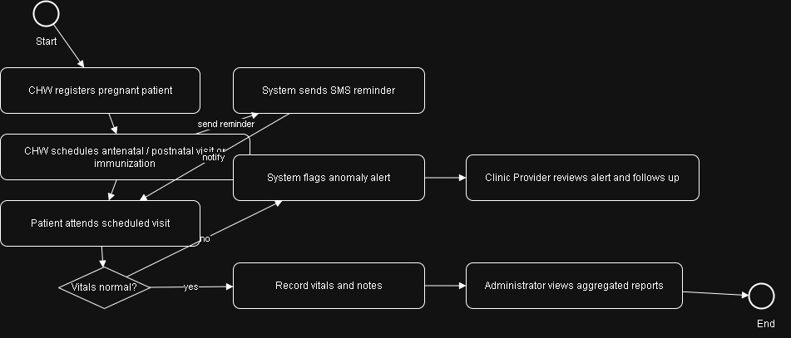
Figure 2 — Activity diagram for the patient visit and risk-escalation workflow.

5.1 Process Narrative
- The CHW visits a patient in the community or clinic, identifies the existing patient record (or registers a new one), and captures vitals — blood pressure, temperature, weight and, where applicable, fetal heart rate — directly on the mobile device.
- The system validates and saves the record locally, then evaluates the captured vitals against configured clinical thresholds (for example, systolic BP ≥ 140 mmHg or diastolic ≥ 90 mmHg).
- Where no danger sign is detected, the visit record is saved, the next visit is automatically scheduled, and the routine pathway ends — no clinician interruption is required.
- Where a danger sign is detected, the system generates a high-risk alert, queues an SMS notification to the duty nurse, and routes the case into the managed pathway.
- The Clinic Nurse or Doctor receives the alert, contacts or recalls the patient, provides the necessary clinical care, and the outcome is recorded to close the case.
This decision point — automatic, threshold-driven, and independent of an individual CHW noticing a problem — is the central mechanism by which MCH Connect addresses the delayed-detection problem identified in Section 3.

6. System Description
MCH Connect is architected as a mobile-first, offline-capable clinical application backed by a central server that exposes a standards-based interoperability layer. This section describes the architecture, database design, and the delivery methodology used to plan and sequence the build — including the Accenture-style SDLC approach adopted for this programme.

6.1 Architecture Overview
The platform has three layers. The presentation layer is an Android mobile application used by CHWs in the field and a web console used by clinic and district staff; both write to a local, encrypted data store so that registration and vitals capture continue uninterrupted without network access. The application layer hosts the business logic — threshold evaluation, appointment scheduling, and SMS orchestration — and exposes a synchronisation API that reconciles queued offline records once connectivity resumes. The integration layer maps internal records to HL7 FHIR resources (Patient, Encounter, Observation) for two-way exchange with DHIS2, Sierra Leone's national health information system, satisfying the interoperability requirement (NFR1) without duplicating data entry at district level.

6.2 Database Design
The data model is organised around four core entities — Users, Patients, Visits and Alerts — plus two supporting entities, Appointments and SMS_Log, that operationalise scheduling and communication. Role-based access control is enforced at the Users entity, restricting write access to patient and visit data according to the authenticated role (CHW, Nurse, Doctor, or Administrator), directly supporting NFR3.
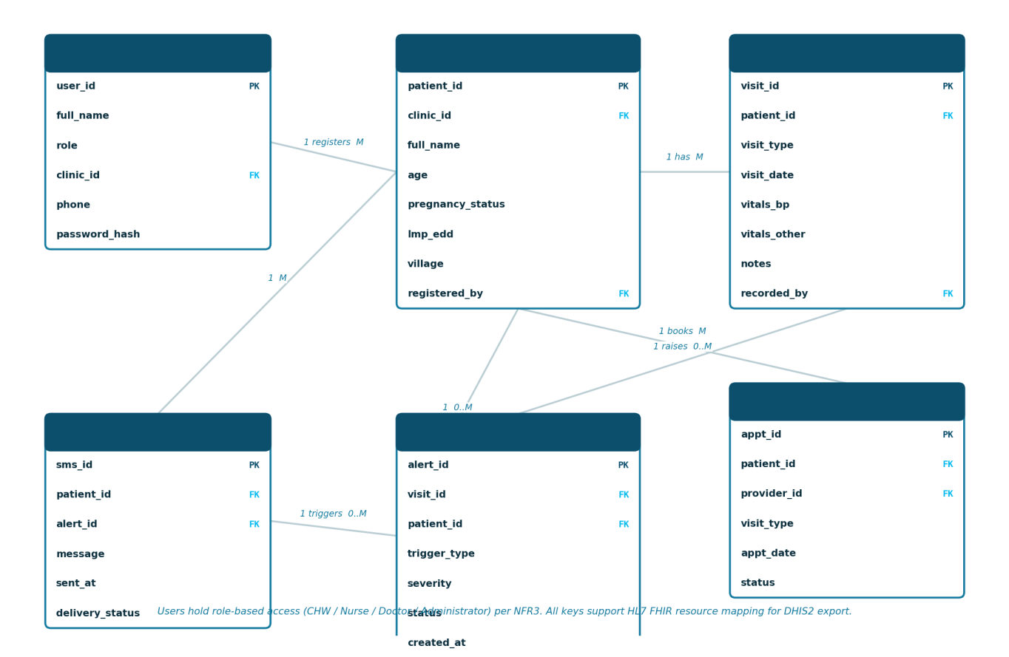
Figure 3 — Entity-relationship diagram for the MCH Connect database.
- Users — CHWs, nurses, doctors and administrators, each bound to a clinic and role for access control.
- Patients — demographic details, pregnancy status, estimated date of delivery, and the registering CHW.
- Visits — timestamped clinical encounters carrying vitals, notes and the recording user.
- Alerts — threshold-violation events linked back to the triggering visit, with severity and resolution status.
- Appointments & SMS_Log — scheduling records and the outbound reminder/alert message trail sent to patients and clinic staff.

6.3 Development Methodology — Accenture-style Delivery SDLC
The programme was planned in a facilitated planning session structured around Accenture's standard delivery-assurance approach: a continuous, six-phase loop of Plan & Discover, Design, Build, Test, Deploy, and Operate & Optimise, with governance checkpoints at each phase gate. Build is executed as a series of agile sprints rather than a single monolithic phase, allowing each functional module to be delivered, demonstrated and refined independently before integration testing begins.
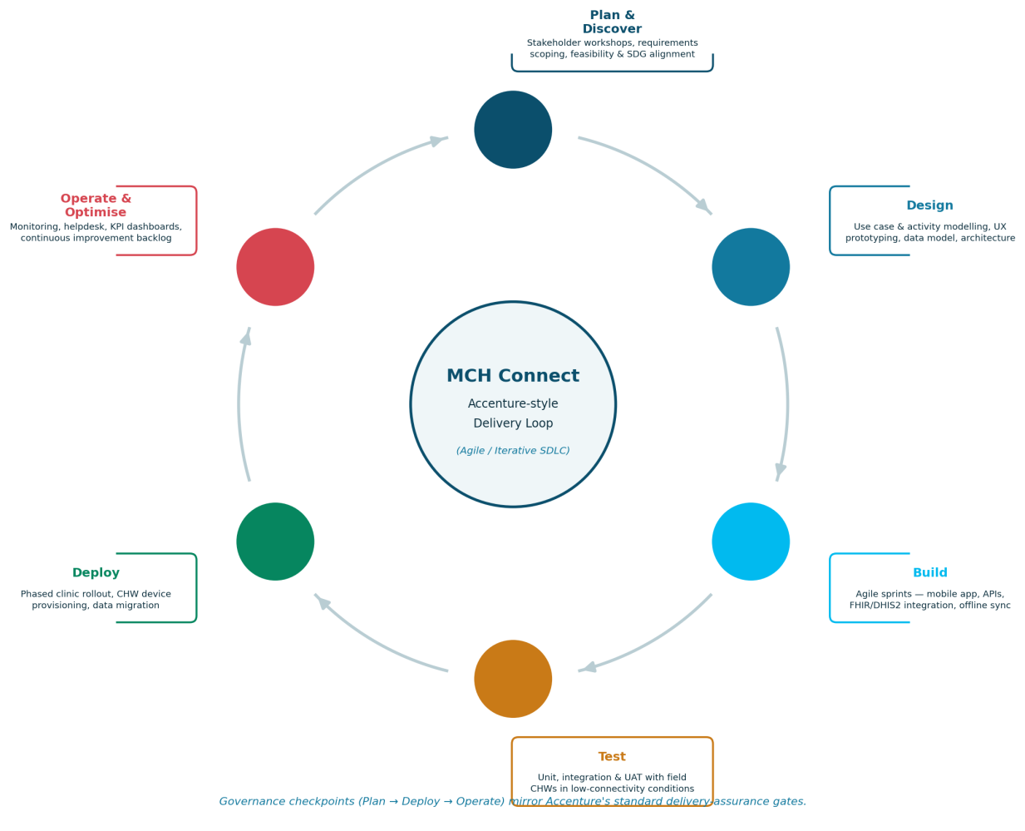
Figure 4 — Accenture-style SDLC delivery loop adopted for the MCH Connect programme.

6.4 Delivery Planning Timeline
The planning session translated the six-phase methodology into a nineteen-week delivery timeline, with the Build phase split into three two-to-three-week sprints — one per functional module — followed by a combined integration and user-acceptance testing window before phased clinic deployment and a hypercare support period.
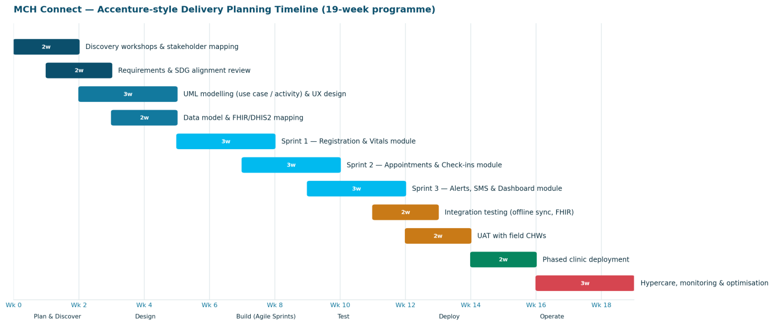
Figure 5 — Nineteen-week delivery planning timeline produced during the Accenture-style planning session.

7. SDG Link
MCH Connect was scoped with explicit reference to the United Nations 2030 Agenda for Sustainable Development. Its primary contribution is to SDG 3 (Good Health and Well-being), and specifically to Target 3.1 — reducing the global maternal mortality ratio — and Target 3.2 — ending preventable deaths of newborns and children under five. Four further goals are engaged as secondary but material contributions.
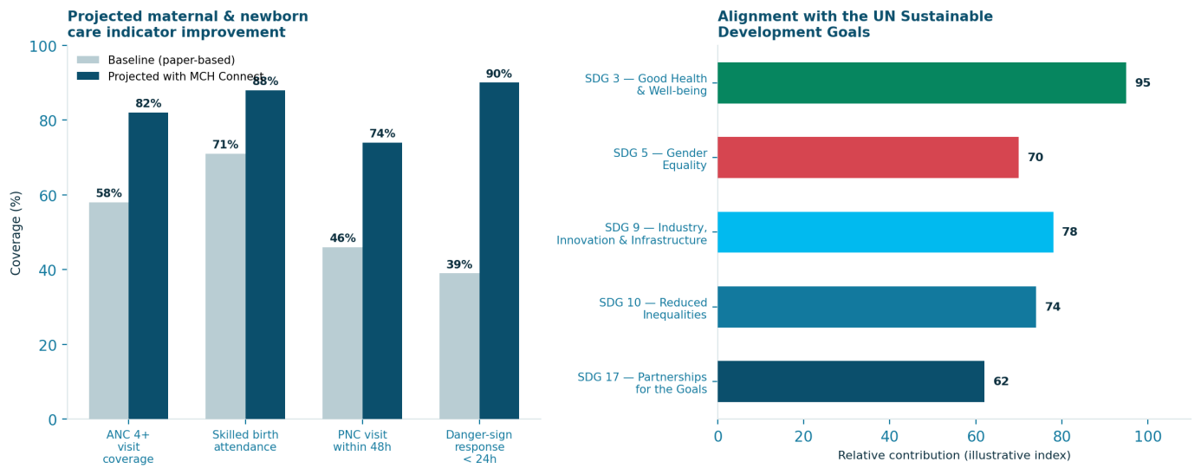
Figure 6 — Projected coverage impact and relative SDG contribution of MCH Connect.
SDG | How MCH Connect contributes
SDG 3 — Good Health & Well-being | Automated danger-sign alerting and visit-adherence tracking directly targets preventable maternal and newborn deaths.
SDG 5 — Gender Equality | Improves pregnant women's access to consistent, quality antenatal and postnatal care, a determinant of women's health autonomy.
SDG 9 — Industry, Innovation & Infrastructure | Introduces resilient, offline-first digital infrastructure into under-served clinics and community health posts.
SDG 10 — Reduced Inequalities | Extends the same standard of data-driven care management to rural and low-connectivity catchment areas as to urban clinics.
SDG 17 — Partnerships for the Goals | HL7 FHIR/DHIS2 interoperability strengthens data-sharing between facility, district and national health authorities.

8. Screen-by-Screen Analysis
The working prototype is organised into four modules, reflecting the functional groupings defined during design. Each module was built responsively — a sidebar/desktop layout on tablets and larger screens, collapsing to a bottom tab-bar, single-column layout on Android phones, the primary device used by CHWs in the field.

8.1 CHW Dashboard
The landing screen gives each CHW an immediate operational picture: active caseload, visits due this week, overdue visits and open risk alerts as headline statistics, a weekly visit-tracker, an ANC/PNC coverage indicator, and a searchable, filterable patient list with at-a-glance visit-status badges.
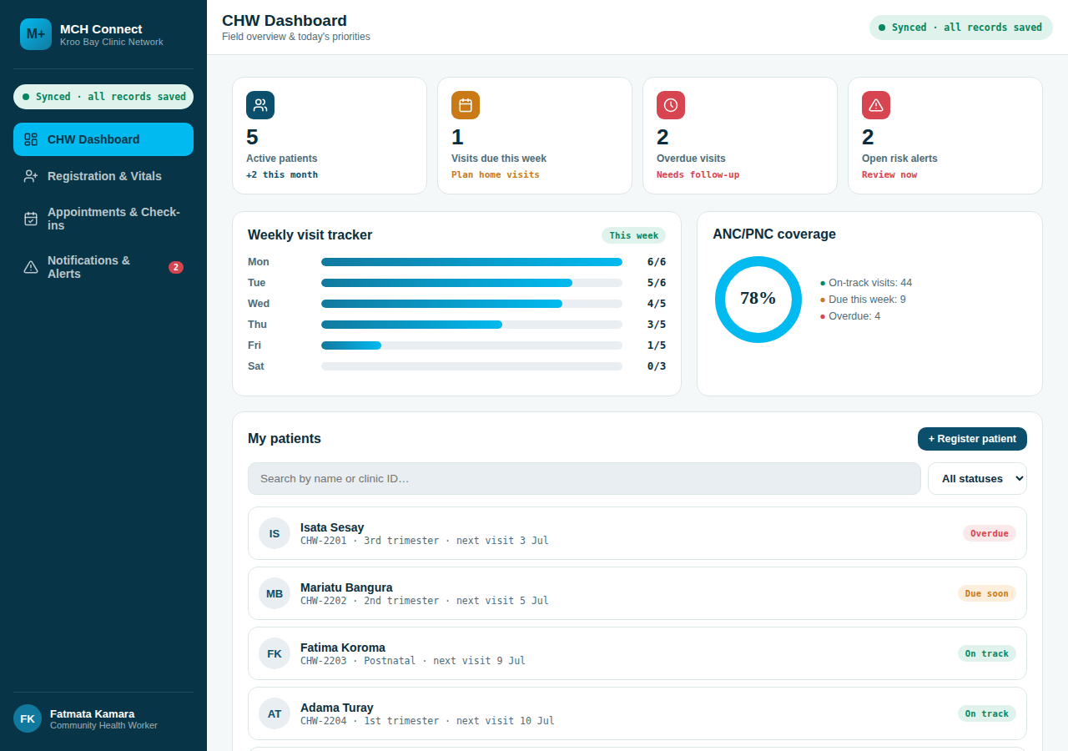
- Stat cards surface overdue visits and open alerts first, so field priorities are visible without navigating further.
- The patient list supports search-by-name/ID and status filtering (on track / due / overdue).
- Tapping a patient opens a detail view with quick actions to record vitals or schedule a visit.

8.2 Registration & Vitals
This module captures the two data-entry workflows defined in FR1: enrolling a new patient with demographic and pregnancy-status details, and recording a clinical visit against an existing patient, including blood pressure, blood sugar, weight, temperature and fetal heart rate.
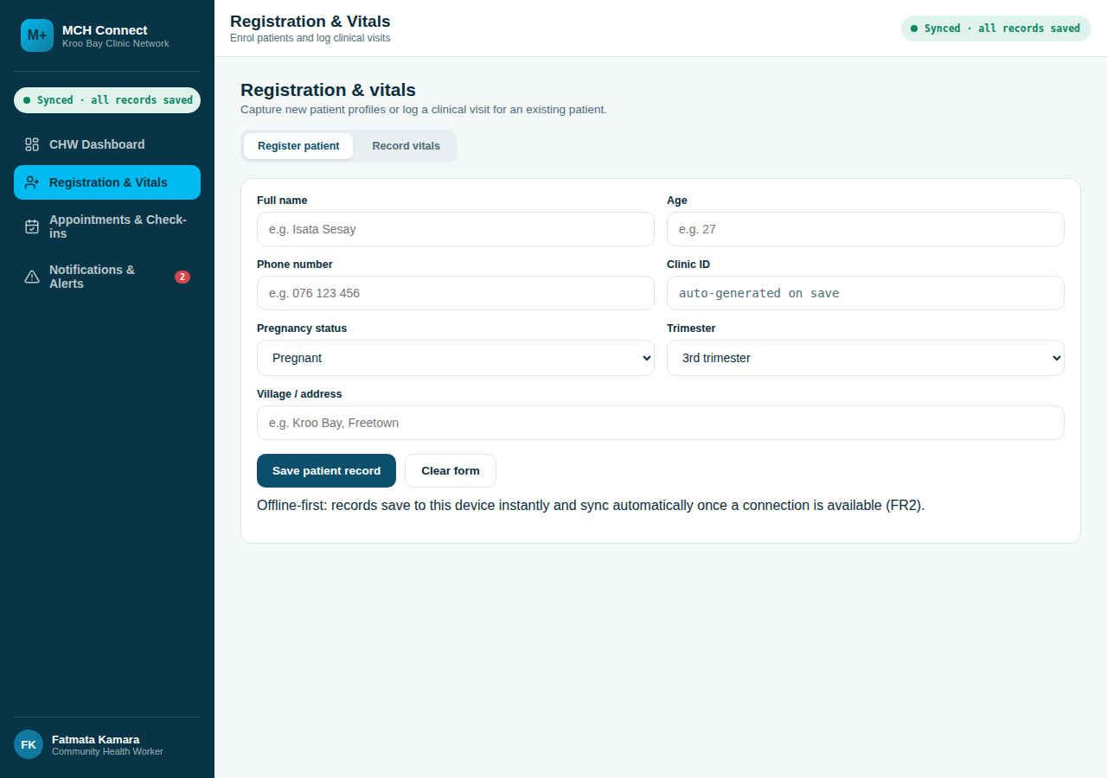
- Clinic IDs are generated automatically on save, removing a manual data-entry error source.
- Vitals are checked against clinical thresholds as they are entered, surfacing a danger-sign warning before the record is even saved.
- All entries save to the device immediately and sync automatically once a connection is available, fulfilling the offline-first requirement (FR2).

8.3 Appointments & Check-ins
CHWs and clinic staff use this module to schedule antenatal, postnatal and immunization visits against a named provider and date, and to move a patient through the visit lifecycle — Scheduled → Checked in → Completed — on the day of the appointment.
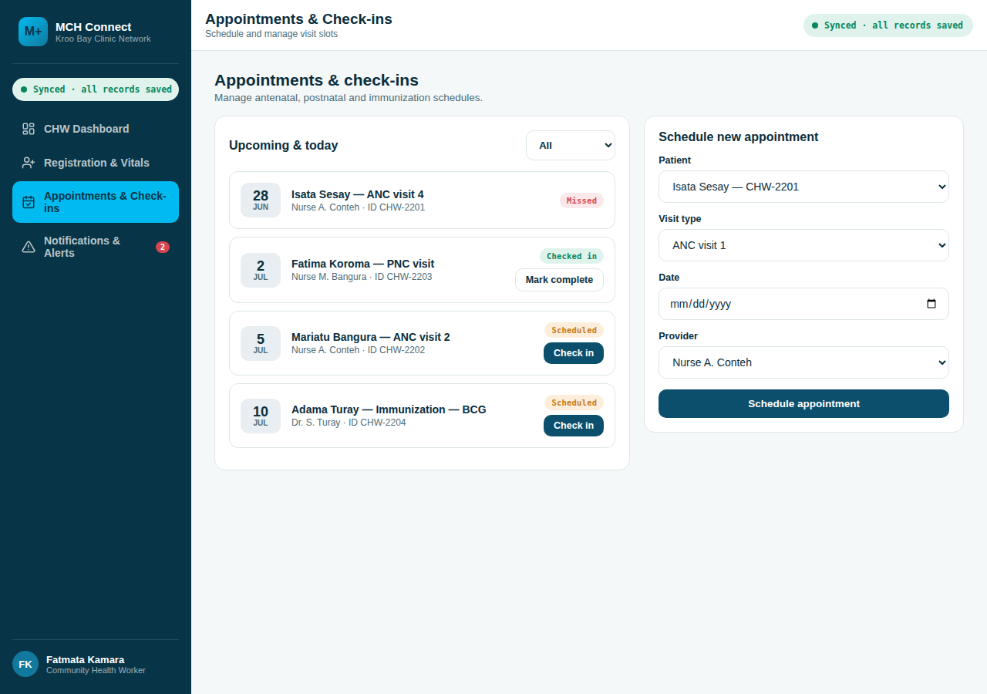
- Appointments are filterable by status, giving clinic staff a live check-in queue during outreach sessions.
- Scheduling a visit automatically queues a confirmation SMS to the patient.
- Missed appointments remain visible in the list, feeding directly into the CHW Dashboard's overdue-visit count.

8.4 Notifications & Alerts
This module operationalises FR3. Critical alerts generated from out-of-range vitals or missed visits are listed with severity, timestamp and a one-tap "mark as contacted/resolved" action, alongside a running SMS log of every reminder and alert message dispatched to patients and clinic staff.
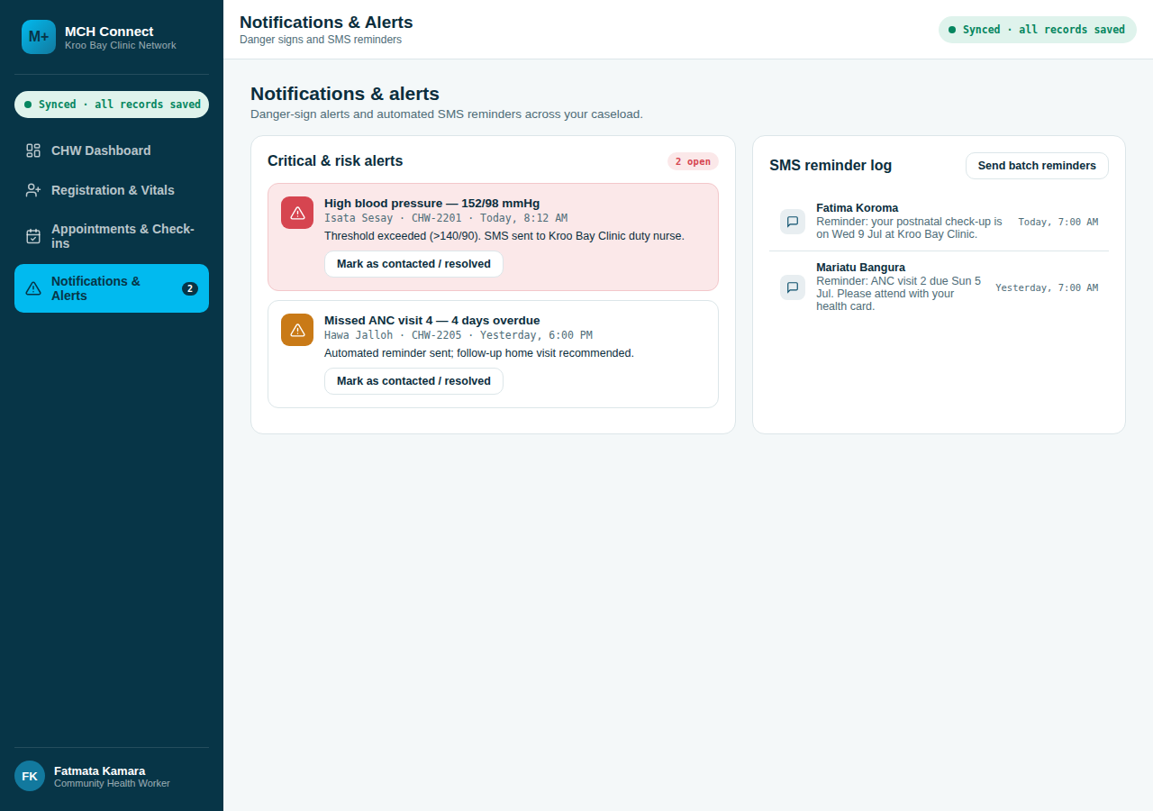
- Alerts are visually distinguished by severity, with critical (danger-sign) alerts highlighted for immediate attention.
- A batch-reminder action lets a clinic supervisor send SMS visit reminders to every currently overdue patient in one step.
- The SMS log gives a full audit trail of automated communication, supporting quality-of-care review.

8.5 Responsive Behaviour
The same codebase renders both layouts below from a single responsive breakpoint, ensuring CHWs and clinic administrators see a consistent information hierarchy regardless of device.
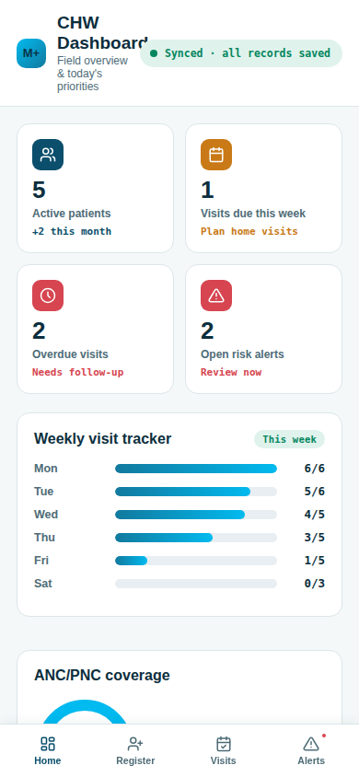
Figure 7 — CHW Dashboard rendered on an Android-sized viewport (390px width).

9. Functional & Non-Functional Requirements

9.1 Functional Requirements
ID | Requirement
FR1 | The system shall allow CHWs to register patients with a unique, automatically generated clinic ID.
FR2 | The system shall provide offline-first data entry for registration and vitals capture in areas with no network connectivity, syncing automatically once online.
FR3 | The system shall trigger automated SMS alerts to clinic staff when recorded vitals breach configured high-risk thresholds.
FR4 | The system shall generate visual dashboards and reports on maternal health coverage, visit adherence and alert status for clinic and district administrators.
FR5 | The system shall allow scheduling and status tracking (scheduled / checked in / completed / missed) of antenatal, postnatal and immunization appointments.
FR6 | The system shall exchange patient, encounter and observation data with DHIS2 using HL7 FHIR-compliant resources.

9.2 Non-Functional Requirements
ID | Requirement
NFR1 | Interoperability — the system must support HL7 FHIR standards for all external data exchange with national health information systems.
NFR2 | Scalability — the system must handle concurrent data synchronisation from thousands of CHWs without degradation of service.
NFR3 | Security — all patient data must be encrypted at rest and in transit, with role-based access control adhering to "do no harm" data-protection principles.
NFR4 | Usability — the mobile interface must remain fully operable by CHWs with limited digital literacy in low-connectivity field conditions.
NFR5 | Availability — the offline-first mobile client must remain fully functional for core registration and vitals workflows with zero network connectivity.

9.3 Testing Plan
- Unit testing — verifies individual modules in isolation, including registration logic, threshold-evaluation rules and appointment status transitions.
- Integration testing — confirms data flows correctly between the mobile client, the synchronisation API, and the central database, including offline-queue reconciliation.
- User Acceptance Testing (UAT) — conducted directly by field CHWs during the Test phase (Section 6.3) to confirm the interface is intuitive under real low-resource field conditions.

10. Conclusion
MCH Connect demonstrates how a deliberately offline-first, standards-based digital platform can close a persistent gap in maternal and newborn health delivery: the absence of automated, threshold-driven risk detection at the point of a community health worker's home visit. The use case and activity models presented in Sections 4 and 5 show a workflow that requires no additional cognitive burden on the CHW, while the architecture and database design in Section 6 demonstrate that this can be achieved without sacrificing interoperability with Sierra Leone's national health information system.
Delivered through an Accenture-style, phase-gated agile methodology, the project moved from a facilitated planning session through to a working, responsive prototype covering all four core modules within the nineteen-week programme timeline. The functional and non-functional requirements in Section 9 give the panel a clear basis against which to assess prototype completeness, and the SDG alignment in Section 7 situates the project within the broader development priorities it is intended to serve.
The recommended next step is a controlled pilot at a single clinic catchment area, instrumented to validate the projected coverage improvements shown in Figure 6 against real field data before a phased district-wide rollout.

11. References
Accenture. (2023). Delivering enterprise technology programmes: an agile, phase-gated SDLC approach. Accenture Insights.
DHIS2. (n.d.). DHIS2 documentation and implementation guides. University of Oslo, Health Information Systems Programme. https://docs.dhis2.org
HL7 International. (n.d.). HL7 FHIR Release 4 specification. https://www.hl7.org/fhir/
Republic of Sierra Leone, Ministry of Health and Sanitation. (2021). Reproductive, Maternal, Newborn, Child and Adolescent Health Strategy.
United Nations. (2015). Transforming our world: the 2030 Agenda for Sustainable Development. UN General Assembly Resolution A/RES/70/1.
World Health Organization. (2016). WHO recommendations on antenatal care for a positive pregnancy experience. Geneva: WHO.
World Health Organization. (2022). Trends in maternal mortality 2000 to 2020: estimates by WHO, UNICEF, UNFPA, World Bank Group and UNDESA/Population Division. Geneva: WHO.
World Health Organization & UNICEF. (2018). WHO/UNICEF joint statement: home visits for the newborn child — a strategy to improve survival.

