**Introduction**

The topic I had chosen was squashes. Five main groups of squashes exist *Cucurbita argyrosperma, C. ficifolia, C. maxima, C. moschata* and *C. pepo*. *Cucurbita* plants are large, viney and branched with tendrils. (ZHENG, Y. et al) They bear large yellow to orange flowers which can be between 10 and 16 centimeters in diameter. One flower is produced per node, with the first node producing male flowers exclusively. *Cucurbita* plants are diploids with 20 pairs of chromosomes. Fruit shapes, sizes and colours can vary among different cultivars. The edible fruits are referred to pumpkin or squash dependent on shape, the inedible or unpalatable fruits are referred to as gourds.

*C. pepo* is the most widely grown species out of this genus. This species is native to the temperate regions of North America. It was one of the first plants which was described in America by Europeans. *C. pepo* plants can be viney or bushy. The leaves are pentagonal and angular and can vary from deeply incised to deeply incised. The foliage is spiculate which can help *C. pepo* be distinguished from the other species of the genus. This species is well adapted to all temperate regions and is grown mostly for the use of its immature fruits. In cooler areas this species is also grown for the flesh of its mature fruits, seeds, seed oil and as ornaments. *C. pepo* is argued to be the most diverse species for fruit characteristics in the entire plant kingdom. Fruits can range from 100 g to 20 kg in various shapes, colours and structures.

Considering that *C. pepo* is cultivated and used over the whole world, the importance of the species is immense. This is why it is important to know how the distribution and possible distribution of this species can be affected in the future. This can be done by creating species distribution models using R and MaxEnt.

Using species distribution models the following question will be answered: How will the distribution of *Cucurbita pepo*  change in the future? Since *C. pepo* is well adapted to temperate regions, it will likely shift northward for the Northern hemisphere due to climate change.(*Sciencedirect.com* (2019))

**Methodology and results**

Using data for *C. pepo* from GBIF and climate data from worldclim. The species distribution data had to be converted to an NA style concerning the longitude and latitude. The climate data that was used had a 10km (5m) resolution. Only the bioclimatic variables were used. Loading this it into R a map (Figure 1.) could be made showing the current distribution of *C. pepo*.

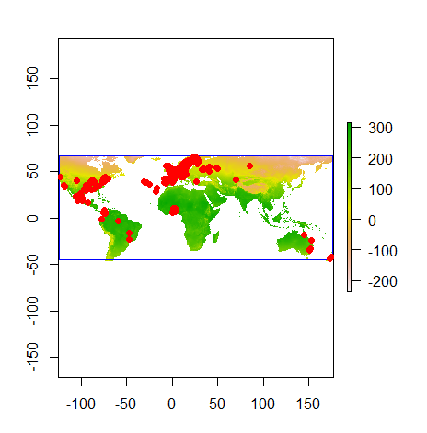

Figure 1. Current distribution of *C. pepo* in R studio.

In the next steps the bioclimatic variables were cropped. More about this in the discussion.

The bioclimatic variables were checked for autocorrelation by checking the excel file for pearson values higher than 0.7 or lower than -0.7. Rows and columns containing two or more of these values were deleted, resulting in keeping only Bio02, Bio08, Bio09, Bio14, Bio15, Bio18 and Bio19. Later a VIF test was used to check if additional bioclimatic variables should be removed.

Variables VIF

1 Bio02 1.698335

2 Bio08 1.736004

3 Bio09 1.651445

4 Bio14 3.006586

5 Bio15 1.925531

6 Bio18 1.772612

7 Bio19 2.045753

Figure 2. VIF-test results.

No values were above 10 or even 5 (Figure 2.). We will continue with this. So in the end the following variables were used: Mean Diurnal Range, Mean Temperature of Wettest Quarter, Mean Temperature of Driest Quarter, Precipitation of Driest Month, Precipitation of Seasonality, Precipitation of Warmest Quarter and the Precipitation of Coldest Quarter.

The occurrence data was loaded into MaxEnt with only the bioclimatic variables 02, 08, 09, 14, 15, 18 and 19 being used. This was used on the Present data and the four different Future scenarios.

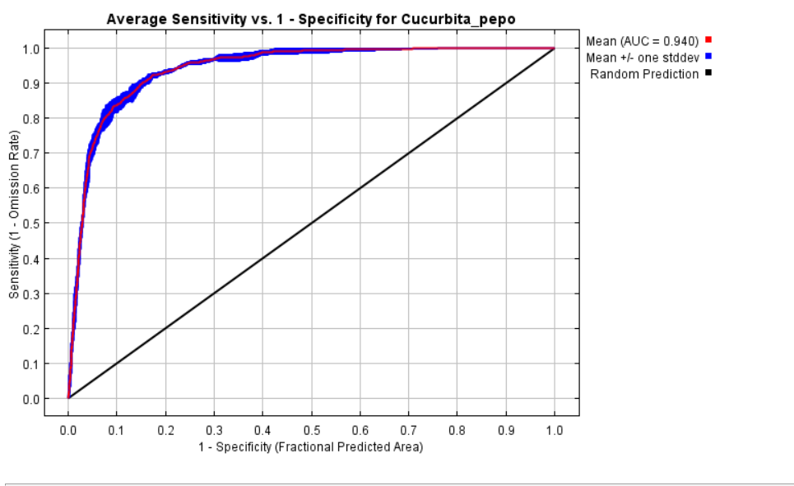

Figure 3. Average Sensitivity vs 1. – Specificity for Cucurbita_pepo.

From Figure 3. the mean AUC value can be checked: 0.940. This graph shows a stabilizing sensitivity for a specificity between 0.1 and 0.3.

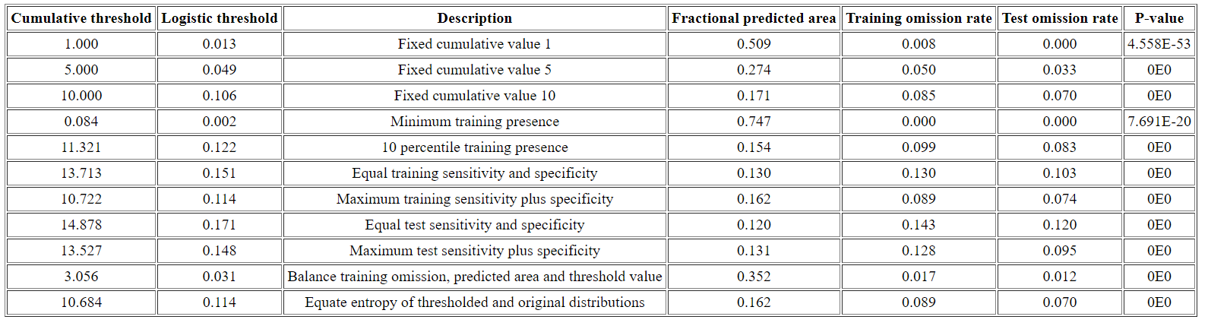

Figure 4. Threshold table.

From Figure 4. the maximum training sensitivity plus specificity can be checked which is 0.114. This will be the threshold for the change detection map.

**The maps**

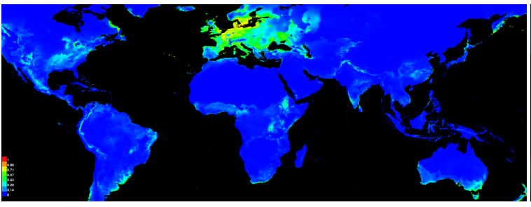

Figure 5. Map from three output grids.

Present_WLD

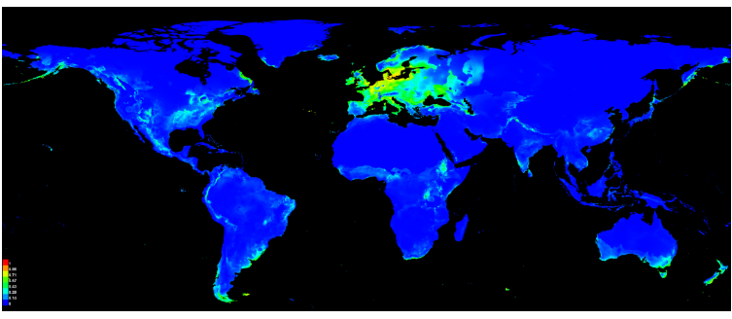

Figure 6. Map from Present_WLD

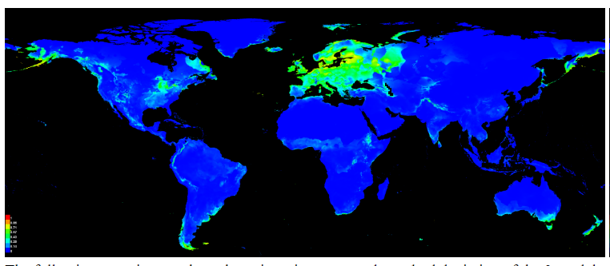

Figure 7. Map from He26bi50.

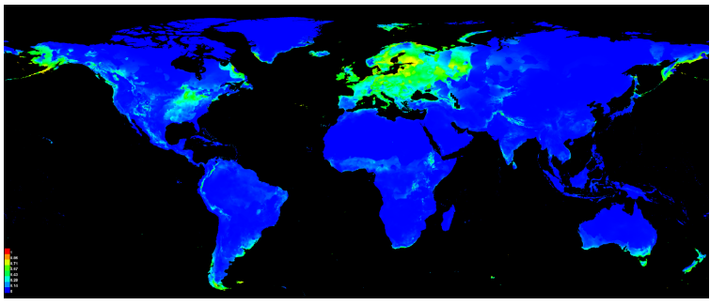

Figure 8. Map from He45bi50.

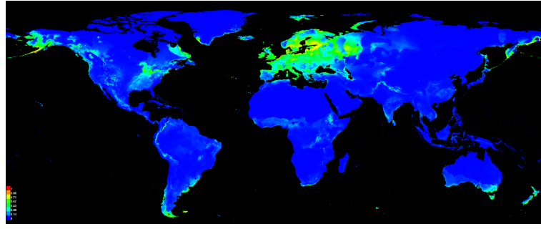

Figure 9. Map from He60bi50.

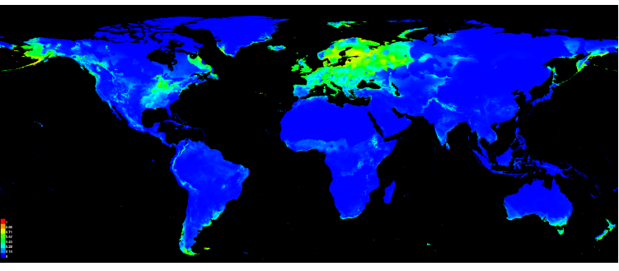

Figure 10. Map from He85bi50.

From Figure 5 to 10 we can see the difference in the distribution of *C. pepo*. While it is not a dramatic difference, it can be seen that in the species expands Northwards. There is not much change in the southern end of the northern distribution. More can is supposed to be made clear with the change maps coming up.

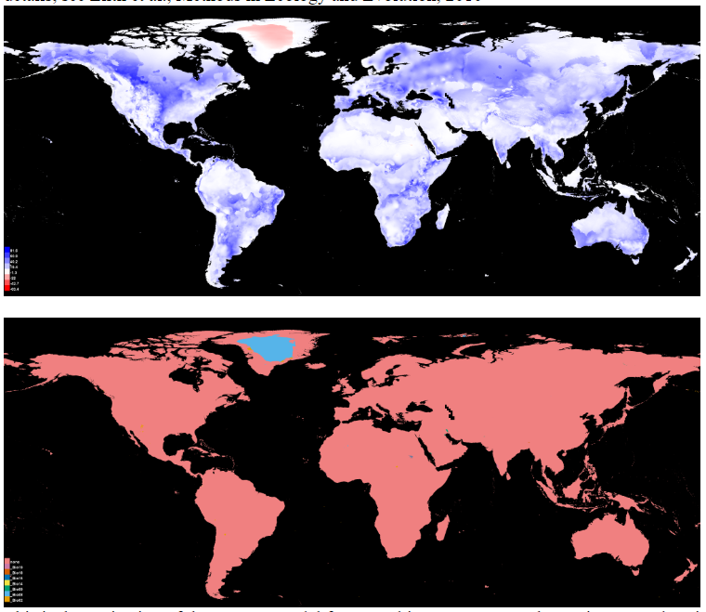

Figure 11. Training range and areas outside of the training range.

In Figure 11. the training range is shown in the first image. The second image shows the areas outside the training range in blue which only includes Greenland. This is also the only part which is slightly red in the first image.

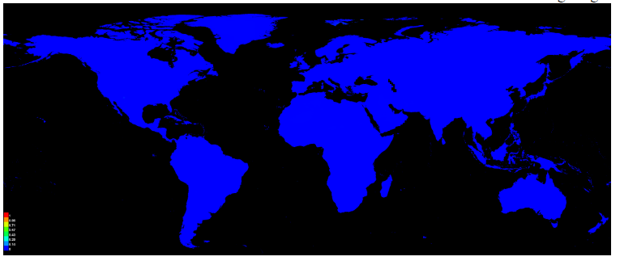

Figure 12. The effect of clamping

In Figure 12. Does not show any area where extra clamping could have an effect.

**Change maps**

The data produced by MaxEnt was loaded into R studio again to produce maps that show the change in species distribution. This should be more clear than the maps prior, since the change is so little. This could be due to the fact that the species probably does not distribute (far enough) on its own. Since it is mostly distributed for human consumption, it also probably distributed by humans.

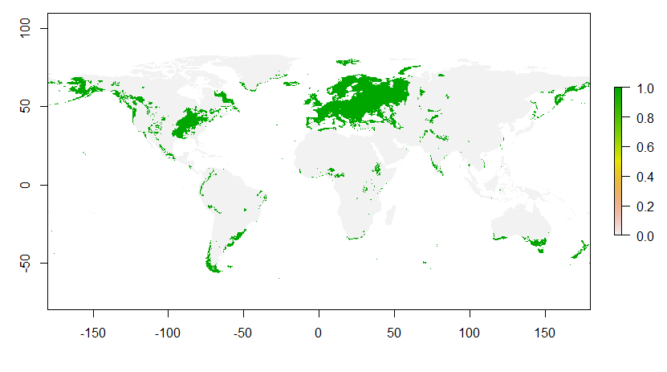

Figure 13. Moderate scenario.

In this Figure X. we see very little change from the present.

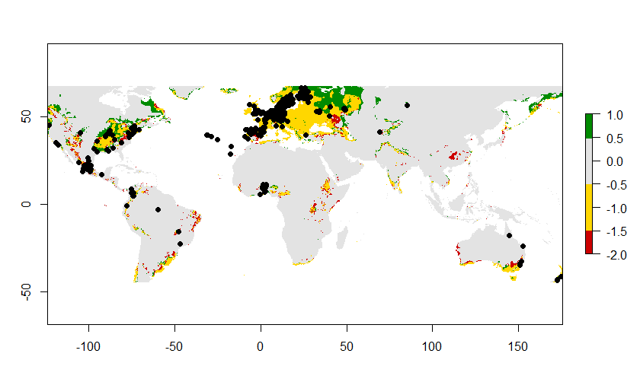

Figure 14. Change in suitable habitat and current occurrence

The map shown in Figure x. is the most important. It shows where the species are currently present and the suitable area. Grey are the areas that are never suitable, green is the suitable area that is gained, red is the suitable area that is lost and yellow is the suitable area that stays the same. A lot of area stays unsuitable and a lot remains the same. There is more green than there is red.

**Conclusion and discussion**

When using the _AOI files I ran into some errors that could not be solved. Judging from where my species occurred, I chose to go with the uncropped (_WLD) versions for MaxEnt only. The final maps show, in my opinion, a good enough picture on the change in distribution and suitable area for *C. pepo* which is why I chose to not include a GIS map as it did not make it more clear and I feel that it was incorrect. I felt like the species occurrence was not always correct when you compare the suitable habitat for the species with it, but I decided to not remove these points.

For the conclusions that can be made. The hypothesis can be adopted to an extent. In the maps it can be seen that, at least for Europe, the species has a slight shift upwards. The other regions in the world don’t show that much change. However, it is important to note that most of the occurrences came from Europe and the occurrences elsewhere are more sparse. This can be due to a difference in the amount of people documenting species occurrence or the occurrence of *C. pepo* there altogether. In the suitable area change maps it can clearly be seen that most of the suitable area stays the same, while a good bit also became new suitable area. This is most noticeable in Europe and the new suitable area is positioned in the north as expected. In North America a bit of new suitable area can also be seen in the North. For Australia and South America and thus the Southern hemisphere, results are not as clear compared to Europe. It is important to keep in mind that *C. pepo* is a species adjusted to temperate climates, which is less present in this area. However, a slight decrease in suitable area can be seen to the north of its suitable area. The conclusion that can be made is that these SDMs show, to an extent, the future possibilities of the distribution of *C. pepo.*

**Literature**

1.ZHENG, Y., ALVERSON, A., WANG, Q. & PALMER, J. Chloroplast phylogeny of Cucurbita: Evolution of the domesticated and wild species. *Journal of Systematics and Evolution* 51, 326-334 (2013).

2.Cucurbita - an overview | ScienceDirect Topics. *Sciencedirect.com* (2019). at https://www.sciencedirect.com/topics/food-science/cucurbita