**Herding *Rangifer tarandus* into the Future with Species Distribution Modelling**

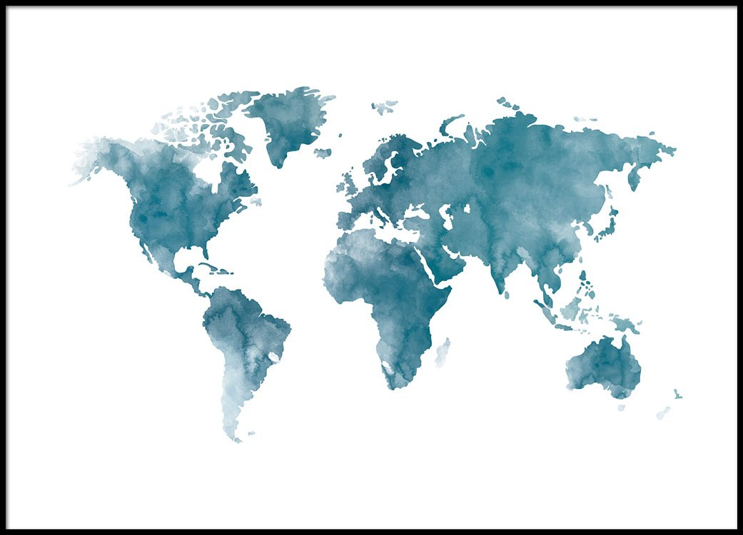

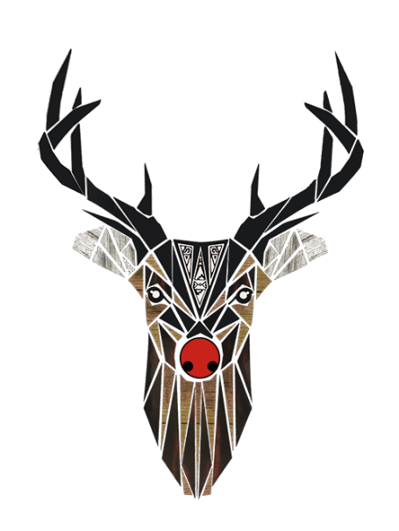

**Methods of Biodiversity Analysis**

**Leiden University**

**By Sybren J. Hilgen**

Contents

Introduction 3

Methodology & Results 4

Discussion & Conclusion 5

Tables & Figures 6

References 9

Appendix 9

# Introduction

Climate is changing, and therewith, species distributions will change. In what order a species is threatened by climate change differs across and within all taxa. Generally, species already populating areas with extreme climates are at high risk of a decrease in suitability of their habitat. In the Arctic region this also concerns *Rangifer tarandus*, reindeer. Reindeer are crucial for various reasons in the arctic and sub-arctic regions. The species is one of the few major herbivores in the sub-arctic and arctic region. Thus they greatly influence the environmental characteristics, especially the composition of the vegetational community1. Besides the environmental importance of reindeer, there are also many people dependent on herding semi-domesticated reindeer herds. This makes their future not just important on an ecosystem level, but also on a social-economic level.

*R. tarandus* can be discerned in several subspecies, conventionally these subspecies are grouped on their morphological characteristics. The continental form is distinguished by long rangy antlers, the woodland form by a larger body size, yet smaller and heavier antlers, and finally the Arctic island form by a relatively small body. Originally scientists presumed that these forms took shape during the last glacial period, in this period they were supposed to have survived in different refugia2. The theory on separate refugia is holding with new genetic analyses of reindeer, yet the distinction of the populations is no longer based on the morphological characteristics as scientists now assume that the morphological adaptations occurred after the great ice shelfs retreated3. I therefor deduct that the subspecies of reindeer are likely well adapted to specific environmental characteristics, which is currently changing rapidly.

There are clear indications that the high rate at which the environmental characteristics are changing threaten reindeer populations. According to the Arctic Program4, herd populations of *Rangifer tarandus caribou* and other wild reindeer herd numbers have declined by 50%, with some herds even declining over 90%. Main factors that are assumed to have cause this decline are increased precipitation and changing vegetational communities5. Increased precipitation can cover winter forage grounds with a for reindeer impenetrable ice layer, preventing them to reach the scarce resources needed for survival. The changing vegetational communities impacts the diet of the reindeer; lichens, which are a preferred food resource by reindeer are on an altitudinal upward shift as temperatures on higher altitudes become optimal, whilst vascular plants outcompete the lichens on lower altitudes6. Whether lichens are actually a key species due to the preference of reindeer or not, due to the small percent of the diet actually consists of lichens, is still debated. Still it is clear that the vegetational shifts are likely to impact reindeer herds, if it is not already doing so. In our attempt to protect reindeer populations from these changes, it would be constructive if policies could be supported by additional tools, like species distribution modelling.

In this research I have done species distribution modelling for reindeer populations, using precipitation data and temperature data, which also serve as a proxy for the vegetational community. Both present climate data, for machine learning, and future climate data, based upon HadGEM2-ES GCM and RCP4.5 as adopted in the IPCC (AR5) 7, were acquired. The scenario was chosen to cover a relatively conservative future prediction, and therefor if changing distribution patterns appear, this is to be considered a minimum as the actual future patterns are likely to be even more profound. Modelling the future distribution of reindeer can be crucial to discern where populations are most at risk, and whether plus which actions should be taken. For we still lack proper understanding on what complications are going to arise in this (sub-)arctic social-ecological system8.

Research question: Can species distribution modelling provide information on future suitable habitat areas for reindeer herds in relation to climate change.

Hypothesis: Modelling future reindeer distribution in relation to a future climate scenario provides information upon which governments can base new policies.

# Methodology & Results

The raw occurrence data for *Rangifer tarandus* used in our modelling was downloaded from GBIF9. From the website I selected the relevant data on occurrence by selecting machine observations, human observations and material samples. Samples from below the equator were removed as these included observations on South Georgia and the South Sandwich Islands, and the French Southern and Antarctic Lands. I opted for removing these observations due to the fact that these animals were introduced on the islands, and their removal would enable better climatic data cropping to the regions in which reindeer are a native species, this increases the accuracy of the species distribution modelling. The other occurrences fitted the expected distribution of the species in relation to their ecological niche, though it can be assumed that there is a spatial bias against occurrences in Russian territories. In these territories there are very few observations in contrast to North America and especially Scandinavia. This means the results will be better applicable in the latter regions.

I modelled the entire species as well as on the various subspecies on MaxEnt10; modelling the subspecies was expected to produce better interpretable results on the various regions where these subspecies occur. From the seven subspecies for which data was available I selected five: *R. t. caribou*, *R. t. fennicus*, *R. t. groenlandicus*, *R. t. platyrhunchus* and *R. t. tarandus*. The subspecies *R. t. granti* and *R. t. pearyi* were removed as there were relatively just two and four occurrence data points.

The climatic data to train the model, and the future climatic data to predict the future species distribution with, were downloaded from WorldClim11. I choose six climatic variables: the annual precipitation, the mean precipitation during the driest and wettest quarters, the annual temperature as well as the mean temperature during the warmest and coldest quarters. On these variables I performed an autocorrelation test and multicollinearity test.

The multicollinearity test showed clear multicollinearity, giving a VIF-value of 318.65 to the annual temperature and 107.87 to annual precipitation. This can be expected in relation to the other measures of temperature and precipitation. Therefor I took out these two variables, as I assume that the impact of climate change will be greatest during the extremer quarters during a year. This resulted in a maximum VIF-value of 2.92 for mean temperature of the coldest quarter; in the correlation test all variables were valued below 0.7. Therefor I continued the species distribution model with these four variables (mean precipitation in the driest and wettest quarter, plus the mean temperature in the warmest and coldest quarter).

I trained the model using the species occurrence data upon the present climate data, which was cropped to encompass the region with data points. The model then projected the species distribution in relation to the climate data on the present uncropped, the future uncropped and future cropped climate data. I used the default MaxEnt settings, with the only additions being the response curves and jackknife values for statistical analysis. The model was run five times to provide insight in any deviations between the replicate models of the future distribution of the species.

The model returned an AUC-value of 0.874 for the overall species modelling (fig.1). The AUC-values for all the subspecies can be found in table 1. The species distribution maps produced by MaxEnt are only included for the species as a whole (fig.2.), the replicates of the model had a very small standard deviation of 0.003. This data was then loaded into ArcMap12 and I constructed a map showing the increase and decrease of the probability of reindeer presence (fig.3). These distribution results were further interpreted using the response curves. The response curves showed a clearer correlation between reindeer and temperature than between reindeer and precipitation (fig.4a), with the only exception on subspecies level being *R. tarandus fennicus* (fig.4b), for which precipitation did contain much information on the subspecies distribution. Both response curves only show the response of occurrence to the climatic variables in the complete model, using the average value of the other variables. The response curves for the variables as individual explanatory variables are not included. When performing jackknife analysis on the various variables, the same pattern could be discerned, with temperature generally containing most information on the species distribution (fig.5).

# Discussion & Conclusion

Species distribution modelling requires a critical perspective when interpreting the results. Firstly, the model provides the distribution of the variables taken to represent the species distribution, not the actual species distribution. Additionally, the climatic data serves as a proxy for vegetational community changes, for which there were no direct data sets available in accordance to the future scenario. When looking at figure 2 and figure 3, the model also predicts reindeer presence in unrealistic regions. Three regions should be discarded when interpreting the shown distribution: the Himalayan region and adjoined areas, the whole southern hemisphere, and finally central and southern Europe. Together this means the model provides information on the future distribution of *Rangifer tarandus*, but it can only superficially predict its distribution, as it has clear limitations.

Yet, even though the results require critical evaluation and future species distribution modelling the reindeer species can be improved, I conclude the results suggest there is valuable information to be obtained with species distribution modelling for policy makers. The clear Northward shift of suitable habitat for reindeer means there could occur great problems for reindeer herds, and their herders, if they do not relocate their migratory routes and feeding grounds. The AUC-values obtained for modelling the subspecies of reindeer were always higher, which can be explained as species distribution modelling becomes more accurate when evaluating smaller areas, even when it concerns fewer data points on occurrences. This implies that on a local scale research can produce more accurate predictions and regions should therefor run models on the area relevant to their community. Concerning wild reindeer herds, it might be harder to support their emigration to new suitable habitat. Finally, if policies are implemented to preserve reindeer populations, the policies should weigh the potential negative impact from increasing reindeer numbers in the new ecosystem heavily in order to prevent new unwanted environmental issues occurring.

# Tables & Figures

Table 1: Species and subspecies modelled with the AUC-value of the resulting predictive models.

|  |  |
| --- | --- |
| **Species or subspecies** | **AUC- value** |
| *Rangifer tarandus* | 0.874 |
| *R.t. caribou* | 0.895 |
| *R.t. fennicus* | 0.993 |
| *R.t. groenlandicus* | 0.942 |
| *R.t. platyrhynchus* | 0.995 |
| *R.t. tarandus* | 0.958 |

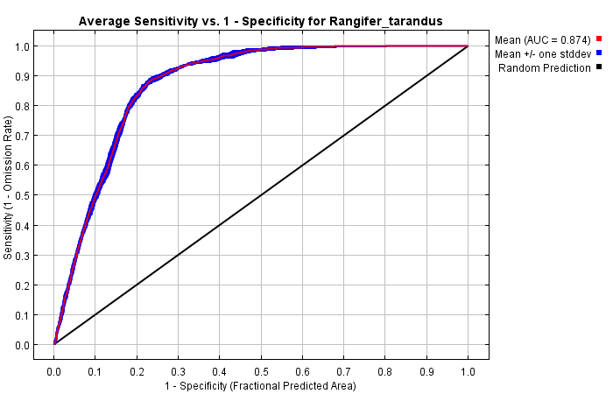

Figure 1: Receiver operating characteristic curve (ROC) averaged for the replicates on *Rangifer tarandus*. Specificity is defined using the predicted area rather than true commission. The average AUC is 0.874, and the standard deviation is 0.003.

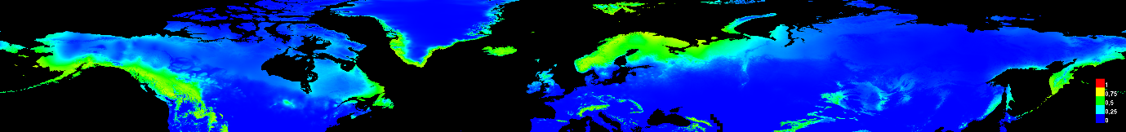

1. Species distribution modelling with present climate data

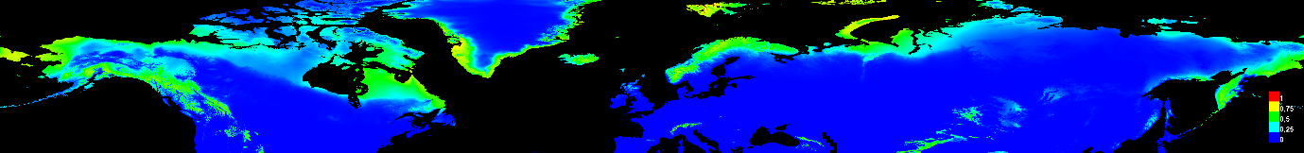

1. Species distribution modelling with future climate data

Figure 2: Species distribution maps for *Rangifer tarandus*. Future climate data is based on the HadGEM2-ES generalized circulation model (GCM) and the representative concentration pathway 4.5 according to the IPCC fifth assessment report (AR5).

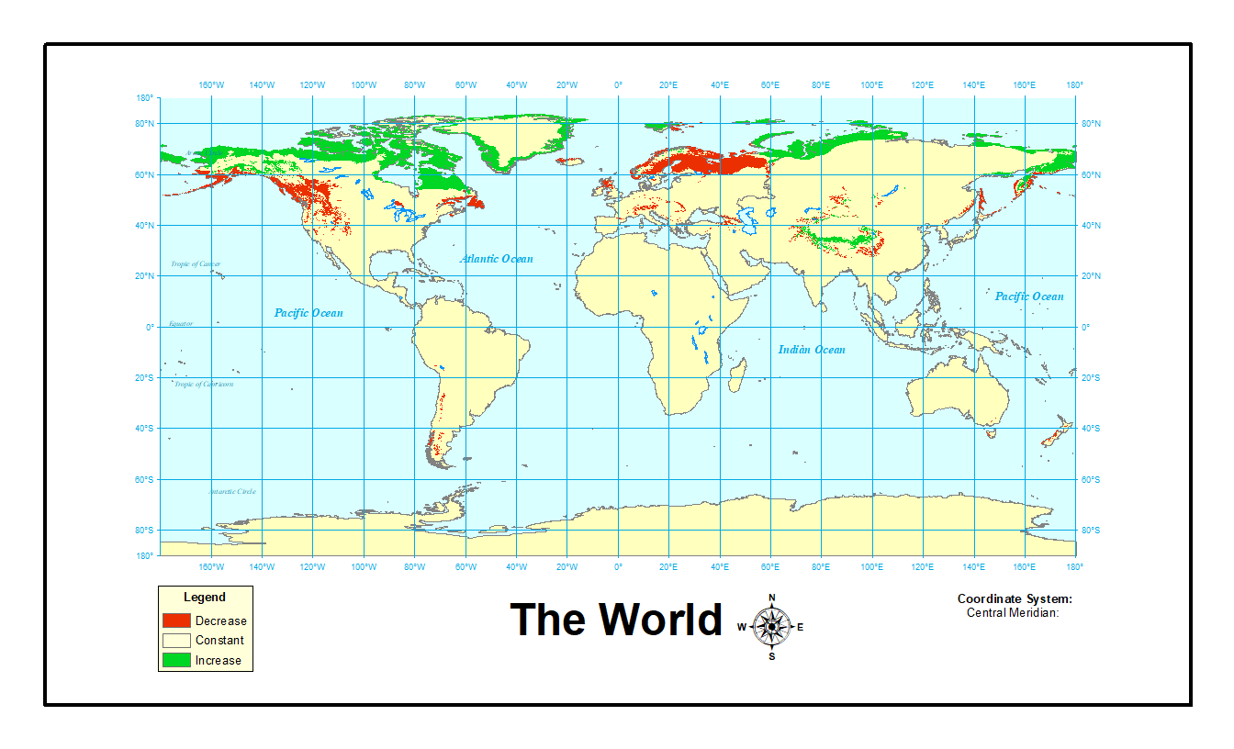 Figure 3: World map showing probability in- and decrease of having reindeer present. Data used to construct the maps were the present uncropped and future uncropped climate data.

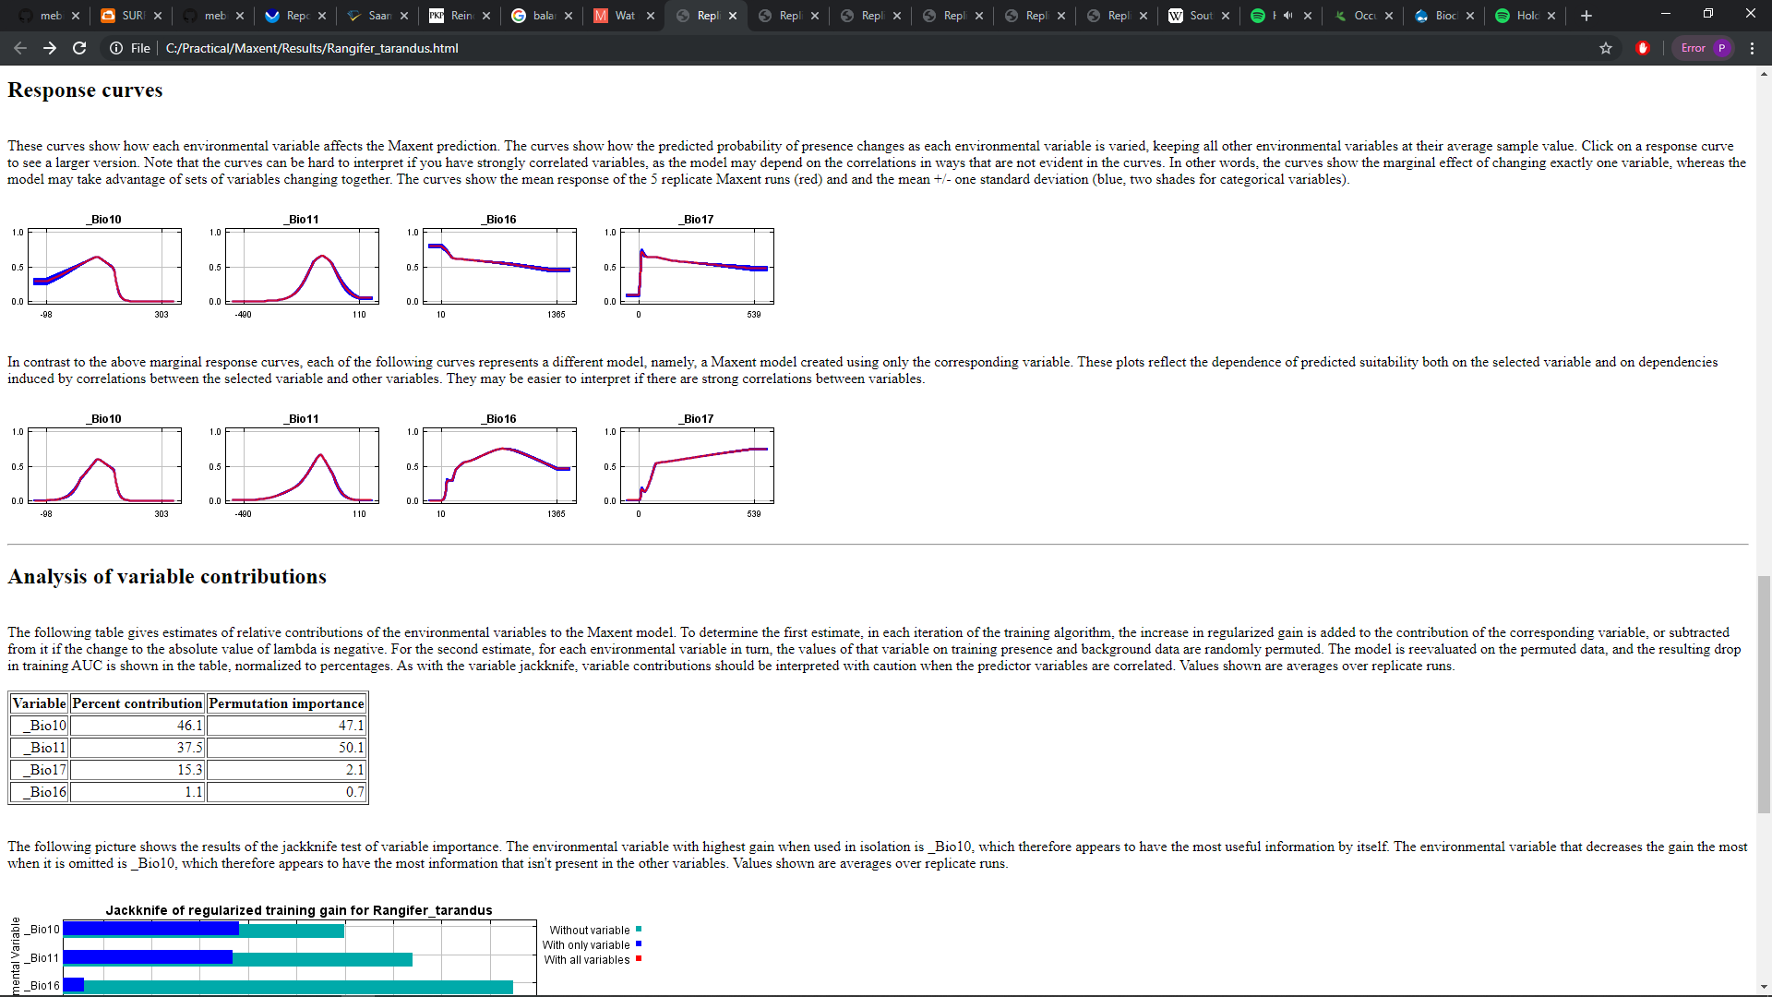

1. *Rangifer tarandus*

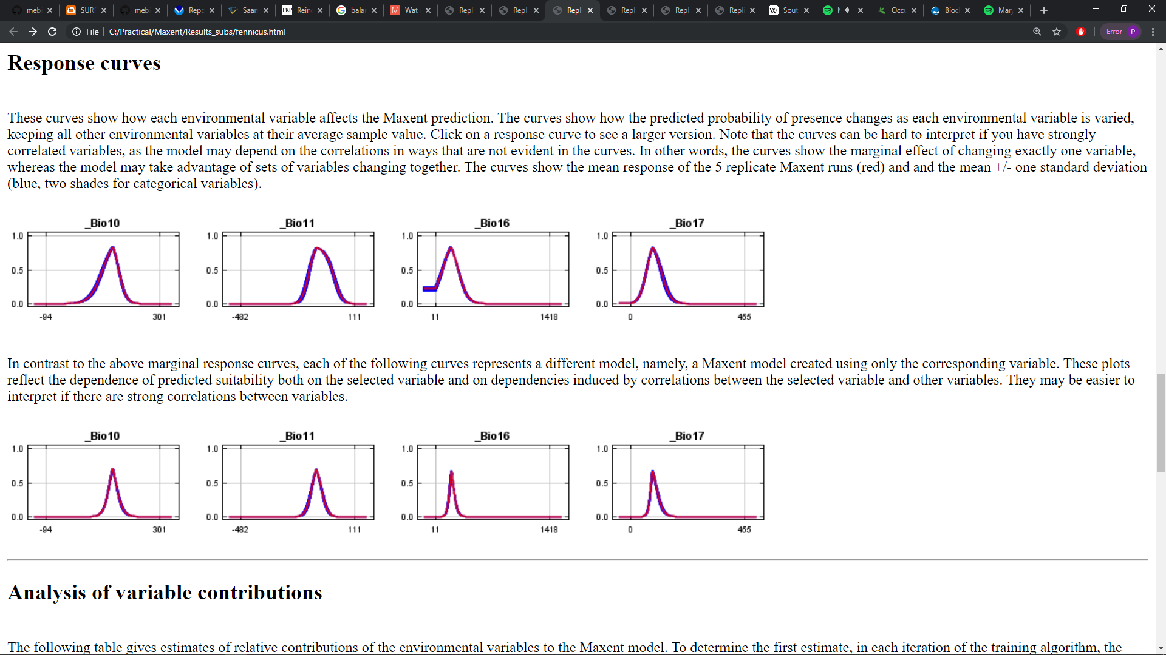

1. *Rangifer tarandus fennicus*

Figure 4: Response curves for the occurences of *Rangifer tarandus* (a) and *Rangifer tarandus fennicus* (b) on the implemented climate variables: mean temperature of warmest quarter (Bio10), mean temperature of coldest quarter (Bio11), mean precipitation of wettest quarter (Bio16) and mean precipitation of driest quarter (Bio17).

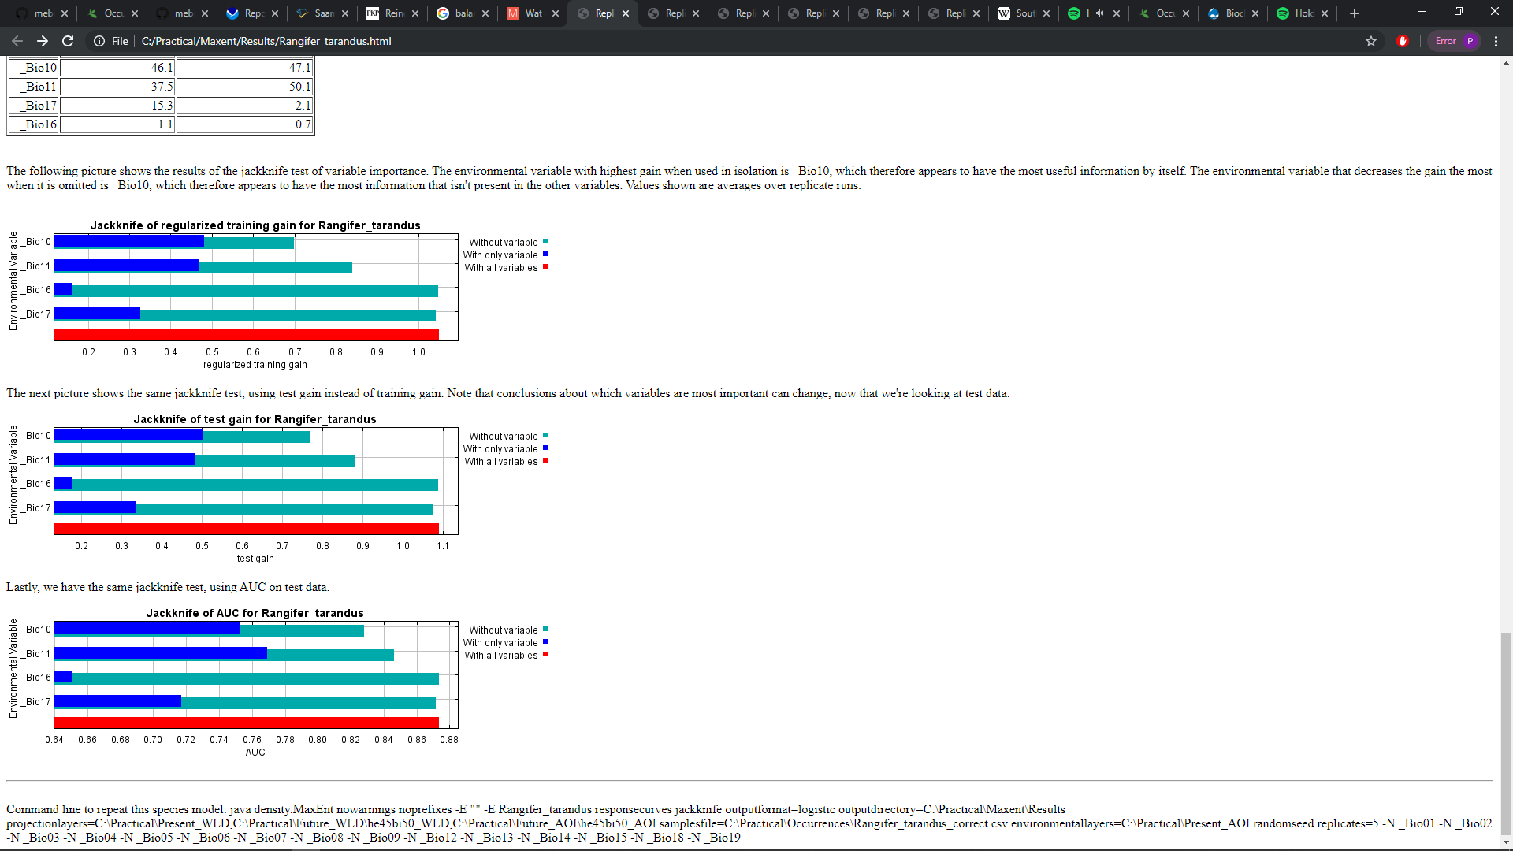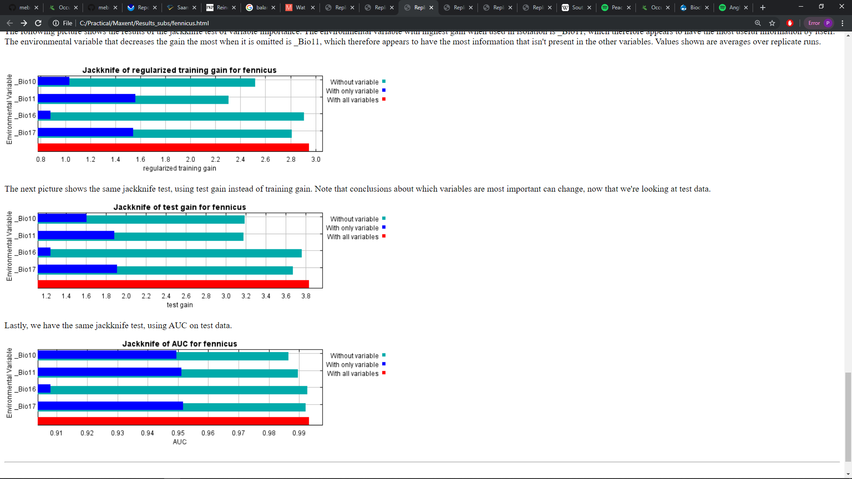





1. Rangifer tarrandus b) Rangifer tarandus fennicus

Figure 5: Jackknife values on the four climatic variables implemented in the species distribution modelling: mean temperature of warmest quarter (Bio10), mean temperature of coldest quarter (Bio11), mean precipitation of wettest quarter (Bio16) and mean precipitation of driest quarter (Bio17). The three graphs from top to bottom discern: the values of the variables for training the model (top), the values of the variables in determining the change in suitability for reindeer in an area (middle) and the values of the variables concerning the AUC-value of the whole model (bottom).

# References

1. Bernes, C., Bråthen, K. A., Forbes, B. C., Speed, J. D. M. & Moen, J. (2015). What are the impacts of reindeer/caribou (Rangifer tarandus L.) on arctic and alpine vegetation? A systematic review. *Environ. Evid.* **4**, 1–26.

2. Banfield, A. (1961). A revision of the reindeer and caribou, genus Rangifer. Biological series. (66).

3. Flagstad, Ø. & Røed, K. H. (2003). Refugial origins of reindeer (Rangifer tarandus L.) inferred from mitochondrial DNA sequences. *Evolution (N. Y).* **57**, 658–670.

4. Arctic Program (2019). Arctic report card. NOAA, United States of America.

5. Heggberget, T. M., Gaare, E. & Ball, J. P. (2002). Reindeer (Rangifer tarandus) and climate change: Importance of winter forage. *Rangifer* **22**, 13.

6. Chapin, F. S., Shaver, G. R., Giblin, A. E., Nadelhoffer, K. J. & Laundre, J. A. Responses of Arctic tundra to experimental and observed changes in climate. *Ecology* **76**, 694–711 (1995).

7. IPCC (2014). Climate Change 2014: Synthesis Report. Contribution of Working Groups I, II and III to the Fifth Assessment Report of the Intergovernmental Panel on Climate Change [Core Writing Team, R.K. Pachauri and L.A. Meyer (eds.)]. IPCC, Geneva, Switzerland, 151 pp.

8. Tyler, N.J., Turi, J.M., Sundset, M.A., Bull, K.S., Sara, M.N., Reinert, E.S., Oskal, N., Nellemann, C., McCarthy, J.J., Mathiesen, S.D., Martello, M.L., Magga, O.H., Hovelsrud, G.K., Hanssen-Bauer, I., Eira, N.I., Eira, I.M., & Corell, R.W. (2007). Saami reindeer pastoralism under climate change: Applying a generalized framework for vulnerability studies to a sub-arctic social–ecological system. *Economics*.

9. GBIF.org (4 December 2019). GBIF Occurrence Download. https://doi.org/10.15468/dl.p7prhx.

10. Hijmans, R.J., Cameron, S., Parra J. (2019). WorldClim version 1.4. Museum of Vertebrate Zoology, University of California.

11. Phillips, S.J., Anderson, R.P., Dudík, M., Schapire, R.E., Blair, M. (2017). Opening the black box: an open-source release of Maxent. *Ecography*.

12. ESRI (2019). ArcGIS Desktop: Release 10. Redlands, CA: Environmental Systems Research Institute.

# Appendix

# 

# Appendix I: Flowchart for the workflow of this study.