**Rice in Europe? A model-based approach to feeding the growing human population in a time of extreme climate change**

Mark Doeland, s1524379

**Introduction**

In the last decades it has become increasingly clear that humanity is facing a future global climate crisis (IPCC, 2014). Global population growth and economic development drive increasing emission of greenhouse gasses and land-use change. This in turn causes global mean temperature rise, sea level rise and loss of functional biodiversity (IPCC, 2014). Agriculture is one of the biggest influences on both carbon dioxide (the most abundant atmospheric greenhouse gas) emissions and land-use change, especially livestock (McMichael et al., 2007; IPCC, 2014). Not only do we need to think of more sustainable food production methods, we also need to think of the influence of the changing climate on food production. Increasing temperatures, change in precipitation and more frequent events of extreme weather in the form of, for example, storms and floods could put huge stress on food availability for the increasing global population.

A case study in Nepal found significant effects on crop yields by increasing precipitation and extreme weather (Poudel et al., 2014). Low precipitation levels and high maximum temperature would negatively influence production of rice (*Oryza sativa)*, a massively important crop in food production in Asia. However increase in minimum temperatures and increase in precipitation levels do not influence rice yields. This means the future yields of rice are highly insecure in the light of future climate change.

This study will further focus on predicting the influence of climate change on global rice production by modelling the predicted global occupied niche for *O. sativa* in 2050 based current occurrence data. The main question is: What is the effect of predicted climate change on the occurrence of *O. sativa*? That includes the following sub-questions: Does *O. sativa* occurrence increase or decrease from now to 2050? In which areas does the occurrence of *O. sativa* increase and decrease? Which climatic factors impact the change in occurrence of *O. sativa*? Following this we want to answer the question: Will Europe be more suitable as a production area for rice in 2050?

**Material and Methods**

Occurrence data for *Oryza sativa* was acquired from GBIF (gbif.org). Only preserved specimens with known coordinates were selected to prevent false observations. This introduces a collection bias, but greatly reduces noise in the occurrence data. Climatic data was acquired via WorldClim (worldclim.org). Data for present bioclimatic conditions (based on observation from 1960 to 1990) was selected at a resolution of 5 minutes (longitude/latitude degree) for optimal computational strength. Future bioclimatic data was selected at a resolution of 5 minutes as well and for a conservative prediction an RCP4.5 scenario was chosen, where measures against climate change are taken to lead to a radiative forcing peak at 4.5 W/m2 in 2040, following the HadGEM2-ES global climate model.

Data was loaded in to RStudio 1.2.5019 to prepare for modelling in MAXENT. Longitude and latitude data for *O. sativa* occurrences was coupled to the environmental data and cropped to a world distribution and a Mediterranean distribution using the “sp”, “rgdal”, “raster” and “biomod2” packages. Scripts follow Van ‘t Zelfde & Vos (2019; <https://github.com/naturalis/mebioda/blob/master/doc/week2/w2d5/README.md>). Bioclimatic variables were tested for autocorrelation using PPC (Pearson’s pairwise correlation) and multicollinearity using VIF (variance inflaction factor). The first eleven bioclimatic variables from WorldClim are temperature dependent and hence correlate more with each other. Similarly the last eight variables are precipitation dependent and hence correlate more with each other and little or not with the first eleven variables. The variables correlating most with other variables were deleted leaving mostly variables dependent on specific periods with a PPC value between -0.7 and 0.7. The following variables were selected: Bio02, Bio05, Bio07, Bio08 , Bio15, Bio16, Bio17, Bio18, Bio19. This corresponds with mean diurnal range, max. temperature of warmest month, temperature annual range, mean temperature of wettest quarter, precipitation seasonality, precipitation of wettest quarter, precipitation of driest quarter, precipitation of warmest quarter and precipitation of coldest quarter. The selected variables did not result in high VIF values (> 10) and hence show low multicollinearity.

|  |  |  |  |  |  |  |  |  |  |  |  |  |  |  |  |  |  |  |  |
| --- | --- | --- | --- | --- | --- | --- | --- | --- | --- | --- | --- | --- | --- | --- | --- | --- | --- | --- | --- |
| **Table 1: Correlation matrix for bioclimatic variables (PPC)** | | | | | | | | | | | | | | | | | | | |
|  | **Bio01** | **Bio02** | **Bio03** | **Bio04** | **Bio05** | **Bio06** | **Bio07** | **Bio08** | **Bio09** | **Bio10** | **Bio11** | **Bio12** | **Bio13** | **Bio14** | **Bio15** | **Bio16** | **Bio17** | **Bio18** | **Bio19** |
| **Bio01** | 1.00 | 0.16 | 0.77 | -0.83 | 0.83 | 0.96 | -0.77 | 0.71 | 0.91 | 0.89 | 0.98 | 0.32 | 0.37 | 0.05 | 0.29 | 0.37 | 0.07 | 0.10 | 0.23 |
| **Bio02** | 0.16 | 1.00 | 0.08 | 0.04 | 0.44 | -0.01 | 0.26 | 0.13 | 0.13 | 0.27 | 0.09 | -0.50 | -0.38 | -0.47 | 0.45 | -0.39 | -0.49 | -0.44 | -0.40 |
| **Bio03** | 0.77 | 0.08 | 1.00 | -0.91 | 0.39 | 0.85 | -0.86 | 0.51 | 0.71 | 0.46 | 0.85 | 0.55 | 0.53 | 0.26 | 0.17 | 0.53 | 0.29 | 0.30 | 0.44 |
| **Bio04** | -0.83 | 0.04 | -0.91 | 1.00 | -0.40 | -0.93 | 0.97 | -0.48 | -0.81 | -0.49 | -0.93 | -0.53 | -0.54 | -0.22 | -0.15 | -0.54 | -0.25 | -0.28 | -0.38 |
| **Bio05** | 0.83 | 0.44 | 0.39 | -0.40 | 1.00 | 0.66 | -0.29 | 0.65 | 0.74 | 0.97 | 0.70 | -0.06 | 0.04 | -0.19 | 0.35 | 0.02 | -0.19 | -0.22 | -0.03 |
| **Bio06** | 0.96 | -0.01 | 0.85 | -0.93 | 0.66 | 1.00 | -0.91 | 0.62 | 0.91 | 0.75 | 0.99 | 0.45 | 0.47 | 0.17 | 0.17 | 0.47 | 0.20 | 0.19 | 0.35 |
| **Bio07** | -0.77 | 0.26 | -0.86 | 0.97 | -0.29 | -0.91 | 1.00 | -0.43 | -0.75 | -0.42 | -0.88 | -0.61 | -0.58 | -0.33 | -0.03 | -0.59 | -0.36 | -0.37 | -0.47 |
| **Bio08** | 0.71 | 0.13 | 0.51 | -0.48 | 0.65 | 0.62 | -0.43 | 1.00 | 0.43 | 0.72 | 0.65 | 0.23 | 0.32 | -0.01 | 0.36 | 0.30 | 0.01 | 0.21 | 0.05 |
| **Bio09** | 0.91 | 0.13 | 0.71 | -0.81 | 0.74 | 0.91 | -0.75 | 0.43 | 1.00 | 0.79 | 0.92 | 0.27 | 0.29 | 0.07 | 0.18 | 0.29 | 0.09 | -0.01 | 0.27 |
| **Bio10** | 0.89 | 0.27 | 0.46 | -0.49 | 0.97 | 0.75 | -0.42 | 0.72 | 0.79 | 1.00 | 0.78 | 0.07 | 0.15 | -0.09 | 0.32 | 0.13 | -0.08 | -0.09 | 0.05 |
| **Bio11** | 0.98 | 0.09 | 0.85 | -0.93 | 0.70 | 0.99 | -0.88 | 0.65 | 0.92 | 0.78 | 1.00 | 0.41 | 0.45 | 0.12 | 0.24 | 0.45 | 0.14 | 0.16 | 0.30 |
| **Bio12** | 0.32 | -0.50 | 0.55 | -0.53 | -0.06 | 0.45 | -0.61 | 0.23 | 0.27 | 0.07 | 0.41 | 1.00 | 0.89 | 0.70 | -0.24 | 0.92 | 0.74 | 0.78 | 0.73 |
| **Bio13** | 0.37 | -0.38 | 0.53 | -0.54 | 0.04 | 0.47 | -0.58 | 0.32 | 0.29 | 0.15 | 0.45 | 0.89 | 1.00 | 0.38 | 0.08 | 0.99 | 0.42 | 0.72 | 0.56 |
| **Bio14** | 0.05 | -0.47 | 0.26 | -0.22 | -0.19 | 0.17 | -0.33 | -0.01 | 0.07 | -0.09 | 0.12 | 0.70 | 0.38 | 1.00 | -0.54 | 0.42 | 0.99 | 0.55 | 0.65 |
| **Bio15** | 0.29 | 0.45 | 0.17 | -0.15 | 0.35 | 0.17 | -0.03 | 0.36 | 0.18 | 0.32 | 0.24 | -0.24 | 0.08 | -0.54 | 1.00 | 0.03 | -0.54 | -0.16 | -0.31 |
| **Bio16** | 0.37 | -0.39 | 0.53 | -0.54 | 0.02 | 0.47 | -0.59 | 0.30 | 0.29 | 0.13 | 0.45 | 0.92 | 0.99 | 0.42 | 0.03 | 1.00 | 0.45 | 0.74 | 0.59 |
| **Bio17** | 0.07 | -0.49 | 0.29 | -0.25 | -0.19 | 0.20 | -0.36 | 0.01 | 0.09 | -0.08 | 0.14 | 0.74 | 0.42 | 0.99 | -0.54 | 0.45 | 1.00 | 0.57 | 0.68 |
| **Bio18** | 0.10 | -0.44 | 0.30 | -0.28 | -0.22 | 0.19 | -0.37 | 0.21 | -0.01 | -0.09 | 0.16 | 0.78 | 0.72 | 0.55 | -0.16 | 0.74 | 0.57 | 1.00 | 0.33 |
| **Bio19** | 0.23 | -0.40 | 0.44 | -0.38 | -0.03 | 0.35 | -0.47 | 0.05 | 0.27 | 0.05 | 0.30 | 0.73 | 0.56 | 0.65 | -0.31 | 0.59 | 0.68 | 0.33 | 1.00 |

Red: PPC values > 0.7

BIO1 = Annual Mean Temperature

BIO2 = Mean Diurnal Range (Mean of monthly (max temp - min temp))

BIO3 = Isothermality (BIO2/BIO7) (* 100)

BIO4 = Temperature Seasonality (standard deviation *100)

BIO5 = Max Temperature of Warmest Month

BIO6 = Min Temperature of Coldest Month

BIO7 = Temperature Annual Range (BIO5-BIO6)

BIO8 = Mean Temperature of Wettest Quarter

BIO9 = Mean Temperature of Driest Quarter

Green: PPC values < -0.7

BIO10 = Mean Temperature of Warmest Quarter

BIO11 = Mean Temperature of Coldest Quarter

BIO12 = Annual Precipitation

BIO13 = Precipitation of Wettest Month

BIO14 = Precipitation of Driest Month

BIO15 = Precipitation Seasonality (Coefficient of Variation)

BIO16 = Precipitation of Wettest Quarter

BIO17 = Precipitation of Driest Quarter

BIO18 = Precipitation of Warmest Quarter

BIO19 = Precipitation of Coldest Quarter

**Table 2: VIF score for selected climatic variables**

|  |  |  |
| --- | --- | --- |
|  | **Variables** | **VIF** |
| **1** | Bio02 | 2.004619 |
| **2** | Bio05 | 2.809688 |
| **3** | Bio07 | 1.978356 |
| **4** | Bio08 | 2.531635 |
| **5** | Bio15 | 2.122581 |
| **6** | Bio16 | 5.058395 |
| **7** | Bio17 | 3.723629 |
| **8** | Bio18 | 4.497062 |
| **9** | Bio19 | 3.349694 |

The occurrence data and the selected bioclimatic variables were loaded into MaxEnt to create response curves with ‘extrapolate’ and ‘do clamping’ on. Variable importance was measured with Jackknife. Five runs were done to ensure sufficient replicates. Sensitivity and specificity of the model were plotted against each other to validate the model to produce an Area Under the Curve (AUC) value for the Receiver Operator Curve (ROC) following Fielding an Bell (1997), McPherson et al. (2004) and Raes and Ter Steege (2007).

**Results**

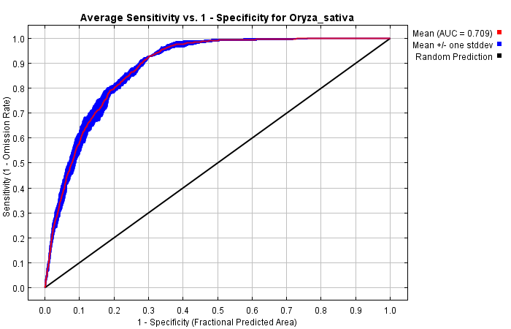

**Figure 1:** Graph for sensitivity (y-axis) vs. specificity (x-axis) of the model. AUC values for a test and training set are calculates against a random model.

The sensitivity vs. specificity plot for the combined five models has an AUC value over 0.7 but under 0.8 (0.709; Figure 1). This means the model is considered sufficient, but not good (Raes and Ter Steege, 2007).

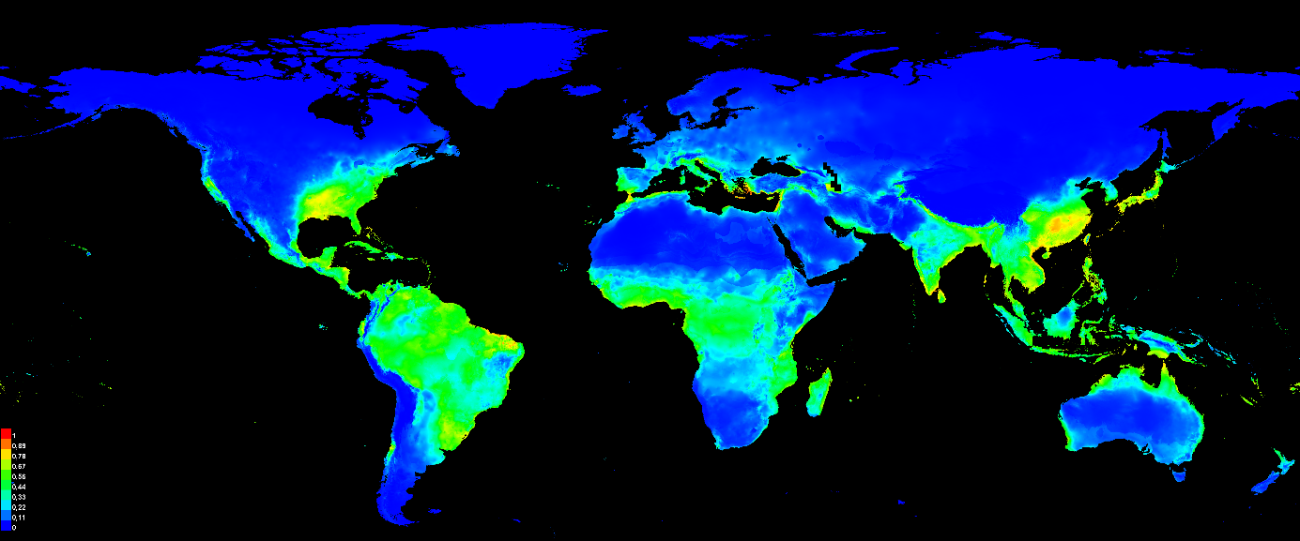

**Figure 2:** Present occurrence of *Oryza sativa* in the combined five models

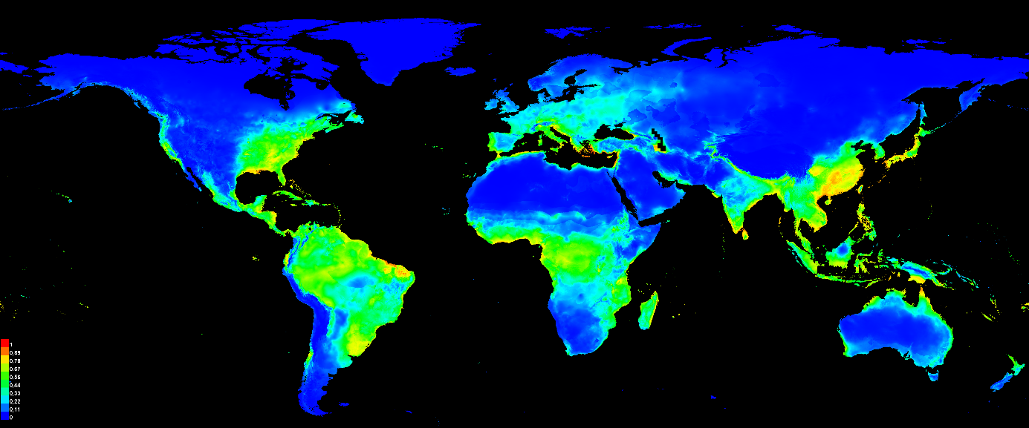

**Figure 3:** Predicted occurrence of *Oryza sativa* in 2050 in the combined five models

The occurrence maps created by MaxEnt show that the predicted occupied niche for *Oryza sativa* will increase globally between now and 2050. Especially around the equator in tropical areas and in the western world, namely Europe and the East and West Coast of the United States.

The equal test sensitivity and specificity threshold for the five models is: 0.359, 0.360, 0.353, 0.319 and 0.376. This leads to an average threshold value of: 0.353.For yet unknown reasons MaxEnt did not return response curves for the combined models. However all models agree that Bio16 is the most influential value on its own, while Bio2 and Bio5 are the two values that have most influence when omitted. This means cultivated rice is most influenced by the max. precipitation of the wettest month, and largely dependent on the temperature range of every month and the max. temperature of the warmest month (Figure 4). Range change based on suitable environment and predicted occurrence align relatively well (Figure 5, 6 and 7).

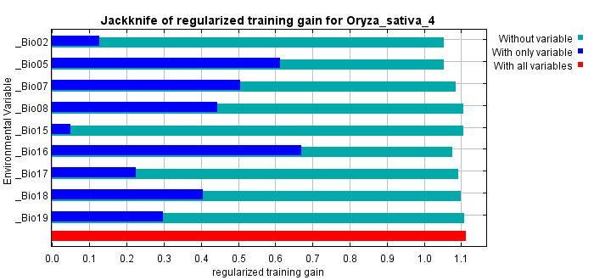

**Figure 4:** Jackknife test of variable importance for the fifth model. The environmental variable with highest gain when used in isolation is bio16 the environmental variable that decreases the gain the most when it is omitted is bio02, followed by bio05. 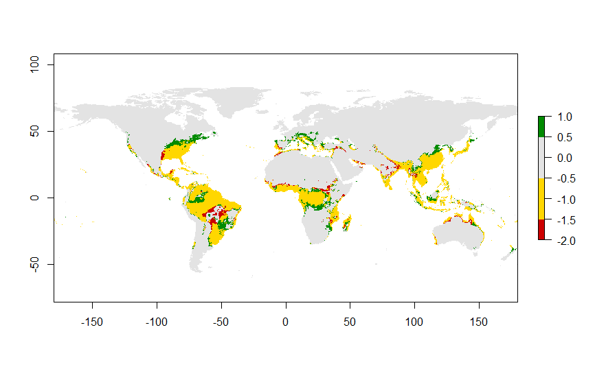

**Figure 5**: Range change of predicted suitable environment from the combined present models to the combined future models. Green = increase in predicted suitable environment, yellow = no change in predicted suitable environment, red = decrease in predicted suitable environment.

**Figure 6**: Range change of predicted occurrences from the combined present models to the combined future models. Green = increase in predicted occurrence area, yellow = no change in predicted occurrence area, red = decrease in predicted occurrence area.

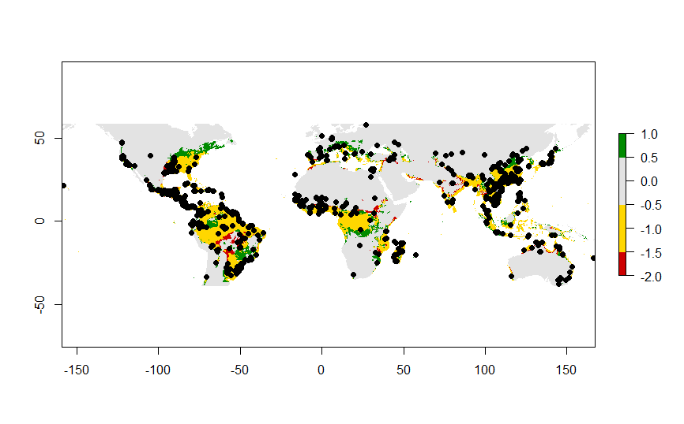**Figure 7**: Visualised combined range change with the original occurrence data from GBIF.

**Discussion**

Climate change does not appear to pose problems in the form of decrease of suitable areas for cultivated rice, according to the run models. In fact, within tropical areas, where rice is a highly important crop for feeding human populations, the predicted occupied niche for rice was found to increase by 2050. The increase of the predicted occupied niche for cultivated rice is even bigger in more temperate areas on the Northern Hemisphere, possibly suggesting that rice will become an important crop for feeding the most populated areas in the western world. It should be noted however that occurrence data for present cultivated rice is highly biased due to human introduction of the rice in these areas. Nonetheless, the model clearly predicts these areas to be more suitable for rice farming in the future. As range change based on suitable environment and predicted occurrence align very well, the predicted change is likely linked to the modelled change in bioclimatic data.

Although the model predicts an increase for suitable rice farming areas in tropical areas, it does not predict better yields. Extreme weather events like floods could severely influence crop yields, without necessarily rendering the effected area not suitable for cultivated rice to exist. It should also be noted that the increased suitable area for cultivated rice could be highly linked to deforestation. Currently human activities turn forest areas into suitable agricultural land, but climate change could also make area less suitable for large forests, automatically creating more space for rice fields. The model is not very strong as visualised by the AUC values and should does be interpreted with care.

**References**

Fielding, A. H., & Bell, J. F. (1997). A review of methods for the assessment of prediction errors in conservation presence/absence models. *Environmental conservation*, *24*(1), 38-49.

IPCC. (2014). *Climate Change 2014: Synthesis Report. Contribution of Working Groups I, II and III to the Fifth Assessment Report of the Intergovernmental Panel on Climate Change*. *Ipcc*.

McMichael, A. J., Powles, J. W., Butler, C. D., & Uauy, R. (2007). Food, livestock production, energy, climate change, and health. *Lancet*, *370*(9594), 1253–1263. https://doi.org/10.1016/S0140-6736(07)61256-2

McPHERSON, J. M., Jetz, W., & Rogers, D. J. (2004). The effects of species’ range sizes on the accuracy of distribution models: ecological phenomenon or statistical artefact?. *Journal of applied ecology*, *41*(5), 811-823.

Poudel, M. P., Chen, S. E., & Huang, W. C. (2014). Climate Influence on Rice, Maize and Wheat Yields and Yield Variability in Nepal. *Journal of Agricultural Science and Technology. B*, *4*(1B), 38.

Raes, N., & ter Steege, H. (2007). A null‐model for significance testing of presence‐only species distribution models. *Ecography*, *30*(5), 727-736.