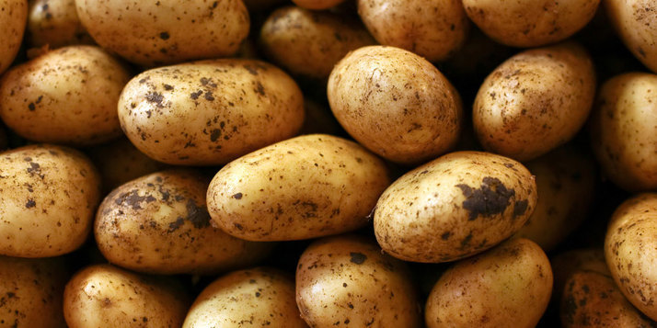Report Solanum tuberosum

09-12-2019

Nathalie Winkster

S1689673

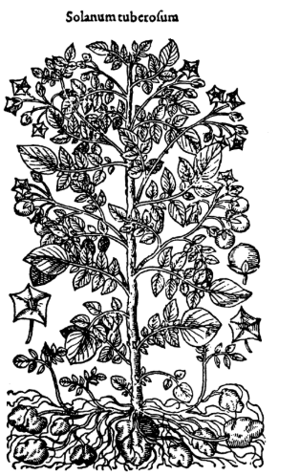**Introduction**

This report will focus on the species *Solanum tuberosum*, better known as the Potato. The *S. tuberosum* is an ancient crop that was domesticated between seven and three thousand years ago in South America, probably in the Andes of Peru or Bolivia (Connell, 1951). During the sixteenth century the *S. tuberosum* was actively dispersed by man after the Spaniards arrived in South America(Connell, 1951). From Spain the *S. tuberosum* was brought to England and from there to the English colonies. The domesticated *S. tuberosum* crop could be found in almost every part of the world (Connell, 1951).

Nowadays the *S. tuberosum* has become a staple food, meaning that in large areas of the world it forms a dominant portion of a daily [diet](https://en.wikipedia.org/wiki/Diet_(nutrition)). In 2014 the *S. tuberosum* was even estimated to be the world's fourth-largest food crop (after corn, wheat and rice). The *S. tuberosum* crop plays an important role in the world's [food supply](https://en.wikipedia.org/wiki/Food_supply).

Fig 1. Historical immage out of the book: History of thepotato, Connell, 1951

**Characteristics**

The book Growing Food: A Guide to Food Production (Winch, 2006) describes the following charicteristics of the *S. tuberosum*plant:

‘’The *S. tuberosum* plant is a perennial that grows to become about 60 cm measured from the ground. It is often referred to as a root vegetable. However the ‘’root’’ is in reality a tuber. This is a swollen underground stem that consists mainly of starch, and it’s the part of the *S. tuberosum* that is eaten. The *S. tuberosum* tuberization is regulated by daylength and takes about 10 weeks to fully grow (Amador et al., 2001). Although *S. tuberosum*es are seed plants by nature, for food production the tuber is used to grow new *S. tuberosum* plants that are exact replicas of their parents. As a general rule, plants with white flowers have tubers with white skin, while plants with pink, red, blue or purple flowers have tubers with coloured skin, normally pinkish.

The *S. tuberosum* grows best in a temperate climate. Its optimum soil temperature lies between the 20–25°C, making them frost sensitive. However in the tropics the *S. tuberosum* can’t flower. The higher the temperature, the more the aerial parts develop at the expense of tuber development. At about 30°C tuber development virtually stops. This is why the *S. tuberosum* is only grown during a cool season or at high altitudes in tropical regions.

Another important biological variable is rainfall. Some varieties can produce a small yield with only 350mm during the growing season, though the optimum is about 25cm per week during the growing season. Drought can be disastrous for *S. tuberosum*es, especially if this occurs when the tubers should be bulking up. More characteristics described by Whinch can be found in table 1.’’

Table 1. Characteristics

|  |  |
| --- | --- |
| External factors | Optimum |
| Temperature | 20–25°C |
| Depth | 5-15 cm |
| Soil ph | 5.5–6 |
| Raindfall during growing season | 350 mm (minimum amount) |
| Altitude minimum | 1800m (maximum 3000m) |
| LAI | 3 |
|  |  |

Since draught can be disastrous for *S. tuberosum*es, it would be interesting to look at the minimum amount of rainfall. Due to global warming it is possible that the global distribution of the *S. tuberosum* could possible shift, since some area’s will become warmer and their for ether more or less suitable to grow *S. tuberosum*es depending on the temperature. However, since the soil temperature can’t be to warm other area’s might no longer be suitable to grow *S. tuberosum*es.

This leads to the following research question: Is there a shift in the distribution of *S. tuberosum* in the future due to climate change?

H0: There is no shift in the distribution of in the future?

H1: There will be a shift in the distribution of in the future?

Using SDM with a selected future scenario a comparison can be made to see where *S. tuberosum* can occur.

**Methodology**

**Workflow**

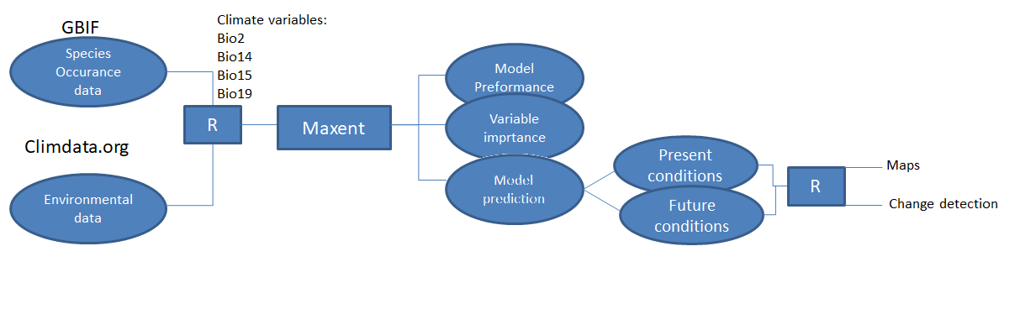First the occurrence data (extracted from GBIF) and environmental data (extracted from Climdata.org) were collected. The GBIF data was filtered so duplicates and missing values were no longer present.

In R Studio the occurrence and environmental data were prepared for use in Maxent to create a model. With the help of a correlation table four climate variables from climdata.org where choose to use in the model.

The amount of replicates was set to 5 times to train the model. In reality it would be better to run this even more often, but it’s a time-consuming step.

The output of Maxent could be used to compare present conditions to future conditions and look at the effect of the variables on the predictions of the model. In R studio maps were created show the difference between the present state of the *S. tuberosum* occurrence and the future state.

**Environmental data**

Given the characters of the *S. tuberosum*, described in the introduction it would be interesting to look at the soil temperature, amount of rainfall in the driest month and the latitude. For this study we use the climate variables available on worldclim.org only, figure 3.

Figure 3. Bioclimatic variables from worldclim.org

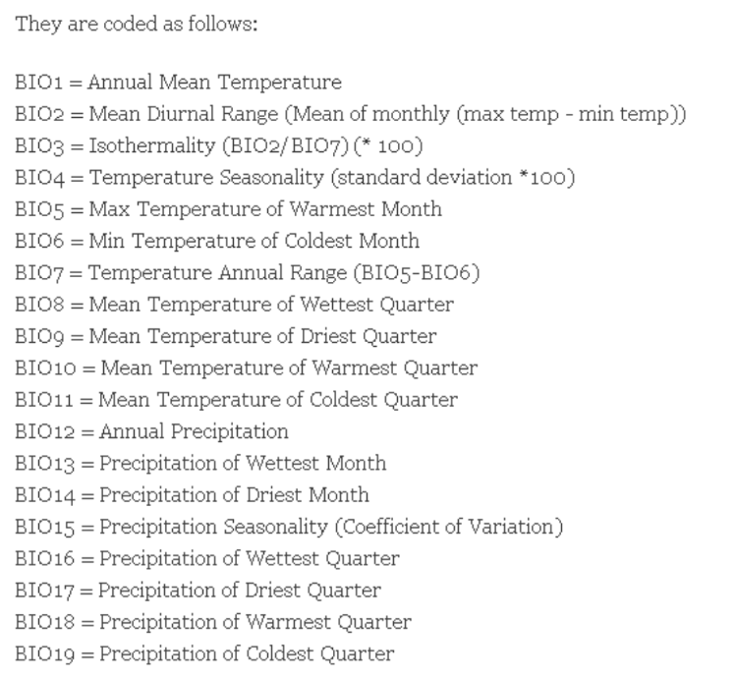

The following biological variables could be interesting to use: Bio 5 (max. temperature of the warmest month), Bio 6 (min. temperature in the coldest month), Bio 14 (precipitation of driest month), Bio15 (precipitation seasonality) and Bio 17 (precipitation in the warmest quarter).

*S. tuberosum*es are sensitive to both frost and warm soil temperatures. Looking at the maximum temperature in the warmest month and the minimum temperature in the coldest month can be really interesting. Especially information about the coldest temperature in the coldest month could be useful if you can observe areas that currently experience frost (in the winter) but in the future this might change, meaning that this area might become more suitable for the *S. tuberosum*.

Since draught can be disastrous for *S. tuberosum*es the precipitation of driest month, (precipitation seasonality and precipitation in the warmest quarter would be interesting too. The *S. tuberosum* needs at least 350mm when growing (Winch, 2006).

However taking statistical justification into account, using a correlation table made in Excel, the following climate variables where used in the actual model: Bio2 (Mean Diurnal Range (mean of monthly max temp – min temp) , Bio 14 (precipitation of driest month), Bio15 (precipitation seasonality) and Bio 19 (Precipitation of the Coldest Quarter) because they seemed to be the most independent, figure 5. To test for multicollinearity a VIF test was used, figure 4. All variables were smaller than 5 so they could be used.

Figure 4. Correlation table

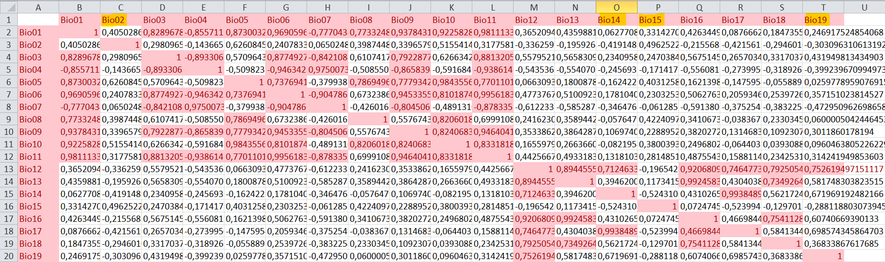

Figure 5. VIF results

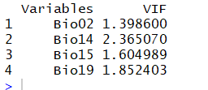

**Maxent**

To model the species niches and distributions maximum entropy modeling was used in a program called Maxent. Bio2, Bio14, Bio 15 and Bio 19 were used in the model. A Jackknife was done to measure the importance of every of these variables. The random seed was used to produce new randomized models for every replication. To train the model 5 replicates were performed. Finally Extrapolating was also used to create a worldwide coverage of the species.

**Threshold in R Studio**

To convert habitat suitability to the maps that we will create in R Studio a threshold binary of 0.4012 was used. Because 5 replicates were made to train the model in Maxent, the average of the logical threshold of ‘Maximum training sensitivity plus specificity’ was used, table 2.

Table 2. logical threshold of ‘Maximum training sensitivity plus specificity’, ran 5 times

|  |  |
| --- | --- |
| Logistical thresholds | |
| 0 | 0.393 |
| 1 | 0.395 |
| 2 | 0.392 |
| 3 | 0.447 |
| 4 | 0.379 |

**Results**

**Occurrence data**

First of all, a simple distribution map of the *S. tuberosum* was made in R Studio, fig 6. Looking at the distribution of the *S. tuberosum*, the crop can be found on almost all continents. However, the density is highest in Europe. Given Europe’s temperate climate, long lasting history concerning this crop and a possible spatial sampling bias (most of Europe is in general relatively well studied compared to other parts of the world), this is not a surprise. Looking at the other dense areas on the map they are also located within the temporal zone, more or less around the same height of Europe. As described in the introduction, a temperate climate works best for cultivating *S. tuberosum*es.

The *S. tuberosum* does hardly occur in the tropics. However in South America, the origin of the crop, it’s still cultivated. A clear pattern can be observed, being that the *S. tuberosum* mainly is grown in the Andes. In Asia we also see that the density is highest in area’s with natural higher altitudes, in other words mountains.

Another characteristic of this map is that there are almost no *S. tuberosum*es growing in dry dessert like area’s like the sahara and a huge part of Australia.

Looking at the ecological niche of the *S. tuberosum*, described in the introduction, a lot of overlap can be found with this map.

Fig 6. Occurrence data of the *S. tuberosum* world wide

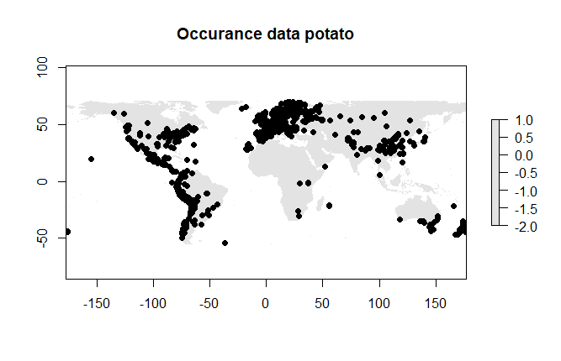

**Model output Maxent**

**AUC**

To look at the model accuracy a ROC curve was made. This graph is used to determine the average AUC for the 5 replicate runs. The average test AUC is 0.775, and the standard deviation is 0.005, figure 5. A AUC higher than 0.7 is considered reliable, figure 7.

Figure 7. ROC curve

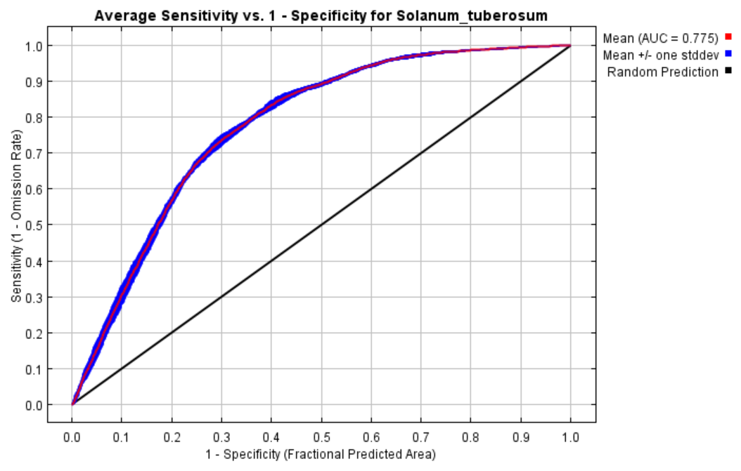

**Bioclimatic variables**

In this model the following bioclimatic variables where used: Bio2 (Mean Diurnal Range (mean of monthly max temp – min temp) , Bio14 (precipitation of driest month), Bio15 (precipitation seasonality) and Bio19 (Precipitation of the Coldest Quarter). The response curves show how each environmental variable affects the Maxent prediction. The curves show how the predicted probability of presence changes as each environmental variable is varied, keeping all other environmental variables at their average sample value, according Maxent, figure 8.

Bio2

Looking at figure 8.a it is clear that a high Mean Diurnal Range is more suitable for the occurrence of the *S. tuberosum* than a low Mean Diurnal Range. Looking at figure 8b. we see more or less the same pattern, meaning that this variable is not corresponding a lot with the other variables.

Bio14

Figure 8a. also shows that Bio14 when there is a lot of precipitation in the driest month the model predics that this habitat will be less suitable. Just like Bio2, the pattern in figure 8b hardly changes, meaning that this variable is not corresponding a lot with the other variables.

Bio15

Figure 8a. shows that with a high amount of precipitation (seasonality) the model predicts that this habitat will be less suitable for the *S. tuberosum*. However, looking at figure 8b, a rather different response pattern occurs, showing high probability for little and high precipitation. This indicates that this variable is corresponding with other variables. The main idea that more precipitation will result in a prediction of lower suitability is still more or less the same.

Bio19

Figure 8a shows that a high amount of precipitation in that the model predicts that this habitat will be less suitable for the *S. tuberosum*. Figure 8a and 8b show a lot of similarity so this variable is not corresponding a lot with the other variables.

Figure 8. Response curves of the bioclimatic variables

Ran together

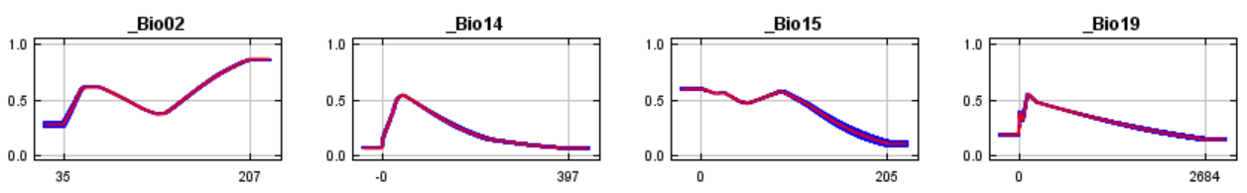

Ran individually

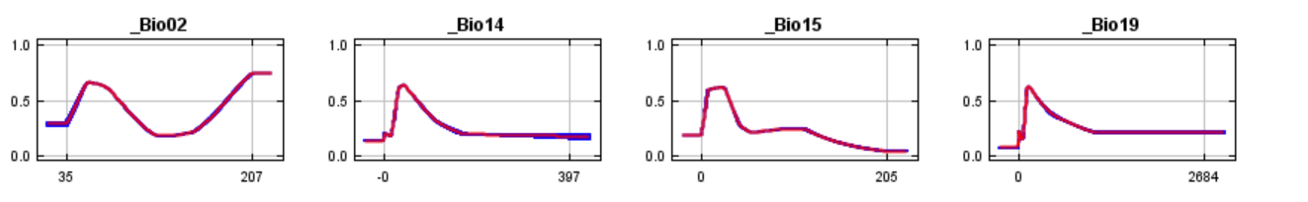

Looking at the variable contributions given in table 3, we see that Bio14 contributes the most to the response of Maxent. It’s contributed 70 and is the most important variable.

Table 3. Contributions per variable

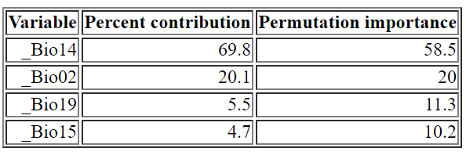

**SDM**

The present situation of the possible distribution shows that the *S. tuberosum* has a wide range of possible suitable habitats worldwide.

Figure 9. Present predictions of suitable habitats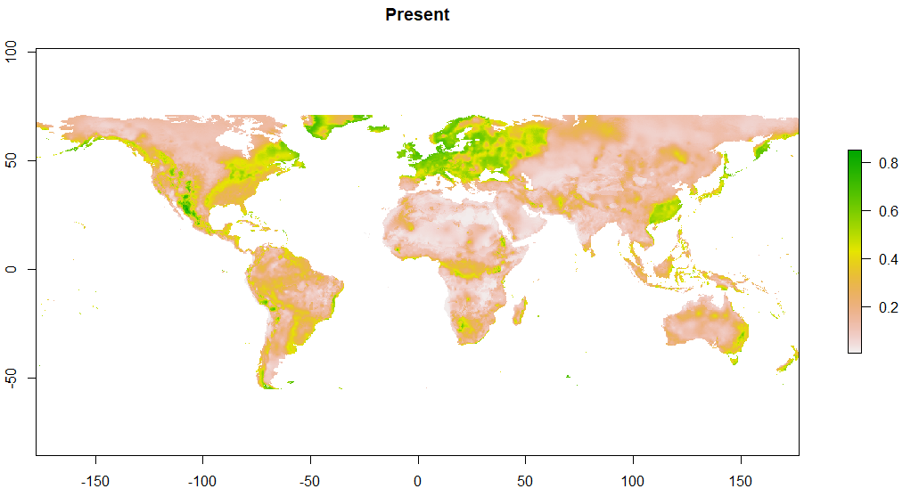

In the following maps the area’s with a high possibility of a suitable area and occurance are highlighted in green, figure 10. These sections had a treshold value that was greater than 0.4012.

Figure 10. Areas with a high possibiliy of being suitable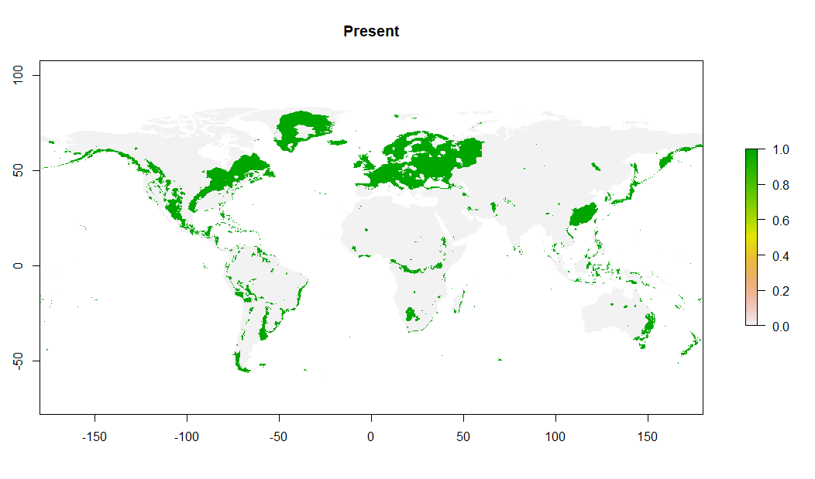

For the future *scenario*s RCB2.6 and RCB8.5 where choosen for this project. *Scenario* RCB2.6 was the most positive future *scenario*, in wich the radiation will increase by 2,6 W/m2  in 2050, this corresponds with a temperature increase of 1 °C. In the case of *scenario* RCB8.5 there will be an increase of 8,5 W/m2, that correspons with an increase of 2 °C by 2050. Because these scenarios differ the most, it would be interesting to compare them. Below figure 11 shows the change rate of the RCB2.6 scenario and figure 12 shows the change rate of the RCB8.5 scenario.

Figure 11. Change map RCB2.6

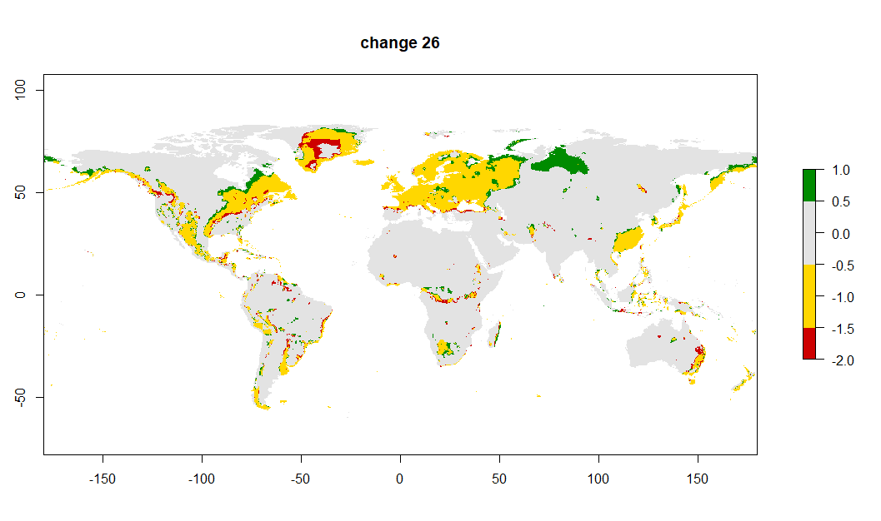

Figure 12. Change map RCB8.5 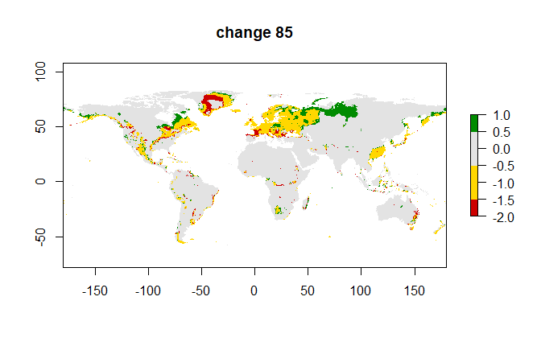

Figure 13 shows a map with the current occurrence data, and future scenario RBC8.5.

Figure 13. Change map RCB8.5 with occurrence data

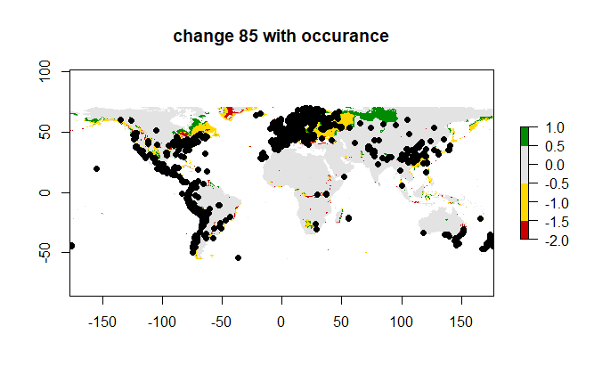

**Discussion and conclusions**

**Occurrence data**

Looking at the occurrence map of the present distribution of the *S. tuberosum* it is clear that the *S. tuberosum* has a wide range of possible suitable habitats. The probability of the habitat suitability differs strongly. However across the world the highest densities are found at locations that correspond with the highest chance that an area is suitable, like in Europe. However in areas in which the change of a habitat being less suitable, there are still observations. Because we are looking at a cultivated crop, the chances of farmers watering their crop during dry periods high. In this way the crop can occur in places where it would not survive in the wild, this is not taken into account by the model which adds a factor of uncertainty to the reliability of it’s predictions and lowers the predicting capability.

Also if a species can occur somewhere, that does not mean that it will occur there. Looking at figure 13, that shows the current occurrence data and future scenario RBC8.5, you see that there is a lot of overlap, however there are still yellow and green places that suggest to be suitable where no observations were made. Ofcourse this could also be due to sampling biases since in Afrika and Russia there are hardly any observation points. However there are still a lot of predictions based on these areas which could lower the reliability of the model.

**Present and future scenarios**

To answer the original research question: Is there a shift in the distribution of *S. tuberosum* in the future due to climate change? A map of the present situation and a future situation will be created.

In this report maps were created for both the RBC25 and RBC8,5 future scenarios. By comparing themaps (figure 9; 2,6) and (figure 12; 8,5) it is clear that there is a difference between these scenario’s. The overall amount of change in the prediction of suitable habitats is greater in looking at the scenario RBC8.5. Both the amount off loss and gain of predicted habitats are larger compared to the amount of change seen in the RBC2,6 map. Since the temperature increase is two times higher in RBC8,5 compared to RBC2,5 the scenario it is expected to find more extreme effects.

Since the effects are bigger in the RBC8,5 future scenario this scenario will be used to answer the research question. By looking at change map, figure 12, we can conclude that the H0 is true and that there is an effect visable. To say if the *S. tuberosum* benefits or suffers from a 2 °C temperature increase is hard to tell because the probability of an area being suitable increases in some parts of the world and decreases in others.

It appears that the biggest gain in possible suitability can be observed in Russia and the highest loss in warmer dryer areas like Africa and Australia.

**Bioclimatic variables**

For this study the bioclimatic variables Bio2, Bio14, Bio15 and Bio19 where used because they showed little correlation with other variables. Looking at the characters of the *S. tuberosum* Bio5, Bio 6 and Bio 17 could be of interest too, like described in the environmental data section; however these traits showed a lot of correlation.

Bio14 would have been chosen in any case because of the fact that the *S. tuberosum* can’t grow a tuber when there is not enough water available during the growing period. It seems to be a critical variable. Table 3. Confirms this more or less by showing that contributions per variable is highest for variable Bio14, more than 70%.

However there were only a vew bioclimatic variables available. The latitude and soil temperature could provide a better base for the predictions.

**Replicates**

To train the model 5 replicates were made. However this is still on the lower side to give an accurate prediction.

**References:**

Amador, V., Bou, J., Martínez-García, J., Monte, E., Rodríguez-Falcon, M., Russo, E., & Prat, S. (2001). Regulation of *S. tuberosum* tuberization by daylength and gibberellins. *International Journal of Developmental Biology*, *45*(SUPPL. 1), 37–38. https://doi.org/10.1387/ijdb.01450037

Connell, K. H. (1951). The History of the *S. tuberosum*. *The Economic History Review*, *3*(3), 388. https://doi.org/10.2307/2599996

Winch, T. (2006). *Growing Food: A Guide to Food Production - Tony Winch - Google Books*. Retrieved from https://books.google.com.pk/books?id=QDrqL2J-AiYC&pg=PA209&dq=*S. tuberosum*+plants+60+cm&redir_esc=y&hl=en#v=onepage&q=*S. tuberosum* plants 60 cm&f=false