Adaptive Neural Network: Learning From a Changed Reality
Workshop Three Professional Portfolio Artifact
Purpose | Demonstrate how an artificial neural network responds when the environment changes and connect that technical behavior to resilience, ethical judgment, communication, and adaptive leadership.
Tool | Python, NumPy, scikit-learn MLPClassifier, and Matplotlib.
Problem | Concept drift: a model trained on an earlier pattern may become less accurate when the data distribution changes.
Evidence | Accuracy changed from 94.4% in the original environment to 81.7% after drift, then improved to 95.0% after retraining.

Issue Solved With Python
The code creates a two-class synthetic dataset, trains a small feed-forward neural network, and then changes the feature space by rotating, scaling, and shifting it. The changed pattern represents a new operating reality. The original model is tested without adaptation and then a second model is trained on representative data from the changed environment.
model = MLPClassifier(hidden_layer_sizes=(16, 8), activation="relu", max_iter=2000)
model.fit(x_train, y_train)
original_accuracy = accuracy_score(y_test, model.predict(x_test))
changed_features = create_changed_reality(features)
drift_accuracy = accuracy_score(yd_test, model.predict(xd_test))
adapted_model.fit(xd_train, yd_train)
adapted_accuracy = accuracy_score(yd_test, adapted_model.predict(xd_test))

Results and Interpretation
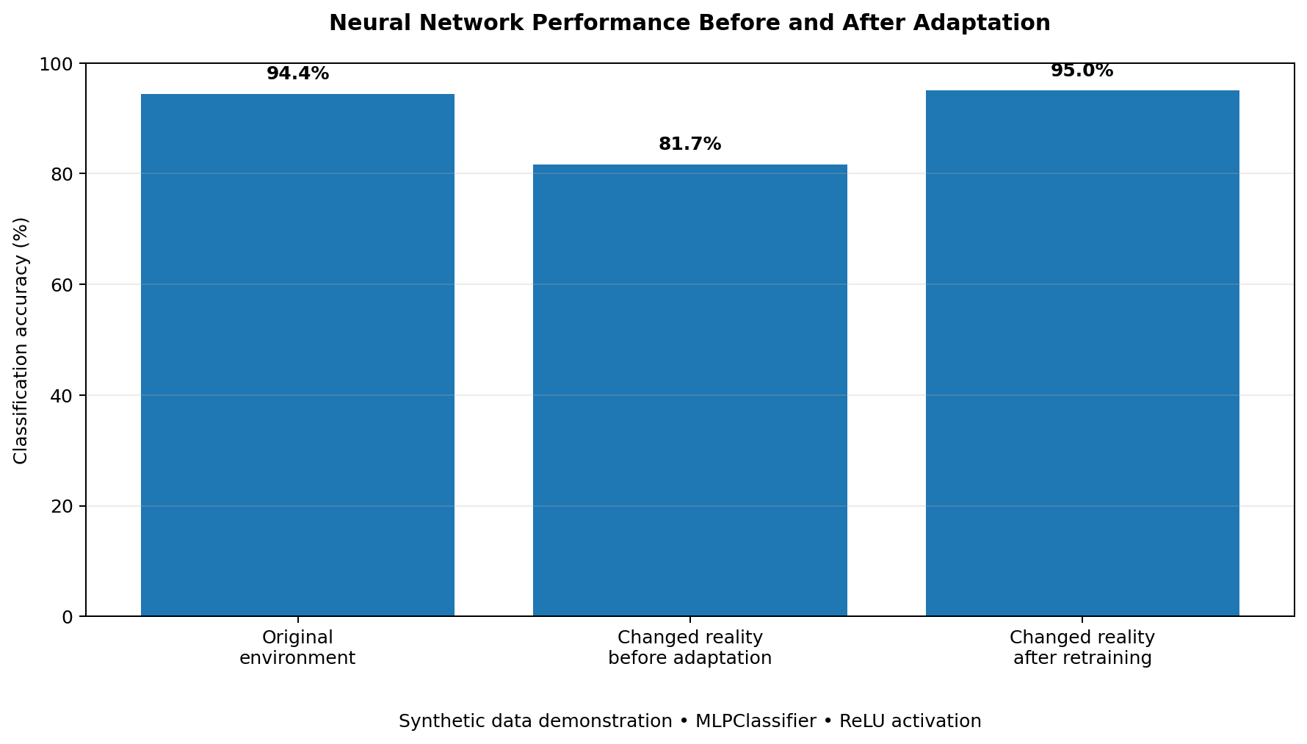
Figure 1. Accuracy before and after the data pattern changed and the model was retrained.
The drop from 94.4% to 81.7% shows that a successful model can become less dependable when its assumptions no longer match reality. Retraining with relevant data raised accuracy to 95.0%. The lesson is not that retraining always solves every problem; it is that monitoring, feedback, representative evidence, and deliberate adjustment are necessary when conditions change.

Connection to Problem-Solving and Leadership
Neural networks learn through repeated exposure, feedback, and adjustment. People and organizations face a similar challenge when familiar methods stop working in a changed environment. My leadership response should begin with listening and measurement rather than defending an outdated approach. I should explain what changed, invite feedback from technical and nontechnical stakeholders, test a smaller adjustment, and communicate the reason for the change. Like a model, a team needs trustworthy input and clear feedback, but human leadership also requires empathy, moral judgment, and accountability.

Faith, Resilience, and Adaptive Leadership
Nehemiah demonstrated adaptive leadership when opposition changed the conditions of rebuilding Jerusalem. He kept the mission but reorganized the people so they could build and guard at the same time (New International Version, 2011, Nehemiah 4:16–18). This example reminds me that faith does not remove uncertainty; it provides steadiness, wisdom, and courage while the method is adjusted. In AI/ML integration, I should remain grounded in service, honesty, and responsibility while helping others understand and respond to change.

Ethical Reflection
This demonstration uses clearly labeled synthetic data and does not imitate real people or use private records. Synthetic data can support learning and testing, but generated images, audio, or video can also create deepfakes and deception. Responsible practice requires disclosure, consent when identity is involved, access controls, and human review. Technical capability should never be treated as automatic permission to use a tool.

Reflection and Self-Assessment
This artifact helped me move from describing neural networks to demonstrating how they learn and why performance can change. My strongest contribution was connecting a measurable technical result to a practical leadership lesson. I also kept the example small, reproducible, and privacy-conscious. A limitation is that the simulation is simpler than real organizational data drift. In future work, I would add repeated experiments, fairness checks, and a monitoring threshold that signals when human review or retraining is required. Overall, this artifact shows growth in Python, neural-network concepts, communication, responsible AI, and change leadership.

Evidence Files
- adaptive_neural_network.py — complete reproducible Python code
- adaptive-neural-network-results.txt — recorded output
- adaptive-neural-network-chart.png — visual comparison of accuracy

References
LeCun, Y., Bengio, Y., & Hinton, G. (2015). Deep learning. Nature, 521(7553), 436–444. https://doi.org/10.1038/nature14539
Sarker, I. H. (2021). Machine learning: Algorithms, real-world applications and research directions. SN Computer Science, 2, Article 160. https://doi.org/10.1007/s42979-021-00592-x

