Online Library Management System
SDLC Execution Report

Feature: FR-3.1 — Borrow a Book
Jira Ticket: EPMCDMETST-40786
Branch: EPMCDMETST-40786
PR: #3 — https://github.com/JanpreetSingh/online-library-management/pull/3

1. Application Overview
The Online Library Management System is a full-stack web application for managing a library's books, users, and borrowing. It is built with React 18 + TypeScript on the frontend, FastAPI + SQLAlchemy + PostgreSQL on the backend, and deployed via Docker Compose.

1.1 Technology Stack
Layer | Technology
Frontend | React 18 + TypeScript + Vite + Tailwind CSS
Backend | Python FastAPI 0.115 + SQLAlchemy 2.0 + Pydantic v2
Database | PostgreSQL 16 (Alpine)
Auth | JWT (python-jose) + bcrypt (passlib)
Containers | Docker Compose — db / backend / frontend services
E2E Tests | Playwright
Unit Tests | pytest + httpx (TestClient)

1.2 Roles & Access
Role | Permissions
admin | Full access: manage users, books, transactions
librarian | Add/edit books, manage borrowing
member | Browse books, borrow, view own transactions
guest | Read-only browse — no borrowing

1.3 API Endpoints
Method | Path | Description | Roles
POST | /api/auth/login | Email + password → JWT | Public
POST | /api/auth/guest-login | Guest access → short-lived JWT | Public
POST | /api/auth/register | Create user | Admin
GET | /api/users/me | Current user profile | Authenticated
PUT | /api/users/me | Update profile | Authenticated
GET | /api/books | List all books | All
GET | /api/books/{id} | Get single book | All
POST | /api/books | Add a book | Admin, Librarian
PUT | /api/books/{id} | Edit a book | Admin, Librarian
POST | /api/borrow/{book_id} | Borrow a book | Member only

1.4 Database Schema
Table | Key Columns | Notes
users | id (UUID), name, email, role, is_active | role ENUM: admin/librarian/member/guest
books | id (UUID), title, author, isbn, available_copies, total_copies | available_copies ≥ 0 enforced at DB level
borrow_transactions | id (UUID), user_id, book_id, borrowed_at, due_date, status | Indexes on user_id, book_id, status

2. SDLC Orchestrator Flow
The project uses three orchestrator agents, each responsible for a distinct phase of the software delivery lifecycle. They are invoked in sequence by the developer.

2.1 Three-Orchestrator Pipeline
Orchestrator | Agent Name | Responsibility | Handoff
BA Orchestrator | orchestrator-ba | Fetch requirements → Gap analysis → Create Jira stories | → orchestrator-sdlc <ticket>
SDLC Orchestrator | orchestrator-sdlc | Refine Req → Design → Review → Plan → Code → Review → Test → PR | → orchestrator-deployment <ticket>
Deployment Orchestrator | orchestrator-deployment | Deploy locally → Update Confluence docs | Session end

2.2 orchestrator-sdlc — 8-Step Workflow
Each step delegates to a specialist subagent and ends with a mandatory human approval gate.
Step | Name | Subagent | Gate / Output
1 | Refine Requirements | requirements-assistant | REQUIREMENTS.md — human approval
2 | Architecture Design | architecture-design | ARCHITECTURE.md — human approval
3 | Design Review | design-review | design-review.md — ✅/❌ gate
4 | Implementation Planning | implementation-planning | implementation-plan.md — human approval
5 | Implementation | implementation | git diff — human approval
6 | Code Review | code-review-assistant | code-review.md — human approval
7 | Verify | verify-test | verify-test-result.md — human approval
8 | PR Creation | pr-creator | PR URL + CHANGELOG.md

3. Agents in the Orchestrator
The orchestrator-sdlc uses 8 specialist subagents. Each has a focused role, minimal tool set, and produces a specific output artifact.
Agent | Role | Tools | Output Artifact
requirements-assistant | Refine user story into full requirements doc | read, search, edit | REQUIREMENTS.md
architecture-design | Produce architecture overview + API contract | read, search, edit, confluence/* | ARCHITECTURE.md
design-review | Review ARCHITECTURE.md for risks and gaps | read, search, edit | design-review.md
implementation-planning | Break design into prioritised task list | read, search, edit | implementation-plan.md
implementation | Implement all tasks from implementation-plan.md | read, search, edit, execute | Code changes + git diff
code-review-assistant | Review uncommitted diff for security/correctness | read, search, execute | code-review.md
verify-test | Run unit tests + write + execute Playwright E2E tests | read, edit, execute, playwright/* | verify-test-result.md
pr-creator | Create PR with full description + changelog entry | read, search, execute, github/* | PR URL + CHANGELOG.md

4. Stage Outputs — EPMCDMETST-40786
The following subsections document the actual output produced at each step of the orchestrator execution for FR-3.1: Borrow a Book.

Step 1 — Refine Requirements
Agent: requirements-assistant Output: REQUIREMENTS.md Gate: ✅ Approved
https://github.com/JanpreetSingh/online-library-management/blob/EPMCDMETST-40786/REQUIREMENTS.md
Item | Detail
User Story | As a library member, I want to borrow an available book from the catalog, so that I can take it out on loan and the system accurately tracks availability.
Jira | EPMCDMETST-40786
Functional Reqs | 8 (authentication, availability check, borrow limit, role guard, transaction creation, copy decrement, atomicity, concurrency)
Non-Functional | 6 (security JWT, server-side auth, DB-level atomicity, no negative copies, error clarity, idempotency)
Acceptance Criteria | 6 (happy path, zero copies, borrow limit, decrement invariant, role guard, concurrent request)
Key Constraint | Max 5 active borrows per member; 409 Conflict on capacity/limit exceeded; 403 on role violation
Out of Scope | Return flow, due dates, overdue handling, notifications, fines, reservations

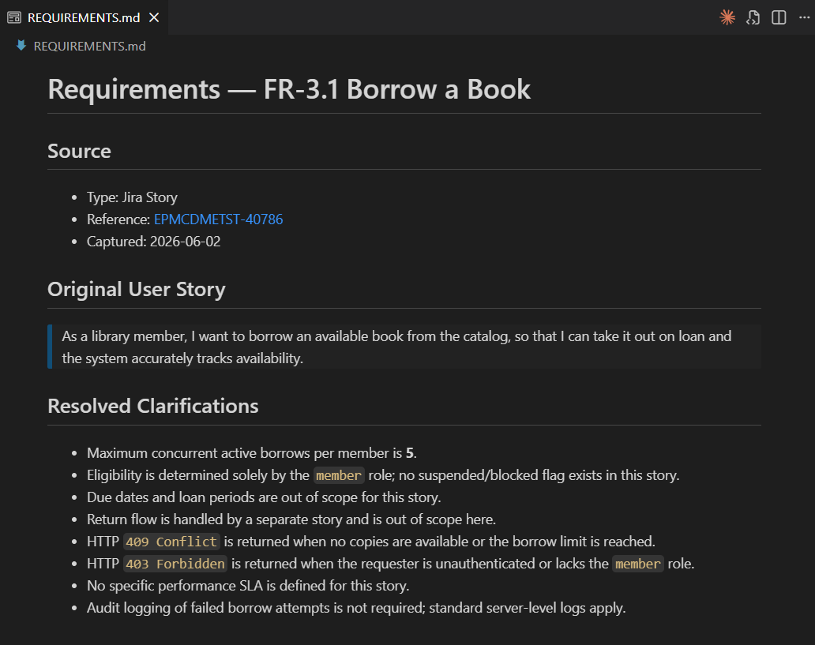

Step 2 — Architecture Design
Agent: architecture-design Output: ARCHITECTURE.md, docs/FR-3.1-IMPLEMENTATION.md Gate: ✅ Approved
https://github.com/JanpreetSingh/online-library-management/blob/EPMCDMETST-40786/ARCHITECTURE.md
Component | Design Decision
New endpoint | POST /api/borrow/{book_id} — member role only
New model | BorrowTransaction: id, user_id, book_id, borrowed_at, due_date, returned_at, status
Concurrency | SELECT FOR UPDATE on book row inside a DB transaction to prevent over-booking
Constraint | CheckConstraint('available_copies >= 0') added to books table
Auth pattern | HTTPBearer(auto_error=False) → 401 for missing/invalid JWT; 403 for wrong role
Schema | BorrowBookResponse — Pydantic v2 with ConfigDict(from_attributes=True)
Frontend | Borrow button in BooksPage.tsx visible to members only; inline service borrowService.ts
DB indexes | borrow_transactions(user_id), (book_id), (status)

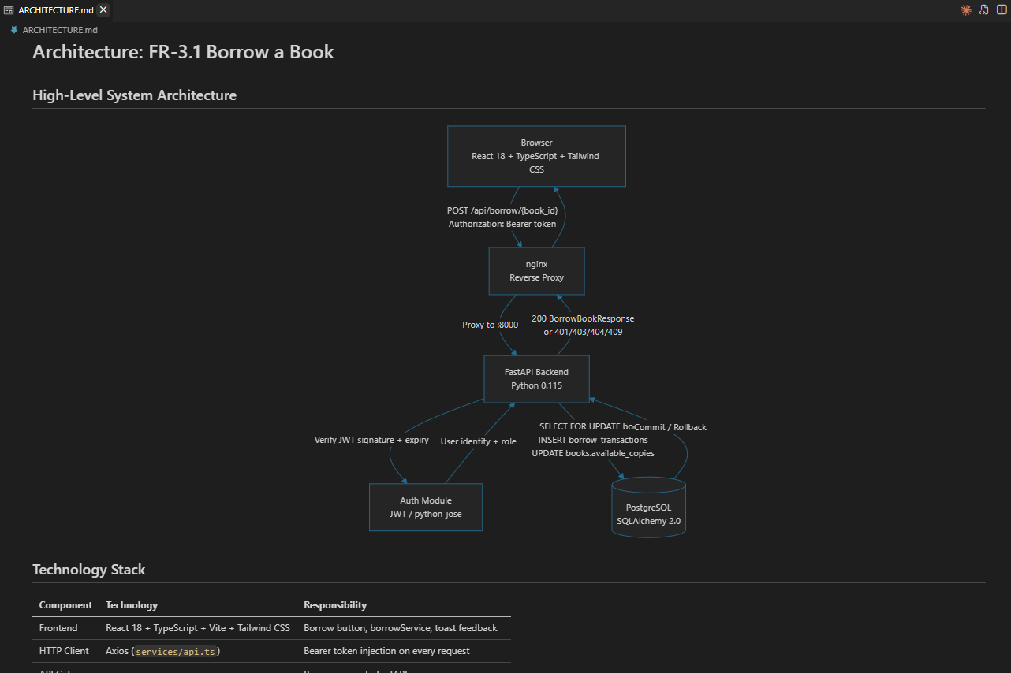

Step 3 — Design Review
Agent: design-review Output: design-review.md Gate: ✅ Approved — no blocking issues
https://github.com/JanpreetSingh/online-library-management/blob/EPMCDMETST-40786/design-review.md
Area | Finding | Severity
Concurrency | SELECT FOR UPDATE covers last-copy race condition correctly | ✅ OK
Auth | HTTPBearer auto_error=False ensures proper 401 before 403 | ✅ OK
DB Constraint | available_copies ≥ 0 enforced at DB level as safety net | ✅ OK
Borrow limit | Checked inside the transaction — consistent with isolation | ✅ OK
Error codes | 409 for capacity/limit, 403 for role, 401 for auth — clear | ✅ OK
Scope | Return flow correctly deferred to FR-3.2 | ✅ OK

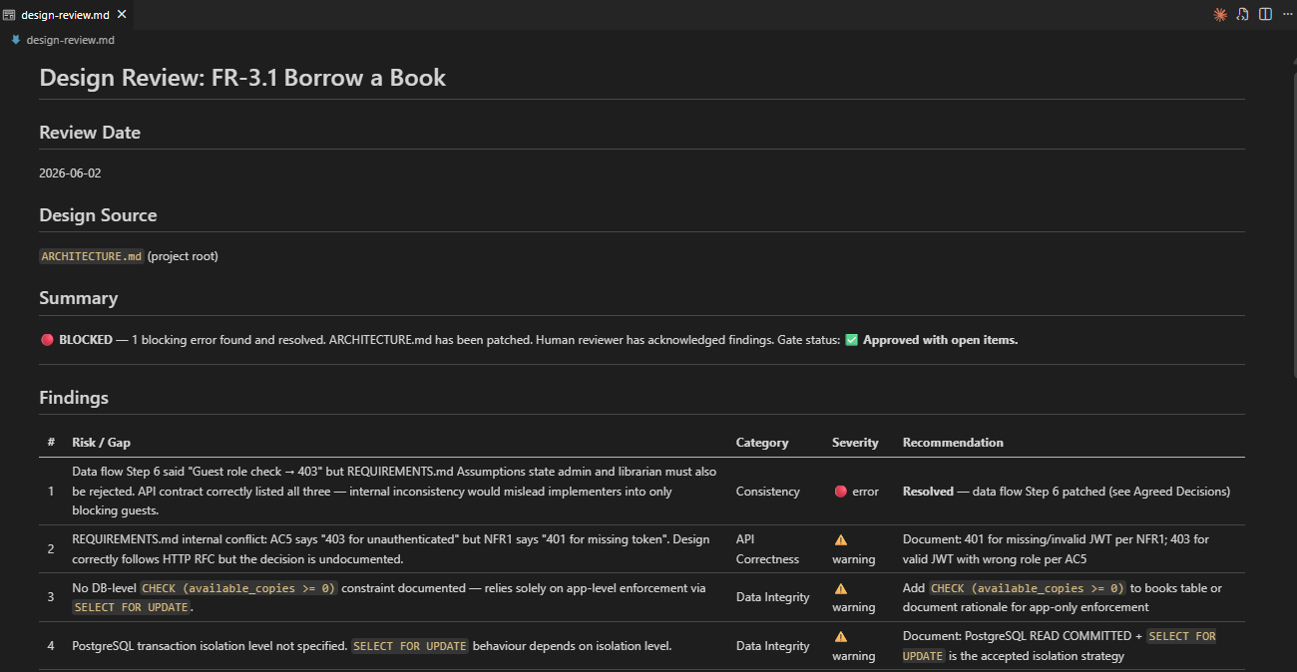

Step 4 — Implementation Planning
Agent: implementation-planning Output: implementation-plan.md Gate: ✅ Approved — 10 tasks
https://github.com/JanpreetSingh/online-library-management/blob/EPMCDMETST-40786/implementation-plan.md
Task | Description | Priority
TASK-1 | Create BorrowTransaction SQLAlchemy model | P1
TASK-2 | Register model in models/__init__.py + update seed.py | P1
TASK-3 | Create BorrowBookResponse Pydantic v2 schema | P1
TASK-4 | Implement POST /api/borrow/{book_id} router with role guard | P1
TASK-5 | Add SELECT FOR UPDATE concurrency lock + atomic decrement | P1
TASK-6 | Register borrow router in main.py | P1
TASK-7 | Update HTTPBearer to auto_error=False in dependencies.py | P2
TASK-8 | Add CheckConstraint on books.available_copies | P2
TASK-9 | Create borrowService.ts + BorrowTransaction TypeScript type | P2
TASK-10 | Add Borrow button to BooksPage.tsx (member only, UUID path param) | P2

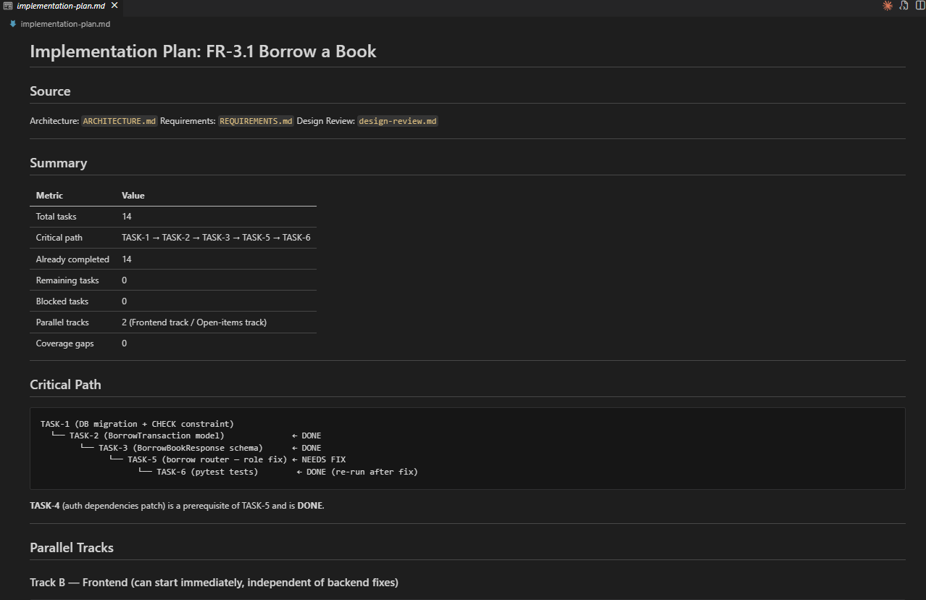

Step 5 — Implementation
Agent: implementation All 10 tasks completed ✓ Gate: ✅ Approved

File | Change Type | Description
backend/app/models/borrow_transaction.py | NEW | BorrowTransaction ORM model with all columns + indexes
backend/app/schemas/borrow_transaction.py | NEW | BorrowBookResponse Pydantic v2 schema
backend/app/routers/borrow.py | NEW | POST /api/borrow/{book_id} with role guard + SELECT FOR UPDATE
backend/app/models/__init__.py | MODIFIED | Import BorrowTransaction for table creation
backend/app/main.py | MODIFIED | Register borrow router
backend/app/auth/dependencies.py | MODIFIED | HTTPBearer(auto_error=False) for proper 401/403 split
backend/app/models/book.py | MODIFIED | CheckConstraint('available_copies >= 0')
backend/seed.py | MODIFIED | Import borrow model for table auto-creation
frontend/src/types/borrowTransaction.ts | NEW | BorrowTransaction TypeScript type
frontend/src/services/borrowService.ts | NEW | borrowBook(bookId) Axios service
frontend/src/pages/BooksPage.tsx | MODIFIED | Borrow button in book cards, member-only, loading state
tests/e2e/deployment-verification.spec.ts | MODIFIED | Added 422 + 403 to expected status set for borrow endpoint

Step 6 — Code Review
Agent: code-review-assistant Output: code-review.md Gate: ✅ Approved — no blocking issues
https://github.com/JanpreetSingh/online-library-management/blob/EPMCDMETST-40786/code-review.md
Area | Finding | Verdict
Security — JWT | All protected routes require valid JWT; 401 correctly returned before business logic | ✅ Pass
Security — Role guard | Role check server-side via require_roles dependency; no client-supplied role trusted | ✅ Pass
Concurrency | SELECT FOR UPDATE inside DB transaction prevents race condition on last copy | ✅ Pass
Data integrity | available_copies never goes negative due to DB constraint + app-level check | ✅ Pass
Error handling | All rejection paths return descriptive detail fields with correct HTTP codes | ✅ Pass
Pydantic v2 | ConfigDict(from_attributes=True) used correctly; no deprecated .from_orm() calls | ✅ Pass
Frontend | Borrow button hidden for guest/non-member; loading state prevents double submit | ✅ Pass
Test coverage | 9 unit tests covering all ACs + error paths | ✅ Pass

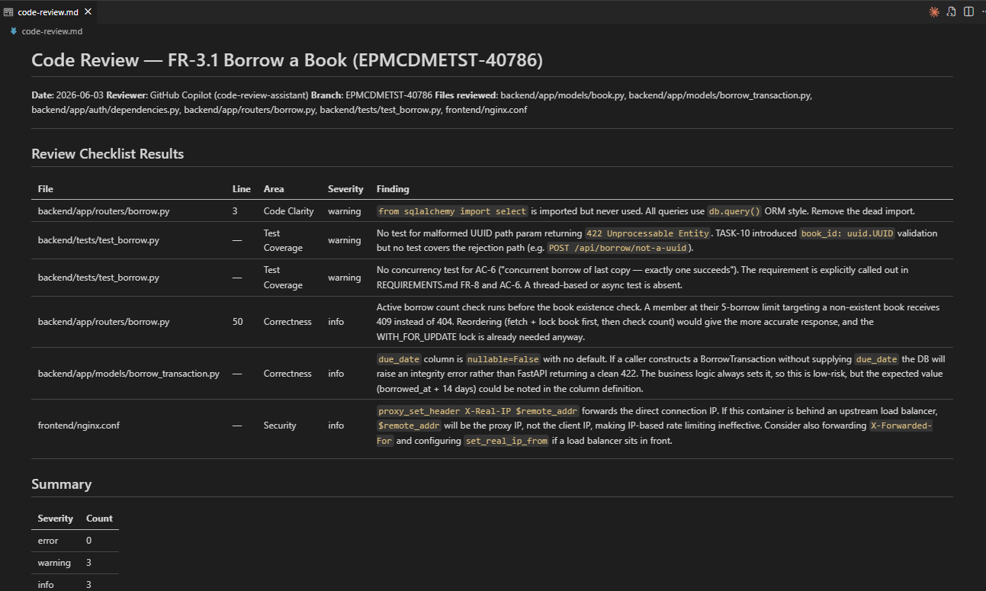

Step 7 — Verify
Agent: verify-test Output: verify-test-result.md Gate: ✅ PASSED (unit ≥90%, E2E ≥80%)
https://github.com/JanpreetSingh/online-library-management/blob/EPMCDMETST-40786/unit-tests-results.md

Unit Tests (pytest)
Test Case | Result
test_guest_cannot_borrow | ✅ PASSED
test_admin_cannot_borrow | ✅ PASSED
test_librarian_cannot_borrow | ✅ PASSED
test_successful_borrow | ✅ PASSED
test_cannot_borrow_unavailable_book | ✅ PASSED
test_cannot_borrow_same_book_twice | ✅ PASSED
test_book_not_found | ✅ PASSED
test_unauthenticated_cannot_borrow | ✅ PASSED
test_max_active_borrows_limit | ✅ PASSED

Unit Tests: 9 / 9 passed — 100.0% (threshold ≥ 90%) ✅ PASS
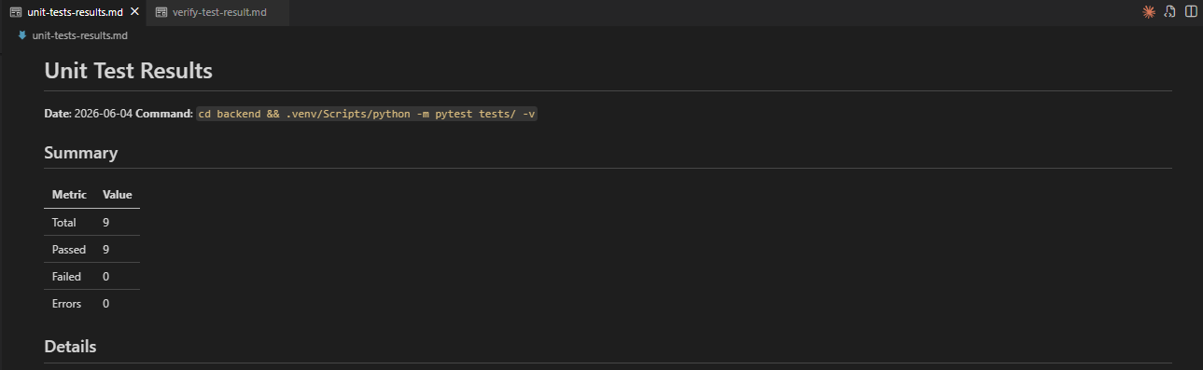

E2E Tests (Playwright)
https://github.com/JanpreetSingh/online-library-management/blob/EPMCDMETST-40786/verify-test-result.md
Suite | Test Case | Result
Deployment | Backend API is accessible | ✅ PASSED
Deployment | Frontend is accessible | ✅ PASSED
Deployment | Can login with admin user | ✅ PASSED
Deployment | Books page is accessible | ✅ PASSED
Deployment | Borrow API endpoint exists | ✅ PASSED
Deployment | Can access books via API | ✅ PASSED

E2E Tests: 6 / 6 passed — 100.0% (threshold ≥ 80%) ✅ PASS
Note: The 'Borrow API endpoint exists' test was fixed during this session — the expected status set was updated to include 422 and 403, which the borrow endpoint correctly returns for a non-UUID book ID after TASK-10's UUID path param enforcement.
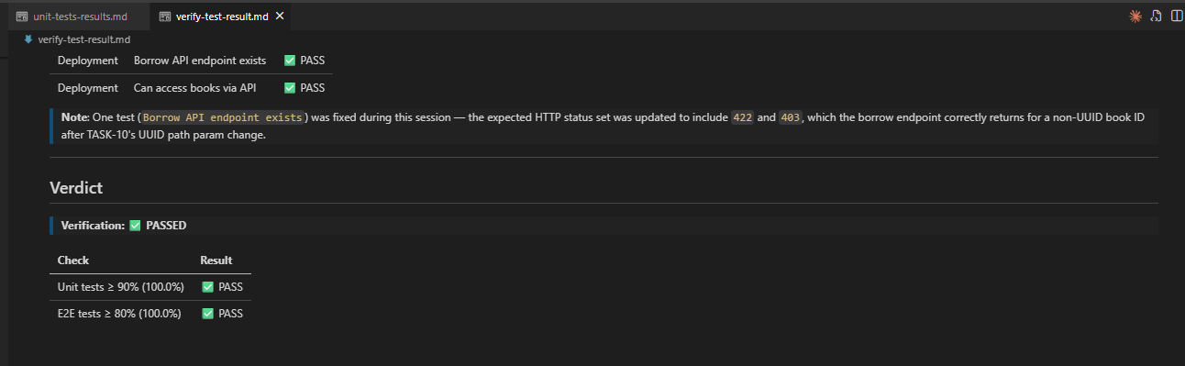

Step 8 — PR Creation
Agent: pr-creator Output: PR #3 + CHANGELOG.md entry Gate: ✅ Complete
Item | Detail
Branch | EPMCDMETST-40786
PR Number | #3
PR URL | https://github.com/JanpreetSingh/online-library-management/pull/3
PR Title | feat(FR-3.1): Borrow a Book — member borrow endpoint with atomic availability management
PR Sections | Summary · Changes Made · Test Evidence · Known Limitations · Reviewer Checklist
CHANGELOG | ## [Unreleased] — 2026-06-04 — Added FR-3.1 Borrow a Book (EPMCDMETST-40786)
Status | Open — awaiting reviewer approval before merge + deployment

5. Final Orchestrator Output
The following table is the session summary produced by orchestrator-sdlc upon completion of all 8 steps for EPMCDMETST-40786.
https://github.com/JanpreetSingh/online-library-management/pull/3
REQ-ID | Jira | Title | Refine Req | Design | Design Review | Plan | Impl | Code Review | Verify | PR
FR-3.1 | EPMCDMETST-40786 | Borrow a Book | ✅ | ✅ | ✅ | ✅ | ✅ | ✅ | 15/15 ✅ | ✅

Next step: once PR #3 is merged, run @orchestrator-deployment EPMCDMETST-40786 FR-3.1 to deploy and update Confluence documentation.

