**LAPORAN**

**TUGAS 2**

**DATA WAREHOUSE DAN BISNIS INTELLIGENCE**



Oleh:

Janrian Nahom Simbolon

(181402072)

Kom C

**JURUSAN TEKNOLOGI INFORMASI**

**FAKULTAS ILMU KOMPUTER - TEKNOLOGI INFORMASI**

**UNIVERSITAS SUMATERA UTARA**

**MEDAN**

**2021**

# Module 2 Assignment using Web PivotTable

Assignment 1 provides experience with WebPivotTable, an open source application for business intelligence. Using WebPivotTable, you will customize a pivot table and extend it to show more aggregated fields. WebPivotTable is a pure Javascript application that can be used in any browser without plugins.

Before starting this assignment, you should read the Web pivot table tutorial. The tutorial demonstrates the usage of WebPivotTable and the OLAP cube source used for this assignment. It also demonstrates MDX to specify a pivot table. If you have not read the tutorial yet, please refer to it prior to starting this assignment.

## Load the Data Cube

1. Select the preloaded OLAP cube Microsoft Adventure Works (same cube used in tutorial) from the Demo list to create the pivot table.
2. Take some time exploring the data cube before beginning on the details of the assignment.

## Create the Pivot Table

Create a customized pivot table that shows the following:

* + 1. Expand the “Promotions” dimension in the Fields List.
    2. Select “Promotions” field inside the “Promotions” dimensions in the Rows area.
    3. Expand the “Delivery Date” dimension in the Fields List.
    4. Select “Delivery Date.Month of Year” in the Columns area. If it appears in the Rows area, move it from the Rows to the Columns area.
    5. Expand the Measures in the Fields List.
    6. Select “Average Sales Amount” in the values area
    7. Take a screen snapshot and paste it into a document as the snapshot for part 2 of the WebPivotTable assignment. The snapshot should show All Promotions and All Periods with complete expansion on the rows and columns with Average Sales Amount in the cells.
    8. Keep the sheet open for the next part.

**Answer :**

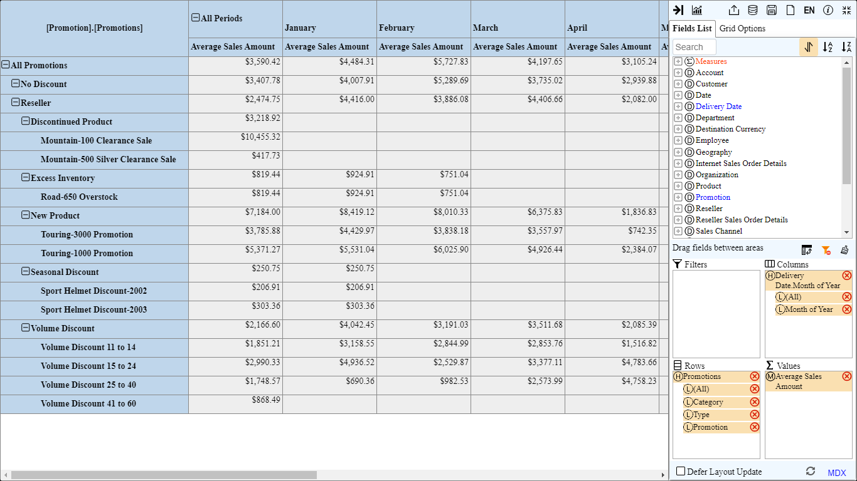

## Extend the Pivot Table

* 1. Add “Source Currency” level (Do NOT include “ALL” level) from the Source Currency dimension to the Filters area.
  2. Create a filter such that the pivot table displays value only for “Canadian Dollar” and “US Dollar”.
  3. Take a screen snapshot and paste it into a document as the snapshot for part 3 of WebPivotTable assignment. The snapshot should show a complete expansion of All Periods and All Promotions with January Average Sales Amount in the cells.
  4. Keep the sheet open for the next part.

**Answer :**

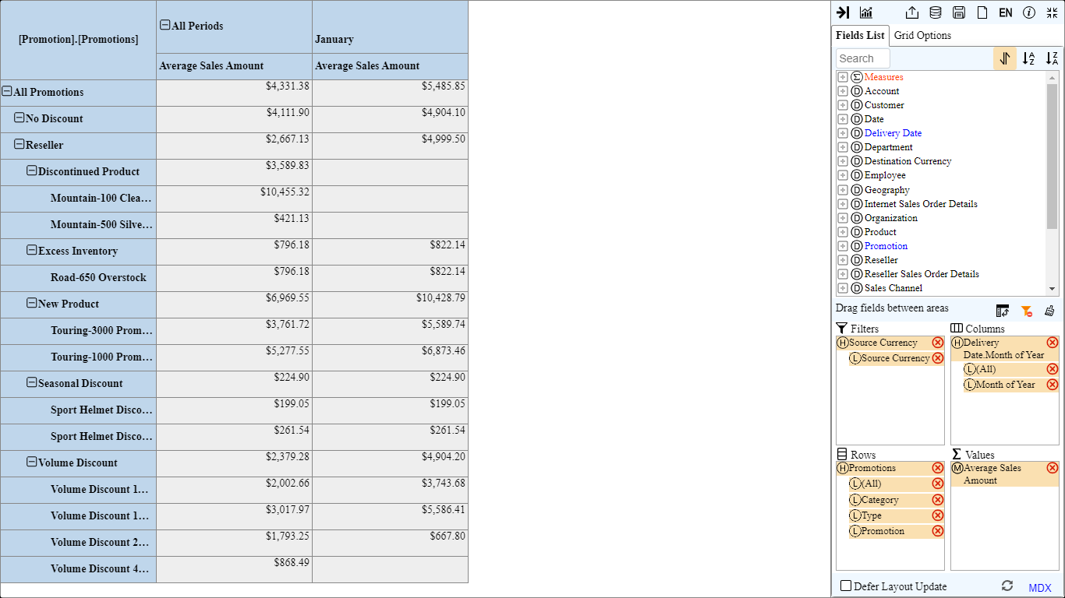

## Extend the Pivot Table with Filter Changes and Rollups

1. Modify the filter to show results only for the source Currency “EURO”.
2. Collapse all reseller promotions except for Excess Inventory. Show only the subcategories within the Excess Inventory item.
3. Remove the pivot chart so that the sheet only displays the pivot table.
4. Take a screen snapshot and paste it into a document as the snapshot for part 4 of the WebPivotTable assignment. The snapshot should show the Average Sales Amount for All Periods along with a subset of the expansion of All Promotions for Excess Inventory promotions.

**Answer :**

